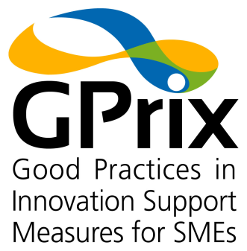

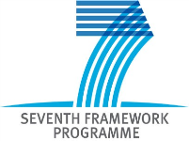



**Instrument:** SP4-Capacities - CSA - Support Action

**Call:** FP7-SME-2009-1 **Grant agreement Number:** 245459

**Start date of project:** 1st December 2009 **Duration:** 27 months

**Project acronym:** GPrix

**Project full name:** Good Practices in Innovation Support Measures for SMEs: facilitating transition from the traditional to the knowledge economy

**Consortium:**



|  |
| --- |
| **D1.7- Impact assessment of measures on SMEs** |

**Date of deliverable**: 30th November 2011

**Organisation name of lead beneficiary for this deliverable**: INOVA+

**Author (s):** The GPrix consortium

|  |  |  |
| --- | --- | --- |
| **Project co-funded by the European Commission within the Seventh Framework Programme (2007- 20013)** | | |
| Dissemination level | | |
| PU | Public | 🗹 |
| PP | Restricted to other programme participants (including the Commission Services) |  |
| RE | Restricted to a group specified by the consortium (including the Commission Services) |  |
| CO | Confidential, only for members of the consortium (including the Commission Services) |  |

**Date of deliverable**: 31stDecember 2011

**Table of Contents**

1 Executive summary 8

2 Methodological Approach 10

2.1 Overview 10

2.2 Online Survey 10

2.2.1 Fraunhofer IFF attempts to reach SME in Saxony-Anhalt (Germany) 10

2.2.2 Staffordshire University Business School Approach to reach SME in West Midleands (UK) 11

2.2.3 Universitat poliècnica de valencia UPVLC experience to reach SME on Valencia region (spain) 12

2.2.4 ESTERs Experience to reach SMEs in Limousin Region (France) 12

2.2.5 Data Cleaning process 13

2.3 Interviews and Case Studies 14

3 Results of impact assessment of measures on SMEs 16

3.1 Description of sample 16

3.2 Innovation activities and impact 26

3.2.1 Types of innovation activities 26

3.2.2 Innovation intensity 30

3.2.3 Impact of innovation 33

3.2.4 Innovation capabilities 35

3.3 Support measures 37

3.4 Impact of the chosen Support measures 47

3.5 SME needs in support programmes 51

4 Annex 55

4.1 Case studies overview 55

4.2 Case studies DE – Saxony-Anhalt 58

4.2.1 MSB3 – Successful innovation in mechanical engineering company 58

4.2.2 MSB2 – Successful innovation in a mechanical engineering SME 62

4.2.3 SMB1 – two successful innovations of a mechanical engineering SME 65

4.2.4 AMS2 – innovation support of an automotive cluster 69

4.2.5 MVU1–metal working SME without innovation (support) 72

4.2.6 SMB4 – stopped innovation project of a subsidiary small company 75

4.2.7 AMS1 – successful innovation of a small automotive supplier 78

4.2.8 AUN1 – support programm experiences of a food company 81

4.3 Case studies ES – Comunidad Valencia 84

4.3.1 Aceitunas Gutierrez 84

4.3.2 A y M Navarro S.L. 87

4.3.3 Aceitunas Guerola S.L. 89

4.3.4 Representaciones Mondragon S.L. 91

4.3.5 EMAC Complementos S.L. 92

4.3.6 Textisol SL (Textile Sector) 96

4.4 Case studies FR – Limousin 100

4.4.1 Atelier Lo Tillou on - No essential support measure. 100

4.4.2 FR-CR1 on the measure Support to collaborative projects of competitiveness clusters (SIF). 103

4.4.3 company Kimeko on No support measure. 109

4.4.4 company Porcelaine Pierre Arquié on the Recruitment Assistance measure 112

4.4.5 A case study of the company FR-LR1on No support measure. 116

4.4.6 Company Pact on the Innovation Support measure 118

4.5 Case studies IT – Emilia-Romagna 123

4.5.1 IT-AM1- MARZOCCHI TENNECO srl 123

4.5.2 IT-ME1 - VISION TECH srl 124

4.5.3 IT-ME2 - MAC. ANT. Srl 126

4.5.4 IT-ME3 - ZETAUTOMATION srl 127

4.5.5 IT-ME4 - GIULIANI FEDERICO snc 129

4.5.6 IT-ME5- ITALSIGMA srl 130

4.5.7 IT-ME6 - C.A.T. PROGETTI srl 131

4.5.8 IT-CR1- INPROCER 133

4.5.9 IT-AM2 - STUDIO PEDRINI srl 134

4.5.10 IT-FD1 - LCA Lab srl 136

4.5.11 IT-LR1- LOGIS 3D 138

4.6 Case studies NL – North Brabant 141

4.6.1 Leather NL (anonimised) 141

4.6.2 Artofil BV 143

4.6.3 Cedeko Raamdekoraties BV 146

4.6.4 Van Haandel 148

4.6.5 Voertuig BV (anonimised) 151

4.6.6 Metaal Industrie Uden BV 153

4.6.7 Van den Berkmortel Fijnmetaal BV 157

4.6.8 Prins Autogassystemen BV 159

4.6.9 Food NL (anonimised) 163

4.6.10 Metal NL (anonimised) 164

4.7 Case studies PT – Northern / Central Portugal 166

4.7.1 PT-TX1 – Textile SME No MEASURE (anonimised) 166

4.7.2 PT-ME1 - 3DTECH Lda. 168

4.7.3 PT-ME2 – Meireles S.A. 172

4.7.4 PT-ME5 – TEGOPI – Indústria Metalomecânica S.A. 175

4.7.5 PT-LR1 – LEATHER SME (anonimised) 178

4.8 Case studies UK – West Midlands 182

4.8.1 Leather SME #1 – No Measure Received 195

4.8.2 Case Study: Leather SME #2 – Measure Received – OMIS 202

4.8.3 Textiles SME #1 – Kiniki – Two Measures Received – MAS-WM Strategic Change Project and Passport to Export 209

4.8.4 Textiles SME #2 – Selectus – No Measure Received 213

4.8.5 Textiles SME #3 – Party Shop Supplies (brand name: Charlie Crow) – Two Measures Received – Passport to Export and ERDF Internationalisation Scheme 216

4.8.6 Ceramics SME #1 – No Measure Received 220

4.8.7 Automotive SME #1 – Wild Springs & Wireforms Ltd. – Measure Received – Capital Funding 225

Introduction to Case Studies 4.8.8 to 4.8.10: SMEs in groups 231

4.8.8 Metallurgy SME #1 – No Measure Received 236

4.8.9 Metallurgy SME #2 – Range of Measures Received 241

4.8.10 Automotive SME #2 – No Measure Received 247

4.9 Sources 253

**Figures**

Figure 1: GPrix sample by countries 16

Figure 2: Case studies by country 17

Figure 3: Employment in 2005 & 2009 18

Figure 4: SME classes regarding employment in 2005 and 2009 18

Figure 5: Case studies by number of employees 19

Figure 6: Turnover in 2005 & 2009 in Euro 20

Figure 7: SME classes regarding turnover in 2005 and 2009 20

Figure 8: Case studies by annual turnover 21

Figure 9: Distribution of sample by type of activity 22

Figure 10: Distribution of sample by sector of activity 23

Figure 11: Distribution of case studies by sector of activity 24

Figure 12: Strength of competition 25

Figure 13: Destination of firms’ sales (mean % for each category) 25

Figure 14: Destination of firms’ sales by country (mean % for each category) 26

Figure 15: Importance of types of innovation for firm performance (MV = 14, 14, 16, 18) 27

Figure 16: Companies concept of innovation 28

Figure 17: Companies objectives regarding innovation activities 28

Figure 18: Product innovation, 2005-09 29

Figure 19: Marketing innovation 30

Figure 20: Spending on innovation as a percentage of turnover, 2009 (percentage of firms in each spending category) 31

Figure 21: Resources devoted to innovation in 2005 compared to 2009 (MV = 15) 32

Figure 22:Impact of recession on new/improved and established products 32

Figure 23: The employment effect of innovation (multiple responses permitted, MV = 9) 34

Figure 24: Proportion of sales from technological innovation (MV = 18) 35

Figure 25: Firms’ self-assessment of their technological innovation capability in relation to their industry 2005 and 2009 36

Figure 26: Firms’ self-assessment of their non-technological innovation capability in relation to their industry 37

Figure 27: Percentage of firms using different numbers of support programmes 38

Figure 28: Percentage of firms using different numbers of support programmes, 2005-09: by country 39

Figure 29: Range of publicly funded innovation in Europe (source: Gallup 2007) 40

Figure 30: Participation rate in GPrix sample (number of SMEs with or without innovation support measures) 41

Figure 31: Innovation activities supported by 1st and 2nd Support Measures, 2005-09 (multiple responses permitted) 42

Figure 32: Innovation activities supported by 1st Support Measure, 2005-09: by country (multiple responses permitted) 43

Figure 33: The six different support measure types within the GPrix sample 44

Figure 34: The distribution of support measure 1 within the six different support measure types 45

Figure 35: Type of innovation support measure 46

Figure 36: Reason for choosing concrete innovation support measures 47

Figure 37: Impact of the 1st and 2nd Support Measures 48

Figure 38: Results and impact of innovation support measures for the interviewed SMEs 49

Figure 39: Additionality of support measure 1 49

Figure 40: Additionality of Support Measure 1 by Regions 50

Figure 41: Additionality of support measure 51

Figure 42: SME needs to enable participation in support programmes (range of MVs, 34-44) 52

Figure 43: Good experiences with innovation support measures 53

Figure 44: Challenges concerning innovation support measures 53

**Tables**

Table 1: Assignment of countries and regions within the GPrix sample 17

Table 2: Sectors covered per region 23

Table 3: Cross tabulation between resources devoted to innovation and market competition 31

Table 4: Comparison of proportion of sales with new products 35

Table 5: Comparison of innovation active companies with public financial innovation support 40

Table 6: Case study overview by country / region 56

Table 7: Case study overview by industrial sector 57

# Executive summary

This document contains the results of GPrix online survey and the following detailed interviews which were transferred into case studies.

***The sample:*** The online questionnaire was filled out by 333 people, mostly from traditional[1] SMEs. Two-thirds of them are from the manufacturing sector. Regarding employment 37 per cent are micro, 38 per cent small, 21 per cent medium and only 3 per cent big companies. This picture changes regarding turnover: here are 59 per cent micro, 27 per cent small, 12 per cent medium and only 2 per cent big companies. Most SME (28%) belong to the metallurgy/ mechanical engineering sector, followed by food sector (15%), automotive supplier and textile industry (both 12%). Below 10 per cent participants are from ceramics (8%) and leather (4%) industries. 21 per cent are from other industries. Within the case study subset – 61 SMEs out of the 333 took part in the interviews – the distribution is quite similar.

***Importance of innovation:*** Innovation is essential even for the so called traditional sector. More than half of the respondents (54%) spent more than 5% from annual turnover on innovation activities. Product innovation is still the most dominant innovation type, followed by process innovation. Marketing and organisational innovation is perceived nearly similar as less important than the others, but still with importance for SMEs. Innovation activities have definitely an impact on employment: positive and negative as well, depending on the innovation success. All in all we can see that innovation has a more positive than negative effect on employment. The biggest impact regarding employment can be found in “sustaining jobs”. An in-depth econometrics analysis can be found in Del. 3.3.

***Impact of latest financial crisis:*** Within the analysed period (2005-2009) the beginning of the latest financial crisis was noticeable: The recession has bad impacts for established products, as reported by more than 50 per cent of respondents. Only 12 per cent see a good impact for established products within recession. Impression changes when looking at new products: more than 40 per cent do not feel the impact of recession. More than 20 per cent report a good impact. This means that innovation is essential to be competitive within recession times.

***Innovation support:*** The share of participation in innovation support measures is different in the seven regions: from 33 per cent participation in the UK up to 63 per cent in Germany and Spain. The overall participation rate was 45 per cent. The importance of innovation types was very similar according to the usage of support measures for the different innovation types. Most support measures were dedicated to product innovation, followed by process, marketing and organisational innovation. The GPrix consortium identified six different types of support measure. The most commonly used support type was the “support of internal innovation”.

***Impact of innovation support:*** Respondents reported an important impact on the following (descending sequence): turnover, reputation, speed of completion of innovation project, profitability, access to markets and productivity. Regarding additionality of support measures, the SME reported, that 39 per cent would not have made the innovation activity without the measure. 51 per cent would have done the project, but more slowly and less effectively. Only 10 per cent would have done the same without the measure.

***Challenges and needs for innovation support measures:***18 possible needs were rated regarding their importance from the SME viewpoint. All mean values lay between 3 (=important) and 4 (=high importance). The need with the highest importance for SME is a simple application (4.0). Simple application is followed – with little distance – by simple reporting requirements, short application to funding period and easy access to information (each 3.7). The network of potential partners is the “lowest” need, which is still important.27 SME (77% out of 35 case studies) had challenges with a high administrative effort and 17 with high effort for reporting. 14 SME reported long responses or decisions from program managers (40% out of 35 case studies).

All 61 case studies can be found in detail in the annex of this deliverable.

A detailed econometrics analysis will be presented within Del. 3.3.

# Methodological Approach

## Overview

The Project work was organized according to the following steps (see Del. 1.1):

Step 1 – Conceptual framework

Step 2 – Draft of Pilot Questionnaire and interview guidelines

Step 3 – Pilot testing: Interviews, testing and study of potential respondents

Step 4 – Developing final versions of survey tools, questionnaires and interview guidelines

Step 5 – Large scale implementation of survey

Step 6 – Analysis of results

Step 7 – Development of policy recommendations for better structuring national/ regional support R&D&I programmes

Step 8 – Mapping user needs

Step 9 – European scale validation of recommendations developed and conclusion of the policy recommendation

Step 10 – Start of Pilot implementation of the recommendations developed

This deliverable is situated in step 6 of the GPrix methodology.

## Online Survey

The online survey template is part of deliverable 1.1 (see page 10 ff.). The questionnaire was translated into the six different project languages to lower the barriers to participation for traditional-sector SMEs. The online survey was published on 1st of June 2011 and closed on 15th of November 2011. It was hard for all partners in the consortium to motivate SMEs to fill out the questionnaire. There were several reasons for this common experience. Some regions had better framework conditions than others. The following paragraphs show some experiences and challenges regarding the motivation of SMEs to complete questionnaires.

### Fraunhofer IFF attempts to reach SME in Saxony-Anhalt (Germany)

Fraunhofer IFF used a two way strategy to reach SMEs. The first strategy was to use enterprise associations or open internet platforms to disseminate the questionnaire. The second strategy was direct communication via email, mail or telephone.

**First strategy:** Contacted associations were for example: Chamber of Commerce and Industry, Institute for Competence in AutoMobility (IKAM), Automotive Cluster East Germany (ACOD), Network SME, Investment and Marketing Association, City of Magdeburg, MAHREG, Network Nutrition Saxony-Anhalt or tti Magdeburg GmbH. Furthermore we used regional SME events – e.g. Nutrition Day, Cluster Event Mechanical Engineering or industry workshop “Plant Construction” – to distribute printed questionnaires. Electronic platforms to share the online survey link were also used, e.g. research portal Saxony-Anhalt and different regional/sector groups in XING.

**Second strategy:** As a first step correct addresses from SMEs, especially from the executive boards, were needed. Fraunhofer IFF used the Hoppenstedt enterprise database ([www.firmendatenbank.de](http://www.firmendatenbank.de)) to research and collect company data. We got 564 addresses matching the required parameters:

* SME status (<250 employees)
* Located in Saxony-Anhalt
* Industry sector: automotive, mechanical/metallurgy and food

SMEs were contacted four times via:

1. Letter mailing with the link to the project homepage
2. Electronic mailing with the direct link to the online survey
3. Letter mailing with a print version of the questionnaire and return postage envelope
4. Telephone calls

The most successful action was the second letter mailing with the printed questionnaire in combination with the telephone calls.

### Staffordshire University Business School Approach to reach SME in West Midleands (UK)

In the UK, it is notoriously difficult to get responses from manufacturing firms in general – even from large firms, where there can be a company officer whose job it is to respond to external requests for information. Researchers have found that over recent decades response rates from firms have fallen from perhaps 10-20 percent to a few percent at best. Moreover, it is particularly difficult to get responses from SMEs. In the UK, even trade associations and other organizations that SMEs have chosen to join – and so, presumably, regard as useful – find it difficult to obtain information from their SME members. Accordingly, STAFFS did anticipate that it would be particularly difficult to obtain a substantial number of responses from SMEs in traditional manufacturing sectors. Our experience on the GPrix confirmed this and gave us insight into the causes of low response rates. Owners and managers of high-tech SMEs are often used to working with academics (or, at the very least, are academically qualified themselves) and, maybe for that reason, can be inclined to cooperate with researchers by completing questionnaires. This might also help to explain why researchers are more attracted to studying this type of firm. Conversely, at least in the UK, most traditional sector SMEs have no contact with universities and often owners and managers have no experience themselves of higher education. This explanation was advanced by some of our case-study collaborators; for example, one explained that he was happy to help the project “because I’m a graduate myself”, and advanced the view that non-graduates were less likely to appreciate the usefulness of research. Moreover, even when there is no such cultural barrier, SMEs owners and managers typically have to focus on immediate operational matters. Hence, non-essentials – like completing questionnaires (even if the research is seen as potentially useful) – are pushed to the bottom of the pile. Finally, in our experience, all SME owners and managers hate paperwork, which unfortunately includes questionnaires.

Having said all this, STAFFS did not anticipate quite how difficult it would be to meet the target of 100 returns. The strategy STAFFS adopted was five-fold.

1. Wherever possible, we used existing lists of SMEs to approach firms by e-mail or, where this was the only alternative, by post. Investigations of the sectors uncovered lists for the automotive sector (which overlapped with the metallurgy/metal fabrication sector), the leather industry and the textile industry.
2. We approached sympathetic organizations – including the two sub-regional Chambers of Commerce in the West Midlands – to publicize the survey via their web sites and/or through their newsletters.
3. We have also publicized the survey through business focused web lists and discussion forums.
4. Where possible, we persuaded trade associations and similar organisations to support the project by sending e-mails to their members in the West Midlands. Here, the response to our appeals for help was mixed. The British Ceramic Confederation (BCC) and the Ceramic Industry Forum agreed to do this. However, the Engineering Employers Federation national office declined our request for cooperation. The EEF has a policy not to cooperate with research projects, on the grounds that their members receive too many requests for information.
5. Where possible, we persuaded programme managers to send e-mails to all firms who had applied for support in the period 2005-09 (so that both participants and non-participants were approached). Our main success in this approach was with the regional Innovation Voucher scheme, who sent out around 400 e-mails for us. Other programmes are either run nationally, in which case we found it much harder to gain this support. Other programmes have lists only of participants and no information on firms that made enquiries or unsuccessful applications.
6. We also offered an “incentive”; namely, all respondents were entered into a prize draw for one of five £100 vouchers for either a top-class restaurant or a department store.

This process was very time consuming; it took much longer than anticipated. STAFFS sent out around 2,500 questionnaires by post (Approach 1, above), around 400 e-mails were sent to Innovation Voucher applicants (Approach 5) and several hundred more went to SMEs in the ceramics industry (Approach 4). We cannot even guess at how many firms we have reached by Approaches 2 and 3. All in all, a response rate of – at the most – 2-3%. In the end STAFFS reached the highest response rate in the GPrix sample (98 completed questionnaires).

### Universitat poliècnica de valencia UPVLC experience to reach SME on Valencia region (spain)

In the Valencian region it was also difficult to get responses from SMEs in the sectors related to the project (ceramics, textile, food). Our experience has been that SMEs have more difficulties to understand the benefits collaborating on research project like GPRIX. An important number of them expressed to not have time for this kind of studies, and have the feeling that it will not be useful for them in a short time period.

The strategies adopted by our group to reach SMEs were:

1. Use the University database of SME that had been working with any entity at the University in the past. By this strategy we were able to have a better response for those SME. It was a good starting point but most of them just were interested to participate in practical projects. Also they have better understanding with some professors or researcher inside the university. Thus, even we are from the same university, the relation was not that fluent as we supposed at the beginning.
2. Attend to several trade fairs related to the sectors of the project looking for SMEs that could fit the needs agreed for the queries. This strategy brought us a large list of contacts and also gave us the possibility to disseminate the project idea. We made some queries at the event, but most of them were made the week after.
3. Contact to Chambers of Commerce in order to make dissemination and have information about events where we could participate and make the queries.
4. Trade Association of the different sectors (ceramic, textile, and food), where we found a great support and all the last queries. As Association they try to promote all kind of institutional relations with other entities and sharing experiences between the SME they represent.

In general terms we used more time that we planned.

### ESTERs Experience to reach SMEs in Limousin Region (France)

To administer a survey in Limousin, it first required to have databases of companies in different sectors as leather, ceramics, textile, mechanical/metallurgy and automobile industries. Besides our databases, we worked with our local partners as Chambers of Commerce and Industry, Ceramic European cluster. Finally, we bought an update database containing 332 businesses, to complete our list of local firms.

Secondly, we have contacted SMEs on several occasions and by various means:

1. Letter mailing with the project description and objectives and the link to the project homepage (about 340)
2. Electronic mailing with the direct link to the project homepage (about 340)
3. Remind by mail with the direct link to the project homepage (about 320)
4. Fax of the first letter with the link to the project homepage (about 151 including 111 successful)
5. Telephone calls (or meeting) of the huge majority companies did not respond (about 100)

We spent much more time than we planned on this phase. As we wanted to have quite good results, we also sent paper versions to the firms that we’re going to get back in all the companies. Then we answered the survey online thanks to the completed paper versions we get back.

The business managers do not feel concerned by these types of studies, which they consider very far from their concerns. The business managers used several times this reason, even without reading the survey. Besides, they are very often approached by other surveys and are tired of answering them.

To conclude, most of the firms in Limousin are quite small firms, that’s why they do not take time for this kind of survey and prefer to focus on their own activity.

### Data Cleaning process

Although all partners had great difficulty in obtaining responses to our questionnaire survey, those firms who did respond did so conscientiously. Missing values arising from non-response is an endemic problem in survey data. So it was pleasing that the final GPrix database of 333 responses had a low rate of missing values: few variables had more than 10 percent missing values; typically, variables had around five percent or fewer missing values. Moreover, internal checks revealed consistency among responses. For example, the large number of questions regarding programme participation gave different ways of defining a participation dummy (i.e. a binary indicator: 1 for participation in one or more programmes; 0 for non-participation). The two extremes were a narrow measure derived from the firm naming the support measure and a wide measure derived from responses to questions on participation in different levels of support measure (regional, national and European). The former yielded 141 participants; the latter 143. We favoured the former for analysis, because in this case the evidence was strong and uniform from all these respondents. For the other two respondents in the wide measure, some questions indicated participation; but others – those requiring some particular information – indicated the contrary.

Compared to many well known survey databases, the GPrix database has few missing values and the responses are informative and internally consistent (where this could be checked). Two exceptions were the variables arising from questions asking for the value and level (regional national or European) of programme support. In the case of the former, it was apparent that respondents typically had little or no idea of the value of support programmes in which their firms had participated. The evidence for this is, firstly, a very high rate of missing values and, secondly, many implausibly small or large sums that defied data cleaning (there is a point beyond which data cleaning becomes data invention). In the case of the level of the programme, interview evidence confirmed that respondents often had either forgotten or were not clear about this in the first place: for example, a programme financed by the EU but delivered by a regional authority was typically regarded as simply regional (this was confirmed by interview evidence – even when questioned directly, respondents were often unable to be informative about the provenance of the programme as distinct from the level of delivery).

Both within each region and between regions there is such a wide variety of support measures that these cannot be evaluated individually. In the West Midlands, for example, the 98 responses were not sufficient to have a single response on some important programmes (considering that the proportion of all firms having participated in the different support programmes during the sample period ranged from around one percent to less than 0.1%). Consequently, we allocated all support programmes referred to by respondents into six categories: Human Resources; External Knowledge; Collaboration; Internal Innovation; and Other. These categories were debated and agreed collectively at a GPrix consortium meeting. Then each support measure reported by survey respondents was allocated to one only of these categories.

## Interviews and Case Studies

The online questionnaire contained one question regarding the participation in a follow up interview: Question 32. Would you be happy to participate in a follow up interview? (yes / no).

108 SMEs out of 333 answered this question with yes. Every partner contacted the corresponding SMEs in their region. Finally the GPrix team interviewed 61 SMEs with the interview guideline (see “Del. 1.1 - Methodological Implementation Guidelines” part 6.1).

As described in the selection criteria in “Del. 1.4 - List of selection criteria for selection of the good practice measures” not every SME was suitable for a case study. Depending on the accessible data, SMEs could be excluded from the case study analysis before or after the interview phase.

For every interview approximately 60-90 minutes were planned. Depending on the accessible resources interviews were held with one or two persons, with or without voice recording, via telephone or face to face. After every interview the gathered information were transferred into the case studies. In case of non-native English speaking regions the case studies were first written in local language to approve it by the interviewed person. After approval all case studies were translated into English and could be analyzed by all partners.

To compare the different case studies the consortium developed an Excel-based raster. This raster contained the following categories:

* Company Data / classification
* Companies objective
* Companies concept of innovation
* No. of measures
* Type of measure
* Additionality (same / similar steps without measure?)
* Reason for choosing the measure
* Result / impact for the company
* Good Experience with the specific measure
* Challenges concerning the specific measure

|  |
| --- |
| With different subcategories we were able to quantify the results of the case study analysis. The aim was to underpin the results of the survey analysis with in-depth results from real cases. Thus results from case study analysis will be marked with a blue box (like this). |

# Results of impact assessment of measures on SMEs

## Description of sample

Altogether 333 enterprises filled out the online questionnaire (postal responses were all transferred to the electronic version). Several questions could be skipped by the SME. Some questions were essential for the analysis and should be answered otherwise the whole answer of that particular SME were ignored (see data cleaning process in chapter ).

The great majority of participation SMEs are from the UK, nearly every third answering SME was located in the UK (30%; 98). More than 50 SMEs are from Spain (56; 17%) or Italy (51; 15%). Around 10% of answered questionnaires came from Germany (41; 12%), France (34; 10%) or Netherlands (32; 10%). 21 SMEs were located in Portugal, which is 6% of all participants. The reasons for the quite low participation and the applied strategies can be found in section .

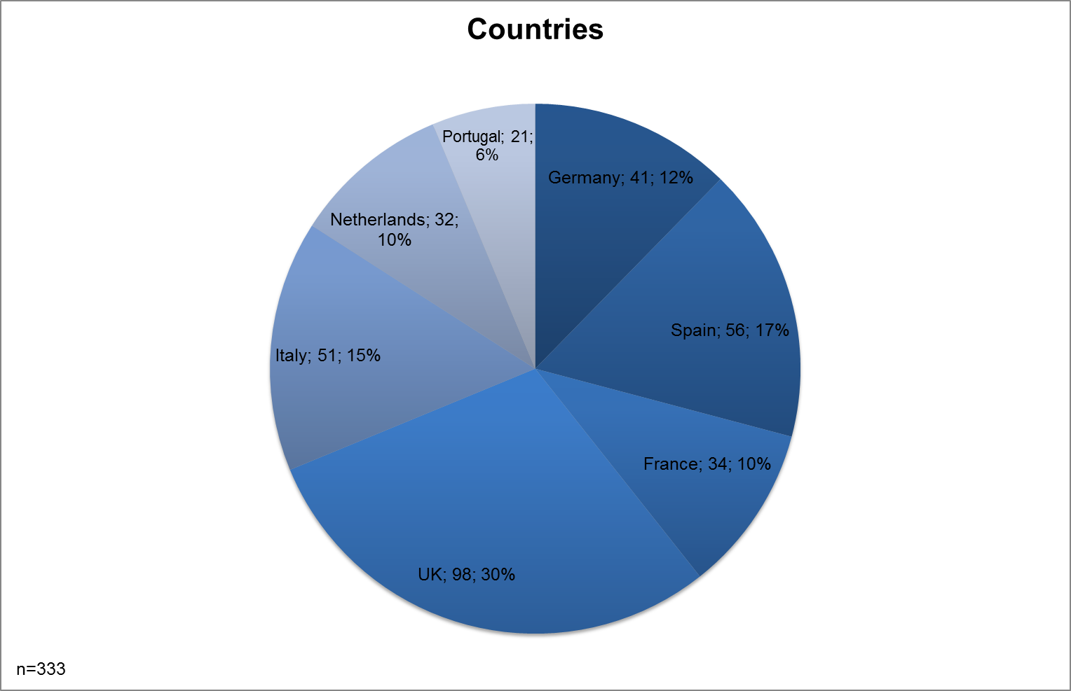

Figure 1: GPrix sample by countries

All partners activated SMEs from their region, so the listing of countries is not quite correct here, because the regions are not representative for their countries. To make it easier for the reader the consortium uses the countries instead of the regions to label the results. lists the correct regions within the seven countries. In all following tables or figures the country codes are used to label the regional results / data.

|  |  |  |
| --- | --- | --- |
| Country code | Country | Region within the country |
| DE | Germany | Saxony-Anhalt |
| ES | Spain | Comunidad Valencia |
| FR | France | Limousin |
| IT | Italy | Emilia-Romagna |
| NL | Netherlands | North Brabant |
| PT | Portugal | Northern / Central Portugal |
| UK | United Kingdom | West Midlands |

Table 1: Assignment of countries and regions within the GPrix sample

|  |
| --- |
| Every consortium partner tried to interview 10 SMEs. For several reasons this could not be reached by everyone. The consortium was bound to the GPrix sample and the willingness of the SMEs to cooperate. Not every SME that checked the interview option within the questionnaire were able to take part in interviews for several reasons. The following figure gives the numbers of case studies by country. From Netherlands, Portugal and the UK we have 10 case studies, even 11 from Italy. 8 cases studies are from Germany and 6 each from Spain and France.    Figure 2: Case studies by country |

As shown in the GPrix sample contains primarily SMEs regarding their employees. The majority employs less than 25 people. The mean value of employees was 80 (in 2005) and 68 (in 2009). As a conclusion we can see slight decrease of employment in the analysed period. The cause for that could be seen in the beginning of the crises 2008/2009. At least for established products the majority of SMEs sees a negative impact of the recession (see ).

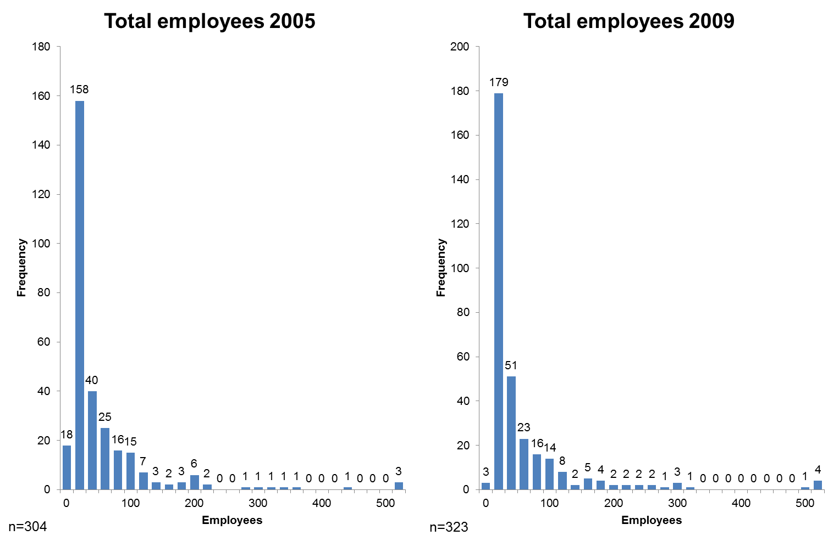

Figure 3: Employment in 2005 & 2009

Within the GPrix sample we can find a majority of small or even micro enterprises (regarding employment). shows that 41 per cent have less than 10 employees (37% in 2005) and 35 per cent have less than 50 employees (38% in 2005). Only 21 per cent can be seen as medium enterprises with less than 250 employees. A very small number of 3 per cent are large enterprises with more than 250 employees (compare EU definition for SME).

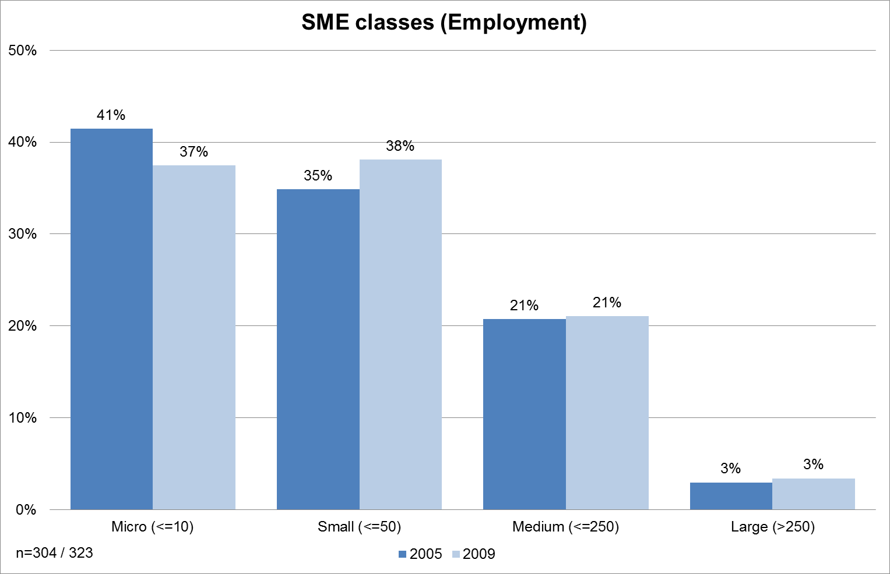

Figure 4: SME classes regarding employment in 2005 and 2009

|  |
| --- |
| Within the group of interviewed SMEs (case studies) the mean value of employees is 52 and thus a bit lower than in the overall sample. Whereas in the overall sample the percentage of micro and small enterprises are more close to each other, we have only 24 per cent of micro enterprises within the interviews. The percentage of small (43%) and medium (31%) enterprises case studies is higher than in the survey. Only one large enterprise was interviewed.    Figure 5: Case studies by number of employees |

The GPrix sample is also typically SME-oriented regarding turnover. 322 enterprises had an annual turnover of less than 50 million Euros. shows the split between different turnover categories (excluding turnover > 50million Euros: 11 firms). The majority of survey participants are characterised as small (less than 10 million Euros) or even micro enterprises (less than 2 million Euros). In 2005 the mean value of turnover was 5.9 million Euros compared to 6.9 million Euros in 2009. This equates to an increase of 18 per cent.

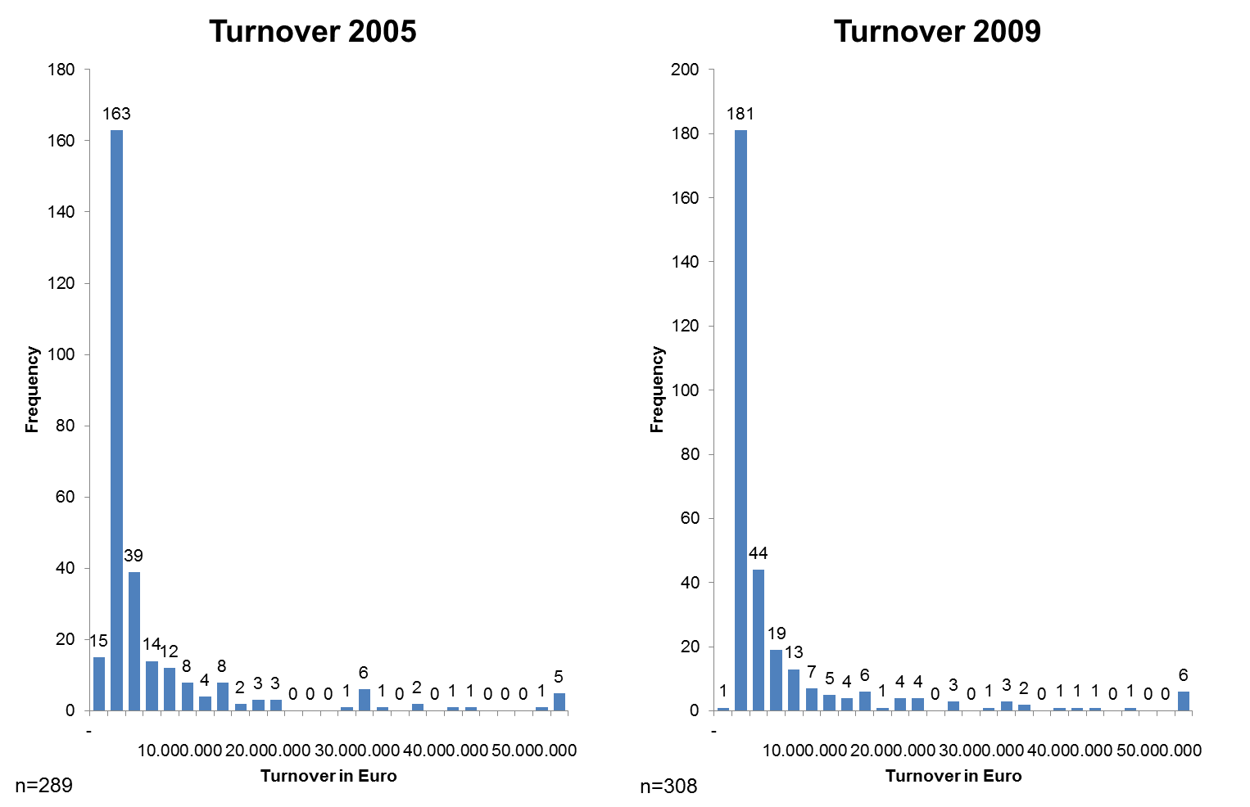

Figure 6: Turnover in 2005 & 2009 in Euro

By using the EU criteria for SME regarding annual turnover the GPrix sample contains 62 per cent micro enterprises (59% in 2005). Every fourth company (25% in 2005) is a small enterprise with an annual turnover less than €10 million. 11 per cent can be seen as medium sized enterprises (12% in 2005) with an annual turnover less than €50 million. Only two per cent are large enterprises with an annual turnover of more than €50 million.

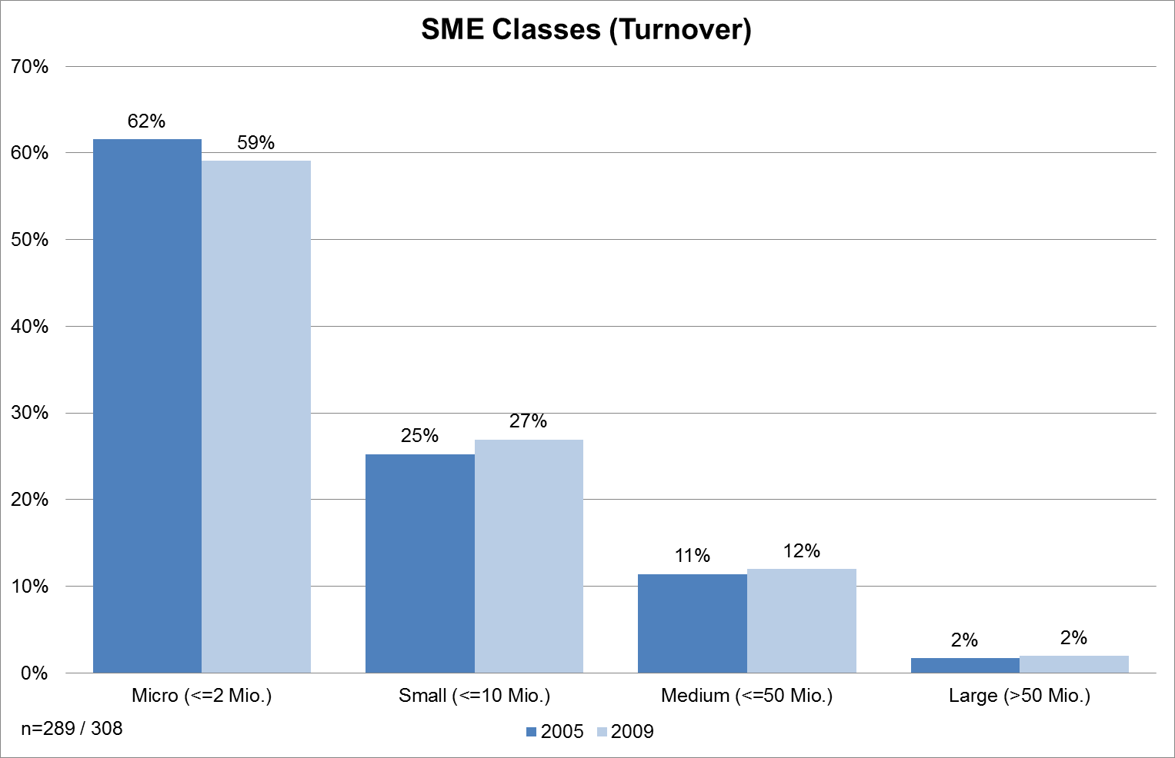

Figure 7: SME classes regarding turnover in 2005 and 2009

|  |
| --- |
| Within the group of interview SME (case studies) the mean value of turnover is around 6.5 Million Euro and thus comparable to the mean value of the overall sample. The case study sample differs from the overall sample, because the consortium wanted to interview nearly equal micro, small and medium sized enterprises. In the end the consortium interviewed 40 per cent micro and small enterprises and 20 per cent medium enterprises.    Figure 8: Case studies by annual turnover |

68 per cent of the participants classify themselves as manufacturing enterprises. 6 per cent belong to wholesale 4 per cent to retail. Industry-related services or other activities are the main type of activity for 11 per cent. This means that potentially 70 per cent – the manufacturing enterprises – directly belong to the GPrix target group, while the others are closely associated with it.

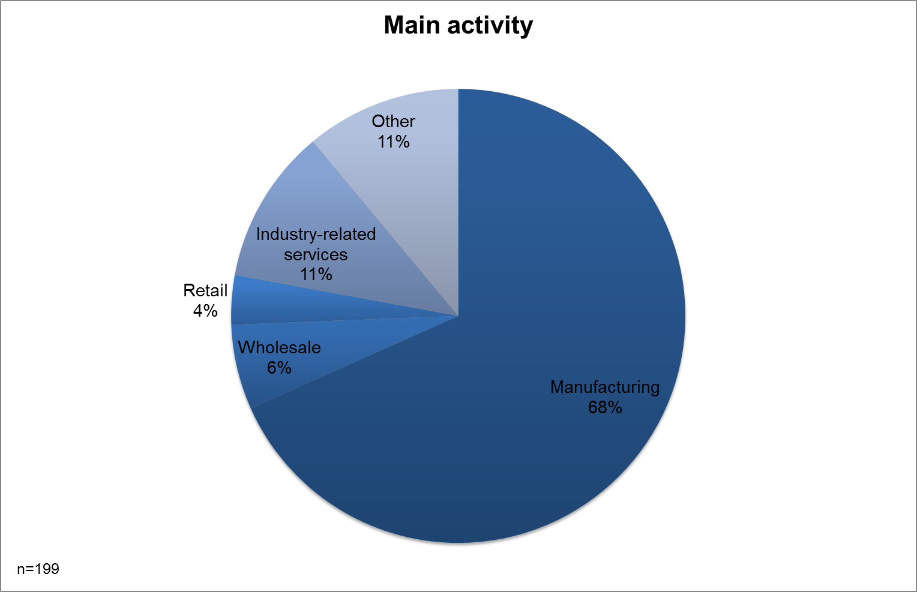

Figure 9: Distribution of sample by type of activity

GPrix focus on traditional sectors such as leather, ceramics, textiles, mechanical/metallurgy, automotive and food production. show that nearly 80 per cent of the survey participants belong to our target group. Only 21 per cent belong to other sectors. The majority of nearly 30 per cent belongs to mechanical / metallurgy sector, followed by food productions with 15 per cent. The smallest group of participants are doing business in the leather sector (4 per cent).

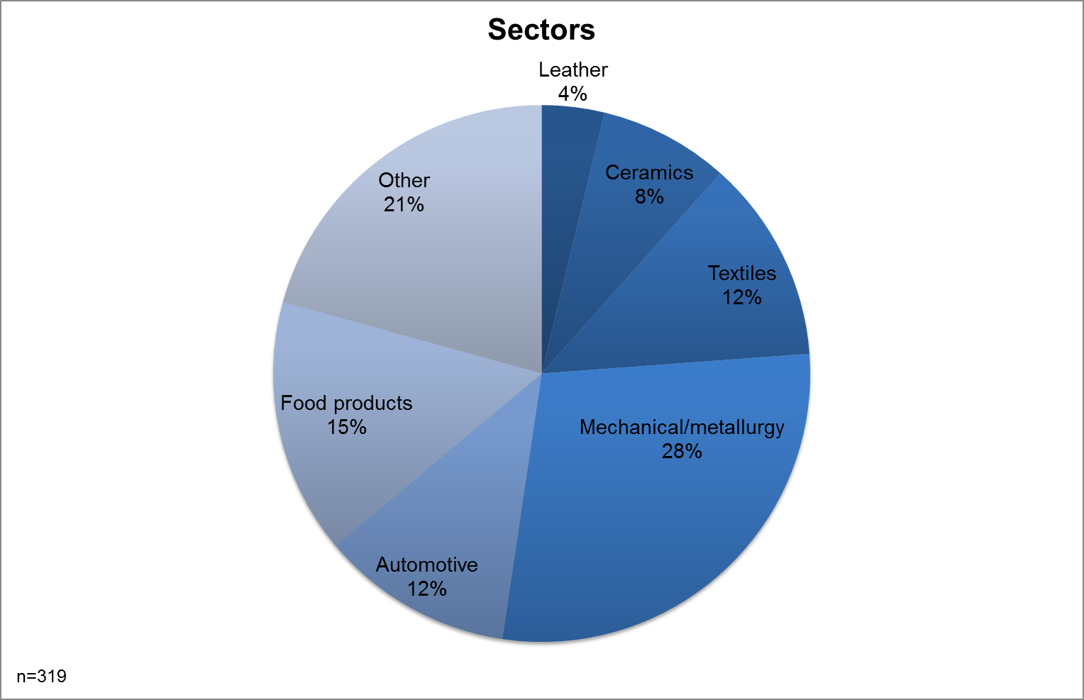

Figure 10: Distribution of sample by sector of activity

Because we used different strategies to motivate participation, we cannot say how many enterprises from each sector were invited to participate. But this distribution is quite interesting because of the covered sectors per region (see ). The leather sector (smallest group) was covered by 5 regions whereas the food production sector (the second biggest group) was only covered by 3 regions.

|  |  |  |  |  |  |  |  |  |
| --- | --- | --- | --- | --- | --- | --- | --- | --- |
| Region/  Sector | North/ Central Portugal | North  Brabant (NL) | Limousin (FR) | Emilia- Romagna (IT) | West  Midlands (UK) | Comunidad Valencia (ES) | Saxony- Anhalt (DE) | Sum |
| Leather | x | x | x | x | x |  |  | 5 |
| Ceramics | x |  | x | x | x | x |  | 4 |
| Textile | x | x | x | x | x | x |  | 6 |
| Mechanical/ Metallurgy | x | x | x | x | x |  | x | 6 |
| Automotive | x | x | x | x | x |  | x | 6 |
| Food products |  | x |  |  |  | x | x | 3 |
| Sum | 5 | 5 | 5 | 5 | 5 | 3 | 3 |  |

Table 2: Sectors covered per region

|  |
| --- |
| In case study analysis the consortium tried to have a similar distribution of sectors as in the survey. Overall the distribution was the following:   * Leather 6 cases (10 per cent of all case studies) * Ceramics 5 cases (8 per cent of all case studies) * Textile 10 cases (16 per cent of all case studies) * Mechanical/ Metallurgy 23 cases (38 per cent of all case studies) * Automotive 9 cases (15 per cent of all case studies) * Food products 6 cases (10 per cent of all case studies)   As in the overall sample the mechanical / metallurgy sector is the biggest group. Instead of the food sector the textile industry is the second biggest group, followed by automotive industry. All other industries are quite similar with around 10 per cent.    Figure 11: Distribution of case studies by sector of activity |

On a scale from very weak to very strong, most enterprises classify themselves as in strong competition (46 per cent, see ).

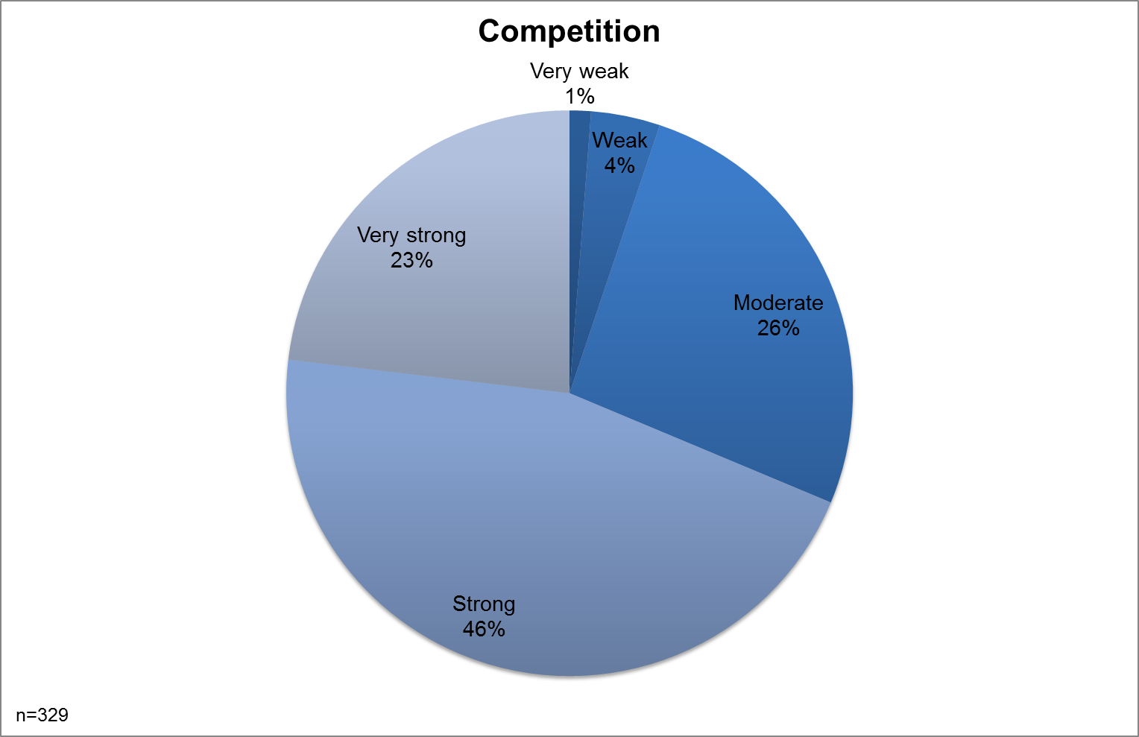

Figure 12: Strength of competition

Traditional sectors are more regional / national oriented than international. The participants gave their destination of sales in per cent for their own region, the rest of the country, rest of Europe and rest of the world. The vast majority of sales go into the same country or region. gives the mean per cent value for each category.

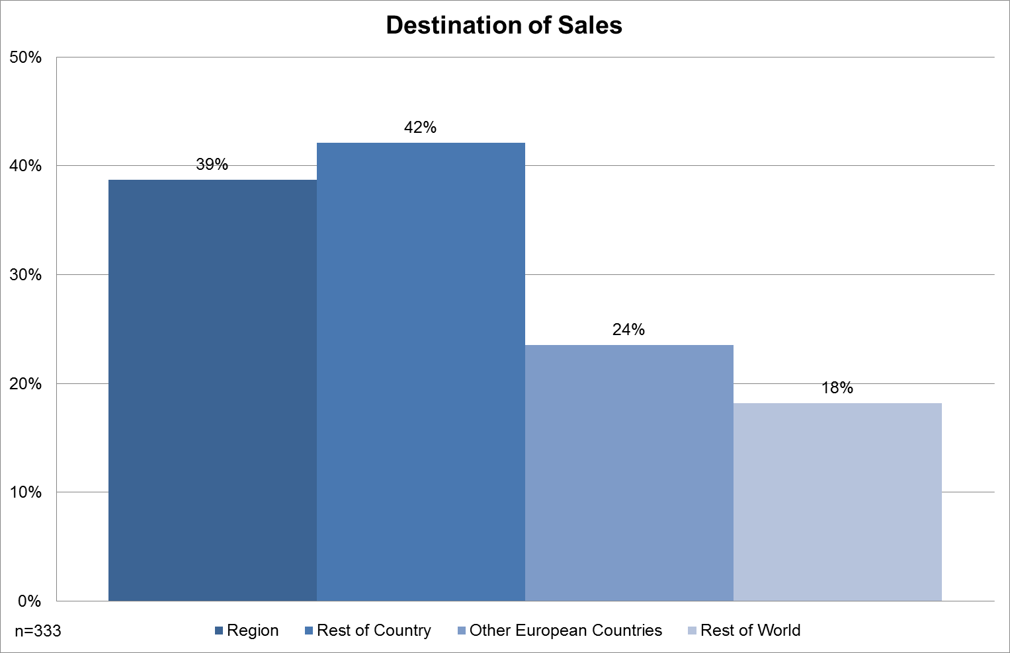

Figure 13: Destination of firms’ sales (mean % for each category)

If we look more into detail we can see different orientation in the different regions / countries. French, German and British traditional-sector SMEs seem to be more national oriented, whereas Spanish or Italian ones are more regionally oriented. Dutch traditional SME are approximately equal in their regional / national orientation. Portuguese traditional SME tend to the European market as their main focus. (See )

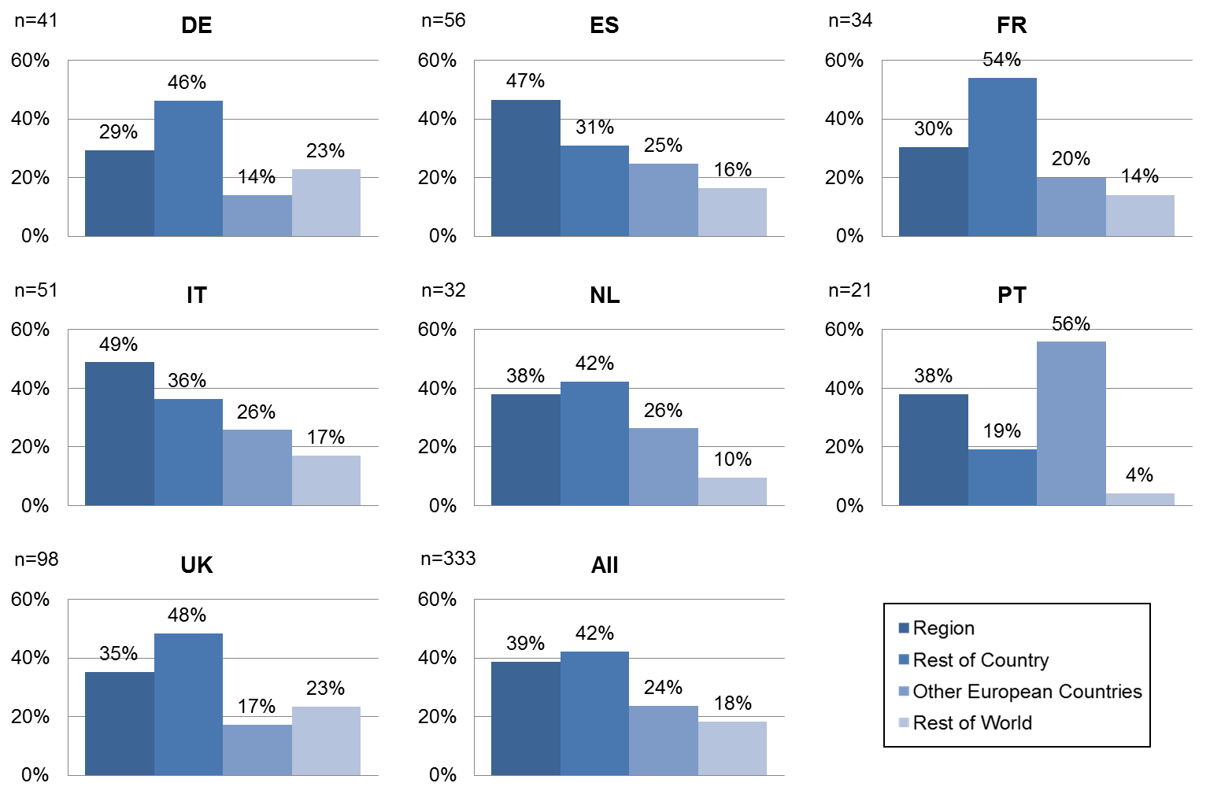

Figure 14: Destination of firms’ sales by country (mean % for each category)

## Innovation activities and impact

### Types of innovation activities

The following paragraphs illustrate the concrete innovation activities of participating SME. Within the survey the GPrix consortium divided between product, process, marketing and organisational innovation. As expected product innovation is the most important innovation type in traditional SME, followed by process, organisational and marketing innovation. Approximately 60 per cent see product innovation as highly important (32 %) or even essential (32 %). Process innovation is highly important (32 %) and essential (14 %) for 46 per cent of traditional SME. A bit less important is organizational innovation: for 37 per cent it is highly important (30 %) or essential (7 %). Nearly equal important – but with a higher “slightly important” rate – is marketing innovation for traditional SME. Marketing innovation is highly important (26 %) and essential (12 %) for 38 per cent.

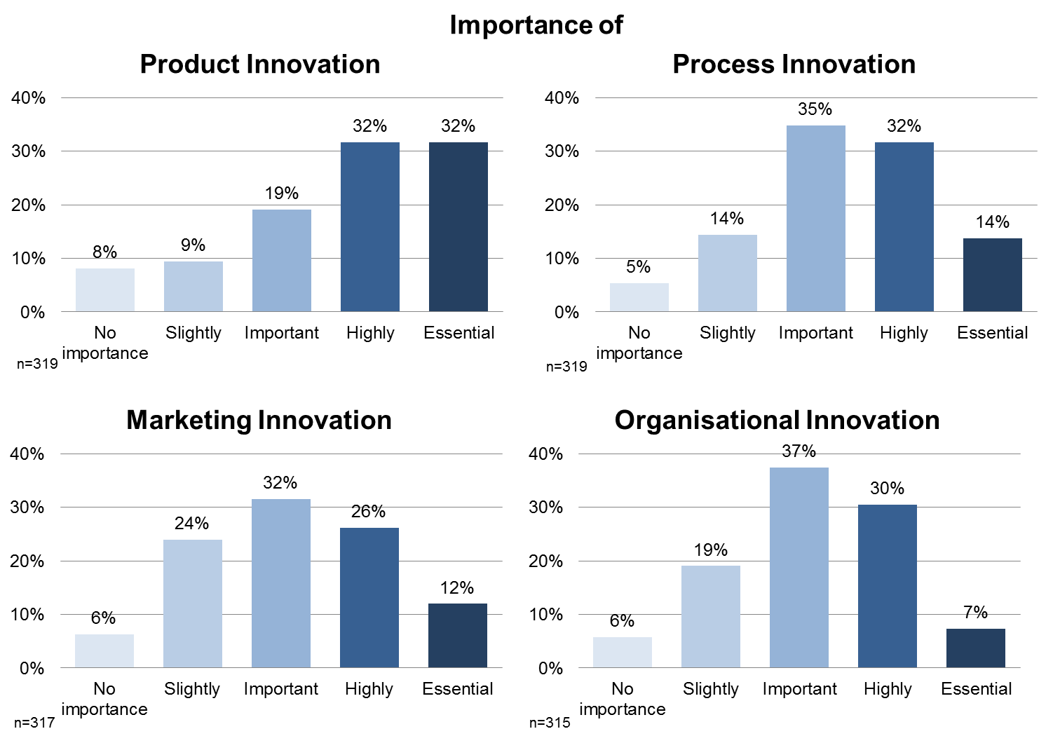

Figure 15: Importance of types of innovation for firm performance (MV[2] = 14, 14, 16, and 18)

|  |
| --- |
| The question about innovation perception was also part of the interviews. Within the case studies the consortium was more interested about companies’ concept of innovation. Therefore the open question “How do you understand the term innovation?” was used. The answers were put in the four categories product, process, marketing or organisational innovation through the interviewer. Most traditional SME (91%) tend to understand innovation in terms of new products. Two out of three interviewed (35 or 64%) SME also see new or improved processes as innovation. Every third interviewed SME does also think in the categories of organisation (35%) or marketing (29%) regarding innovation activities. The conclusion is that traditional SME have a more technical point of view on innovation, first product and second process innovation.    Figure 16: Companies concept of innovation  This technical viewpoint reflects in the companies innovation objectives as well. 70 per cent of the interviewed traditional SME want to develop new products or use new technology (65%). Whereas 58 per cent also think about entering new markets. 39 per cent are making innovation activities or use innovation support measures to become innovative.    Figure 17: Companies objectives regarding innovation activities |

Over 70 per cent of all participants had product innovations in goods between 2005 and 2009. Fewer enterprises innovated in new service products: almost 50 per cent (see ).

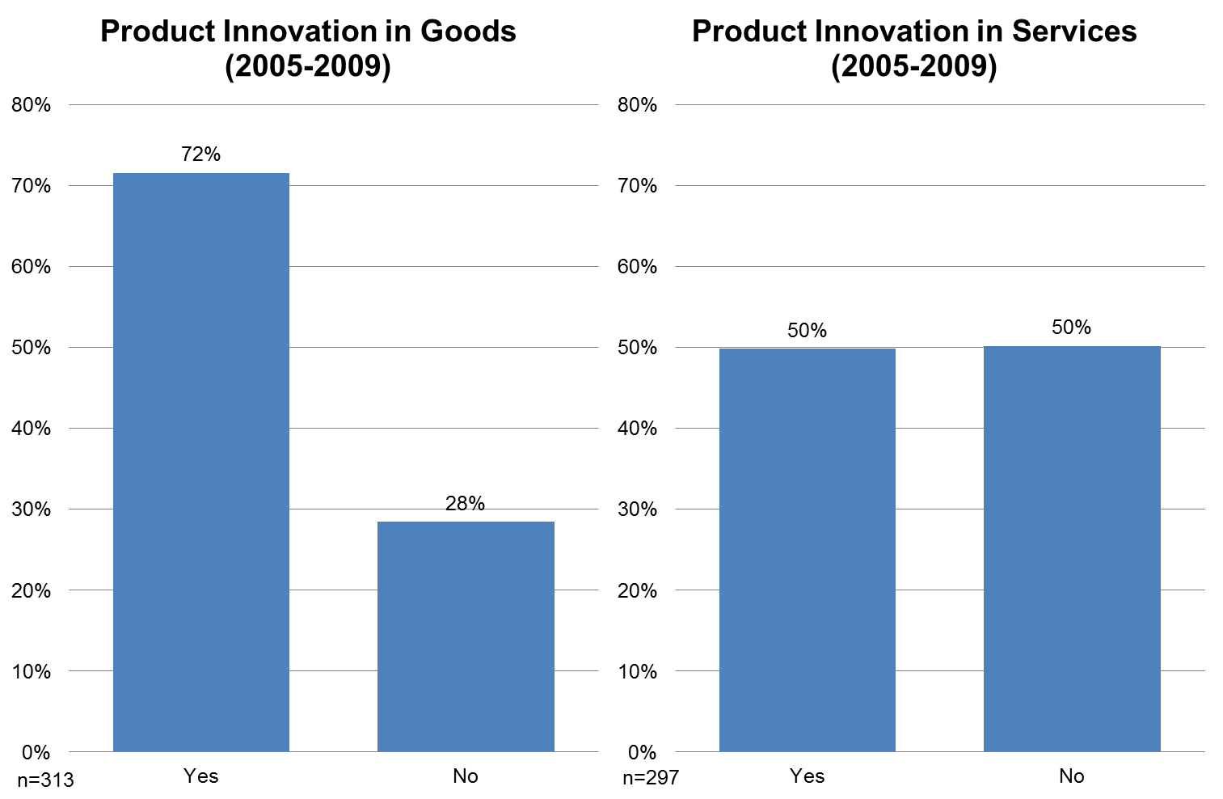

Figure 18: Product innovation, 2005-09

In terms of marketing innovation traditional SME are mainly active in new design / packaging or new promotion activities. Approximately 40 per cent said that they innovated between 2005 and 2009 in design / packaging or promotion (missing values: 14 / 15). Around one-third innovated in sales and around a quarter in pricing (both: 15 missing values). Fewer than 10 per cent innovated in other marketing aspects (275 missing values).

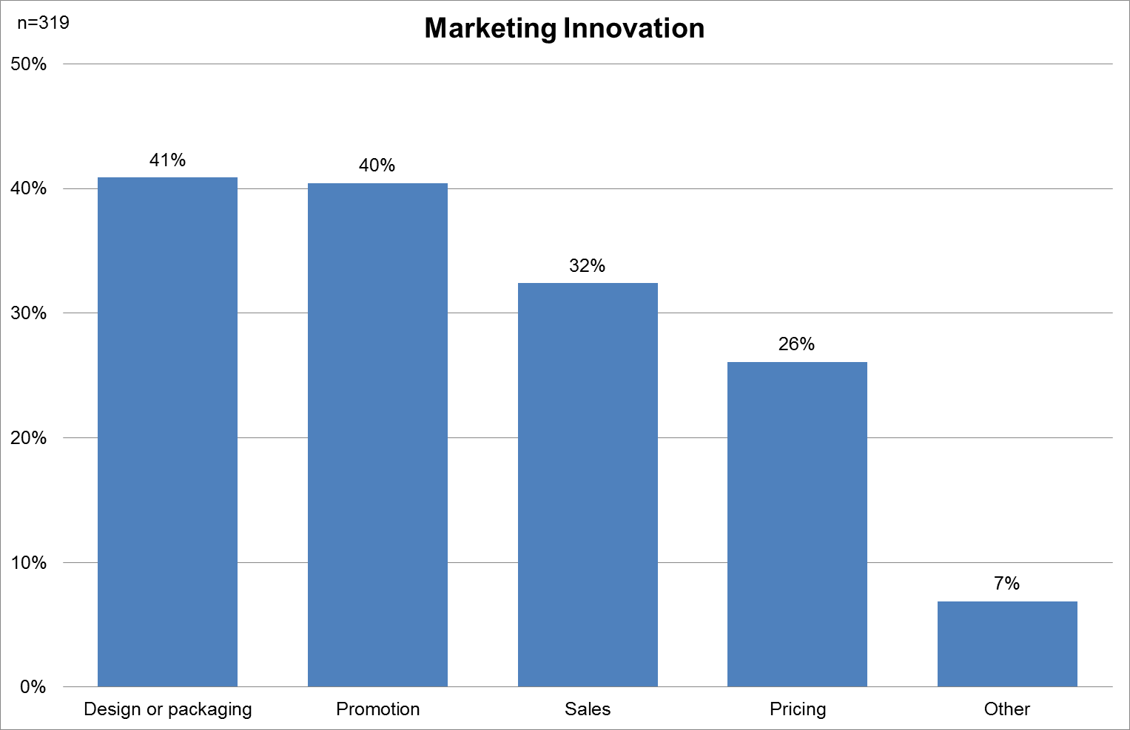

Figure 19: Marketing innovation

### Innovation intensity

37 per cent of the respondents spend 1-5 per cent of their turnover on innovation activities – which is standard for most sectors[3]. A quarter of all responding SME spend 6-10 per cent, which is more typical for research intensive industries. An explanation could be the high participation from the mechanical/metallurgy and automotive sectors. These sectors belong to the research intensive industries[4]together with pharmaceutical, chemical and electronic industries. 29 per cent spend more than 10 per cent of their turnover for innovation activities. This is a quite big quantity that could be explained to some extent by start-up enterprises that need to put a lot of effort into innovation activities to become competitive. Nearly 10 per cent do not spend anything for innovation or research, which is an expected value for traditional sectors.

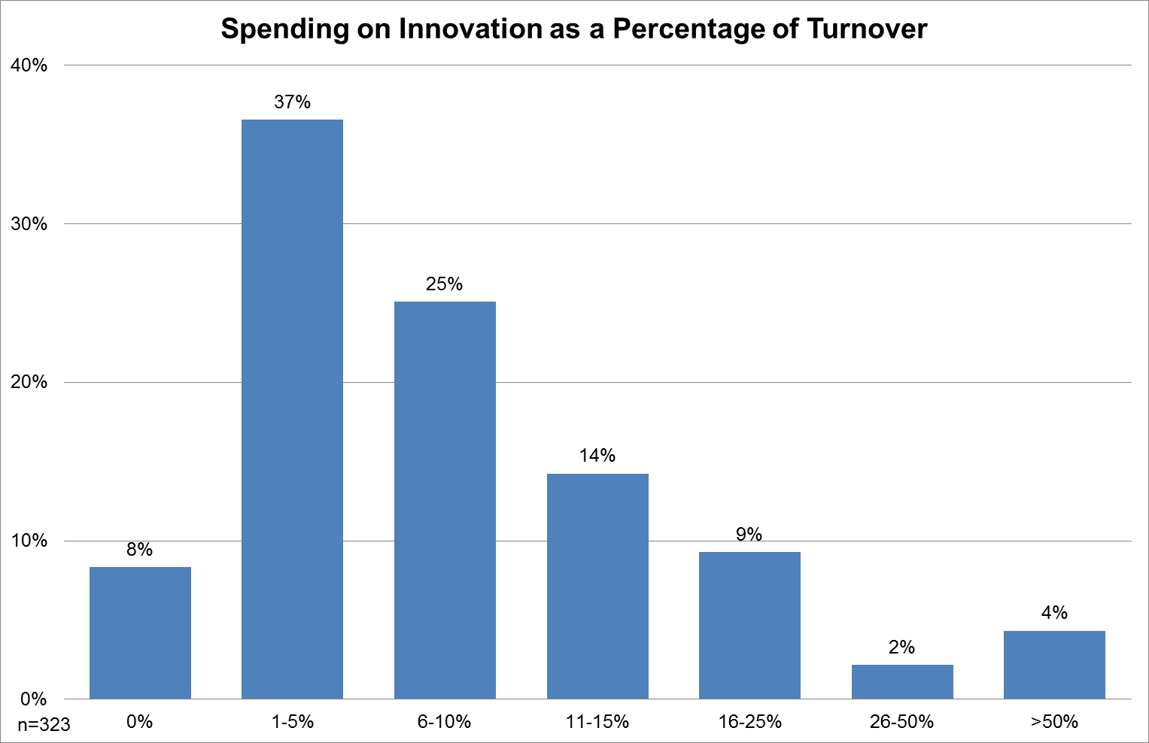

Figure 20: Spending on innovation as a percentage of turnover, 2009 (percentage of firms in each spending category)

Half of the respondents reported no changes in their innovation intensity between 2005 and 2009. But nearly 40 per cent had devoted fewer resources to innovation activities in 2005. Only a minority of about 10 per cent devoted more resources to innovation in 2005 than they did in 2009.

As far as we can see from the GPrix data there is no correlation between competitive pressure and innovation spending. shows the cross tabulation between two variables based on the actual distribution of observations. The null hypothesis for the Pearson chi-squared test states that there is no correlation between resources devoted to innovation in 2005 and the degree of market competition (Pearson chi2 (8) = 11.2444, Pr = 0.188). The test indicates that there is an insufficient evidence to reject the null hypothesis at all conventional levels of significance. Therefore, there is no relationship between resources devoted to innovation in 2005 and the degree of market competition.

|  |  |  |  |  |  |  |
| --- | --- | --- | --- | --- | --- | --- |
| Resources devoted to innovation in 2005 | Strength of competition | | | | | TOTAL |
| Very weak | Weak | Moderate | Strong | Very strong |
| Fewer | 2 | 8 | 28 | 64 | 20 | 122 |
| Same | 1 | 4 | 46 | 67 | 44 | 162 |
| More | 1 | 1 | 6 | 15 | 7 | 30 |
| TOTAL | 4 | 13 | 60 | 146 | 71 | 314 |

Table 3: Cross tabulation between resources devoted to innovation and market competition

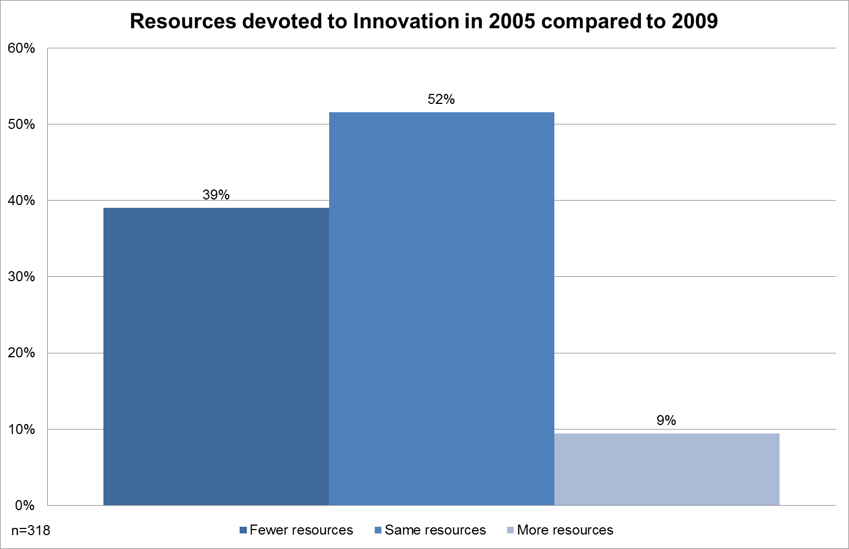

Figure 21: Resources devoted to innovation in 2005 compared to 2009 (MV = 15)

The recession has bad impacts for established products, as reported by more than 50 per cent of respondents. Only 12per cent see a good impact for established products within recession. Impression changes when looking at new products. More than 40 per cent do not feel the impact of recession. More than 20 per cent report a good impact. This means that innovation is essential to be competitive within recession times. Companies investing in new products are better prepared for bad economic situation.

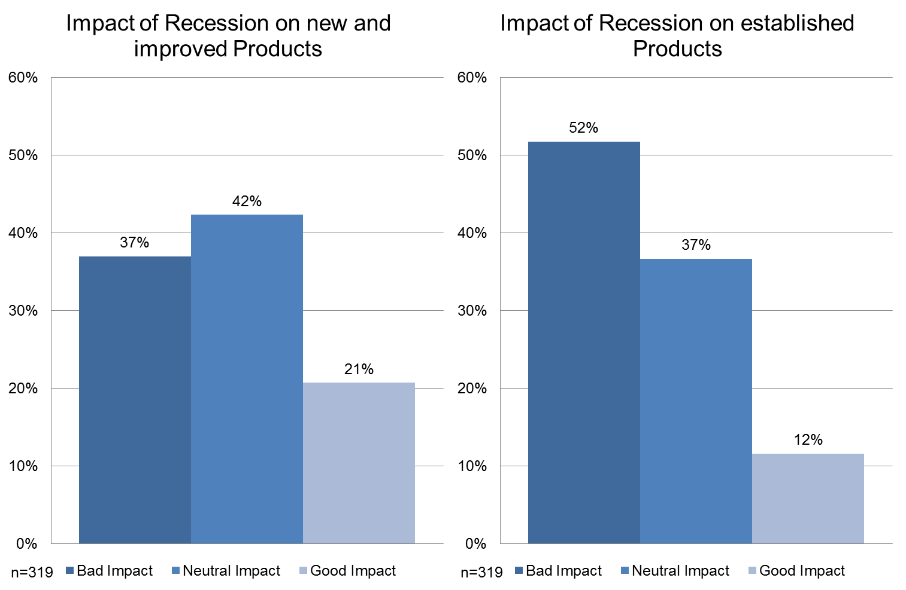

Figure 22: Impact of recession on new/improved and established products

### Impact of innovation

Innovation activities have definitely an impact on employment: positive and negative as well, depending on the innovation success. An unsuccessful innovation can lead to decreasing turnover and in final consequence to decreasing employment. To get a better, more detailed view on that, GPrix asked three different questions (without multiple responses per question): how many jobs were lost, created or sustained through innovation activities?

All in all we can see that innovation has a more positive than negative effect on employment. The question regarding lost jobs answered 61 per cent with zero. 20 per cent lost 1-5 jobs and less than 10 per cent (in sum) lost more than 5 jobs. There are also two outliers that lost more than 50 jobs, but this is a very small minority.

Innovation did not create jobs for 41 per cent of all respondents – which is a very high number. If we see this result alone, we have to say, that innovation in traditional SME is not very successful with respect to employment creation. This could lead towards two different interpretations: (1) Innovation support measures are not very successful as well, because they do not help SME to increase employment. Or (2) Innovation support measures are needed to help traditional SME to create more jobs in future. We will come back to that question within the econometrics analysis in Del. 3.3. But another 41 per cent created 1-5 jobs due to innovation. 15 per cent (in sum) even created 6-30 new jobs. 8 SME reported an even higher amount of created jobs.

The biggest impact regarding employment can be found in “sustaining jobs”. Nearly every third SME sustained 1-5 jobs. 15 per cent sustained 6-10 jobs and 10 per cent sustained 11-20 and nearly 20 per cent sustained even more than 20 jobs! But every fifth SME did not sustain jobs through innovation activities. The high percentage of zero created or sustained jobs could be a result of missing innovation activities altogether: nearly 30 per cent of respondents did not innovate in new products (see ).

As a conclusion we can say, that innovation activities have more positive than negative effect on employment. At least (successful) innovation activities can sustain jobs.

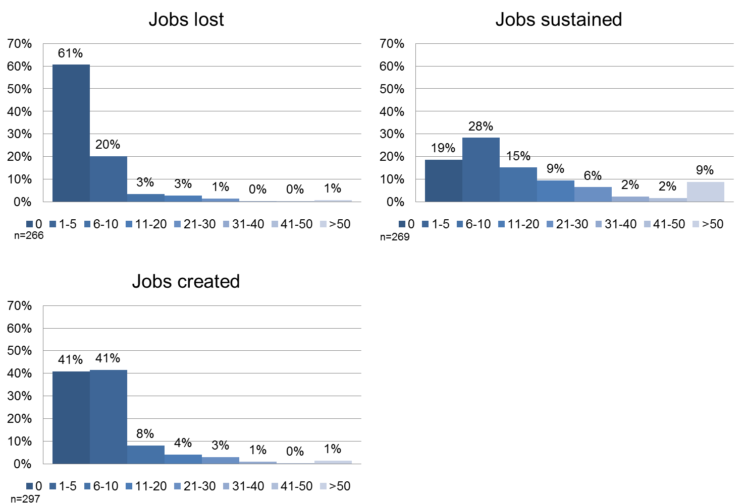

Figure 23: The employment effect of innovation (multiple responses permitted, MV = 9)

Another good indicator regarding innovation success is the proportion of sales from innovation. 8 per cent did not earn money from innovation. This can also be explained with the high proportion of SMEs without product innovation (see ).

14 per cent of respondents earned 1-5 per cent of their turnover from innovation. This is comparable to non knowledge-intensive service providers in Germany (5 per cent in 2009)[5]. 17 per cent of respondents reported a proportion of 6-10 per cent of sales from innovation, which can be compared with knowledge-intensive services or with non research-intensive industry companies in Germany (9 or 10 per cent in 2009)[6]. 12 per cent report 11-15 per cent sales from innovation. Another 18 per cent report 16-25 per cent innovation sales.14 per cent could even reach 25-50 per cent of innovation turnover. German research-intensive industry companies would also count into the same cluster (32 per cent in 2009)[7]. Again an explanation could be the high participation from the mechanical/metallurgy and automotive sectors belonging to research-intensive industries. Even 17 per cent realized more than 50 per cent of annual turnover with innovation.

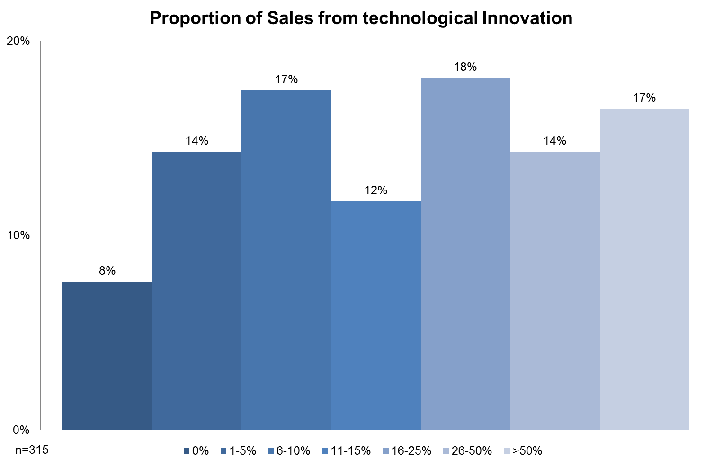

Figure 24: Proportion of sales from technological innovation (MV = 18)

To give a comparison to other sources, the following table shows different percentages of sales from countries that also participated in the GPrix sample. The table compares high technology industry with other industry and knowledge-intensive services. The traditional sectors analysed in the GPrix sample is most likely comparable with “other industry”.

|  |  |  |  |  |
| --- | --- | --- | --- | --- |
| Country | Percentage of Sales with new products (2008) | | | |
| High Technology | Other industry | Knowledge-intensive services | Overall |
| DE | 39% | 13% | 14% | 22% |
| ES | 29% | 18% | 17% | 20% |
| FR | 24% | 13% | 10% | 16% |
| GB | 10% | 10% | 5% | 7% |
| IT | 19% | 10% | 17% | 14% |
| NL | 17% | 8% | 13% | 12% |
| PT | N/A | N/A | N/A | N/A |

Table 4: Comparison of proportion of sales with new products[8]

### Innovation capabilities

In 2005 traditional SMEs from the GPrix sample saw themselves as average regarding product (49 %) and process (55 %) innovation. Scantly above 20 per cent of participants are lagging or above average of their technological innovation (product and process) capability in relation to their industry in 2005. A small minority sees themselves as leading in terms of product or process innovation.

This picture changed towards 2009. There is still a small majority of about 42 (product) and 44 per cent (process) with an average self-assessment. The above average cluster increased up to 42 per cent (process, and 37 for product). That means, that at least 20 per cent (up to 25 if increasing “leading” is taken into account) of participating SME enhanced themselves.

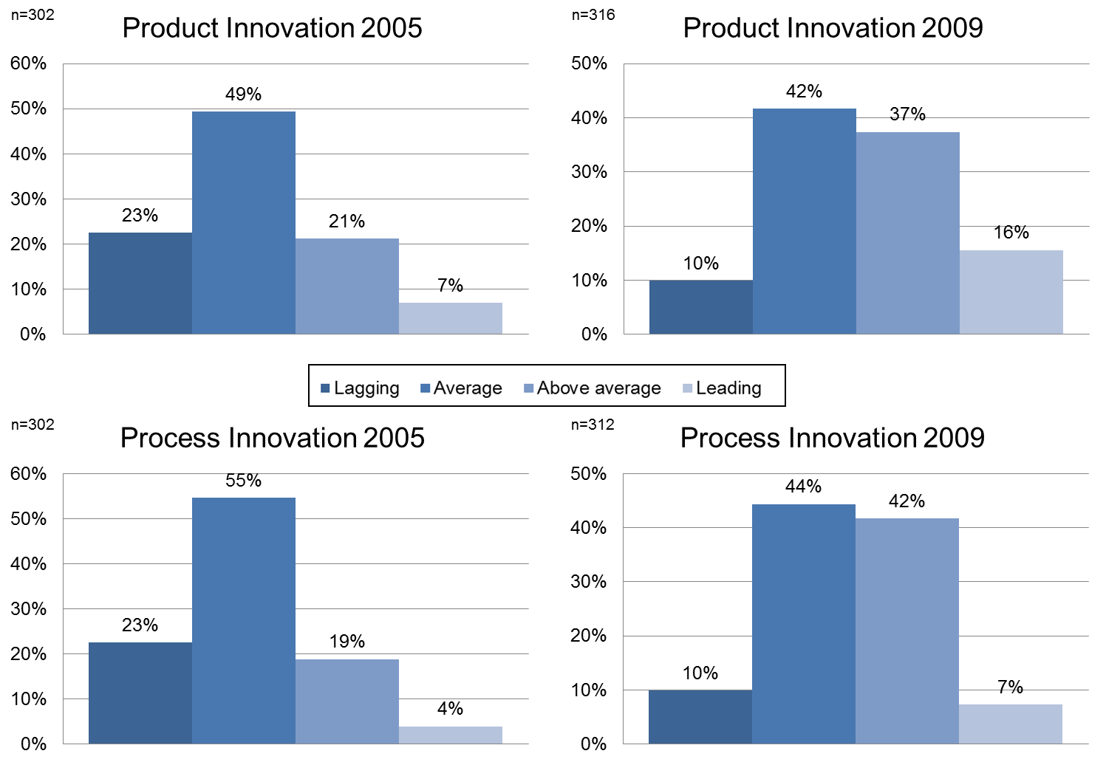

Figure 25: Firms’ self-assessment of their technological innovation capability in relation to their industry 2005 and 2009

Within the non-technological innovation capabilities (marketing and organisational innovation) this image is a bit different. We can find positive effects from 2005 to 2009 too, but not that much. Every third SME assesset itself as lagging and every second as average regarding marketing innovation in 2005. Only 13 per cent are above average or even leading (insignificant1 %). The lagging cluster decreased nearly about the half (to 17 %) whereas the above average cluster nearly doubled to 23 per cent. 8 per cent are leading in terms of marketing innovation in 2009.

Te effects regarding organisational innovation are very similar. Nearly 60 per cent said that they were average to industry constantly (2005 to 2009). The lagging cluster decreases by half (from 27 to 13 %) whereas the above average cluster nearly doubled (from 14 to 27 %). The leading cluster changes marginally from 3 to 5 per cent within the time span.

Compared to the technological innovation capabilities the non-technological are still more average (above 50 % vs. around 40 %) with a much lesser above average cluster (around 20 % vs. nearly 40 %).

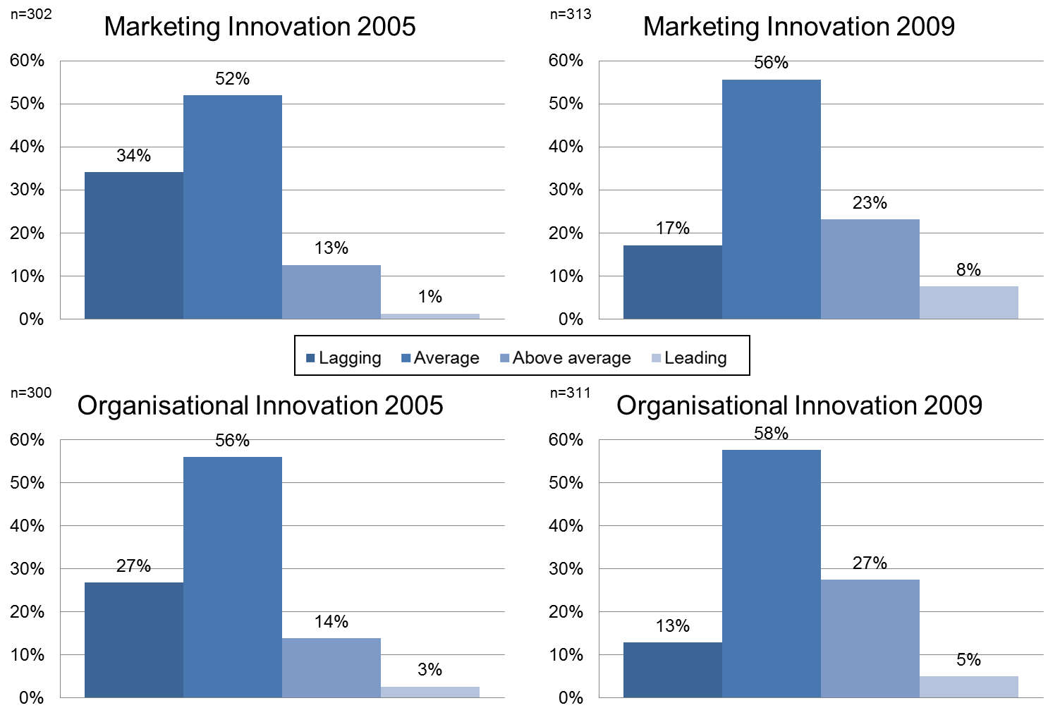

Figure 26: Firms’ self-assessment of their non-technological innovation capability in relation to their industry

## Support measures

The GPrix consortium tried to reach, as much as possible, SMEs from traditional sectors no matter if they participated in innovation support measures or not. Every second (58 %) SME did not take part in innovation support measures, which means that more than 40 per cent took part in one or more innovation support measures. Nearly every fifth SME got innovation support from one measure. Every tenth SME took part in two measures. 14 per cent (in sum) took part in 3 or more measures (see ).

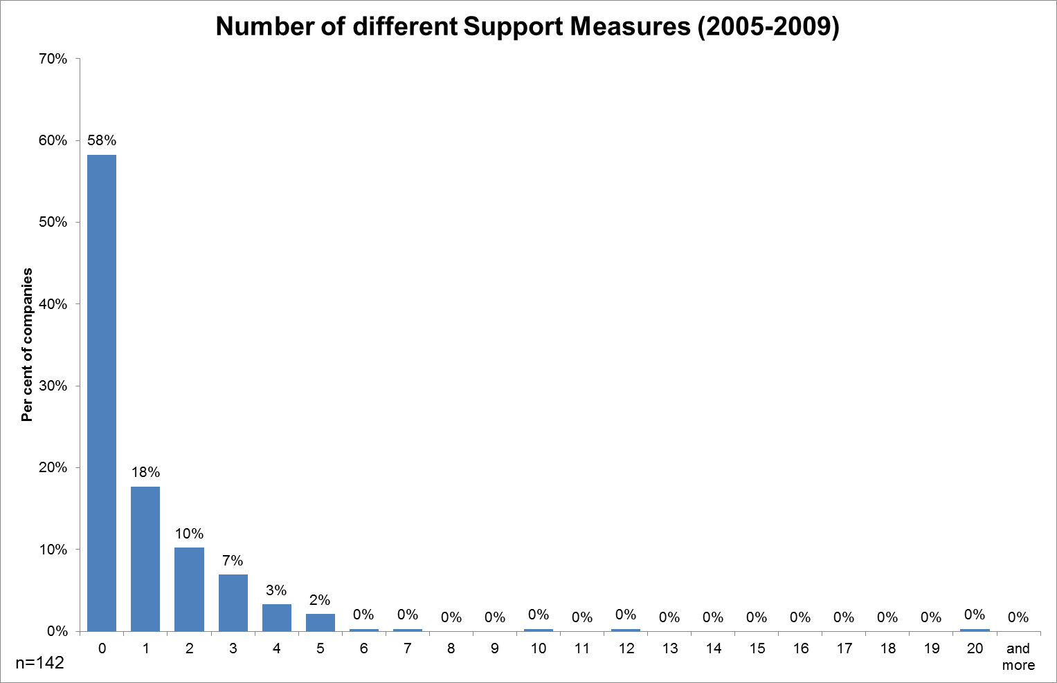

Figure 27: Percentage of firms using different numbers of support programmes

Thus we are able to say, that traditional SME are to some extend overrepresented in innovation support measures (>40 %) – compared to other sources (see ) with ranges from 20 to 35 per cent. If we look into detail we can see, that especially France, UK, Italy and Netherlands have very high rates of SMEs that have no innovation support measure experience (>=60%). In Germany and Portugal nearly every second SME did not participate in innovation support measures. The lowest value with around 40 per cent had Spain. In Spain around 25 per cent had one innovation support, followed by Portugal with 24 per cent. It is interesting too that there is no Portuguese and Italian SME with more than three innovation support measure. From we can clearly see that the more innovation support measures are used the less SME accessed them.

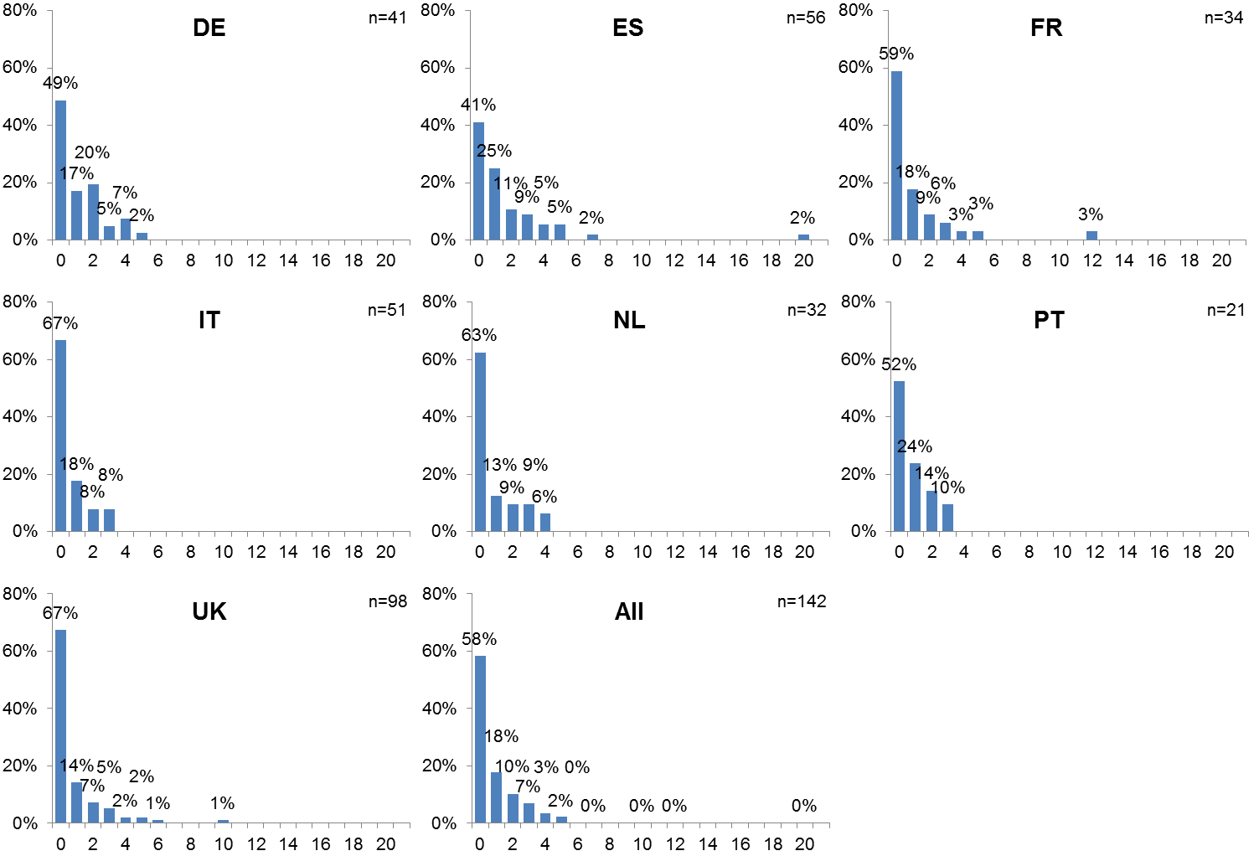

Figure 28: Percentage of firms using different numbers of support programmes, 2005-09: by country

The following table functions as a basis of comparison. It becomes obvious that all values in the GPrix regional samples are much higher than the corresponding nation-wide mean values shown below. For example in Germany we have 20 per cent of companies with public financial innovation support in 2008 but around 50 per cent of participants from Germany used one or more innovation support measures. This seems contradictious.

There are some possible reasons for that. On one hand there are different data bases: GPrix sample is not representative and does focus on SME. The data from ZEW-publication refers to Eurostat: CIS 2008 – which is representative and does not only focus on SME. On the other hand we think that SME which took part in innovation support measures are much more open to related surveys than those without.

Another reasonable explanation is that the analysed regions are not representative for their countries. As an example: in economically underdeveloped regions more funding opportunities exist to support regional innovation activities than in others.

|  |  |  |  |  |  |
| --- | --- | --- | --- | --- | --- |
| Country | Share of innovation active companies with public financial innovation support 2008 | | | |  |
| High Technology | Other industry | Knowledge-intensive services | Overall | GPrix |
| DE | 26% | 18% | 17% | 20% | 51% |
| FR | 23% | 18% | 19% | 20% | 41% |
| GB | N/A | N/A | N/A | N/A | 33% |
| IT | 36% | 35% | 27% | 35% | 33% |
| ES | 35% | 26% | 34% | 30% | 59% |
| NL | 50% | 33% | 27% | 34% | 37% |
| PT | N/A | N/A | N/A | N/A | 48% |

Table 5: Comparison of innovation active companies with public financial innovation support[9]

The 2007 Innobarometer report delivers other values, where the EU27mean value is more equal to the GPrix sample (see ). But in contrast to Eurostat the Innobarometer is not representative because of different methodology[10].

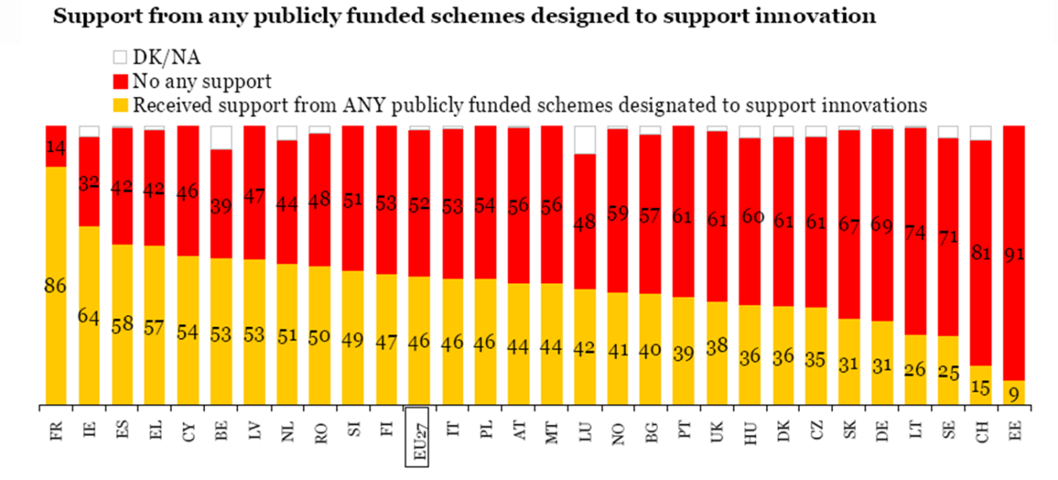

Figure 29: Range of publicly funded innovation in Europe (source: Gallup 2007)

For a better comparison the rate of participation in innovation support measures within the GPrix sample is transferred into the following figure.

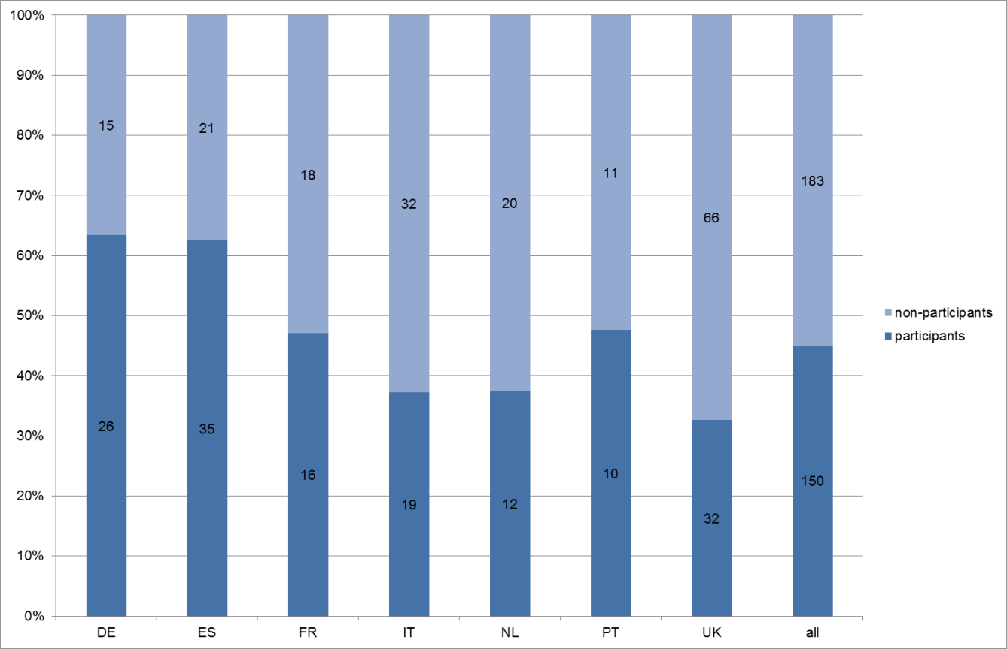

Figure 30: Participation rate in GPrix sample (number of SMEs with or without innovation support measures)

The GPrix questionnaire gave respondents the possibility to describe two different received support measures (referred as support measure 1 [SM1] and support measure 2 [SM2]). Most SME used the innovation support measures for product innovation, followed by process innovation. Marketing or organisational innovation are only secondary. These results are corresponding to importance of different innovation types (see ), with the exception of marketing and organisational innovation. Organisational innovation was rated a bit more important than marketing innovation.

Another point becomes obvious: Support measure 2 is totally dedicated to product innovation (64 out of 64) and influences other innovation activities as well. But not every support measure 1 (only nearly two out of three) supports product innovation (99 out of 142). So SM1

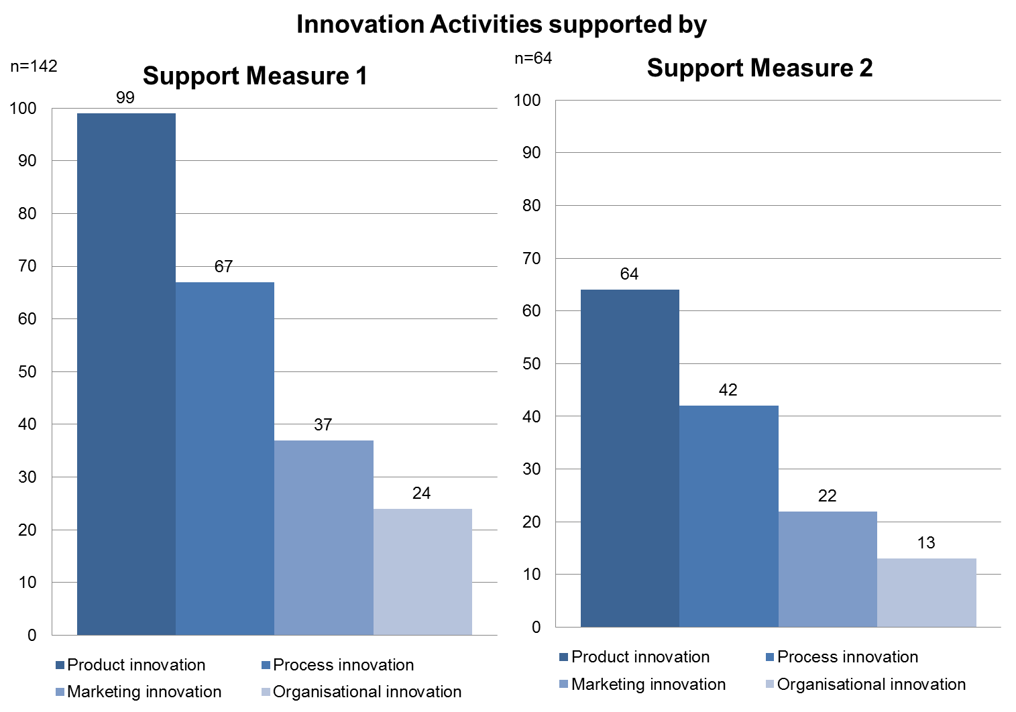

Figure 31: Innovation activities supported by 1st and 2nd Support Measures, 2005-09 (multiple responses permitted)

The usage of innovation support measures differs slightly among the countries. In all countries – except Netherlands (mostly process innovation) – most support measures were used for product innovation. Spain and Portugal is similar to the GPrix sample distribution. In France, Italy, Germany and Netherlands more SMEs used support for organisational than for marketing innovation. In the UK marketing innovation is more supported than process innovation.

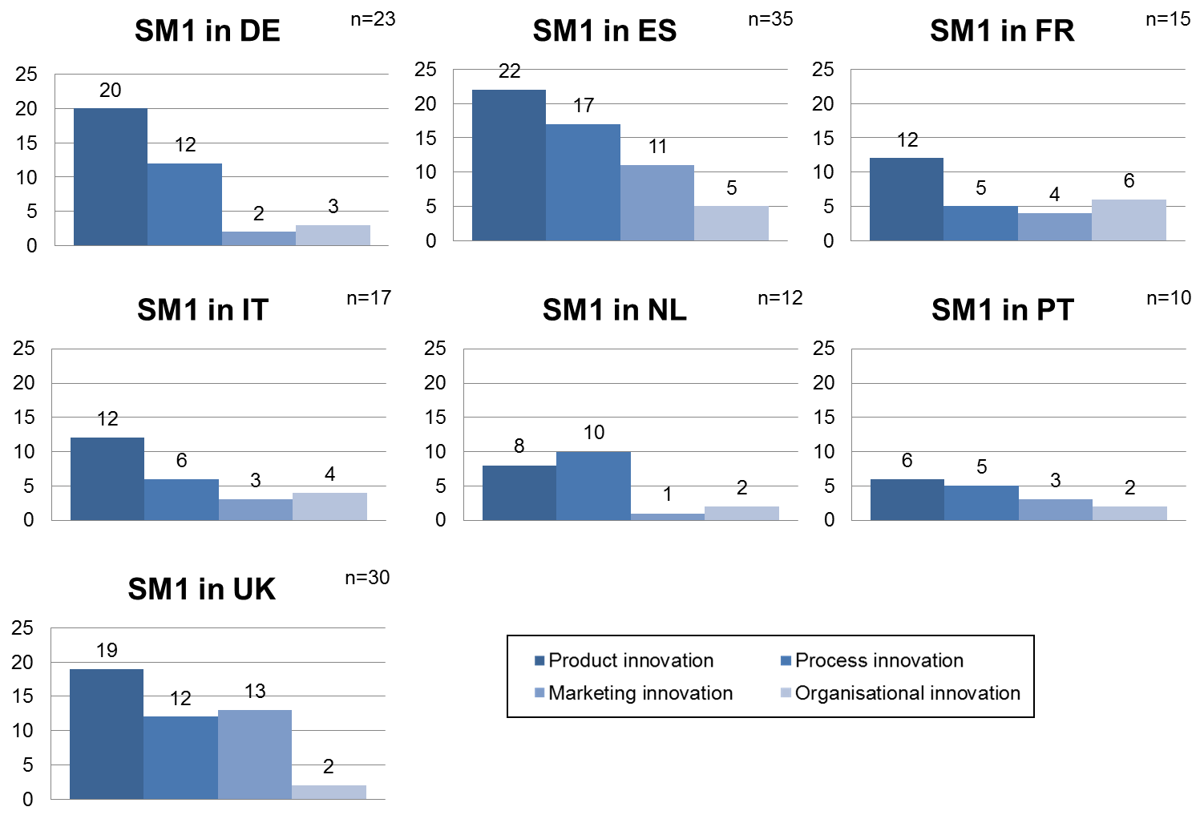

Figure 32: Innovation activities supported by 1st Support Measure, 2005-09: by country (multiple responses permitted)

Within the questionnaire the SMEs were asked to name the concrete support measure they received. The partners of the GPrix consortium know their regional innovation support programmes and thus could categorize the different named measures, even if the measures were not always named correctly. Within the different programmes the GPrix consortium made the following six clusters:

* Human resources for innovation (e.g. innovation coach or innovation officer)
* External knowledge (knowledge transfer, vouchers)
* Collaborative measures (e.g. collaborative R&D&I projects)
* Support internal innovation (e.g. internal R&D&I projects)
* Internationalisation (marketing, export promotion)
* Others

Particularly noteworthy is the proportion of “internationalisation” measures reported by firms for both Support Measure 1 and 2. Support of this kind, e.g. for export promotion, is consistent with classic definitions of innovation, which embrace “new markets” (Schumpeter) but not with recent definitions used in the OECD’s OSLO Manual[11] and the EU’s Community Innovation Survey[12], which include new marketing techniques as innovation but not actual entry into new markets). Otherwise, the preponderance of measures “supporting internal innovation” was as expected.

Each bar shows the proportion of measures used for each type of support. Reading across the chart, first are the respective proportions for Support Measure 1; and then for Support Measure 2.

The mostly used type of innovation support measure is the support of internal innovation. Nearly every second SME used SM1 for internal innovation. SM2 is used from almost 40 per cent of SME to support internal innovation. The lowest number of concrete measures was used from respondents regarding human resources (less than 5%). All other categories – expect “others” are used from less around 10 per cent. The category others fits to around every fifth SM1 and to every third SM2.



Figure 33: The six different support measure types within the GPrix sample

If we look regionally into detail we can see, that in most regions SM1 is used mostly for support of internal innovation expect in Germany and UK where the “others” cluster is bigger. In the Netherlands and in Portugal the external knowledge support programmes are more important than in other countries. Within the Netherlands, France and Germany the responding SMEs did not participate in internationalization support measures.



Figure 34: The distribution of support measure 1 within the six different support measure types.

|  |
| --- |
| The distribution among the six types of support measures of the concrete innovation support measures chosen by the SMEs was also part of the interviews. The overall picture is very similar, internal innovation dominates again. The consortium tried to have an equal distribution as in the overall sample. An exception is the “other” category which was not that much interesting for analysis because of its heterogeneity (containing all the innovation support measures that do not fit into the other categories).    Figure 35: Type of innovation support measure  In the detailed interviews the consortium wanted to know why certain measures were chosen. There are two main reasons why SME selected the different support programmes. First of all SME looked for financially interesting programmes (e.g. high funding rates). The second main issue are the general conditions of the support programmes: does the concrete innovation activity to the official requirements? This was important for 60 per cent of the interviewed SMEs. For 43 per cent of interviewed SME the estimated success rate to get the support measure was also a selection criterion. Every fourth interviewed SME had external decision support (external consultation or choice of the consortium) or wanted to keep up with competitors and thus asked for support measures. Only 3 SME did not know other support measures.    Figure 36: Reason for choosing concrete innovation support measures  An interpretation could be that there is a quite good transparency regarding the offered innovation support measures. It seems that SME have the opportunity to choose between different support measures (e.g. the financially most attractive) for their innovation activities. |

## Impact of the chosen Support measures

Respondents were asked about the impact of the different received innovation support on a scale from no importance, low importance, important, high importance to very high importance. The following Figure represents the impact sorted by the mean importance of SM1 and SM2. The five impacts with a mean of at least “important” are, in descending order, turnover, speed of completion, reputation, profitability and access to market. Impact with less than low importance are quality certification and safety & environmental. All other impacts range between low importance and important.

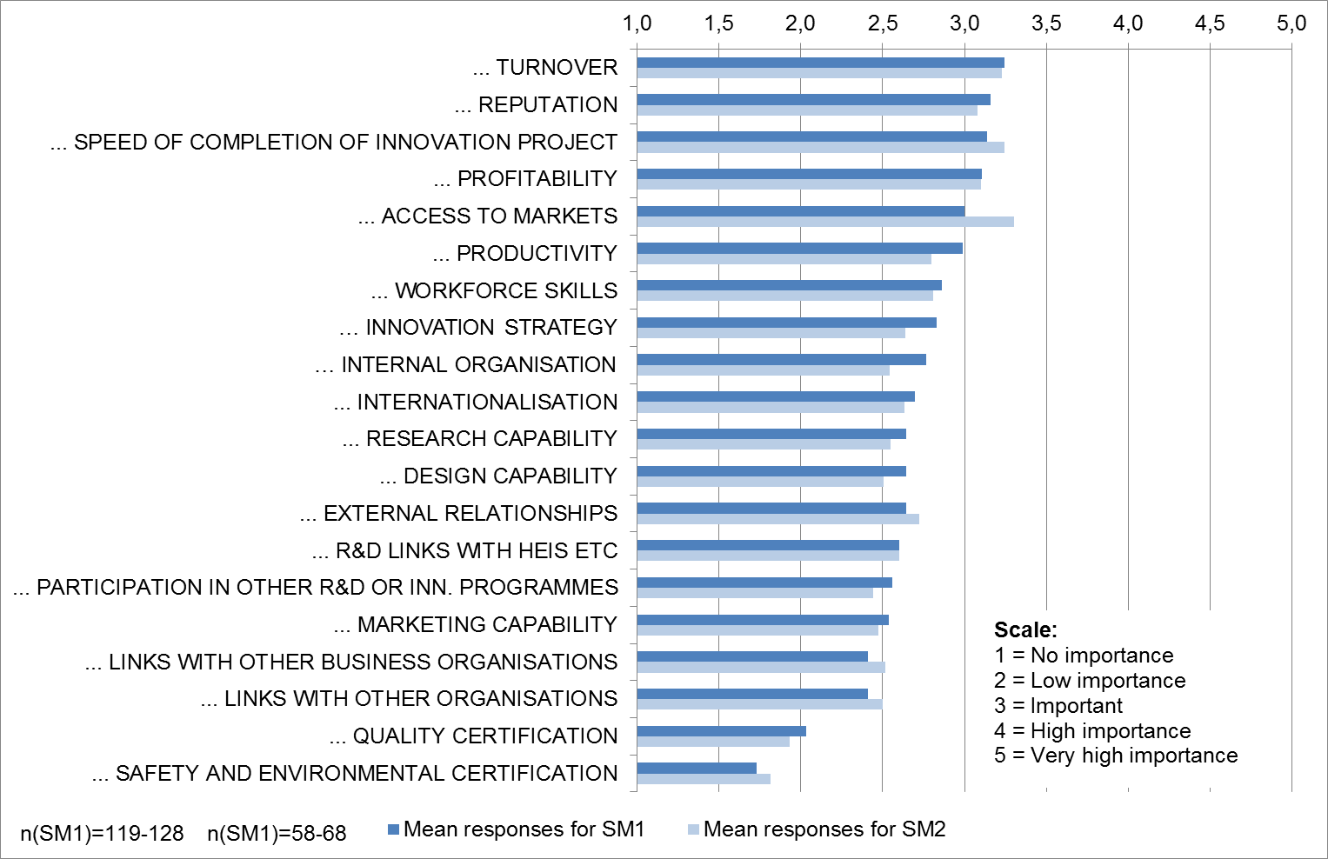

Figure 37: Impact of the 1st and 2nd Support Measures

|  |
| --- |
| The question about the impact of the specific support measure was also part of the interviews. As a result of a self-assessment nearly three out of four interviewed SMEs see themselves as more innovative due to the use of innovations support measures. Every second SME generates a higher turnover out of the innovation support measures. Nearly every second interviewed SME enters new markets with innovation support (e.g. new products in new markets or internationalisation strategies). Every third interviewed SME could increase their employment.    Figure 38: Results and impact of innovation support measures for the interviewed SMEs |

Innovation support measures are established to stimulate innovation activities within SMEs. Thus a support measure should not be an additional financial source but should help SMEs because of their lower innovation abilities. In the GPrix questionnaire we covered this by the concept of “additionality”. The question asked whether the SME would have taken the same or similar steps without this public support.

The big majority uses innovation support measures to boost their activities in terms of time and effectiveness: Every second SME (51 %) answered with “Yes – but more slowly and less effectively”. More than every third SME would not have taken the innovation activities: 39 per cent answered with “No – not at all”. 10 per cent answered with “Yes – and as quickly”. In every third case the innovation support measures hit directly the bull’s-eye. These support measures stimulated SME to be innovative. Every second support measure enables SME to innovate more effectively and efficiently. Only 10 per cent miss the target, which is apparently very good value.

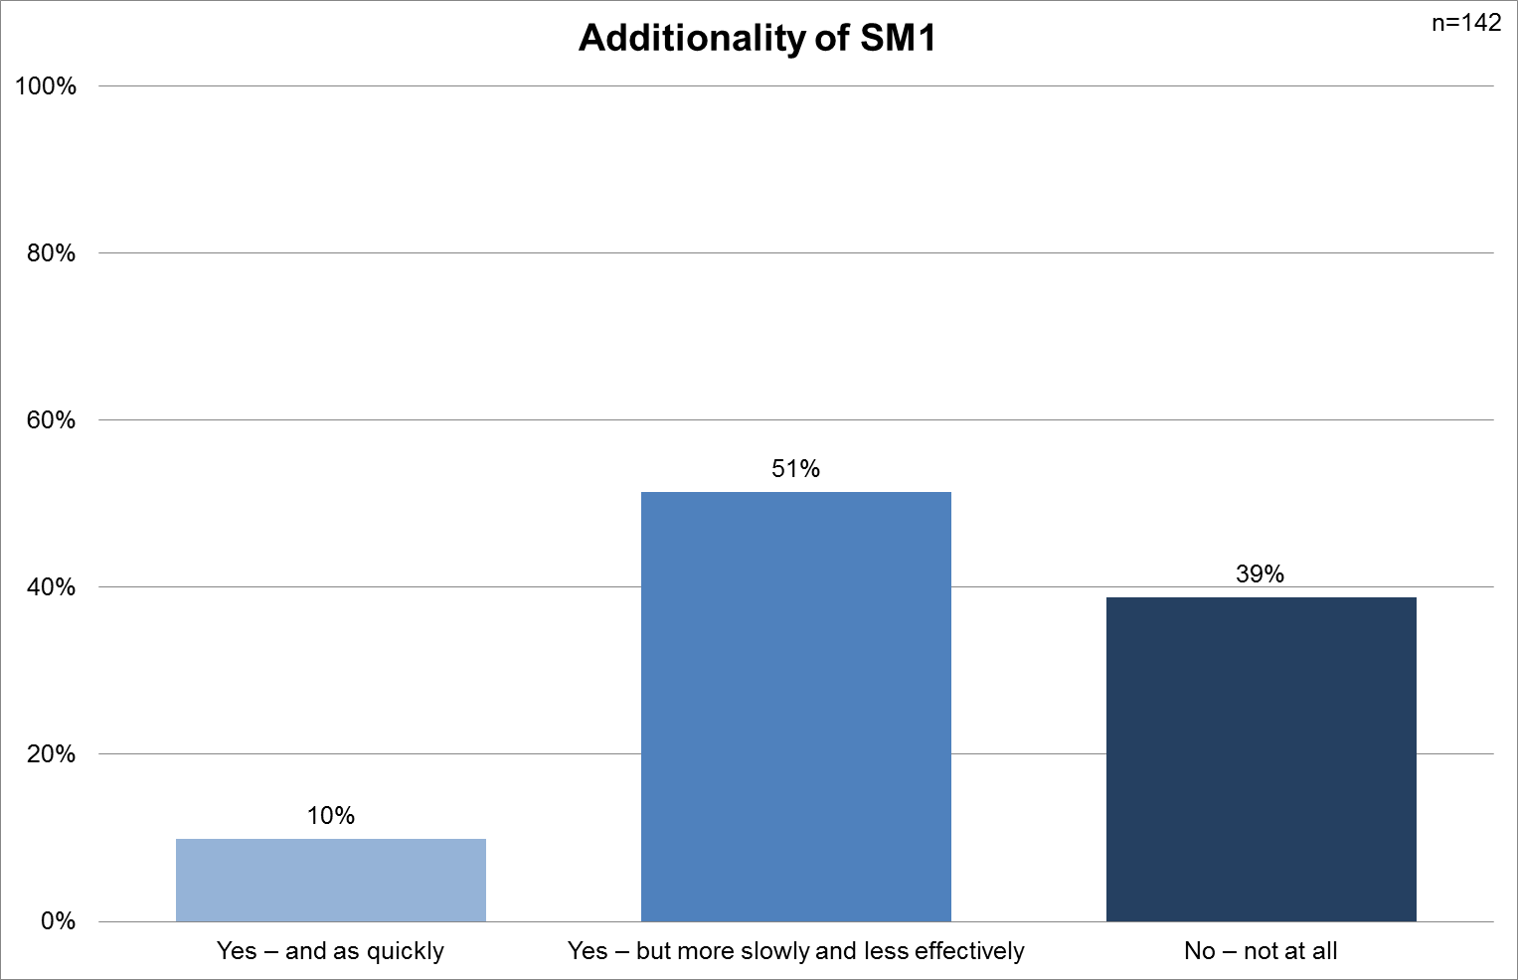

Figure 39: Additionality of support measure 1

It is interesting to go into detail within that question. We can see some differences between the different regions. Especially in Germany and France the SME would not have done the same innovation steps without the public support. In all other regions the proportion for “Yes – but more slowly and less effectively” was higher than “No – not at all”. The highest value with 70 per cent and 83 per cent for “Yes – but more slowly and less effectively” were reached in Portugal and Netherlands. The highest proportion of “Yes – and as quickly” responses was recorded for Spain with 23 per cent.

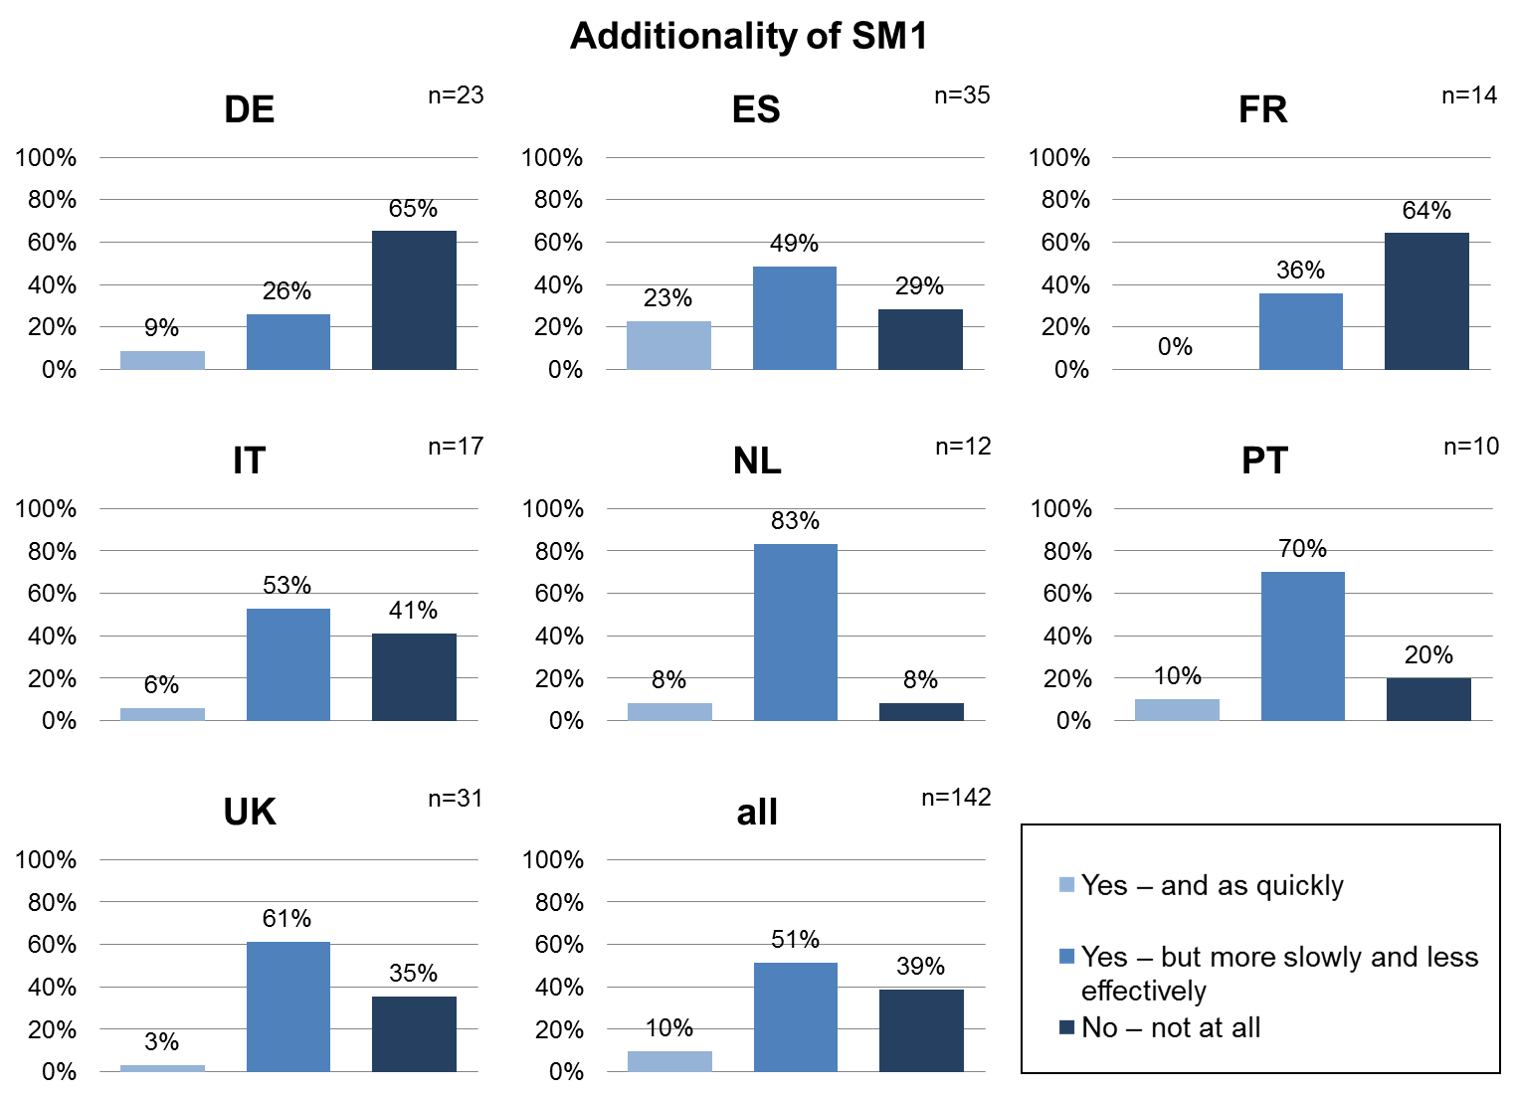

Figure 40: Additionality of Support Measure 1 by Regions

At first glance the graphic could be interpreted as most successful in France and Germany, as most of the respondents here would not have undertaken any innovation action without supporting measures. It seems that there is room for improvement in Spain regarding additionality. But this has to be considered in relation to regional innovation policy on the one hand and to the concrete design of the assessed support measures on the other hand.

|  |
| --- |
| The question about the additionality of innovation support measure was also part of the interviews. The concrete numbers differ slightly but the overall trend from the questionnaire analysis can be proved. For only 15 per cent the support measure was additional, that means the SME would have done the same without support and even as quickly. Nearly 60 per cent would have done the same activities without the support measure but more slowly. Every fourth interviewed SME would not have done its innovation activity.    Figure 41: Additionality of support measure |

## SME needs in support programmes

One of the most important questions within the GPrix questionnaire covered SME needs regarding innovation support measures. 18 possible needs are rated regarding their importance from the SME viewpoint. The needs were rated on a scale from no importance, low importance, important, high importance and very high importance. All mean values lay between 3 (which is important) and 4 (which is high importance). The need with the highest importance for SME is a *simple application* (4,0). Simple application is followed – with little distance – by *simple reporting requirements*, *short application to funding period* and *easy access to information* (each 3,7). With just above 3 (3,1) the *network of potential partners* is the “lowest important” need, which is still important. From the 333 GPrix respondents 34 to 44 enterprises did not answer that question.

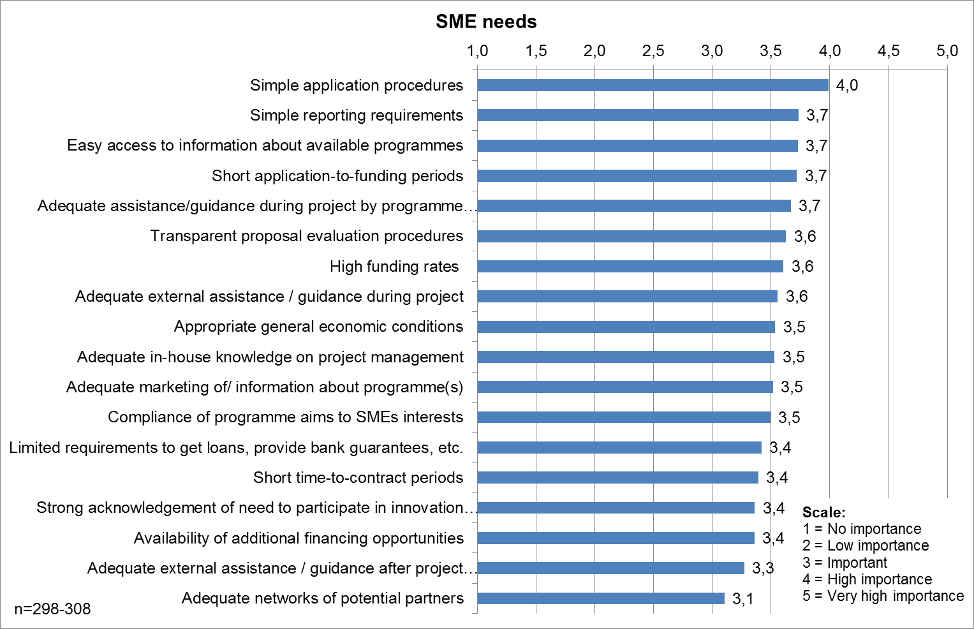

Figure 42: SME needs to enable participation in support programmes(range of MVs, 34-44)

|  |
| --- |
| Within the interviews the SMEs were also asked about their needs regarding support measures. The consortium used open questions within the interviews so that the SME could explain its positive or negative experiences. After finishing the case studies the consortium put the experiences into different clusters.  More than 40 per cent had good experiences regarding low administration effort and good cooperation with partners. Just below 40 per cent the SME reported they had good communication with program managers. Eight SME said they had low effort for reporting and six had low effort for evaluation as well. Four SME stressed out the fast responses and decisions from program managers.    Figure 43: Good experiences with innovation support measures  All these experience clusters can be inverted and thus the consortium used them to count the negative experience. 27 SME (77%) had challenges with a high administrative effort and 17 with high effort for reporting. 14 SME reported long responses or decisions from program managers (40%) and five SME even had a bad communication with program managers. Three SME reported high effort for evaluation and one SME had bad cooperation with other partners.    Figure 44: Challenges concerning innovation support measures  Both figures have to be seen together. Because of the heterogeneity of the analyzed innovation support measures we cannot put them altogether. There seem to be some very good support measures which led to low efforts for administration and reporting on the SME’s side. But there are more with potential to even lower efforts for administration and reporting. The effort for evaluation does not play a big role for SMEs – or with other words: the evaluation effort does not seem to be a problem. Cooperation does not seem to be a problem for SME, neither with partners (universities or other companies) nor with program managers.  What can be a problem is the time until decision or response. The time to market is a key success factor for innovation. Thus decisions to get a support measure have to made fast, because in most support measures the concrete activity may not start before the final decision. |

# Annex

## Case studies overview

The following table gives an overview of the selected case studies sorted by country /region.

|  |  |  |  |
| --- | --- | --- | --- |
| Country | Code Name | Industry | Page |
| DE: SAXONY-ANHALT | MSB3 | mechanical/metallurgy | 58 |
| MSB2 | mechanical/metallurgy | 62 |
| SMB1 | mechanical/metallurgy | 65 |
| AMS2 | automotive | 69 |
| MVU1 | mechanical/metallurgy | 72 |
| SMB41 | mechanical/metallurgy | 75 |
| AMS1 | automotive | 78 |
| AUN1 | food | 81 |
| ES: COMUNIDAD VALENCIA | AG1 / Aceitunas Gutierrez | food | 84 |
| AMN1 / A y M Navarro S.L. | food | 87 |
| AG2 / Aceitunas Guerola S.L. | food | 89 |
| RM1 / Representaciones Mondragón S.L. | others | 91 |
| EMC1 / EMAC Complementos S.L. | mechanical/metallurgy | 92 |
| TXT1 / Textisol S.L. | textiles | 96 |
| FR: LIMOUSIN | PACT | ceramics | 118 |
| Kimeko | automotive | 109 |
| Atelier Lo Tillou | textiles | 100 |
| Porcelaine Pierre Arquié | ceramics | 112 |
| FR-CR1 | ceramics | 103 |
| FR-LR1 | leather | 116 |
| IT: EMILIA-ROMAGNA | IT-AM1 | automotive | 123 |
| IT-ME1 | mechanical/metallurgy | 123 |
| IT-ME2 | mechanical/metallurgy | 126 |
| IT-ME3 | mechanical/metallurgy | 126 |
| IT-ME4 | mechanical/metallurgy | 127 |
| IT-ME5 | mechanical/metallurgy | 130 |
| IT-ME6 | mechanical/metallurgy | 131 |
| IT-CR1 | ceramics | 133 |
| IT-AM2 | automotive | 134 |
| IT-FD1 | food | 136 |
| IT-LR1 | leather | 138 |
| NL: NORTH BRABANT | Artofil B.V. | textiles | 143 |
| Cedesko | textiles | 146 |
| Van den Berkmortel | mechanical/metallurgy | 157 |
| MetaalindustrieUden B.V. | mechanical/metallurgy | 153 |
| Prins Autogassystemen B.V. | automotive | 159 |
| Voertuig | automotive | 151 |
| Van Haandelmetaal | mechanical/metallurgy | 148 |
| Leather NL | leather | 141 |
| Food NL | food | 163 |
| Metal NL | mechanical/metallurgy | 164 |
| PT: NORTHERN / CENTRAL PORTUGAL | PT-TX1 | textiles | 166 |
| PT-LR1 | leather | 168 |
| PT-ME1 | mechanical/metallurgy | 168 |
| PT-ME2 | mechanical/metallurgy | 172 |
| PT-ME3 | mechanical/metallurgy | 175 |
| PT-OR1 | others | 178 |
| PT-TX2 | textiles | **Error! Bookmark not defined.** |
| PT-ME4 | mechanical/metallurgy | **Error! Bookmark not defined.** |
| PT-TX3 | textiles | **Error! Bookmark not defined.** |
| PT-ME5 | mechanical/metallurgy | **Error! Bookmark not defined.** |
| UK: WEST MIDLANDS | Leather SME #1 | leather | 195 |
| Leather SME #2 | leather | 202 |
| Textiles SME #1 | textiles | 209 |
| Textiles SME #2 | textiles | 213 |
| Textiles SME #3 | textiles | 216 |
| Ceramics SME #1 | ceramics | 220 |
| Automotive SME #1 | automotive | 225 |
| Metallurgy SME #1 | mechanical/metallurgy | 236 |
| Metallurgy SME #2 | mechanical/metallurgy | 241 |
| Automotive SME #2 | automotive | 247 |

Table 6: Case study overview by country / region

The following table gives an overview of the selected case studies sorted by industry.

|  |  |  |  |
| --- | --- | --- | --- |
| Industry | Country | Code Name | pages |
| automotive | DE | AMS2 | 69 |
| DE | AMS1 | 78 |
| IT | IT-AM1 | 123 |
| IT | IT-AM2 | 134 |
| NL | PrinsAutogassystemen B.V. | 159 |
| NL | Voertuig | 151 |
| UK | Automotive SME #1 | 225 |
| UK | Automotive SME #2 | 247 |
| FR | Kimeko | 109 |
| ceramics | IT | IT-CR1 | 133 |
| UK | Ceramics SME #1 | 220 |
| FR | PACT | 118 |
| FR | Porcelaine Pierre Arquié | 112 |
| FR | FR-CR1 | 103 |
| food | DE | AUN1 | 81 |
| ES | AG1 / Aceitunas Gutierrez | 84 |
| ES | AMN1 / A y M Navarro S.L. | 87 |
| ES | AG2 / AceitunasGuerola S.L. | 89 |
| IT | IT-FD1 | 136 |
| NL | FoodNL | 163 |
| leather | IT | IT-LR1 | 138 |
| NL | Leather | 141 |
| UK | Leather SME #1 | 195 |
| UK | Leather SME #2 | 202 |
| FR | FR-LR1 | 116 |
| PT | PT-LR1 | 168 |
| mechanical/metallurgy | DE | MSB3 | 75 |
| DE | MSB2 | 62 |
| DE | SMB1 | 65 |
| DE | MVU1 | 72 |
| DE | SMB41 | 75 |
| ES | EMC1 / EMAC Complementos S.L. | 92 |
| IT | IT-ME1 | 123 |
| IT | IT-ME2 | 126 |
| IT | IT-ME3 | 126 |
| IT | IT-ME4 | 127 |
| IT | IT-ME5 | 130 |
| IT | IT-ME6 | 131 |
| NL | Van den Berkmortel | 157 |
| NL | MetaalindustrieUden B.V. | 153 |
| NL | Van Haandelmetaal | 148 |
| NL | Metal NL | 164 |
| UK | Metallurgy SME #1 | 236 |
| UK | Metallurgy SME #2 | 241 |
| PT | PT-ME1 | 168 |
| PT | PT-ME2 | 172 |
| PT | PT-ME3 | 175 |
| PT | PT-ME4 | **Error! Bookmark not defined.** |
| PT | PT-ME5 | **Error! Bookmark not defined.** |
| Textiles | ES | TXT1 / Textisol S.L. | 96 |
| NL | Artofil B.V. | 143 |
| NL | Cedesko | 146 |
| UK | Textiles SME #1 | 209 |
| UK | Textiles SME #2 | 213 |
| UK | Textiles SME #3 | 216 |
| FR | Atelier Lo Tillou | 100 |
| PT | PT-TX1 | 166 |
| PT | PT-TX2 | **Error! Bookmark not defined.** |
| PT | PT-TX3 | **Error! Bookmark not defined.** |
| Others | ES | RM1 / Representaciones Mondragón S.L. | 91 |
| PT | PT-OR1 | 178 |

Table 7: Case study overview by industrial sector

## Case studies DE – Saxony-Anhalt

As described in the selection criteria in “Del. 1.4 - List of selection criteria for selection of the good practice measures” not every SME was suitable for a case study. The following table gives an overview about the case studies from Germany – Saxony-Anhalt. Within Saxony-Anhalt sub-sample we can find a good distribution among the following criteria (quite similar distributed as in the survey results in Saxony-Anhalt):

* Different types of support measures
* Micros, small and medium enterprises [Employees]
* Dependent vs. independent enterprises [SME status]
* All industry sectors (automotive, mechanical engineering / metallurgy, food industry) covered
* Successful vs. unsuccessful innovation
* Participants vs. non-participants of innovation support measures

|  |  |  |  |  |  |
| --- | --- | --- | --- | --- | --- |
| Name | Type of Support Measure | Employees | SME status | Industry sector | Success rate |
| MSB3 | Support for internal innovation | 179 | No | Mechanical enginee­ring / metallurgy | Successful innovation |
| MSB2 | Support for internal innovation | 40 | Yes | Mechanical enginee­ring / metallurgy | Successful innovation |
| SMB1 | Collaborative measure | 100 | Yes | Mechanical enginee­ring / metallurgy | Successful innovation |
| AMS2 | Collaborative measure | 3 | Yes | Automotive | Successful innovation |
| MVU1 | No innovation support measure | 11 | Yes | Mechanical enginee­ring / metallurgy | No measure |
| SMB4 | As subcontractor within a collaborative measure | 150 | No | Mechanical enginee­ring / metallurgy | Project stop, no innovation |
| AMS1 | Support for internal innovation | 16 | Yes | Automotive | Successful innovation |
| AUN1 | No innovation support measure | 40 | Yes | Food | No measures |

### MSB3 – Successful innovation in mechanical engineering company

1. **Introduction**

The engineering industry in Saxony-Anhalt has a long tradition with numerous innovative developments. Nowadays, mechanical engineering is one of the largest industries in the region, which is dependent on continuous innovation and customer orientation due to strong business competition. Currently the engineering industry in Saxony-Anhalt has to face a challenge, the lack of highly qualified professionals.

The innovation support policy of the federal state of Saxony-Anhalt is also designed to help SMEs to get more involved in research and development to be innovative and to strengthen the economic base. For example, support measures are set up that will support transferring results of science and research to SMEs (transfer of knowledge and technology or innovation manager).

Summarizing the case study, it can be said that in recent years, MSB3 has carried out many successful innovation promotion projects. In the area of innovation, a detailed examination of the processes of the application to completion of support measures took place. Further obstacles and potential improvements are identified.

MSB3 is a medium-sized enterprise. The funding measure ZIM used by the company is not a regional funding program; however, it is widespread over Germany and also very successful. This was also reflected in innovation support projects in the company. Thus, all relevant pre-established criteria have been considered for selecting the companies for this case study.

**B. Analysis of Experiences with the Innovation Support Measure**

**B.1. Company Background**

MSB3 stands for precision hydraulics with deep expertise in developing and manufacturing directional control valves, control blocks and oil immersed units. The annual turnover of the company in 2009 was just over a million Euros.

MSB3 was founded in 1920. It was originally a firm making agricultural machinery, but during World War II the operations had to be shifted to the production of apparatus for aircraft construction. After the war they initially produced mining machinery. At the end of the 60’s the company started to specialize in hydraulic products. After the German reunification MSB3 was a part of a group of companies, but acted completely independent and therefore also led research and development projects on their own site.

MSB3 is a mid-size business with 200 employees, located near Magdeburg in Central Germany. As one of the region’s largest employers, they are committed to providing vocational training for the young generation. By practicing this training on a long-term and ongoing basis, they are in a position to draw on a high-performing workforce of young skilled personnel and experienced key staff.

The current product range is manufactured on modern and highly productive production lines. The parts can be made with an accuracy of up to 0,001 mm. Modern testing facilities ensure that every part is checked several times during the manufacturing and assembly process. The entire production process is carried out according to the quality management system DIN EN ISO 9001:2000.

The products are used in almost all industrial sectors: in the tool and agricultural machinery industry, shipbuilding and automotive, plastic processing machines, and similar industries.

In the company, innovation is understood especially in the context of new or significantly improved products, processes and technologies.

**B.2. Innovation Support Measure**

Overall, in recent years about 20 development projects were carried out. Solely 12 of these funded projects were located in the area of product innovation.

MSB3 has hired an external consultant for the selection and application of support measures. In the last couple of years, innovation support measures from the Federal were the main part of the requested funding. Above all, ZIM and PRO INNO support measures have to be mentioned. The focus in the following analysis is on the ZIM support program of the Federal Ministry of Economy and Technology (BMWi).

ZIM (=German abbreviation for: Central Innovation Program for SMEs) is the basic program of the BMWi for market-oriented technology supporting of innovative SMEs in Germany.

The technology supporting of the BMWi tries to use ZIM to

* encourage SMEs to increase research, development and innovation,
* reduce the technical and economic risks of R & D projects,
* rapidly turn R & D results into market-effective innovations,
* improve the cooperation between SMEs and research institutions,
* increase the involvement of SMEs in R & D cooperation and innovation networks and
* improve the innovation, collaboration and network management in SMEs.

ZIM is a nationwide, technology-and industry-funding program for SMEs and open to collaborating with these industry-oriented research facilities. ZIM can be used to fund individual as well as networking and cooperation projects. The chosen project was a single, individual operating project to develop in-house innovation capabilities.

Since the administrative burden for the company for the selection and application of support measures was not to handle alone, the company was assisted by an external consultant who already had a longstanding relationship with MSB3.

The funding program with financial support amounting to € 100,000 served its purpose and led to a successful completion of the innovation project in which a new compact air-conditioning service unit for all coolants was developed. Existing service units could only deal with individual cooling liquids, so that the user had to hold several different service units.

As a result of the successful project 10 employees could be hired for the production of compact air-conditioning service equipment and one new employee in technology. Through the successful innovation the company could increase the demand and achieve a substantial increase in sale. Without ZIM this innovative project would not have been carried out or would have been elapsed a longer time frame, as the financial support was the decisive aspect for the project. By the external needs of program managers regarding administration / reporting, a certain pressure is built up which has a positive effect on the course of the project. SMEs, such as MSB3, are strongly driven by the operational business, strategic initiatives such as research projects can occasionally be postponed due to the daily business. The schedules and milestones for execution and settlement of funded projects provide here a necessary structure and thus lead to an acceleration of the innovation process.

In addition, through the development of the compact air-conditioning service unit a new business was opened and the sales of the company were increased. Except for the enormous effort required to apply for the funding program, the experiences with the ZIM support were very good.

However, there are support measures that are tied to an increase in the number of employees. This is especially in times of economic crisis and shortage of skilled labour often difficult or not feasible.

Mainly to control the lack of skilled workers MSB3 is cooperating with regional colleges for years. There are repeatedly highly qualified students for internships in the company; however, an employment in the company seems to be unattractive to many students after graduation. This has its origin for example in the lower level of wages in the new federal states or the lack of regional attractiveness (countryside area).

The variety of support measures used, for example, consulting services to optimize the internal organization were utilized. With this funding measure, a staff survey was conducted, which should analyze the internal satisfaction and possible corporate potential. Also, this promotion was very successful, but had in regard to the potential for innovation rather an indirect influence. In addition, quality assurance measures were conducted in the environmental field with the help of support measures. All processes and materials were examined for their environmental impact. Additionally material saving potential was identified, waste was minimized and a waste water filter system was installed.

**C. Recommendations & Conclusions**

Suggestions for innovation promotion should encourage SMEs in particular and consequently reduce bureaucratic hurdles in the application of support measures. This concern primarily the time required to apply for funding measures. The company MSB3 uses an external consultant to assist because of the bureaucracy. This is not possible for many small business owners. The company sees a possible solution to the problem in direct support of the program manager or in financing of external consultants within or before applying for the funding measure.

The extreme effort in applying the measures has been established at all regional and national programs used and, therefore, it should not only be improved in the ZIM project but generally in all support measures.

From the viewpoint of MSB3 the time between the application and granting of the fund could be shortened. This should be done due to transparency about all necessary documents, so that the subsequently submission of documents is not necessary.

Furthermore, the development of innovative products, their manufacturing processes and patenting should be combined in one support project and not as yet available in three separate funding projects. The current practice leads to an increase in administrative burden both on the part of companies and on the part of funds donors and program managers.

In addition, the support measures should be adapted better to economic conditions. The company used the short-time working in the last economic crisis, that way that only three employees – not taken out of the permanent staff – had to be laid off. The release of employees, however, is contrary to the objectives of funding donors that the measure should generate new jobs. This implies that a bound on the funding measure staff reinforcement should be softened or adjusted in economically depressed times.

**D. Information Sources**

* + - The company website
    - Websites dedicated to the specific measure being analyzed here
    - Websites dedicated to providing information the innovation policy
    - Interview from 6.9.2011
    - by the company completed questionnaire

### MSB2 – Successful innovation in a mechanical engineering SME

1. **Introduction**

The engineering industry in Saxony-Anhalt has a long tradition with numerous innovative developments. Nowadays, mechanical engineering is one of the largest industries in the region, which is dependent on continuous innovation and customer orientation due to strong business competition. Currently the engineering industry in Saxony-Anhalt has to face the challenge of a lack of highly qualified professionals.

The innovation support policy of the federal state of Saxony-Anhalt is also designed to help SMEs to get more involved in research and development to be innovative and to strengthen the economic base. For example, support measures are set up that will support transferring results of science and research to SMEs (transfer of knowledge and technology or innovation manager).

The present case study deals with how using support measures have successfully implemented innovative developments. In doing so, the procedure from applying funding to completing support measures was considered carefully. In addition, difficulties and potential improvements have been identified during the use of innovation support measures.

**B. Analysis of Experiences with the Innovation Support Measure**

**B.1. Company Background**

In the 19thCentury MSB2wasfoundedas a mechanical workshop and grew rapidly to a strongbox factory over the years. After World War I the company was primarily occupied with repairs in the gunsmith sector. The company buildings were largely destroyed after World War II. The plant was rebuilt and acted as a supplier for the German Reichsbahn.

Meanwhile the development and manufacture of deflectometers was started. They are still in the product portfolio of MSB2in a different kind.

After the ISO 9001certifiedcompanywith 35employees was taken over by the current owner, it became a modern company with proprietary research and development.

Due to the considerable wider range of products the companyMSB2has delivered over 25.000 testing devices and instruments in the world up to the present day. The units are demanded in the countries of Eastern and Western Europe as well as in Japan, Brazil and India.

Especially the devices of the light deflectometer series helped achieving one of the world's leading market positions in recent years.

The dynamic loading-plate compression test with the help of the light deflectometer is applied to earthworks, civil engineering, roads and rail construction. It is used to determine the bearing capacity and assessment of the compaction of soils, unbound bearing courses and soil improvements. The test procedure and the device are approved by the German test method TPBF-StB Part 8.3.

The services of the companyMSB2include the development, production, maintenance and distribution of material testing devices for:

* Metals and iron according to Shore, Vickers and Brinell;
* Rubber and plastics for hardness and impact resistance and flexural strength;
* building materials for hardness and cube compressive strength;
* road materials to bearing capacity;
* paper and pulp to grinding degree on wet basis.

In addition, precision parts are made in CNC machining centres to customer specifications and complete modules are assembled.

Innovation is perceived by MSB2 as a property, which sets the company apart from the market and distinguishes it from competitors. This innovative feature is not only limited to products but can also include marketing activities, production processes or organizational processes.

**B.2. Innovation Support Measure**

MSB2 used a regional promotion of the Investment Promotion Bank Saxony-Anhalt, titled "research, development and innovation". The decision to take part of the funding measure was made due to the cooperation with a regional technology transfer facility, which offers companies and technology-oriented start-ups a holistic range of services from one source in the fields of research and development, national and international cooperation at foundation and business development as well as business growth.

The technology transfer facility functioned as an external consultant, whose contribution to MSB2 was charged. The service package included the work to find appropriate support measures and the entire application.

The funding measure "research, development and innovation" is supposed to help small and medium-sized businesses realizing the potential for innovation to develop new products and processes, and pushing forward research. Individual projects, joint projects between companies and joint projects between SMEs and universities in the areas of industrial research and experimental development can be funded. The measure promotes projects with innovative technological content, which are fostering the development of new products and processes in the field of industrial research and experimental development.

In the case of MSB2 the measure included a financial assistance amounting to some € 100,000 for the development of a significantly improved electronic of a street testing device. This was a single project without partners, the innovation was provided by the company itself. The development process was marked by a deviation from the original plan, which did not change the project aim, but the project properties.

These changes, however, had no effect on the funding scope. The changes in product characteristics became necessary due to the fact that there was an innovative idea from the start of funding, but the practical feasibility was not sufficiently explored. Originally a Bluetooth transmission of data should be included but was rejected in the course of the innovation project and replaced with a SD memory card, which corresponded much more sensitive to market requirements, technical possibilities and the pricing of the product to be developed. The SD card for storage of data is unique and a great step forward for street testing devices. In addition to this innovation, the unit does also have a graphics-capable display for showing and analyzing measurement results, and an optional GPS module, which enables location-based mapping of measurement results. The product is unique on the market due to the combination of these characteristics.

The project proceeded in spite of the described content changes very successful and fulfilled the goal of promotion. Due to the promotion, the result was a prototype after 1.5 years of developing that could be transferred into a scalable product. Without financial support, the innovative development of the new electronics of the street testing device would have been well developed, but not been implemented as quickly. In addition, another employee would not be adjusted. In summary, the promotion brought a time-effective development period and some protection against external economic influences such as the onset of the economic crisis within the project course. Without the funding the financing during the economic crisis would have been extremely vulnerable. For the company, the crisis meant a loss of around 30 percent. Since the products of MSB2 are used in the construction sector, the sales are also heavily dependent on international projects, such as the highway construction in Africa, which is driven mainly by Chinese investors.

Currently, the share of sales of the product developed in the funded project is the total sales at around 30% which equates to about 800,000 €. The product lifecycle of a new developed deflectometer is about 5years.Therefore, it can be said to be a very successful project funding.

In addition to the previously described support measure "research, development and innovation", further measures were already used successfully. These measures include fair and patent funding. The fair funding is also an incentive measure of the Investment Promotion Bank Saxony-Anhalt. This will help presenting the products and services of the company and to be able to increase sales prospects and boost sales. Fairs and exhibitions are indispensable marketplaces and industry meetings for companies – this funding makes it possible to take advantage of this potential for small and medium-sized enterprises. The focus of the patent promotion, however, is aimed to secure knowledge in business, use innovation in the production process and to protect the investments made by patent application over the competition. Therefore, the Investment Promotion Bank Saxony-Anhalt encourages measures for the application of patents and other intellectual property rights, the continuation of certain stages in Germany and abroad as well as the implementation of function certifications.

However, these additional programs are not considered in detail in the interview.

**C. Recommendations & Conclusions**

In general, the innovation is perceived as important. The funding measure "research, development and innovation" went well and no organizational obstacles were caused which blocked or interfered the progress of the project.

However, some aspects of the framework of the funding measure, which were obstacles to the course of the project, are viewed as a challenge. Instead of keeping the promotion general that it corresponds to the different organizational requirements of SMEs, they have to adapt the organizational requirements of the funding measure. These include for example the prescribed classification of the research project into work packages and the appropriate allocation of costs. The organization system of the funding measure is perceived as rigid and inflexible. For example, administrative processes for once planned work package structures have to be used again and again.

From the experience of MSB2 it can be said that especially innovative ideas are subject to certain risks and are therefore reviewed in the course of the development process, and adjusted if necessary. From the perspective of MSB2 this is not provided in the context of the project organization of the funding measure. From the viewpoint of the company, for example, the project course could be adjusted to new ideas and developments in consultation with the funding authorities/program manager by a semi-annual review. Interim reports, for example, were not required within the project administration.

In addition, this should be coupled with a smaller effort in applying for the funding measure. These are currently time-consuming from the perspective of MSB2 and represent such a huge hurdle that the external technology transfer facility had to be asked to assist in researching and applying for support measures.

Furthermore, MSB2 criticizes the need to give the same documents multiple times to the same program carrier for any support measures. This problem arises particularly if the entire innovation process should be supported by various promotional activities. This is the case after a successful, funded innovation project additional support for a patent or a trade fair is requested. Viewed by the company, this is one possibility for improvements on the side of the program manager and on the side of the submitting SMEs. The company considers the combination of support measures and bundling applications to be productive.

**D. Information Sources**

* + - The company website
    - Websites dedicated to the specific measure being analysed here.
    - Websites dedicated to providing information the innovation policy
    - Interview from 05.09.2011
    - by the company completed questionnaire

### SMB1 – two successful innovations of a mechanical engineering SME

1. **Introduction**

The engineering industry in Saxony-Anhalt has a long tradition with numerous innovative developments. Nowadays, mechanical engineering is one of the largest industries in the region, which is dependent on continuous innovation and customer orientation due to strong business competition. Currently the engineering industry in Saxony-Anhalt has to face the challenge of a lack of highly qualified professionals.

The innovation support policy of the federal state of Saxony-Anhalt is also designed to help SMEs to get more involved in research and development to be innovative and to strengthen the economic base. For example, support measures are set up that will support transferring results of science and research to SMEs (transfer of knowledge and technology or innovation manager).

The present case study deals with how using support measures have successfully implemented innovative developments. In doing so, the procedure from applying funding to completing support measures was considered carefully. In addition, difficulties and potential improvements have been identified during the use of innovation support measures.

**B. Analysis of Experiences with the Innovation Support Measure**

**B.1. Company Background**

The company based in Saxony-Anhalt is a producer of special purpose machines for different fields of application. SMB1 designs, produces and installs machines, plants and devices for different branches of industries. While doing that, individual and innovative solutions for problems are found and delivered at best quality from one source. To provide the specific solutions the company is divided into the following departments:

* R&D
* Construction
* Production
* Installation and
* Industrial Service.

SMB1 is a so called Turn-Key Supplier, implicating that the customer receives a turnkey plant in the end. Thus, the company yields all work, starting from the concept and the construction over production and installation to commissioning and training. The SME designs and produces modern special purpose machines with mechanically, hydraulically, pneumatically and electronically geared motor drive concepts. All produced special purpose machines and plants are partly or completely pre-assembled in the companies´ own assembly hall thus, tests or commissioning can be done.

The company comprises of approximately one hundred highly qualified employees, that are able to implement technically advanced, tailor made and complex tasks. Besides extensive know-how and long working experiences the high quality of work is also realized with the help of the newest computer- and software engineering.

SMB1 is a former state controlled manufacturer of forest machinery, which afterwards was turned into a rationalization means construction. The company estimates itself as innovative with an above-average level operating in a moderately competitive industrial branch. 75% of turnover is realized by exports, whereas the main part of turnover is gained outside the European Union. Approximately 6-10% of turnover is spent for innovation. Due to product, special purpose machines, the developed innovations are often a combination of product and process innovation. Often an innovative special purpose machine (product innovation) is developed by a novel production process (process innovation). To be innovative the company is cooperating with diverse partners like suppliers, customers and research institutes.

SMB1 recognizes innovation as product and process improvements, to develop technical solutions for customers. The main aspect is that developed products need to stand out of the competition, to be recognized as innovation.

**B.2. Innovation Support Measure**

The company received two funding from a regional innovation support measure, the Research, Development and Innovation support measure from the IB bank of Saxony-Anhalt. The fund has the goal to strengthen the economic power of Saxony-Anhalt as well as creation and protection of working places. Furthermore, the cooperation between small and medium sized companies with research institutes is focused to improve industrial research and experimental development.

Thus, especially SMEs are assisted to access research and development as well as the realization of future-oriented innovative solutions.

**Support Measure 1:**

The first measure regards a product and process innovation. The goal of the measure was to develop machines for laser welding of large components up to 30 meter of length. Laser welding hasn´t been used for large components like that before, therefore the laser machine is an innovative technology. An advantage of this new technology is that the welding of large components can be done with a higher quality compared to traditional procedures. In addition the newly developed welding plant can also be used for lightweight constructions and offers an improved resistance to corrosion of the components that need to be welded.

The supported project regards both, a product as well as a process innovation. The challenge of the project was to develop a machine that offers the opportunity of a serial capable welding procedure that meets the needs of customers especially for large components.

A special challenge, due to the innovative procedure, is that a major part of the plant is planned to be transferred abroad. On the one hand the challenge regards the qualification of employees that differs compared to Germany. On the other hand there the manufacturing ranges of tolerance in the target country differ from the ones in Germany and Europe. Therefore the machine had to possess a certain degree of intelligence. As an example for the Asian market the machines had to enable a permanent target/performance comparison with CAD data.

The research project would have also been realized without the financial innovation support measure although with a time delay. Nevertheless the financial support gave the company a planning certainty. The company was consulted by a technological transfer institute regarding the diverse possibilities of financial support. Furthermore SMB1 is member of a regional cluster for special purpose machines and plant construction which is managed by the technology transfer institute. Thus, there is a long connection between both organizations. Due to the geographical proximity to the Investment Promotion Bank Saxony-Anhalt in Magdeburg (program manager) and the regional connection of the company, a regional fund was chosen as innovation support measure. The framework conditions meet the needs of the company perfectly.

SMB1 received a fund of approximately 200.000 Euro, from which the main part is used for personnel costs. Another important factor for the choice of the support measure was that other cost position, like investments in test plants and subcontracts for procedure qualifications are eligible as well. The fund is a research and development support, which meets the needs of the company. Downstream phases of innovation process aren´t highly relevant for the fund as this section is already covered by the company.

Due to the innovation support measure the companies’ development was very good. On the one hand a promising product development could be started. On the other hand a test plant was built which provides the company with the security of being able to realize the innovative welding process. The test plant also functions as reference for acquisition of orders. The built welding plant is highly requested and thus the market introduction was successfully implemented. Currently SMB 1 plans to sell one to two plants per year with a volume of orders of at least 1.5 million Euros. This goal is realistic as the demand for these kinds of plants exists and the volume of order correlates with the production capacity.

With the security of the innovation support measure that SMB 1 received a new employee was hired. Furthermore the competence of the company in the sector of welding was fostered by the innovation support measure. This increased competence also gains from a cooperation with a renowned local partner from the field of welding. Due to the cooperation between these two partners the company experiences an increased reputation toward potential customers which in turn increases the volume of order.

Not solely based on the good results SMB1 evaluates the innovation support measure as valuable, all together the whole project procedure was smooth and without any disturbance.

**Support Measure 2:**

The second support measure regarded an innovative product, which should complete existing products. In the course of the second project, methods for NC-programming and simulation are planned to be developed. The NC-programming of simple machines or plants can be done by conventional commercial software tools. For more complex tasks and flexible solutions a programmer is needed. Single, so called machine specific cycles are only considered with laborious and time as well as cost consuming effort. A higher grade of automation is not possible for special solutions anymore. Moreover under these conditions circumstances like collisions of machine arms of a welding plant are more difficult to avoid, which in turn has expensive consequences.

The development of methods for NC-programming and simulation was planned to be transferred into an IT-tool. Crucial components of the completed work are two new solutions: one tool for the effective automotive NC-programming and the machine-oriented NC-simulation in real-time. The programming tool completely describes all movements and process parameters for machining the component in a 3D simulation. It can transfer all common CAD formats into the programming environment as well as integrate machine specific cycles.

Thereby the user of special purpose machines can already simulate the reaction of the plant by programming the control (NC). Thus, incorrect programming does not lead to production faults or even plant breakdown, as they are virtually done. If the simulation provides a satisfying result, the real production can be started. This is an additional benefit which the company offers with its actual products (special purpose machines and plants).

This project, which has been realized with a subcontractor, would not have been done without the support measure as it would not have been attractive for SMB1. The company received a premature measure notification from the program manager. Thus, the company had taken all formal barriers. Due to budgetary delays, it could not be started as planned with the complete official subsidy notice.

Thus the project started slowly and delayed since subcontracts could not be delegated as planned. The delay could not be made up in the course of the project, wherefore a project extension was requested. This request was accepted by the program manager without any problems. The flexibility and the appreciation of the program manager were evaluated as very positive by the SMB1.

For the support measure 2 SMB1 cooperated with a research institute (applied research), whereas the research institute had a subcontract in the project. Thus, important know-how was directly implemented in the research and development process of the SME. Due to experiences of the research institute regarding publicly supported projects, the SME could be advised if necessary. The cooperation of both partners worked especially well, which is reflected by a joint release in the journal of the research institute. The cooperation with a renowned research institute had positive effects on development of competences as well as on the reputation.

In the end of the project a new supplement product could generated. “Due to the connection of the NC-programming-environment with the NC-code-simulation a more powerful package was generated, which supports us as machine developer as well as an operator of machines” reflects the managing director.

Due to research project the company is independent of external systems by now and can develop new products on its own. The used procedure of resistance spot welding for the considered machines can be replaced in the case of new plants by laser beam welding. Thus, the variety of application of the new supplement product (software) for other products rises.

**C. Recommendations & Conclusions**

All together SMB1 evaluated both support measures as very positive. Unexpectedly, the bureaucratic effort was limited. Although already submitted document for measure 1 needed to be handed in again for measure 2, the effort was acceptable. The contact and communication with the program manager from the Investment Promotion Bank Saxony-Anhalt was very good and can be highlighted as ideal. For questions always a competent contact person was available.

The proof of generated personnel capacity generated by the support measures could be done by SMB1 without any problems. Since the company almost exclusively operates in projects, the project-related documentation of working hours was nothing new to internal organization of SMB1. The employees are familiar with allocation and documentation of working hours to projects and orders. That an additional time sheet was necessary for the support measure was not a burden for the employees. SMB1 appreciates that certain guidelines and rules exists which need to be followed and that the program manager forms that are adjusted to the own institute.

From the company’s point of view, the local support measures should stay as they are. Both, the extents of fund (research and development) as well as the framework conditions (eligible expenditure, funding rate etc.) are reasonable. The support measures should consequently go on and not be reduced or cancelled.

The financial crisis 2008/2009 just had minor effects on the company as the ordering of special purpose machines is rather long term oriented. Nevertheless some orders have been stopped by customers, but the available resources have been integrated into acquisition attempts. This was especially true for the toll manufacturing department, which experienced sudden changes in order volumes. Due to the financial crisis a lot of well qualified engineers were available, thus the company could expand the engineering department. Some of these new hired staff has already left the company which effects in a noticeable lack of specialist. As SMB1 has a good apprenticeship section the lack of specialists is just noticeable in the engineering section but not in the skilled worker section.

**D. Information Sources**

* + - The company website
    - Websites dedicated to the specific measure being analysed here.
    - Websites dedicated to providing information the innovation policy
    - Publication regarding the innovative project 2
    - Interview am 6.9.2011
    - Filled in questionnaire of the company

### AMS2 – innovation support of an automotive cluster

1. **Introduction**

The automotive industry in Saxony-Anhalt always had rich traditions. As an example, Magdeburg was considered the centre of German machinery and plant engineering. The region Harz witnessed over centuries a development of foundry technology and Dessau enjoyed a good reputation in the automotive industry. The flourishing development of those industries has always been tied to finding new innovations and thus it has not been very surprising that new products and methods found their place in Saxony-Anhalt. Nowadays these industries are considered more and more a main industrial growth driver. Many corporations, whose offerings range from the production of parts and systems to engineering services, are met with demand from renowned German car manufacturers like VW, Porsche, BMW and Daimler.

Saxony-Anhalt’s innovation policy aims for an extended inclusion of SMEs into research and development. This is done in order to enable SMEs to bring forth innovations and reinforce their economic foundations. For example, incentives are set up that will support transferring results of science and research to SMEs (knowledge and technology transfer or innovation manager).

This case study describes the experiences with innovation support measures of an automotive cluster.

**B. Analysis of Experiences with the Innovation Support Measure**

**B.1. Company Background**

The central aim of automotive cluster AMS2 is to strengthen the performance and innovation capacities of regional automotive suppliers. These goals will be implemented through an intensive knowledge and technology transfer between research organisations, service providers and manufacturers. More innovation through information and cooperation is the maxim of AMS2. Thus AMS2 wants to evolve regional suppliers from part to component suppliers. This could be reached through cooperative development of materials, processes and products. The aim is to provide complete assemblies and systems from Saxony-Anhalt to the OEMs (like VW or BMW). Saxony-Anhalt thus should develop in such way, that it becomes a centre of development and manufacturing of light weight components for alternative, energy efficient drive system.

In 1999 the constitutional concept for an innovation network was awarded by the Federal Ministry of Education and Research (BMBF). The initial support by BMBF began around the turn of the millennium. The cluster implements the networking and support of automotive supplier through organisation of innovation forums, joint stands at trade fairs or monthly publications. AMS2 is especially successful in initiating research and cooperation projects among its members or with external research organisations and companies.

**B.2. Innovation Support Measure**

AMS2’s notion of innovation is complex: an innovation is seen by the cluster manager as an idea that became an accepted product. Furthermore a new process can be seen as innovation if it helps one the one hand to save resources, make the process more secure or qualitative better. On the other hand this new process is innovative, if it strengthens the company’s market position and thus secures and creates new jobs.

The cluster also supports its members initiating and realizing product or process innovation together. AMS2 considers itself as an active supporter for funding projects and thus organizes a “project consultation day”. Besides the provision of information the cluster management supports applications of cluster members. After the starting years the cluster management is supported with the joint Federal Government/ Federal Länder scheme for “Improving regional economic structures” (short GRW)[13]. This support measure is intended to innovation support for companies located in the new Federal Länder (East Germany). Enterprise networks (clusters) have a high priority in economy policy of the new Federal Länder. For this reason the support measure was enlarged towards the funding of cluster management.

Since 2005 non-investment costs of cluster management can be funded with the support measure “cooperation networks and cluster management” as a part of the joint Federal Government/ Federal Länder scheme for “Improving regional economic structures”. Costs regarding the development of cross-corporate structures and cluster management are eligible. These tasks can be supported pending 300,000 Euro (or even 500,000 for big initiatives) in the start-up phase (see Werner 2010).

This specific support measure is one of few possibilities to co-finance cluster management task with public funds. Besides the GRW exists a measure from Federal Ministry of Economics and Technology (BMWi) called ZIM NEMO. Because of the regional activities of AMS2 within Saxony-Anhalt the more regional oriented GWR measure was appropriate.

The GRW support measure gives only short periods (three years twice) to verify the success of initiatives. Because of AMS2’s aim to support cluster members from passing on contacts as well as training; it is hard to proof the more long term oriented success. Passing on contacts and initiating cooperation between companies are named as an example. An arranged networking possibly leads towards a realized and successful innovation some years after a joint research and development project. The retrospective proof that this successful innovation was realized because of the networking activities supported by AMS2 is hardly possible.

The specific support measure was working very well from AMS2’s view. GRW support measure has very strict confines. There are only restricted possibilities to generate revenue with third-party services. The actual problem from AMS2’s perspective is rather fundamental and can be seen in the basic conditions of GRW. The measure is based on too positive prerequisites as it always focuses on the best case. Thus the aim of the support measure is only fully achievable if all conditions are optimal for the course of the initiative. This is unrealistic within times of a financial crisis.

From AMS2’s perspective cluster management is dependent on public funding. A network is a special interest group lobbying for its members and the region as a whole. Cluster’s successful work is even practised business development and good location marketing. At least in structurally weak areas this cannot be privately-financed alone. Finally a cluster has to be financially independent to act objectively. Many cluster activities cannot be financed only by members (e.g. fair trade presentation, public relations, passing on contacts). From AMS2’s perspective a basic public funding (e.g. 60 per cent) would be appropriate.

1. **Recommendations & Conclusions**

AMS2 is convinced that economic goals are feasible in long term. Thus certain continuity in public funding has to be recognizable. The time period given to realize the support measure’s aim should be adapted to long term too. For an example it is unrealistic to expect from a pre-competitive research project that followed by project closure a marketable product and working distribution structures are existing.

AMS2 cluster represents their member interests and considers itself as their service provider and voice. From AMS2’s perspective the challenge is a thin equity base of regional automotive suppliers. This fact results in lean management structures and staff typically. SMEs often lack qualified staff to apply and handle funded research projects. The shortage of skilled workers in Saxony-Anhalt intensifies this effect. Saxony-Anhalt is still situated in a process of contraction: skilled workers migrate to old Federal Länder. This is because of infrastructure but also because of resources of regional enterprises (worse payment in Saxony-Anhalt). Saxony-Anhalt provides a special support programme for in research inexperienced SME: “Promote the employment of innovation assistants and staff exchange”. With this measure SME can hire qualified graduates to introduce and implement innovation management. However this measure does not help SMEs to retain qualified research staff due to better payment.

The latest financial crisis increased the obstacles to innovation of regional automotive suppliers: a lot of innovation activities could not be started or realized and as the crisis declined SMEs were too deeply involved with operative business. This argues in favour to establish special innovation support programmes within critical times or to raise the funds. Thus a SME could even in critical situation ensure / finance its innovation activities. Success evaluation criteria (often created jobs) have to be adapted additionally, because within financial crisis enterprises reduce their staff. Original criteria could otherwise distort innovation success.

From AMS2’s perspective regional challenges within innovation support have to be treated sustainably. A reasonable approach would be to extend the duration of research and development projects. It would be helpful to support not only the development of utility models but also of product-quality prototypes. Furthermore administrative procedures should be accelerated and bureaucracy should be taken away. Time schedules starting with the idea to application, grant and all the way to accounting are too long and efforts are too high (application procedure, grant agreement).

**D. Information Sources**

* + - The cluster’s website
    - Websites dedicated to the specific measure being analysed here.
    - Websites dedicated to providing information the innovation policy
    - Interview 6th September 2011
    - Werner, J. W. (2010): Strategien der Clusterförderung – Eine Untersuchung am Beispiel ausgewählter Cluster in Rheinland-Pfalz Arbeitspapiere zur Regionalentwicklung. Elektronische Schriftenreihe des Lehrstuhls Regionalentwicklung und Raumordnung Band 9, Herausgeber: Prof. Dr. Gabi Troeger-Weiß, Dr. Hans-Jörg Domhardt (Technische Universität Kaiserslautern). Online: http://www.mittelstandsfreundliche-kommunen.de/infothek/innovation_cluster_netzwerke/troeger_weiss_domhardt(2010)_clusterfoerderung_rlp.pdf

### MVU1–metal working SME without innovation (support)

1. **Introduction**

The company looked at in this case study, belongs to the industry sector of metal processing and is solely positioned as toll manufacturer in the market. Thus, the company has neither applied for nor received any financial innovation support so far.

The innovation policy of Saxony-Anhalt has the goal to ease the access of R&D for SMEs, which in turn should result in a higher rate of innovations that are thought to strengthen the economical basis of the federal state. Therefore special innovation transfer programs are initiated. These programs, like “knowledge- and technology transfer” and “innovation manager”, try to transfer scientific knowledge from Research Institutes and Universities into SMEs to encourage innovative attempts.

The company MVU1 is just one of many other toll manufacturer of Saxony-Anhalt’s metal processing industry, which do not develop own products, but manufacture customer´s order and customer´s specification instead. MVU1 is a micro enterprise, which is due to restricted personnel resources strongly linked to operative business. Consequently, strategic thinking as well as R&D projects are extremely difficult to implement into the companies ‘course of business.

Therefore this case study primarily observes the reason why MVU1 did not apply for any innovation support measure so far, the reasons hindering them as well as economic plans of the company for the future. Due to the aspect that MVU1 does not innovate, they were not aware of the possibilities applying for innovation support measures. Thus, possibilities of receiving innovation support measures to implement R&D attempts in order to develop own products were part of the interview.

**B. Analysis of Experiences with the Innovation Support Measure**

**B.1. Company Background**

MVU1 was founded in February 1997 and currently employs eleven co-workers that are mainly qualified and work experienced toolmakers and welders. The company is specialized in stamping, tool making, welding and light steel construction. The range of services comprises of:

* Construction of auxiliary devices for production of complicated work pieces
* Production of customized series of small work pieces
* Individual customers´ specified tool making (cut and deformation tools)
* specialized welding company for steel, stainless steel and aluminium

Special customer demands can be easy fulfilled with the own tool making. Rail vehicle construction, mechanical engineering, as well as companies of other metal working areas belong to the customer base of MVU1. In the construction sector the company produces for private end-users, housing association and building contractors. MVU1 as a classical toll manufacturer does not produce own products but rather manufactures on customer order.

Nevertheless, developments of products are done by the company if they are requested by customers. MVU1 sees itself as a problem solver which includes to develop improvements of products (like cost efficient variants of production, different usage material) for customers. This kind of customer orientation in turn is perceived by MVU1 as innovative.

Since any product developments and productions are not made in a classical sense, the companies perceived innovation does not meet definitions and policies of program managers regarding innovation support. The company constantly improves the own production processes by investing in more productive machines or further education for employees. Nevertheless MVU1 does not develop innovative production processes.

The products aren´t solely manufactured for the German market, but also for countries like the former CIS countries, China, Austria, the Netherlands and Arabic states. However the main turnover is generated nationwide whereof 40% of turnover is gained from the regional market (Saxony-Anhalt and Saxony) and 45% of turnover is achieved in other federal states within Germany. Approximately 15% of turnover is gained from markets outside of Germany. According to these gains of turnover, the competition of MVU1 is mainly regional. Nevertheless this regional market is highly competitive, which is especially reflected by prices, which in turn leads to small profit margin.

**B.3. Alternatively, Describe “No Measure”;**

Due to MVU1 orientation as toll manufacturing company, there have not been activities in the field of innovation since now. Thus, innovation support measures have not been in the focus of MVU1. Nevertheless the company already gained first support measure experiences. Therefore MVU1 was able to give information regarding requirements of support measures. The used support measure was evaluated as uncomplicated and reasonable regarding the effort to apply for the measure compared to the received fund. Since the support measure was used outside the analyzed period of 2005-2009, this measure was not focused in the course of the case study.

In the financial crisis 2008/2009 the company experienced a massive reduction of incoming orders as well as a drop of turnover. Customers of MVU1 that experienced drops in turnover directly saved money by reducing external cost as done by MVU1. Thus MVU1 depended directly on development of turnover from customers and had to register for short-time work. Due to the experiences of the financial crisis 2008/2009 the company wants to change the business strategy and offer own products, to be less prone to customers outsourcing activities. Currently MVU1 has a lack of qualified employees in order to enter into research and development and to develop own products.

As a first step, the regional support measures “innovation manager” (promote the employment of innovation assistants and staff exchange) of Saxony-Anhalt would fit the needs of MVU1. In this program the hiring and employment of staff with an academic technical diploma of a university is financed in order to manage projects with innovate, technology oriented content. In a second step potential project ideas of the innovation manager can be benefit from the support measure “innovation consultation” (innovation voucher) of the Federal Ministry of Economics and Technology (BMWi) since this measure tests the marketability of the innovative idea. One part of this measure is the choice of suitable innovation support measures for a potential realization of the idea.

MVU1 was not aware of these support measures. On the one hand the company has not actively tried to get information about support measures; on the other hand the company has not been informed. The SME receives periodic calls with offers for consultation sessions on support opportunities, but often they turn out to be pure acquisition calls of expensive sale on consulting and IT products. Therefore, MVU1 is critical regarding support measure consultation.

The Investment Promotion Bank Saxony-Anhalt which is responsible for regional support measures like the “innovation manager” has been known by the MVU1 but not the detailed support measures they offer. Accordingly the marketing measures used by the Investment Promotion Bank Saxony-Anhalt seem to be improvable. Although a single issue cannot count for the entirety.

Due to the interview MVU1 will study, check the suitability of the mentioned support measures above and use the consultation opportunity of the program manager of the programmes. MVU1 seems very interested to gain more information to be better positioned and to develop a new product.

**C. Recommendations & Conclusions**

The SME could give information on demands of innovation support measures, although it has never received these kind of support. First of all, information regarding support measures for SMEs need to be noticed. The company has known that there are support measures for SMEs but has not known that they can be used to introduce innovation projects for companies that have not developed own products so far. Measures that qualify SMEs to for innovation (innovation manager, innovation voucher) projects have been absolutely unfamiliar. The executive of MVU1 did not consider the company to be eligible for innovation support measures. Due to these thoughts MVU1 previously did not even tried to inform itself about the diverse possibilities of support measures. Due to the streamlined structure – one general manager and less than then employees for production – and a strong operative involvement the time was missing to proactively search for support measures.

As far as the support measures are known, from the point of view of MVU1 it is important that the application procedure is uncomplicated and reasonable. This includes transparent application criteria and framework conditions (e.g. admission requirements, demands for reporting/evaluation of success) as well as a limited bureaucracy for the composition of the necessary documents. Especially for inexperienced SMEs as MVU1 the supply of “translator” for the bureaucratic language used by support measures (e.g. FAQ or checklists) is important. Often long and complicated guidelines already scare potential SMEs off applying for support measures.

Furthermore the company evaluates the support before, during and after the project by the program manager as very important. Advisory service before the application procedure starts would be an ideal solution. Thus, the decentralized position of the Investment Promotion Bank Saxony-Anhalt with local branch office (not only in the capital Magdeburg) as well as open office hours is exactly what MVU1 prefers.

The amount of funding rates is seen as important, but not as a crucial criterion by MVU1. More important are the reasonable economic framework conditions – e.g. flexibility of the program manager in supernormal situations that manoeuvres a micro enterprise as MVU1 quickly into financial shortages.

**D. Information Sources**

* + - The company website / brochure
    - Websites dedicated to the specific measures: <http://www.inno-beratung.de/> and <http://www.ib-sachsen-anhalt.de/firmenkunden/forschen-entwickeln/sachsen-anhalt-innovationsmanager.html>
    - Interview 20th September 2011 with the managing director
    - Survey-Data of MVU1

### SMB4 – stopped innovation project of a subsidiary small company

1. **Introduction**

The engineering industry in Saxony-Anhalt has a long tradition with numerous innovative developments. Nowadays, mechanical engineering is one of the largest industries in the region, which is dependent on continuous innovation and customer orientation due to strong business competition. Currently the engineering industry in Saxony-Anhalt has to face the challenge of a lack of highly qualified professionals.

The innovation support policy of the federal state of Saxony-Anhalt is also designed to help SMEs to get more involved in research and development to be innovative and to strengthen the economic base. For example, support measures are set up that will support transferring results of science and research to SMEs (transfer of knowledge and technology or innovation manager).

The present case study analyses an enterprise – originally acting as an independent SME with a successful, established product portfolio – that nowadays became part of a corporate group. Since that time the company realized the impact of innovation and thus starts with first research and development projects. Due to SMB4’s group affiliation innovation support measures do not come into consideration.

**B. Analysis of Experiences with the Innovation Support Measure**

**B.1. Company Background**

SMB4 is developing, producing and selling electric special drives for hoisting devices and material handling equipment. Customer-specific applications combine technical innovation and commercial advantages. Since 2005 SMB4 is a plant of a corporate group that is acting on the global scale. Thus SMB4 is no longer independently doing business. SMB4 is the competence centre of electrohydraulic lifting units-devices within the group

SMB4 is a modern company specialising in German and European mechanical engineering with a tradition of more than 100 years of mechanical engineering. The company was established in the mid-19th century as a machine factory and iron foundry to manufacture agricultural machines. After World War II the range of products was changed to a great extent and widened. In particular the nature of the company today has been shaped by 50 years' experience in the field of electro-hydraulic brake equipment. But many other mechanical and electrical engineering products pay testimony to the innovation and high standard of quality of our engineers and workers. After Germany’s reunification SMB4 was incorporated as part of the current group.

Today electro-hydraulic units are predominantly employed in heavy lifting equipment and conveying equipment. In combination with modern drum and disk brakes they ensure safe and gentle braking. They ensure the safety of people and machines alike during braking procedures as well as in emergency or power failure situations, for example when then power supply is cut off. Continual innovative further development is characteristic for electrohydraulic units which have been produced for 50 years. Over this period approximately 1 million electro-hydraulic units of four generations of products have been delivered.

The company is not acting independently – the plant does not have an own executive board – but is a centre of competence for “electrohydraulic lifting units” and thus developing new products as well. This is most important because there were no major technological developments within the core technology area (industrial breaks) within the last years. The parent company does a lot of research as well, but in different technology and product areas.

Innovation is connected with the development of new products or services – maybe derived from new technologies – from SMB4’s perspective. An innovation does not have to be radical. Even a combination of established modules or technologies is seen as innovation. Important is a potential market success of these products and services – no innovation without business model

**B.3. Alternatively, Describe “No Measure”;**

SMB4 is no SME by EU definition. Even as it has less than 250 employees, it does not act independently on the market. Since 2005 SMB4 belongs to another company. This parent company has less than 250 employees as well but is fully owned by a stock corporation. Recently even this stock corporation is a majority-owned subsidiary of an enterprise employing nearly 10,000 people. Because of these interdependencies within a group structure SMB4 cannot be seen as a typical SME. For this reason the company is thus not eligible to apply for a grant for most innovation support measures. So SMB4 did not apply for them.

In the past SMB4 did match the SME criteria. The company already got investment allowances, but did not participate in innovation support measures. At that time the enterprise did not see a need to develop new, innovative products. SMB4 did not made research at all. The product portfolio was based on decades of experience and was successful established at the market. Within core competence area SMB4 is world’s market leader and thus was not exposed to heavy competition. The company perceived its innovation abilities as low, but sees the rising importance now.

SMB4 could survive the latest financial crisis by using the short-time work scheme. Currently the incoming orders are yet below the level before the beginning of the crisis. For this reason SMB4 notices a greater need for action to become more innovative and to introduce new products to the market.

Due to the reorganisation of the parent company SMB4 is acting as a profit centre and has to assert itself in the market. Since SMB4 is named competence centre for electrohydraulic lifting units within the group, the investment into research and development of new products is increasing. But even in future the company will not deal with innovation support measures, due to (parent) company’s size and available funds within the group.

SMB4 tries to equip itself for future research through networking with other innovative companies and cooperation with research organisations and higher education institutions. Until now SMB4 was not that well cross-linked within the region. The company is willing to start concrete research and development projects on this new network basis. Thus it is possible that partner will apply for innovation support, but SMB4 will not because of the given reasons.

Besides that opening for cooperation SMB4 is preparing itself through implementation of an internal innovation process. The company gets external support from a consultancy. This initiative was also started within the reorganisation process of the parent company. SMB4’s new way of thinking concerning innovation is thus relatively young and is spreading within the company. Within the new innovation process SMB4 even establishes business development as a prior stage of product development. The aim is to determine the strategic alignment of the company. SMB4 orientates on mega trends to gain a preferably sustainable demand. From company’s perspective these mega trends are environmental orientation, energy efficiency and automation. Obviously new product ideas have to fit to company’s competences as well.

Within internal innovation workshops 50 ideas for new products were generated. After detailed analysis 2 or 3 of them had enough market potential and technological feasibility. Because of its open, cooperative attitude SMB4 hopes for new impulses and partners for realization.

First research and development projects have started meanwhile, which will be described here:

The first project was aiming the development of a wind energy power train (below 10kW). SMB4 was involved as a subcontractor within a cooperation project between a regional manufacturer of small wind energy systems and a regional college. The company did not realised challenges within application or administration directly. But within the course of the project there were some delays that could have had their reasons with administrative processes.

The course of the project was quite good until external factors changed extremely. A special material was needed for the power train, which had a limited availability on world market. Because of an increase in demand of this material in China the prise increased by ten times. Thus the target price of the power train was not obtainable any longer. SMB4 cannot cover potential risks within product development with aimed margins. As a result this project was stopped.

Besides this project SBM4 is developing an electronic drive for truck loading platforms together with suppliers.

**C. Recommendations & Conclusions**

Because SMB4 was only involved as subcontractor within an innovation support measure, no in-depth recommendations for the arrangement of that kind of measures can be given. But some generalizing statements can be given to support SME without research activities to start with innovation.

SME have to cross-link with (at least) regional research organisations or innovative companies to get new impulses for further or new development of products. This contact making / networking should be supported. Saxony-Anhalt provides special innovation support measures for this purpose (“knowledge and technology transfer” or “research and development and innovation support”). But here it is important to announce these measures towards inexperienced SMEs. Whereas research intensive SME will inform themselves proactive.

Besides this external networking the internal requirements have to be established. The example of SMB4 shows the importance of developing organisational prerequisites (e.g. profit centre, innovation process, business development). Additionally project management competencies are essential to deal with research projects. Project management is from SMB4’s perspective an important condition, which had to be learnt via “learning by doing”.

Saxony-Anhalt provides a special support programme for in research inexperienced SME: “Promote the employment of innovation assistants and staff exchange”. With this measure SME can hire qualified graduates to introduce and implement innovation management.

**D. Information Sources**

* + - The company website
    - Enterprise database ([www.firmendatenbank.de](http://www.firmendatenbank.de))
    - Websites dedicated to providing information the innovation policy
    - Interview am 22.09.2011
    - Online Survey

### AMS1 – successful innovation of a small automotive supplier

1. **Introduction**

The automotive industry in Saxony-Anhalt always had rich traditions. As an example, Magdeburg was considered the centre of German machinery and plant engineering. The region Harz witnessed over centuries a development of foundry technology and Dessau enjoyed a good reputation in the automotive industry. The flourishing development of those industries has always been tied to finding new innovations and thus it has not been very surprising that new products and methods found their place in Saxony-Anhalt. Nowadays these industries are considered more and more a main industrial growth driver. Many corporations, whose offerings range from the production of parts and systems to engineering services, are met with demand from renowned German car manufacturers like VW, Porsche, BMW and Daimler.

Saxony-Anhalt’s innovation policy aims for an extended inclusion of SMEs into research and development. This is done in order to enable SMEs to bring forth innovations and reinforce their economic foundations. For example, incentives are set up that will support transferring results of science and research to SMEs (knowledge and technology transfer or innovation manager).

To summarize the case study, one can say that AMS1 currently makes the first experiences with the promotion of innovation projects. The procedure was observed carefully from the application for funds until the conclusion of the funding measure. In addition, difficulties and potential for improvement during the use of innovation support measures have been identified.

The company AMS1 is a small company (25 employees). The funding measure used by the company “Research & Development and Innovation” is a regional funding program of the Investment Promotion Bank of Saxony-Anhalt and so far running successfully. The innovation project ends in 2012.

**B. Analysis of Experiences with the Innovation Support Measure**

**B.1. Company Background**

AMS1 is a leading global provider of products and services in the field of 3D measurement and test specimens for the field of quality assurance. AMS1 is capable to carry out measurements in all areas of industrial technology. At the time of writing approximately two thirds of sales were generated through services (on-site-measurements at the customer, calibration of measuring instruments, etc.). In addition, the consulting, development and production of measuring systems for quality assurance in the industrial sector are considered a main area. Customers of AMS1 are mainly from the automotive, aerospace, shipbuilding, steel and construction, renewable energy and supplier industries. The product portfolio also includes metrology equipment, which is produced and distributed through AMS1, and accounts for approximately one-third of annual sales.

AMS1 is characterized by above-average growth. The strengths of AMS1 are to adapt to technical challenges and implement high quality and innovative ideas. In 2009, AMS1 achieved a total sales of 900,000 € and employed a staff of 16. To meet the strong competition in the industry and the specific needs of customers, in 2009 about a quarter of the annual turnover was invested in innovation. Through this highly innovative orientation many employees could be recruited and thus the growth of the company will be strengthened.

Innovation is understood in terms of process and product innovation. Thus the term innovation is used for new yet unknown products, measurement procedures and processes, which contribute to quality assurance for customers. Therefore, the improvement in favour of the client is the focus of innovation.

**B.2. Innovation Support Measure**

For the development of an optical 3D measurement device AMS1 uses the funding measure “research, development and innovation” of the Investment Promotion Bank of Saxony-Anhalt. The funding serves the strengthening of economic power of the country and creation of new and protection of existing jobs. It is in the best interest of the country to support small and medium-sized industrial companies with the goal of a sustainable improvement of competitiveness. Furthermore the cooperation between SMEs and research departments of companies, business-related research centres, institutes and research groups from universities, colleges for industrial research and experimental development projects is encouraged. This particular feature allows small and medium-sized companies an entry into the research and development and in the realization of tomorrow's innovative solutions.

AMS1 is using such cooperation with a regional applied research institute for industrial research, experimental development and deployment of an optical 3D measurement device. The funding measure was used to gain 2-3 new employees in research and development unit. Through this the research project has already created the first direct jobs, which are to be secured by a long-term successful launch of the final product.

After the idea to develop a secure optical 3D-measuring device was born, the employees analysed the funding possibilities. Because of the lucrative financial terms, the decision was quickly made in favour of the funding project “research, development and innovation”. To assist in the application phase and as a consultant during the project, contact was made to a technology transfer institution. The technology transfer institution provides companies in the areas of research and development with a comprehensive range of services; it is an approved consultant for innovative programs. It offers management and consulting services for the preparation and implementation of product and process innovations for small businesses, which in turn are supported by innovation vouchers up to 50% by the Federal Ministry of Economics and Technology (BMWi). The technology transfer institution supported the SME in the application phase as well as during the course of the project (e.g. tried to fasten administrative processes). Thus, the financial calculation was refined, which would not be possible by solely studying the application forms. Therefore potential problems have been solved before the project started.

The application procedure and its scope was perceived as appropriate, as a detailed elaboration of the project, were essential for project itself anyway. Thus the work and the statements which had to be made were regarded as meaningful and understandable. Communication with the Program Manager from Investment Promotion Bank of Saxony-Anhalt went very well since AMS1 felt from the outset in the role of the customer. However, some difficult conditions which applied (like which argumentation chain to include into the funding proposal) came forth only in the course of discussions with the investment bank or through the support of technology transfer institution.

Upon completion of the grant application in late September 2009, it took until the end of May 2010 to decide whether to fund the project. According to guidelines, this should not take more than 3 months. These delays in the approval of funds led to delays of the project, which nearly scuppered the project and endangered the existence of the company as high amount of money needed to be pre-financed by the SME. The common pre-financing period of three month was enlarged by a notification about an early beginning of the support measure (beginning of the project without a final commitment increased the risk of the SME).

In the course of the innovation project there were repeated delays in the disbursement of funding. There were large amounts of money concerned which led to critical situations in the course of the project and had an aggravating effect on the planning. The problems were overcome due to the optimism of the management. In the end, all funds were paid out. This dependence on the funding already shows that this project would have been inconceivable without the funding measure. Since the project targets completely new technology, an increased risk for development is given. This burden alone could not be lifted by SME without funding.

The developmentof3Dmeasuring device will be completed in 2012.As a result of the funding measures three new employees could be gained. The project has led to an increased ability of innovation (for self-assessment byAMS1) because critical skills could be developed in the project. Upon completion of the project, the3D-measuring devices by AMS1 are distributed to customers.

**C. Recommendations & Conclusions**

As a result of the experiences and problems during the grant project, the reliability with respect to the disbursement of funding is the most important factor for improvement. Moreover, there should be a focus on the compliance of the 3-month rule in the processing of funding applications.

These two organizational issues on the side of the project manager (investment bank) are necessary to ensure the secure planning of the project and project schedule. Much more important, however, is the effect of rapid disbursement of funding for SMEs, as all costs have to be financed beforehand. This is essential, especially for small companies like AMS1.

In addition the funding constraints are rigid and sometimes a lot of experience in applying for funding is needed. A proposal is to improve the flexibility of usage of requested costs. As an example, here a concrete experience of AMS1: Due to the existing uncertainty, expensive equipment has been hired in the course of the research project. Realising that these devices are essential for the project, they were purchased at a later date. The purchase price was reckoned up with the rents, which were paid in advance. Generally, grants are not given for rental but for purchase only. Due to the already paid rates, the purchase price was significantly lower as was the grant associated with it. This is a fact not taken into account in the grants of the funded project.

**D. Information Sources**

* + - The company website
    - Websites dedicated to the specific measure: <http://www.ib-sachsen-anhalt.de/firmenkunden/forschen-entwickeln/forschung-und-entwicklung.html>
    - Interview 27th September 2011 with the project coordinator
    - Survey-Data of AMS1

### AUN1 – support programm experiences of a food company

1. **Introduction**

Comprising of 21.700 employees in circa 190 companies and an annual turnover of about seven million Euro, the food industry is the branch with the highest turnover and the most employees in Saxony-Anhalt. Of 1.2 million hectare of agricultural land in Saxony-Anhalt, 80% are farmland which is a national high score. A strong connection between universities, research institutes and companies stimulates the innovative capability and the safeguarding of the future of the food industry in Saxony-Anhalt. A great number of initiatives like the network “Food Industry Saxony-Anhalt” and the network “Food industry of South Saxony-Anhalt” encourages members to secure the competitiveness as well as the merchandising their products. The agrarian marketing association of Saxony-Anhalt fosters a stronger public perception of the industry and supports the export activity of companies.

1. **Analysis of Experiences with the Innovation Support Measure**

**B.1. Company Background**

AUN1 is an agricultural company with three subsidiary companies, which are located in Saxony-Anhalt as well as in Saxony. The business segments of the subsidiaries include agriculture, milk production and the operation of a biogas plant with combined heat and power units. AUN1 has 47 employees which generated an annual turnover of 4.5 million Euros in 2009.

The company describes innovation as the development of new procedures and technologies as well as possibilities to generate higher rates of revenue. The innovation attempts of AUN1 mostly regard the optimization of processes, the expansion of the own knowledge and the improvement of the quality management in the sections milk production and agriculture.

Generally, AUN1 is very open-minded regarding innovation and research projects, which is not a matter of course for an agricultural company. Compared to other agricultural companies AUN1 is rather successful and a pioneer of its field. A good economic development of the company was validated by the house bank and an external consultant. In the past, the company has been often asked to engage in innovation projects.

AUN1 has participated in a research project regarding the extraction of mineral oil-like liquid with the help of hydrolyse procedure over a period of three years. At that time, they were already looking for places to build special plants, AUN1 wanted to cover the technology. Nevertheless the risk was too high for the SME and AUN1 left the project. As a whole the research project to extract this mineral-oil-like liquid with the help of hydrolyse procedure was ended without results as well as discussions in research papers. AUN1 has taken the risk and financed this project without the help of support measures.

**B.2. Alternatively, Describe “No Measure”;**

AUN1 already has a lot of experiences with support measures but not in the section of innovation. Until now mainly agricultural support measures of Saxony-Anhalt and Saxony have been used by AUN1 as well as support of integrated rural development. These measures included support to newly construct stables and other buildings or investments for vehicles. The used support measures are mainly local funds in the form of reduced credits and grants.

Thus, for example a biogas plant with combined heat and power units with 500 kW was built. Another biogas plant is already in the planning stage and is going to be put up very soon. Without the support of 15% the construction of the first biogas plant would not have been possible. Since 2011 the support of biogas plants is cancelled, thus the second plant is commercial financed.

Innovation support measures, that meet the needs of farmer do not exist respectively innovations of farmer would not meet the requirements of funding guidelines of innovation support measures of Saxony-Anhalt. Following the regulation (EG) Nr. 1998/2006 the granting of funds for companies that primarily produce agricultural products is not possible.

AUN1 will keep its open mindedness towards innovation and will take the risk and participate in innovative projects as far as possible. Thus, the company is interested in cooperation with other companies or institutes.

**Experiences with support measures**

Although AUN1 has no experiences regarding the use of innovation support measures, the company has a lot of experiences with the application and execution of support measures in the agricultural field. Due to AUN1 the communication with responsible agents is good and they do whatever they can do. In the future responsible administrative bodies are not able, due to limited capacity to consult companies about the variety of support measures. Companies have to pay external consultants to get the needed information about application processes and conditions. AUN1 has already used external consultants in past.

From the point of view of AUN1 application form of support measures are too complicated and the effort that is needed to get the information is very high. Even little variation in given data results in questions and delays of processing by the administrative body. In the last years a staff reduction was executed thus, an overload of existing staff was created which leads to longer processing times of applications.

1. **Recommendations & Conclusions**

The support measures for the agricultural field generally meet the needs of the company. As innovative activities are rather seldom for agricultural companies, separated innovation support measures are not necessary.

From the point of view of AUN1 the main improvement regards the processing time of application that needs to be reduced and fixed deadlines of execution should be set, to enable applicants to plan. This recommendation regards the fact that applied projects cannot start until the final notification was sent.

Additionally, bureaucratic hurdles need to be reduced. This especially regards an ease of application forms. Beside the forms also the accounting of funds need to be eased as well as the submission of proofs. For each support measures numerous files are produced and stored for 10 years. A simplification of application and accounting procedures would not only help the SMEs, it would also relieve the staff at administrative bodies.

In the agricultural sector it is not possible for some support measures to apply for more than one measure at the same time. A funded project needs to be fully finalized including the accounting and verification before a new application for support measures can be handed in. Therefore SMEs need to think about combining projects. Thus, AUN1 combined the application of construct the biogas plant with the building of another construction project. These kind of information needs to be more transparent and openly communicated for companies. Due to the reduction of consulting capacities these issue is not going to be improved.

As these facts do not regard innovation support measures, the case study is just limited usable but displays common circumstances of the food industry in Saxony-Anhalt. Nevertheless recommendations can also be derived from this case study:

* + - Fixed application processing durations should be kept for innovation support measures
    - Consulting offers by program managers should be expended and not be reduced, nevertheless external consultants, that help to choose the support measure and can be paid with low priced vouchers are advisable
    - Administrative efforts for applying and finalizing supported projects should be reduced

1. **Information Sources**
   * + The company website
     + Interview the management director on 30thof September 2011
     + Questionnaire filled in by the company

## Case studies ES – Comunidad Valencia

### Aceitunas Gutierrez

1. **Introduction**

The table olive industry is extremely dynamic. It is a product of great economic and social importance, especially in Andalusia (province that leads the production in Spain). The olive tree dedicated to the production of table olives, requires some care so special that they could almost be compared to the tasks of gardening, and once the olive in his proper state of maturity, are picked by hand to avoid damaging the fruit. This gives an idea of the amount of labour needed. Already in the industry we find similar needs for the stages of dressing, picked, sorted, pitted, stuffed and packed.

This economic and social impact is even more evident in many areas in which practically no alternative to that crop and the only industry that exists is dedicated to the production of olives for direct consumption.

Depending on their colour, are classified as green olives, changing colour, natural black and finally black darkened by oxidation.

Only 10% of the production of olives in the world dedicated to table, that is, about two million tonnes a year (as variable data campaigns).

In Arab countries with large consumption and less industrial vocation, this percentage may be higher, while in Spain, only 3.62% of the olive groves addresses table consumption. But how are the world leaders in production and marketing as shown in the following statistics.

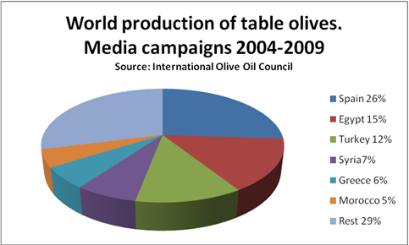

We classify companies between cooperatives and private companies, interesting classification in order to analyze the fate of the raw olives. It notes that of all firms, 30% are cooperatives and 70% in private industry, those receiving the 46.59% of the 53.41%and the latter according to data from recent seasons.

Considering the complexity of the processes, it can also distinguish two types of firms mainly: entamadoras, those who usually perform the initial processing of the olives is to convert the raw olives in a food product, and entamadoras-packing, which are those that make the whole process of dressing, pitting, stuffing and packaging.

The table olive is a very fragmented sector, with small-and medium-sized and mostly known for its traditional commitment to export. Taking data from 2003, exports of table olives in Spain, including shipments to European Union countries, reached 248,670 Tons, worth 433.3 million euro.

A series of performances appear as a priority to ensure a better future for the sector:

• Land area: the large number of operators and strong growth in production and processing capacity necessitate the adoption of management measures and regulation of the sector and the market to guarantee a minimum return for products and manufacturers.

• Quality Care: both the production and processing, there is a clear focus on volume rather than quality, which contributes nothing to the appreciation of the product. You need to start from the farmer, the chain will give much more importance to quality, and discarding those that do not meet olives minimum standards and therefore should not be marketed.

• Promotion of the olive sector: it is necessary to recover the promotion of table olives that gave such good results until the last few seasons that were made in 1990-1991. This requires establishing a framework for cooperation among all organizations representing the sector, using the inter-branch organization.

• The lack of branding is one of the great shortcomings of the sector: which devotes most of its capabilities to produce olives with marks of others. It is becoming increasingly clear need for a profound reflection on the foundation on which sits the sector's current development and future risks to companies to decide the most appropriate strategies.

The rationale for analyzing aid to companies in this sector lies in the importance of this sector to the Spanish economy. As leaders of worldwide production was necessary to know how companies are using the Valencia Community aids that exist to adapt their businesses to the market.

1. **Analysis of Experiences with the Innovation Support Measure**

**B.1. Company Background**

Family business, that began in 1950 with positions of olives. Later they distribute to the catering business. The company grows, finding new suppliers, and investing in design.

They adapt to the future to fully integrate the demands of the market. They have a team dumps in the study, research and product development. They have a project based on constant innovation and development, both the quality and appearance of the product, to make them more attractive and enjoyable. Discuss the evolution not only your business but if the companies with which they have intercourse.

New materials for boats, designs, machines and packaging lines.  Passed from hand to pasteurization do it with a pasteurizer. The evolution has been constant over the years

Currently no longer sell directly to the hotel but its customers are distributors in various parts of the Spanish geography.

They are working to improve the issue of exports. Highlight some sales as in Mexico, Dallas (USA). They begin to make contacts with IVEX (Instituto Valenciano de la Exportación), ICEX (Instituto Español del Comercio Exterior). Detect a great help for fairs and exhibitions by the aforementioned institutions.

Constant innovation for labels, packaging, and all the flavours. The experiences abroad have had to adapt their product to suit the recipient country.

Both support and without them, they clearly can not stop investing in innovation. Many of the improvements of the company have been held with investments by the company.

**B.2. Innovation Support Measure**

The company participated in different support measure in the period 2005-2009. The name of the programme they decide highlight is the “Agro food aid from the EU”.

The scope and the objectives of the measure are empowering companies working in the profession of agriculture, fishing and eating.

Agriculture and the rural environment continue to be regarded as “vital issues” for Europe’s future. Agriculture, food and forestry sectors also provide sources for significant ‘green growth’ potential, an area of growing importance and significance in all sectors. Regional and cohesion policy is also active in this field and rural areas are benefiting from the EU’s complementary funding initiatives, which offer synergies from the foresting of market-orientation and business competitiveness through Europe’s countryside.

Rural development measures offer many opportunities for enhancing the competitiveness of the agricultural, food and forestry sectors, but in a way that is environmentally sustainable, using fewer resources and producing less pollution.

The measure was chosen because was the support that best fits the type of company and the objectives.

The type of support received was an economic aid of 20% of the investment of 500.000€ approx. Dedicated to improving the machinery for the manufacturing process. Channelling the wastewater, new packing line and improve the pasteurizer machine.

Now the company is working at 20% of its possibilities. They have doubled the production capacity of the firm. They may increase to 80% more production if the demand requires it.

The entities involved are Generalitat Valenciana, European Economic Community, Aceitunas Gutierrez and a Project Consultant.

Changes were necessary for the company to evolve and improve production so they would make it even without the measure. They were already aware of the needs of the company to implement all these improvements and they had planned. Aid came later.

The most important aspects of the measure were the amount of money and how fast they received it. Everything fine in general terms. No remarkable problems. They never had support of this size. Of course if the percentage is greater would be better supported. Cite lack of access to support current and the possibilities for SME’s.

1. **Recommendations & Conclusions**

The good experience has driven them to continue looking for other similar aid and invest more in innovation. Furthermore, in various forums have told other about the good results, encouraging them to also seek funds they were suit their projects.

1. **Information Sources**
   * + The company website
     + <http://www.aceitunasgutierrez.com/>
     + Websites dedicated to providing information the innovation policy
     + <http://www.marm.es/es/alimentacion/temas/industria-agroalimentaria/ayudas-a-la-industria-agroalimentaria/default.aspx>

### A y M Navarro S.L.

1. **Introduction**

Alicante wines.

Due to the diversity of climates, regions and varieties; Alicante offers a wide range of different wines. Far from wanting to be just a Protected Denomination of Origin (P.D.O) or limited to a marketing category, we aim to be creative, diverse and varied, reflecting the Mediterranean spirit which has been with us forever.

As a result, the wines of Alicante have varying styles. Interestingly almost none go unnoticed and they all represent the origin. Alicante offers a wine for every type of consumer, or taste and this cultural asset should not be ignored.

Alicante Wines PDO is stabilized with the creation of ‘Alicante Protected Denomination of Origin’ in 1932 and the establishment of its first ‘Regulatory Council’ in 1957.

These were years of attempting to organize the sector, to gather the production, to encourage improved quality, the process of filling the bottles and developing the approach to modern consumers.

The changes made in the mid 90’s combined with the arrival of new innovative wineries as well as the traditions from older wineries ensured the successful progression of Alicante wines PDO. Nowadays our development has enabled us to have new facilities, new wines, employ experts, win awards and honours and improve the reputation of wine culture.

Exports of Alicante wines under the Denomination of Origin (DO) rose 10.73 percent in the first half of 2011 over the same period last year, reaching the amount of 2,001,446.5 litres, as reported industry sources.

The same sources have stated that this figure noted "positive trends" within the sector from "a year and a half," and stressed that "finally" has exceeded the volume of two million litres exported. By product, the bottled wine has increased by 19.67 percent, while the bulk "suffers slightly a 3.315 per cent."

For recipient countries, Germany continues to lead all markets, with "a slight increase of 2.25% of the bottled and bulk up." But it also confirmed "the upward trend in bottled in countries like the U.S., which has risen to sixth customer, with a rise of 41.33% in the bottled during this half year." This good behaviour occurs also in China, Brazil, Switzerland and several other countries on five continents, reflecting "the general growth being recorded for all wines" Spanish Denomination of Origin, have ensured the above sources. The destinations of wine production in the first six months of the year cover a total of 38 countries and two new Europe: Slovakia and Serbia. "Fewer countries than in other periods, but again to ratify the stabilization of shopping" in some areas with "best potential" and "targeting wineries in these markets,” are according to the sector.

The case study is especially important for large number of companies at the *Comunidad Valenciana* dedicated to the manufacture of wines. For these, the improvement of its machinery, improvements in marketing innovation, or export support may mean a substantial improvement in their businesses. Thus, this case study may serve as an example for many other SME sectors that are thinking of applying for support for innovation and want to have a case example of success.

1. **Analysis of Experiences with the Innovation Support Measure**

**B.1. Company Background**

Since 1956, Bodegas Terra Natura has continued with a rich wine-producing tradition that was carried on by the family business run by A. & M. Navarro for many years, dedicated to the production of high prestige Mediterranean wines.

Through our dedication and the incorporation of the latest wine-production technologies, the best essences of tradition are wisely combined with our family philosophy to give each of our wines its own particular character.

The company A. & M. Navarro, S.L. belongs to the Alicante Origin Denomination, witch guaranties quality and a strict control of all our products, making sure that each bottle you drink will be great pleasure for your palate.

There is a Regulating Board with different work areas, which ensures strict enforcement of the rules, the harvesting of the grapes, the process of production and the final presentation of the product.

**B.2. Innovation Support Measure**

The name of the programme is Support for the introduction of machinery from the Chamber of Commerce (Valencia).

The scope and objectives are investments in tangible assets (land, building, machinery and equipment for the creation of a new facility, expanding an existing one, or starting an activity involving a radical change in the product or production processes of an existing establishment).

It was chosen by the SME because the effort to improve the machinery is large and sought aid to support the higher cost.

The objective of the call matched perfectly with the objectives of the SME.

The type of support received was 12% of expenses incurred. They introduced all new machinery: a bottling machine, filtering, pasteurizing, machines and some stainless steel tanks. With all these measures they have improve the quality of the product. They also have renewed all the antique machinery. The most important aspect of the measure was to multiply by 10 the production.

The best experience regarding the measure was that finally they received the support after all the effort. To improve, increase the amount of money and was received rather late.

Challenges regarding the measure were to prepare all the procedures. For them the learning curve was quite high.

1. **Recommendations & Conclusions**

The offices that provide support should have also a group of people dedicated to guiding companies in the negotiations. The operation of IVEX is valued highly.

1. **Information Sources**

Regarding the information sources distinguishing between:

* + - The company website.
    - <http://www.bodegasterranatura.com/>
    - Alicante Origin Denomination
    - <http://www.crdo-alicante.org/>

### Aceitunas Guerola S.L.

1. **Introduction**

The table olive industry is extremely dynamic. It is a product of great economic and social importance, especially in Andalusia (province that leads the production in Spain). The olive tree dedicated to the production of table olives, requires some care so special that they could almost be compared to the tasks of gardening, and once the olive in his proper state of maturity, are picked by hand to avoid damaging the fruit. This gives an idea of the amount of labour needed. Already in the industry we find similar needs for the stages of dressing, picked, sorted, pitted, stuffed and packed.

This economic and social impact is even more evident in many areas in which practically no alternative to that crop and the only industry that exists is dedicated to the production of olives for direct consumption.

Depending on their colour, are classified as green olives, changing colour, natural black and finally black darkened by oxidation.

Only 10% of the production of olives in the world dedicated to table, that is, about two million tonnes a year (as variable data campaigns).

In Arab countries with large consumption and less industrial vocation, this percentage may be higher, while in Spain, only 3.62% of the olive groves addresses table consumption. But how are the world leaders in production and marketing as shown in the following statistics.



We classify companies between cooperatives and private companies, interesting classification in order to analyze the fate of the raw olives. It notes that of all firms, 30% are cooperatives and 70% in private industry, those receiving the 46.59% of the 53.41%and the latter according to data from recent seasons.

Considering the complexity of the processes, it can also distinguish two types of firms mainly: entamadoras, those who usually perform the initial processing of the olives is to convert the raw olives in a food product, and entamadotas-packing, which are those that make the whole process of dressing, pitting, stuffing and packaging.

The table olive is a very fragmented sector, with small-and medium-sized and mostly known for its traditional commitment to export. Taking data from 2003, exports of table olives in Spain, including shipments to European Union countries, reached 248,670 Tons, worth 433.3 million euro.

A series of performances appear as a priority to ensure a better future for the sector:

• Land area: the large number of operators and strong growth in production and processing capacity necessitate the adoption of management measures and regulation of the sector and the market to guarantee a minimum return for products and manufacturers.

• Quality Care: both the production and processing, there is a clear focus on volume rather than quality, which contributes nothing to the appreciation of the product. You need to start from the farmer, the chain will give much more importance to quality, and discarding those that do not meet olives minimum standards and therefore should not be marketed.

• Promotion of the olive sector: it is necessary to recover the promotion of table olives that gave such good results until the last few seasons that were made in 1990-1991. This requires establishing a framework for cooperation among all organizations representing the sector, using the inter-branch organization.

• The lack of branding is one of the great shortcomings of the sector: which devotes most of its capabilities to produce olives with marks of others. It is becoming increasingly clear need for a profound reflection on the foundation on which sits the sector's current development and future risks to companies to decide the most appropriate strategies.

The rationale for analyzing aid to companies in this sector lies in the importance of this sector to the Spanish economy. As leaders of worldwide production was necessary to know how companies are using the Valencia Community aids that exist to adapt their businesses to the market. Explain/justify the choice of the case study: why is interested or relevant?

1. **Analysis of Experiences with the Innovation Support Measure**

**B.1. Company Background**

Aceitunas Guerola is a family business founded in 1972, settling in the neighbourhood of Benipeixcar of Gandia.

This is a traditional family company with many years of experience in developing packaging of olives and pickles of the best areas of Spain.

In 1990 was created the brand “La Jordana” to target mainly the catering and hospitality.

Due to expansion of enterprise and infrastructure improvements, in 1997 the company moved to the city of Piles.

The firm enjoys a wide acceptance in the Levant and surrounding provinces by the great care and diligence in the preparation and presentation of their products, they get a touch of Distinction at its most varied consumer tastes ensuring their quality.

Since its inception the company has changed a lot the preparation of the olives. All of these changes have been made with the sole source of investment company.

They have clear that if they don’t continue with the innovation the will be less competitive and it will hurt company profits.

**B.3. Alternatively, Describe “No Measure”;**

Aceitunas Guerola have not apply for any support measure during the period studied. No apply for measure because they say they have no resources to dedicate for this task. Is a small company where everyone has too much to do and they think is difficult to learn about how to apply for the measures. Also they said there is no too much info about which kind of support can be provided and from where. The administration always pay too late and they think is no worth the effort.

If some organization could help them it identifies which measure fits with their company and how to manage to apply for it, they would try. They are aware of the importance of innovation

1. **Recommendations & Conclusions**

The conclusions by this case study is an example of many companies that know innovation is important for them but cannot find the right time to be involved in their first measure support.

As recommendations the company would like to have more information about where to ask for information. Also it would be useful an organization able to support the SME’s on the process of manage the innovation project.

1. **Information Sources**
   * + The company website
     + <http://www.aceitunas-guerola.com/>

### Representaciones Mondragon S.L.

1. **Introduction**

This sector is specially related to furniture sector that is one of the most representative of the Comunitat Valenciana and especially relevant at national level. The manufacturing sector of furniture in Spain is characterized by a fragmentation of the number of companies consist of about 12000 companies. Of all the companies of the sector of furniture manufacturing in Spain, approximately 89% is composed with fewer than 20 employees.

The Comunitat Valenciana is the second in number of companies producing furniture in the whole country. In terms of turnover, represents about 18% of the national furniture manufacturing. Valencia furniture represents 13% of Spanish companies and furniture covers more than 18% of workers.

According to the latest report of the Spanish Observatory Furniture Marketing (OM), prepared by the Technological Institute for Furniture, Wood, Packaging and Allied AIDIMA, the sector’s turnover reached 5.183 million euro.

1. **Analysis of Experiences with the Innovation Support Measure**

**B.1. Company Background**

Mondragón is a company dedicated since 1969 in the distribution of furniture fittings of the highest quality. With leading companies we represent, we offer products different than those already existing, improving its functionality and putting at the forefront of innovation and design.

The company offer design, innovation and technology into products of the highest trendsetters within and outside our country. They have a fast response, not only in product shipments, but also advice, looking for the solution to ensure success.

Their offer includes a wide range of uprising systems, drawer systems and exhaust guides, mechanisms of sliding and folding doors, groups of union structures and aluminium windows, baseboards, kitchen interior design, lighting, tables, handles, etc.

Mondragón, bet and will keep on a different product, to innovate and propose something else, because a small details is a big step forward.

**B.2. Innovation Support Measure**

The programme they use to innovate was called “Competitive Analysis Diagnostic and Industrial Development Plan from IMPIVA organization.

The Institute for Small and Medium Industry of the Generalitat Valenciana (IMPIVA) is a public entity of the Generalitat Valenciana. Its role is to develop policies for promoting innovation for the Valencian Government in the field of small and medium enterprises.

The IMPIVA aid programs is to improve the technological capabilities of enterprise, supporting the generation of scientific knowledge or techniques to get products, processes or services with higher technological level and adjust its offer to growing markets demands.

In order to obtain better results of the support program, Mondragón worked together with a company, called IFEDES Group, which was in charge of the management on the initiative.

IFEDES Group is a consulting company that helps to address and seize new opportunities to the SME’s, with a strategic shift in its business model, adapting to new scenarios and competitive dynamics of their sector. They offer strategic and innovate perspective, enriched with more than 20 years of experience and knowledge to make and execute better decisions.

The company needed to improve the company’s online efforts, so they were looking for some support focus on a web site creation. They analyse that direct competition was on the web having more options by offering their products, distribution opportunities and through marketing online.

The measure was chosen because it was perfectly suited to their needs. Once the web was created, they could prove fast the increment of the clients, and who many of them used the site to place orders.

The impact is very positive and the results have exceeded their expectations. They would make these changes even without the found, because was something they really needed.

In their case the management of the support was not a problem since they had a consulting company responsible of the task.

To improve the measure comment that would be necessary that aid arrives faster. It took almost a year receive the money.

1. **Recommendations & Conclusions**

The most relevant conclusion about this case study is the great role played by companies that help SMEs to seek aid. On the one hand indentifying the needs of SMEs and offering a catalogue of measures that suit to their sector, and problems. Also accompanying them in the process of managing aid and advising them at all times about the steps they have to take. For many of these SMEs would be very difficult to devote time and resources to this task, given the small number of workers and the few resources available.

1. **Information Sources**

Regarding the information sources distinguishing between:

* + - The company website
    - [http://www.mondragonline.com](http://www.mondragonline.com/)
    - <http://www.grupoifedes.com/>
    - Web site of the support measure
    - [http://www.impiva.es](http://www.impiva.es/)

### EMAC Complementos S.L.

1. **Introduction**

According to data provided by the Spanish Association of Manufacturers of Ceramics (ASCER), the sector in 2006 reached a production of about 660 million square meters. This translated into money, involves a total sales value approximately 4,200 million euro, of which 2,183 million are from the export. We therefore, that only direct sales by sector (without taking into account raw material suppliers, services, etc) and involve the generation of business of high economic level and worthy of being appreciated.

In addition, the sector also generates over the province of Castellón, since about 80% of the plants (about 190) have their production facilities there, ascending up to 86% if we refer to companies located in the Valencia region (more 200 factories). Of the 236 companies included in the sector in 2006, approximately 90% of workers had number less than 250, i.e. SME could be considered.

Spain is the second largest producer of ceramic tiles with a market share of about8% and the first product in the EU-27 with a market share above 38%. Castellón concentrates 94.5% of national production.

The companies that make the business of the Spanish tile industry (mainly located in the Valencia and Castellón especially) are extended especially in an area bounded on the north by Alcora and Borriol, west by Onda, south by Nules and east by Castellón de la Plana. The geographical proximity of firms allows the interplay between them, accumulation and development of knowledge and common support services.

The participation of the ceramic industry in total industry of the Comunidad Valenciana represents: about 2% of all businesses, employs about 8% of workers and generates a business net of 6%.

In the national total, the Region concentrates 43% of all enterprises of the ceramic industry, employs 70% of workers and generates a net amount of 69% business.

For the tiles, in particular, those percentages rise to 83% of Spanish ceramics companies, 92% of employment and net business.

According to data from the first half of the year 2011, the value of ceramic products, reached a growth of 8% (with 9.2 million of euro). They were the 3rd most exported product group, then cars and fruits, with 8% of the total.

The cumulative exporting during the last 2010 years in the ceramics sector of Valencia reached a value of 1,765 million euro. Growth corresponded to slightly less than 6%.

From Castellón, in particular ceramic products were exported valued at 1.544billion euro (87% of regional total and 74% of Spain).

Ceramic products are the 3 rd largest export tariff heading the Region, with 9% of the total. The Valencia Region represents 85% of all exports of Spanish ceramic tile industry.

The main destination of these Valencian products is France (with 12% of export). Next in importance Russia, the UK, and Saudi Arabia, these four major clients concentrated near the quarter of the values exports of ceramic products (30%).

Among the main destinations with the highest rates of increase over the previous year (over 36%) stands in Israel and Russia.

By type of product, glazed tiles are the most exported ceramic goods (with, 90% of total exports of ceramic products).

China is the leading supplier with 53% of the value of ceramic products imported.

1. **Analysis of Experiences with the Innovation Support Measure**

**B.1. Company Background**

**Profiles for ceramic tiles around the world.**

EMAC is the most important Spanish manufacturer of profiles and trims for ceramic tiles. They offer the broadest profile range in the market of decorative and protection solutions for tiles, as well as expansion and structural joints for all kind of floorings, walls, facades and urban pavements.

EMAC are present in more than 110 countries, and we have a division in USA that allow us to supply our EMAC profiles with fluidity to all American countries.

Every year EMAC are in more than 10 trade fairs around the world to introduce all our novelties and give us the kind possibility to attend to our clients.

**Immediate Service: Over 2000 items in 24 hours.**

Our customers, warehouse and distributors, know that we have the deepest range in market, with more than 2000 items, sizes, finishing, and colours… with the highest quality.

EMAC are the sole company in the world completely specialized in profiles and trims for ceramic tiles.

One of the mainstays of EMAC Policy is the guarantee of an immediate 24hours service. Therefore, we have the biggest inventory of profile in the market and all of their logistic activities are controlled by intelligent storage management software, which allows us to optimize the service we provide to our clients.

**Certified Quality.**

EMAC has obtained in 2009 the ISO 9001:2008 recertification, an update and improvement of the Rule 9001:2000, that means its appreciation of quality and innovation, as well appreciate the quality and professionalism of our human team.

**Innovation in profiles for wall and flooring applications.**

Every year EMAC introduces the more exclusive products following the trends of the ceramic market, and offer to their customers the newest solutions. New designs, new models, new materials, new finishing and colours to solve any kind of project with the final touch.

All their new products are developed and tested in collaboration with Technologic Institutes Net of Valencia Region (REDIT), from the design stage until its sales.

**B.2. Innovation Support Measure**

The Innovation Support Measure that EMAC used was the Programme for Research Technological Development for SMEs manages by the Institute for Small and Medium Industry of the Generalitat Valenciana (IMPIVA),that is a public entity of the Generalitat Valenciana Region.

Its role is to develop policies for promoting innovation of the Valencian Government in the field of small and medium enterprises.

The specific objectives of the programme is to improve the technological capabilities of enterprises, supporting the generation of specific knowledge or techniques to get products, processes or services with higher technological level and adjust its offer to growing market demands.

The Beneficiaries are SMEs with office or production facility in the Comunidad Valenciana to develop the project in this geographical area and whose aided projects are located in the territory.

The actions to support are development projects for technology development activities that meet the following characteristics:

* Industrial Research:

The planned research or critical investigation aimed at the acquisition of new knowledge and techniques that can be useful for creating new products, processes or services or to significantly improve existing ones. Includes components to create complex systems which are necessary for industrial research, notably for generic technology validation, except for the prototypes.

* Experimental development:

The acquisition, combination, configuration and use of existing knowledge and techniques, scientific, technical, business or otherwise, with a view to developing plan and arrangements or designs for products, processes or service changed or improved. May include, for example, other activities of the conceptual definition, planning and documentation of new products, processes and services. The activities may comprise producing drafts, drawings, plans and other documentation, provided they are not intended for commercial use. It also includes the development of prototypes and pilot projects that can be used commercially when the prototype and pilot projects that can be used commercially when the prototype is necessarily the final commercial product and its manufacture is too expensive to be used exclusively for demonstration and validation. If subsequent commercial use of pilot or demonstration projects, any revenue generated from such use must be deducted from eligible costs. Are also eligible experimental production and testing products, processes and services provide cannot be used or transformed for use in industrial or commercial applications. Experimental development does not include routine or periodic changes made to products, production lines, manufacturing processes, existing services and other operations in progress, even if such changes may represent improvements themselves.

When a project encompasses different tasks, each of them should be classified as belonging one of these categories.

The kind of support is a repayable grant calculated as a percentage of the eligible costs, with varying intensity depending on the classification of the project, to a maximum of:

* + Industrial research projects: 60%
  + Experimental development projects: 35%

The aid intensity will be determined by beneficiary. In the case of the cost of registration of patents and utility models, the aid intensity shall exceed the intensities of industrial research and/or experimental development that led to such right and/or utility models.

In any case, the aid per company or project may exceed the limit of 10,000,000 Euros for the projects predominantly industrial research and/or 7,500,000 Euros for experimental development. Be considered as a project is predominantly industrial research, if more than 50% of eligible costs through activities which fall into the category of industrial research, respectively. If you cannot set the predominant nature of the project, apply the lower threshold.

The concept of slipperiness was introduced in the CTE (Technical Building Code) from the year 2006, in the current DB DB-SU-SUA (Basic Security Document Use and Accessibility). This term is part of the basic requirement SUA-1 Security against the risk of falls and regulates the level of acceptable slipperiness of floors in various fields of application. It uses the Rd, Slip Resistance value, calculated according to standardized test. The inclusion of slipperiness in the CTE was produced with the aim of preventing that space could pose a risk to the user as a result of the negative statistics of injuries in falls from slipping.

Our range of steps and ramps for auction is available in multiple finishes and shapes not to mention the safety factor. While the CTE provides only Rd floors, a floor that does not reach the minimum required value can be achieved by supplementing it with the appropriate value of our products.

Over the years, we have increased the performance of our profiles to solve any type of pavement with the best warranty. Aware of the importance of security of the people, our effort has been aimed at achieving aesthetic products and, above all, functional.

Emac has made a large investment in technology to show that their shots to enhance the value Rd rungs of pavements when installed as a supplement. These profiles have been tested by the method UNE-ENV 12633:2003, particularly in the CTE, the Construction Technology Institute (AIDICO), an independent institute belonging to the REDIT (Network of Technological Institutes). The results show that the profiles Emac to increase the value steps Rd pavements they accompany them more secure.

The purpose of testing our products for steps is to offer a specific value for Rd each type of product at different floors. This is particularly aimed at professionals who need to know this information in developing their projects.

Skid resistance increases with the installation of the auction to Emac steps on all the pavements tested in different sizes, always obtaining enhanced value from baseline with no step. In some cases reached up to two classes improve soil type.

With these data we can say that the auctions for Emac rungs are the ideal complement to make safer our stairs or ramps, always complying with the provisions of the CTE.

In Emac we know that prevention is the right path. Therefore, we work to develop products that help meet the provisions of the rule. We are the only company profiles for submitting their shots ceramic steps to test for slip resistance, setting the value for all Rd. They are also subject to other tests that certify their excellent properties.

1. **Recommendations & Conclusions**

The special recommendations they have about supports in general is that the economic aid should arrive soon that usually does.

Also as a recommendation for PYMEs, they think it helps to have a network of organizations or consulting companies dedicated to look for the measures. Those organizations will advice PYMEs about measures that fit with PYME objectives and supporting the process of manage the documentation.

1. **Information Sources**
   * + The company website
     + [http://www.emac.es](http://www.emac.es/)
     + Websites dedicated to the specific measure being analysed here.

* + - [http://www.impiva.es](http://www.impiva.es/)

### Textisol SL (Textile Sector)

1. **Introduction**

The panorama of textile and clothing industry has changed dramatically worldwide in the last twenty years and more rapidly from the full integration of China and other countries to free trade in 2005. During these years, a scenario has only a global dimension for the industry. The production sites in the old industrialized countries have changed their working conditions, both in the sphere of production and in trade, and adjustment to the new world has become so urgent and inevitable.

In this transition, which is permanent forever, it has become evident that innovation is, so to speak, they key factor of corporate strategies, both individual and at sector level. Valencia textile industry and clothing industry has understood this and is working very well in the right direction: the strategies undertaken in the areas of the Region, the Competitiveness Plan, national and European make perfectly clear that desire for progress and expansion.

The textile and clothing industry in Spain directly employed almost 211.000 people in the year 2003, which involved approximately 8% of national industrial employment. Of these, 49% worked in the textile subsector, while the rest was in the clothing. Both sectors generated productions these years of 12.721.014 thousand Euros, 4% of Spanish industrial output, of which 51% corresponded to production of textiles and clothing the rest. These figures placed the textile sector in the third position on the Spanish industry as a whole, in terms of employment, behind the food industry, beverages and snuff and metal products (347.298 employees) and the eighth by the value of their production.

Meanwhile, in Valencia the sector employed in 2003 to 35.113 people, about 10% of total industrial employment, of which almost 73% worked in the textile sector, while the rest did in the clothing. The production this year reached a value of 2.409.642 thousand Euros, just over 6.5% of total industry, which 80% corresponded to the textile and clothing to the rest.

The textile and clothing industry represented Valencia approximately 19% of production recorded by the Spanish textile-clothing industry and nearly 17% of employment, well above the region’s contribution to production (11%) and industrial employment Spanish (13%). This position was only higher in Catalonia, which provided just over 47% of national production in 2003, and was ahead of Madrid and Galicia (both 8%).

The latest annual data for 2010 show that textile exports from Valencian Community stood at 620 million Euros, an increase of 10% compared to the provisional data of 2009.

The Community was the 4th most Spanish region exporter of these products with 7% of total textile exports from Spain and 3,3% of total exports of Valencia.

As for the most demanding Valencia textiles abroad, cotton is exported chapter (21% of all textiles, including cotton fabrics, classified as 5209 and 5211). The next most important items for the home textiles (including bed linen, table and dresser 6302 and rugs 6301).

France and Italy are the main destinations for these products (with 25%of the total value of exports of Valencia). Among the major destinations, outstanding dynamism of Turkey and Italy (rates greater than 23% compared to the provisional data 2009).

China is the largest provider of Valencian Community (23% of total textile import Valencia).

The textile industry accounts for approximately 9% of total industrial Valencia, 7% of industrial employment and 4% of net turnover.

Regarding the national total, the Valencia accounts for 17% of companies in the Spanish textile industry and 16% of employment and turnover in the Spanish textile industry.

The latest data from the Spanish Association of Manufacturers of Children’s Fund (ASEPRI) indicate that currently has with 183 companies. ASEPRI associated companies that manufacture children’s clothing items represent 80% while those producing represent 20% of childcare.

The turnover of associated companies ASEPRI rise to 1,074 million Euros in 2010 with a growth of 8,6% over 2009. This data is based on increased export activity to constitute 31,2% of total turnover in the sector.

The importance of this sector in the Valencian Community in 2009 with a turnover of 174 million Euros, 20% of national turnover and exports of 29 million Euros, 11% of Spanish exports of these products.

1. **Analysis of Experiences with the Innovation Support Measure**

**B.1. Company Background**

Is a family company established in 1972 with the purchase of our first needle punch machine. They started their activities with the manufacturing of filters to be used on decorative wall covers. Later on, during the ’80s we started the manufacturing of specialized nonwovens for the footwear sector: shoe felts, insulators, etc.

It was during this decade that we specialized in the “Maliwatt” and “Malivles” technologies for the manufacturing of nonwoven products used in publishing.

At beginning of the 90′s the company purchased their second needle punch machine and the manufacturing of cleaning products started. There was also a strong market demand for more sophisticated cleaning products, with the use of colours, prints and patterns, different finishing’s, etc.

During 2002 the company installed a high technology production line for the mechanical intertwining of fibbers using water jets, technology known as “Spunlace”.

At the beginning of 2003 an exhaust treatment plant was installed in the finishing’s department of.

This event made it possible for our company to start producing nonwoven products for cosmetic and hygiene products (like makeup removal wipes, baby wipes, etc.) and this drove us to introduce very strict quality control procedures to ensure of the safety standards of our products at all levels.

This line of action has currently brought the company to apply for our environmental management system to be rated according to the European Regulation (EC) # 761/2001(EMAS II).

Nonwoven fabrics are a type of fabric-like material made of fibbers that are bonded together by mechanical, thermal or chemical treatments, being neither woven nor knitted. They can mimic the appearance, texture and strength of a woven fabric without being woven. A nonwoven is typically a flat sheet or web structures of flexible and porous fibres, with no weft. In the manufacturing process the textile fibbers are turned into a tray at random without any direction and bonded with each other by mechanical means. Nonwovens can be made absorbent, breathable, drape able, flame resistant, heat sealable, light, lint-free, mouldable, and soft, stable, stiff, tear resistant, water repel-lent, if needed.

**B.2. Innovation Support Measure**

The Innovation Support Measure that Textil S.L. used was the Technological Innovation Voucher Program.

Technological Innovation Voucher Program aims to contribute to the improvement of organizational capital and business innovation, as shown in the following priority axis of the ERDF Operational Programme Valencia: Area 2: "Development and Business Innovation" , Priority Theme 9: "Other actions aimed at stimulating innovation and entrepreneurship in SMEs."

In particular, to promote innovation in SMEs aim to improve the competitiveness of SMEs through strategic projects, promoting innovation in the business to increase the knowledge and dissemination of new techniques and key competitive factors in a global economic environment.

That is why the Innovation Voucher Program supports the acquisition of knowledge and linkages between SMEs and technology research centres, service providers and technology innovation, including a pilot for the year 2010, institutions located in certain European regions.

Through this activity is funded the hiring of one or more services of technological innovation by SMEs of Valencia in one of the following application areas:

* + Advanced technologies and industrial process control.
  + Process development and improvement of products (new materials, development of prototypes, product technology validation, etc ...).
  + Renewable and alternative energy and energy conservation and efficiency.
  + Technology and environmental sustainability.
  + Biotechnology and technologies applied to food, health and comfort.
  + Advanced technologies for logistics, transportation and distribution.
  + Advanced communication technologies applied to the above areas.

The company IMPIVA subsidize up to 75% of advisory service innovation Provider contracted with the Centre, with a maximum grant amount of 4,500 Euros.

The eligible cost of the program is what counselling services in technological innovation, such as technology assistance, technology transfer services, advice on the use of standards employed by the beneficiary SMEs to adopt measures or improvements from specific needs innovation or findings of a previous diagnosis.

The program support, in its two performances may not be used to cover expenses caused by continuous or periodic activity, or are related to normal operating expenses of the company. In no case will be funded testing or analysis that are not linked to the project funded or are not essential for obtaining results. Specifically excludes expenses incurred by the creation of websites, licensing for operating systems and applications, routine tests and standards and ISO and EMAS.

1. **Recommendations & Conclusions**

The innovation is intended to check the one hand, to foster innovation in SMEs Valencia technological areas as production and manufacturing processes, logistics and distribution, energy and sustainability and design management.

Also wants to promote a cultural change and sensitize them towards innovation as a solution of their problems to make them aware of the value added by the incorporation of new knowledge to the company.

1. **Information Sources**
   * + Websites dedicated to the specific measure being analysed here.
     + [http://www.impiva.es](http://www.impiva.es/)

## Case studies FR – Limousin

The Limousin Region is one of the 27 regions of France and is situated in the western central part of the country. Limousin represents 3% of the national metropolitan space with a land area of 16.942 km². Limousin is divided into three departments (Corrèze, Creuse and Haute-Vienne) and 747 municipalities. According to the census of 2009, the population reached 741,000 with an average growth of 0.4% per year over the period 1999–2006 compared to 0.7% at the national level. With exception of Corsica, Limousin appears to be the least populated region (43 inhabitants per km²) in the country. Limousin is predominantly urban but remains to be less urbanized than the entire country. With a GDP per capita of 24,518 € in 2007, Limousin contributes 1% to national wealth creation. Unemployment in the region is significantly lower than the national average: in the second quarter of 2009, 7.7% of the active population in Limousin was unemployed as opposed to 9.1% at the national level. The Limousin economy is mainly dominated by agriculture compared to the other regions, its industry is structured around an efficient fabric of SMEs. The regional sectors of excellence include the food processing industry, the private electrical/electronic sector, the metallurgy and mechanical engineering sector, the porcelain and ceramic sector, the wood industry, as well as the graphic industry.

### Atelier Lo Tillou on - No essential support measure.

1. **Introduction**

The textile, clothing and leather industry covers more than 80 companies in the Limousin region and employs approximately 2,050 employees (figure from Assedic), which represents more than the national average (5.5% of the workforce employed in the Industry as opposed to 4.7% on the national level). This number is declining steadily for years. In 9 years, the number of institutions has decreased by 40% and 30% of working force (48% at the national level). Employment is highly feminized (70% of eligible employees). The related to crafts activities are at a disadvantage compared to imported products. Many entrepreneurs develop strategies of niche, and some add their product lines by imported goods at reduced costs, a condition often required to maintain manufacturing in the region. The tapestry barely keeps up and must find a new life with the help of technical innovation. The leading companies in this sector are Filature de Rougnat, Filature Terrade, Cheri Bibi, Allande, C 2000 etc. Practices of the textile sector in terms of innovation: in order to deal with imports from Asian countries with low cost labour, enterprises in this sector should implement strategies that combine several elements: specialization on a high added value activity, branding, creation, innovation in products (styling, design, new textiles…) and marketing, better service for customers, technological innovation in the manufacturing process (use of new materials), internationalization, improving management (managing human resources, versatility, new skills).

Specialization on activities with high added value is implemented mainly by the use of innovative technical textiles that give a particular specification to certain products (for instance: use of bamboo fiber in wear resistant socks).

Technical textile is mainly represented by two enterprises that have their origin in the manufacture of felts for stationery. The main unit, COFPA, was recently acquired by the American Albany Group, specialized in transfer bands used for machinery paperboard, panels and non-woven. The main weakness of the textile sector in Limousin is its small sized companies (substantially less than 10 employees).

The company Atelier Lo Tillou was selected for the realization of a case study in terms of Gprix project for the reasons of corresponding to the selection criteria and giving an idea of a Limousin small enterprise headquartering in a small village in the Limousin department of Creuse whose activity sector is textile and retouching and which has never benefited from any substantial innovation support measure neither on the regional nor on the national levels. We will try to highlight the most important points on the innovation perception of the company, on the reason why there has never been any support granted, which, irrespective of its size makes efforts to gain customers and to take part in promising projects.

1. **Analysis of Experiences with the Innovation Support Measure**

**B.1. Atelier Lo Tillou Background**

Atelier Lo Tillou was created on April, 2 2008 by Mrs. Jacqueline Peigney, who since her teens was always enthusiastic about sewing and creating original objects from different textiles, the hobby that she succeeded to turn into her handicraft business.

She enjoys working with natural materials and recycling old cloths transforming them into bags, hats etc. She often gives worn-out cloths a second life continuing to invent even new collections. Since the time of the atelier creation the main activity of the company is the conception, creation, production and selling of cloths and textile fashion accessories including those for cats and dogs.

The competition intensity in the sector is considered to be moderate by the Managing Director. Since the company was founded in 2008 its turnover figure is available for 2009 and was 4700 euro. The worst impact of the financial crisis 2008-2010 was, according to Mrs. Peigney, as follows: “customers became rare events, but in recent weeks, it seems that my clients are willing to see me live from my work because I do a good job, and I had some orders for models I created. They want to have unique pieces in a perfect finishing”. The crisis influenced negatively orders of new and improved products as well as already existing products. Today the company’s personnel consist of 1 person. The company has never made part of any group.

To be able to represent her creations to the public, she decided to open an atelier which serves a showroom and an atelier at the same time. Nowadays Jacqueline also opens the door of her atelier to all visitors and tourists (individually and in groups) in the region who want to get acquainted with her couturier activity, she welcomes all people who would like to take training courses in creating cloths, she conducts seminars and organizes demonstrations in her showroom.

The main business competitor of the company in the mentioned field was identified as the crisis which naturally in most cases does not make evolve any business.

The part of total sales in 2009 represented the following redistribution: France - 20%, the Limousin region in particular – 80%, Atelier Lo Tillou does not export its creations abroad to other European countries.

Mrs. Peigney expressed her point of view on the notion of innovation as follows: “in terms of innovation for my company, because of the remote location of my atelier, it should be good to have computer skills to open my business to many more people via the web and it is necessary that I create a real collection and for this I need some financial means to buy fabrics and industrial machinery”.

The situation of the founder of Atelier Lo Tillou seems to be desperate enough today. She makes her living not out of the company profits but thanks to the ASR (Active Solidarity Revenue=le RSA (le revenu de solidarité active), state aid introduced in France since 2009 to help people who already work and whose income is rather limited, its amount depends on a family situation and work revenues) and her garden. She is afraid that because of lack of sales she would be pushed to stop her business. Nowadays she is in contact with the Local Wool Network to start a promotion of wool products made in Limousin and a RMA project promoter (Route des métiers d'art=the Arts and Crafts Trail of Limousin) making efforts to improve the situation. Besides she is dreaming to enlarge the space of her atelier and the present moment is about to look for information on opening a solidarity training centre which she would like to organize to help people come out of misery and for some capital about 5000 euro to finish works in the atelier and purchase sewing machines.

**B.2. No essential support measure**

Atelier Lo Tillou represents the case of a very small enterprise which has never benefited from any substantial support measures on the regional and national levels. The reason of never being supported by the regional responsible authorities and of never being granted any support measures on innovation was explained by Mrs. Peigney: micro-businesses like hers are not interesting for politicians and she didn’t meet all the necessary requirements to be granted an aid. Consequently she never submitted any applications thinking that application procedures being too complicated and measures being not suitable to her expectations.

Though we should mention that Atelier Lo Tillou was supported with the ACCRE provided by the State (L'aide aux demandeursd'emploicréantoureprenantuneentreprise= Support for job seekers creating or taking over a company) which is an exemption from payroll taxes for one year and is a support measure for creation of a firm.

According to the company, between 2008 and 2009 it created or improved the range of products and new production procedures, meanwhile logistics, shipping and distribution activities together with support activities were either created or nor improved. On the level of organizational innovation, the mentioned period of time was not marked by the introduction of new rules of management procedures such as supply chain management commercial reorganization, quality management; neither by work process organization nor by organizational methods for external relations with other firms or public bodies, namely partnerships. On the level of marketing innovation, from 2008 to 2009 the company didn’t introduce any significant changes in products’ design or packaging, but took care of new promotion media or techniques (advertising in the Internet, creation of a webpage which actually needs maintenance), new sales methods and pricing methods. The part of the company’s turnover destined to cover the expenses for innovative activities in 2009 is estimated as 1-5%.

Starting with 2008 the company tried to maintain the same number of employees regardless of the financial crisis. As for the company’s innovation capacity to innovate within the sector in 2009: product innovation capacity was estimated as average, marketing innovation capacity - slow, and organizational innovation capacity – average. Product and marketing innovation is seen as the most crucial for the company’s development, process innovation being of little less importance for Mrs.Peigney. 26-50% of Atelier Lo Tillou’s turnover results from sales of the innovated products starting with 2008. Between 2008 and 2009 the company didn’t collaborate on innovation activities with other enterprises.

To each company-respondent participating in case studies we suggested their taking a closer look at the most essential support measures available within the Limousin Region, which are described in Del. 1.6 asking them to comment on the usage and effectiveness of the enumerated measures on the development of their companies. As far as Atelier Lo Tillou has never benefited from any support measures on innovation on the regional and national levels, out of the list of the indicated measures it indicated none as used for a company’s innovative development.

Finally, as far as we can see from the information available on the company performance, the financial situation of the founder of the company isn’t favourable to develop innovation. Nevertheless, in spite of pessimistic moods Mrs.Peigney proves capable of fighting everyday difficulties but absolutely needs support to maintain her activities.

1. **Recommendations & Conclusions**

We are very interested in the regional SMEs’ feedbacks and points of view referring to improvement issues on their needs, whether they consider the regional support measures attractive and useful enough to promote their innovation activity, if they are well informed on the availability of those measures within their districts, if their needs are met correspondingly and if there exist any issues on their opinion to facilitate all procedures related to effective acquisition of the desired support.

Mrs.Peigney defined the needs of a SME to be able to participate in a programme on innovation aid. According to her opinion: among administrative needs simple application procedures, short application-to-funding periods, simple reporting requirements, transparent proposal evaluation procedures, adequate assistance/guidance during project by programme officer are considered as highly important, and short time-to-contract periods as important; among financial needs limited requirements to get loans, provide bank guarantees, etc. and availability of additional financing opportunities are considered as highly important, high funding rates as important; out of SME – internal and external needs, she underlined the highly importance of the following: adequate networks of potential partners, compliance of programme aims to SMEs interests, strong acknowledgement of need to participate in innovation programmes, easy access to information about available programmes, adequate marketing of/ information about programme(s), adequate external assistance/guidance during project, adequate external assistance/guidance after project (exploitation) and appropriate general economic conditions; adequate in-house knowledge on project management was assessed as important. As a specific need she noted a development of working tools and product promotion in the Internet to enable a SME to participate. Besides she said, that the following should be improved to better correspond to the needs of SMEs: le release of financial aids to help them start real production so that they could expand the circle of their customers.

Mrs.Peigney shared kindly some of her remarks on the innovation policy and her vision of the present situation in her sector to us: what is necessary is to create a balance on the level of support measures distribution! Aid goes always to the same companies even if they probably don’t need it desperately, whereas a lot of small ateliers experience great difficulties. They are not only craftsmen; they create a social link via the relationship which they maintain with their customers. They work not for the particular reason to be rich, but to make their living out of their crafts. But Mrs.Peigney underlines, she doesn’t know if innovation support measures exist in reality, as far as she never received one for her firm. She heard of some existing in her department…

As far as we can see in the case of Atelier Lo Tillou, Mrs.Peigney didn’t always look actively for opportunities to be granted a financial aid for development activities of her company taking into consideration that she has a rather proactive position for projects promoting.

1. **Information Sources**

1. The company’s website – www.atelier-lo-tillou.fr

2. Results of the interview and GPrix survey.

3. Website of the agency of business creation - http://www.apce.com/pid643/accre.html

4. Website on the Active Solidarity Revenue - http://www.rsa.gouv.fr/Qu-est-ce-que-le-rSa,1585.html

### FR-CR1 on the measure Support to collaborative projects of competitiveness clusters (SIF).

1. **Introduction**

The ceramics sector in Limousin comprised about 240 enterprises with more than 2500 employees 2 years ago, which represents more than 6% of the total employment in the region. The traditional activity of the porcelain has generated the creation of a sector which brings together industry makers, manufacturers and suppliers of materials. This sector employs approximately 2500 individuals, of which 1500 are related to porcelain. The main innovative enterprises of the ceramics industry in Limousin are: Bernardaud, Haviland, Royal Limoges, Medard de Noblat etc. The porcelain tableware suffers from repeated crises resulting in closures of companies and reduction in the salaried labour force. The sanitary porcelain is represented by two important establishments in two of the leading groups: Allia and Jacob Delafon (Kohler). It employs approximately 350 employees.

In order to enhance all related to these sectors SMEs, the City of Limoges and its partners, including the Chamber of Commerce and Industry of Limoges and of the Haute-Vienne are engaged in a broad program entitled "The Heritage Economy Center". Alongside the traditional manufacturing there is the development of raw materials suppliers and equipment manufacturers like KPCL, ceramic Elmeceram, Matthey-Beyrand, as well as producers of ceramic sanitary porcelain. In order to consolidate the skills acquired in ceramics and the surface treatment, European Centre of Ceramics was created in September 2010 that brings together all training and existing research centres such as the University of Limoges, the national superior school of ceramic (ENSCI), the national superior school of engineering of Limoges (ENSIL), the laboratory study group of heterogenic material (GEMH), the centre of technologies for ceramics transfer (CTTC), the centre of engineering, treatment and covering of advanced surface (CITRA).

In 2007, production in the mechanics sector included 5,666 workers in 311 industrial establishments and handicrafts, distributed on the three departments of Corrèze, Creuse and Haute-Vienne which in fact is the biggest manufacturing sector, employing 15 per cent of employees. Between 2001 and 2007, this sector has experienced a growth of 6.3% of the number of its employees. This industrial sector covers three areas of activity: the automobile industry, metalworking, mechanical equipment. The main innovative enterprises in this sector are: Lavaud steel constructions, LimousinChaineries, Renault Trucks, Acemeto etc. The main practices in terms of innovation are characterized by the use of special machines, special vehicles and special structures combined. In Limousin, there is a pole of competitiveness in the mechanics sector called VIAMECA and an association named “MecanicVallée”. One of the main existing problems is that that this sector is a very difficult competitive environment, the industry workforce relies heavily on exports and appears shifted in response to changing ways of life. The upscale products which are partly induced by high manufacturing costs, involves an aggressive supply of commercial brands, mainly based on the famous reputation of Limoges as it relates to certain products. This business approach has a high cost, and is out of reach for most factories. Though, in the field of mechanics, enterprises have a certain capacity for innovation that they must operate through the network by their own initiative. For that they should be encouraged by agencies on which VIAMECA relies namely: OSEO, the Regional Chamber of Commerce and Industry in Limousin and the Chamber of Commerce and Industry of Limoges.

The company FR-CR1 was selected for the realization of a case study in terms of Gprix project for the reasons of corresponding to the selection criteria and representing thus a bright example of a Limousin SME headquartering in Limoges which sectors of activity can be identified as mechanics and ceramics because it is specialized in equipment manufacturing dedicated to functional material deposition for printed electronics, inventions used for ceramics production in particular. The company FR-CR1 has benefited from a support measure Support to collaborative projects of competitiveness clusters (SIF) granted on the regional level. We will try to highlight the most important issues on the support obtained and an innovative spirit which leads the company ahead, and consequently it succeeds in being one of the leading companies in its field not only on the national level but as well acknowledged worldwide.

1. **Analysis of Experiences with the Innovation Support Measure**

**B.1. The Company FR-CR1 Background**

Founded in 2006 following a research project carried out at the CNRS, the company FR-CR1 is an innovative small company specializing in equipment for printed electronics and new energy technologies. It has expanded constantly since its creation and employs a multi-disciplinary team of experts spanning materials science, chemistry, precision mechanics and computer science. Its non-graphic bottom-up approach to the inkjet process sets it apart from the competition. Reflecting the company, FR-CR1's innovative value proposition provides each machine customer with specific process assistance.

The company FR-CR1 is an equipment manufacturer specializing in the design and marketing of inkjet printers dedicated to functional material deposition for printed electronics and new energy technologies. The state-of-the-art machines proposed by the company are used for high-accuracy 2D and 3D multi-material printing. Combining its skills in ink formulation and printed component manufacture, the company accompanies customers right from the start of their projects to ensure that their inkjet fabrication process is operational as soon as their equipment is delivered.

The scope of FR-CR1's services spans all its customers' needs. From material requirement to printed component, they cover the entire value chain in order to give customers the best possible assistance for their development projects. They place the following facilities at their customers' disposal: a design office for the mechanical, automation and IT aspects, a machine assembly area, an ink formulation and optimization laboratory, a clean room fitted with four CeraPrinters for process development, a research laboratory for material post-processing. Soon the company hosts visitors to show their latest solution for deposition and 3D structuration by InkJet of ceramic materials. The company constantly carries out R&D in order to market innovative new printing machines and offer a leading-edge customer service.

It is a member of the Minalogic global competitiveness cluster and two regional clusters in Limousin (the European Center of Ceramics and Elopsys), it carries out two types of R&D: R&D on printing equipment, FR-CR1's core business, in the fields of printed electronics and new technologies for energy, process R&D in partnership with customers to define complete new component manufacturing processes using inkjet printing.

The company has extensive in-house R&D resources, as well as access to large-scale characterization facilities through its network of partner laboratories. It provides R&D services on the basis of precise specifications (substrates, materials, geometry of components to be printed, thermal requirement), to demonstrate the technical feasibility of using new inkjet printing to manufacture new components. Their process development team works in close collaboration with their ink formulation laboratory. FR-CR1's highly qualified, responsive maintenance and support team is on hand to assist customers through each stage of their project.

All FR-CR1’s equipment is fitted with a remote support system enabling their support staff to take control of customer’s machines remotely (with their permission) to fix problems directly, saving users a great deal of time and boosting efficiency. In order to guarantee that customer’s ink is fully compatible with their printing systems, FR-CR1 also tests ink/print head chemical compatibility and the head priming sequence, and performs drop ejection characterizations (velocity, volume, angular deviation, reproducibility, open time, temperature stability, comparison of all nozzles on one head, etc.).

The competition intensity in the sector is considered to be moderate by the Managing Director. The company’s turnover was marked with 550 000 euro in 2009. The worst impact of the financial crisis 2008-2010 was the slowing down of the company’s growth but with no critical impact. It influenced neither orders for already existing products nor new and improved products significantly. In 2009 the company’s personnel consisted of 10 people.

The part of total sales in 2009 represented the following redistribution: France - 10%, other European countries - 50%, the rest of the world - 40%. It exports its products successfully worldwide. The Managing Director of the company identified the business competitors of the company in the mentioned field as follows: Dimatix (USA), Pixdro (The Netherlands), Unijet (France). The company has never made a part of any bigger group.

**B.2. Innovation Support Measure - Support to collaborative projects of competitiveness clusters (SIF).**

The company FR-CR1 has benefited from several support measures on the regional, national and European levels. During the last years the company received the support measure named Support to collaborative projects of competitiveness clusters (SIF) (Aide aux projets collaboratifs des pôles de compétitivité (FUI).

Support to collaborative projects of competitiveness clusters (SIF) (Aide aux projets collaboratifs des pôles de compétitivité (FUI) serves to implement a collaborative project on development of new products and innovative services. This project should be certified by one or two competitiveness clusters. Beneficiaries: partners of R&D collaborative projects of competitiveness clusters: a SME of any size and laboratories or public or private research organizations, or formation/training establishments. Objectives: Implementation of a collaborative project aimed to develop new products or services, with high innovative content, leading to commercialization within five years. The project should be realized mainly on the territory of the competitiveness clusters under which guidance the project was undertaken. Financed expenditures: personnel fees involved into the project (researchers, engineers, technicians), amortization of equipment and research material on the usage period, sub-contracting works directly connected to the project under consideration of public or private laboratories. Intervention methods: projects selected on the basis of: calls for projects in terms of Single Interministerial Funds, two calls for projects per year taken in charge completely via teleprocedure. Participation in project funding is in the form of subsiding.

The support measure in the form of a financial aid of 500000 € was granted to the company from the end of 2007 till the end of 2010 for the following objective: implementation of a new technology for producing electronic components in terms of realization of a European project. The measure was provided by three parties: the State - 250K€, 125K€ - the Limousin Region, 125K€ - FEDER (Fondseuropéen de développement regional) =The European Funds of Regional Development) under the guidance of the organization DGCIS (La Direction Générale de la Compétitivité, de l’Industrie et des Services) = The General Directorate of Competitiveness, Industry and Services.

According to the Managing Director, the measure was a substantial financial aid to support all levels of innovation (products, process, marketing and organization), and allowed the project conceived. The company could even undertake the same project without the support granted but not so quickly and less effectively. According to the estimations of the Managing Director: a feature to improve in this measure: one unique agreement for 3 funders+ to transfer an advance in case of funds FEDER..

The impacts of the company’s participation in this measure on the following activities were assessed as follows:

|  |  |
| --- | --- |
| Improved internal organisation (e.g. management of innovation process) | important |
| Improved business or innovation strategy (e.g. an improved business model) | important |
| New quality certifications (ISO) | important |
| New safety or environmental certifications | Not important |
| Improved research competences | The highest importance |
| Improved marketing competences | Highly important |
| Improved design competences | Highly important |
| Improved level of skills of personnel | The highest importance |
| Formation of new partnerships and networks | important |
| Improved R&D linkages with universities and research institutes | Highest importance |
| Improved R&D linkages with other business organisations | important |
| Improved commercial linkages with other organisations | important |
| Enhanced reputation and image | Highest important |
| Facilitated participation in other R&D or innovation programs | highest importance |
| Increased turnover | Highest important |
| Increased profitability | highest importance |
| Enhanced productivity | important |
| Access to markets | important |
| Faster ‘completion’ of innovation project (than would have been the case without the support) | important |

According to the company, between 2006 and 2009 they created or improved their range of products and services available, as well as new production procedures, logistics, shipping, distribution activities together with support activities. On the level of organizational innovation, the mentioned period of time was marked by the introduction of new rules of management procedures, organizational methods for external relations with other firms or public bodies, work process organization. On the level of marketing innovation, from 2006 to 2009 the company introduced significant changes in products’ design or packaging and new sales methods, in new promoting media or techniques and pricing methods. The part of the company’s turnover destined to cover the expenses for innovative activities in 2009 is estimated at more than 50%.

Starting with 2006 the company created about 10 working places regardless of the financial crisis. As for the company’s innovation capacity to innovate within the sector in 2009: product innovation capacity was estimated as being on the top, process innovation capacity- above the average, marketing innovation capacity and organizational innovation capacity were estimated to be average. All types of innovation are seen as the most crucial for the company’s development and they successfully complete the mission thanks to the support measures obtained. More than 50% of the company’s turnover results from sales of the innovated products starting with 2006. Between 2006 and 2009 the company collaborated on innovation activities with suppliers of equipment, material, components or software, clients or buyers, consultants, commercial or private laboratories, R&D institutes, universities, governmental research institutes and public and research organizations.

To each company-respondent participating in case studies we suggested their taking a closer look at the most essential support measures available within the Limousin Region, which are described in Del. 1.6. asking them to comment on the usage and effectiveness of the enumerated measures on the development of their companies. The company FR-CR1 has benefited generally from several support measures. Out of the list of the indicated measures they signalled their usage of such measures as Recruitment Assistance, Innovation Support, Tax Credit for Research, Capital improvement (Support measure for companies consolidating their equities).

Besides the company FR-CR1 benefited as well from the support measure named Growth Contract (“Contrat de croissance”) provided by the Limousin Region. The amount of the financial aid granted is estimated 450000 euro and is considered to be the second essential support measure granted to the company for its development.

Below follows a brief description of the measure provided:

The growth contract aims to facilitate the realization of projects of SMEs and to accompany the global projects of SMEs’ development during 2-3 years proposing them a range of services to meet their needs and simplifying administrative procedures. The growth contract is part of a growing desire for simplification of administrative procedures.

Companies will dispose of visibility of all the economic support measures which they are entitled to under a simplified procedure of application and payment of financial aids according to the extent of the development project realized.

The impacts of the company’s participation in this measure on the following activities were assessed as follows:

|  |  |
| --- | --- |
| Improved internal organisation (e.g. management of innovation process) | The highest importance |
| Improved business or innovation strategy (e.g. an improved business model) | The highest importance |
| New quality certifications (ISO) | The highest importance |
| New safety or environmental certifications | The highest importance |
| Improved research competences | Low importance |
| Improved marketing competences | Highly important |
| Improved design competences | Low importance |
| Improved level of skills of personnel | Low importance |
| Formation of new partnerships and networks | Highly important |
| Improved R&D linkages with universities and research institutes | Low importance |
| Improved R&D linkages with other business organisations | Highly important |
| Improved commercial linkages with other organisations | highly important |
| Enhanced reputation and image | Highly important |
| Facilitated participation in other R&D or innovation programs | highly importance |
| Increased turnover | Highest important |
| Increased profitability | highest importance |
| Enhanced productivity | Highest importance |
| Access to markets | Highest importance |
| Internationalisation of activities | Highest importance |
| Faster ‘completion’ of innovation project (than would have been the case without the support) | Highly important |

1. **Recommendations & Conclusions**

We are very interested in the regional SMEs’ feedbacks and points of view referring to improvement issues on their needs, whether they consider the regional support measures attractive and useful enough to promote their innovation activity, if they are well informed on the availability of those measures within their districts, if their needs are met correspondingly and if there exist any issues on their opinion to facilitate all procedures related to effective acquisition of the desired support.

According to the Managing Director, to better meet the needs of SMEs’ it is desirable to improve the visibility of aids and support measures on innovation through different life stages of a SME (creation, development etc.).

The Managing Director defined the needs of a SME to be able to participate in a programme on innovation aids. According to his opinion: among administrative needs simple application procedures are highly important, short time-to-contract periods, simple reporting requirements, short application-to-funding periods are considered of highest importance, transparent proposal evaluation procedures are adequate assistance/guidance during project by programme officer are just important; among financial needs high funding rates are of highest importance, limited requirements to get loans, provide bank guarantees, etc. and availability of additional financing opportunities are considered important; out of SME – internal and external needs, he underlined the importance of the following: adequate external assistance/guidance after project (exploitation) and adequate marketing of/information about programme(s); strong acknowledgement of need to participate in innovation programmes, adequate external assistance/guidance during project, easy access to information about available programmes, compliance of programme aims to SMEs interests are of low importance; adequate in-house knowledge on project management and appropriate general economic conditions are highly important; adequate networks of potential partners are of highest importance. He underlined as well the necessity of giving them a middle-term idea of the impact of investment made into innovation on their future development via formation modules treating concrete cases.

The activity of the company and its overall performance is directly connected to their implementation of innovation on all the levels. The company is exceptionally well informed on the availability of regional, national and European support measures, they have a definite positive experience of the tools implied and a certain judgment on their usage.

1. **Information Sources**

1. The company’s website (not exposable)

2. Results of the interview and GPrix survey

3. Website Information on services for Limousin companies on support measures-<http://entreprenez.region-limousin.fr/themes/developper/accompagnement_conseils/le_contrat_de_croissance>

5. Website of OSEO - http://www.oseo.fr/votre_projet/innovation/aides_et_financements/aides/aide_aux_projets_collaboratifs_des_poles_de_competitivite_fui

6. <http://www.europe-en-france.gouv.fr/Configuration-Generale-Pages-secondaires/FEDER>

7. http://www.industrie.gouv.fr/dgcis/

### company Kimeko on No support measure.

1. **Introduction**

The textile, clothing and leather industry covers more than 80 companies in the Limousin region and employs approximately 2,050 employees (figure from Assedic), which represents more than the national average (5.5% of the workforce employed in the Industry as opposed to 4.7% on the national level). This number is declining steadily for years. In 9 years, the number of institutions has decreased by 40% and 30% of working force (48% at the national level). Employment is highly feminized (70% of eligible employees). The related to crafts activities are at a disadvantage compared to imported products. Many entrepreneurs develop strategies of niche, and some add their product lines by imported goods at reduced costs, a condition often required to maintain manufacturing in the region. The tapestry barely keeps up and must find a new life with the help of technical innovation. The leading companies in this sector are Filature de Rougnat, Filature Terrade, Cheri Bibi, Allande, C 2000 etc. Practices of the textile sector in terms of innovation: in order to deal with imports from Asian countries with low cost labor, enterprises in this sector should implement strategies that combine several elements: specialization on a high added value activity, branding, creation, innovation in products (styling, design, new textiles…) and marketing, better service for customers, technological innovation in the manufacturing process (use of new materials), internationalization, improving management (managing human resources, versatility, new skills).

Specialization on activities with high added value is implemented mainly by the use of innovative technical textiles that give a particular specification to certain products (for instance: use of bamboo fiber in wear resistant socks).

Technical textile is mainly represented by two enterprises that have their origin in the manufacture of felts for stationery. The main unit, COFPA, was recently acquired by the American Albany Group, specialized in transfer bands used for machinery paperboard, panels and non-woven. The main weakness of the textile sector in Limousin is its small sized companies (substantially less than 10 employees).

The company Kimeko was selected for the realization of a case study in terms of Gprix project for the reasons of corresponding to the selection criteria and giving an idea of a Limousin small enterprise headquartering in the city of Limoges in the Limousin department of Haute-Vienne whose activity sector is textile and manufacturing of fashion accessories and which has never benefited from any innovation support measures neither on the regional nor on the national levels. We will try to highlight the most important points on the innovation perception of the company, on the reason why there has never been any support granted, which, irrespective of its size makes efforts to gain customers and makes them loyal.

1. **Analysis of Experiences with the Innovation Support Measure**

**B.1. Kimeko Background**

The brand Kimeko was born in 2006 from the imagination of Sandrine Frapier. Her grandmother of the Japanese origin was fond of sewing and creating fashion objects on basis of fabrics, her name was Kimeko and in order to pay her tribute, Madam Frapier gave this name to her handicraft business.

The adventure of her boutique creation started with a specially conceived object "Tabag", i.e. a tobacco pouch for smokers who roll their cigarettes, which she invented primarily for her own needs, then Sandrine continued to invent. Ranging from handbags and wallets, check book holders to other wallet-like objects, she created a vast collection ever more original. Her motto is, "everything that can serve me, at prices where I can buy". As far as the product became more and more popular, she decided to create a small company for promoting this key product and nowadays it is distributed in more than 120 sales points all over France and abroad. What is completely remarkable is that her business is environmental-friendly. She provides her production with fabrics bought in such places as Emmaüs and at Secours Populaire or with discontinued fabrics available only with the old plants to save the situation.

Since that time the main activity of the company is the conception, creation, production and selling of textile fashion accessories.

The competition intensity in the sector is considered to be moderate by the Managing Director. Since the company was founded in 2006 its turnover figure is available for 2009 and was 112 000 euro. The worst impact of the financial crisis 2008-2010 was, according to Mrs.Frapier, the lack of money on the side of her customers, but nevertheless it caused a positive influence on orders of new and improved products as well as already existing products. Today the company’s personnel consist of 1 person. The company has never made part of any group.

The leading product Tabag was originally manufactured in Limoges by another enterprise, becoming a growing demand Sandrine had to increase production capacities. To be able to represent her creations to the public, she decided to open a boutique which serves a showroom and an atelier at the same time. Nowadays Sandrine also opens the door of her shop to young entrepreneurs and especially designers, she welcomes other artistes to expose their masterpieces in her boutique being located in the downtown.

The main business competitors of the company in the mentioned field could be identified as any VSE or atelier in a general sense but as far as the brand Tabag is unique and can be produced only by Sandrine, it means there is no rivalry in that business.

The part of total sales in 2009 represented the following redistribution: France - 20%, the Limousin region in particular – 60%, other European countries - 10%, the rest of the world - 10%.

Madam Frapier expressed her point of view on the notion of innovation as follows: “innovation is entirely in the process of conception and creation of my products”, meaning the ideas that generate her new inventions are already innovative basically.

**B.2. No support measure**

Kimeko represents the case of a very small enterprise which has never benefited from any support measures on the regional and national levels. The reason of never being supported by the regional responsible authorities and of never being granted any support measures on innovation is very simple with Sandrine Frapier: the ignorance on possible support measures which could be attributed to her company. Consequently she never submitted any applications.

Nevertheless, according to the company, between 2005 and 2009 it created or improved their range of products, besides new production procedures, logistics, shipping and distribution activities together with support activities were created or improved. On the level of organizational innovation, the mentioned period of time was as well distinguished by the introduction of new rules of management procedures such as supply chain management commercial reorganization, quality management; work process organization and organizational methods for external relations with other firms or public bodies, namely partnerships. On the level of marketing innovation, from 2005 to 2009 the company introduced significant changes in products’ design or packaging, as well as new promotion media or techniques (advertising videos in the Internet, creation of an account on Facebook considering social networks being extremely important today to promote products), new sales methods (sales via Internet) and pricing methods. The part of the company’s turnover destined to cover the expenses for innovative activities in 2009 is estimated as 16-25%. Whereas 5 years ago the firm dedicated fewer resources to innovate.

Starting with 2005 the company tried to maintain the same number of employees regardless of the financial crises. As for the company’s innovation capacity to innovate within the sector in the past and in the future, it remains stable in 2005 and in 2009: product innovation capacity was estimated as average, process innovation capacity- average, marketing innovation capacity - average, and organizational innovation capacity – average. Product innovation is seen as the most crucial for the company’s development, process and marketing innovation being of little less importance for Mrs. Frapier. More than 50% of Kimeko’s turnover results from sales of the innovated products starting with 2005. Between 2005 and 2009 the company didn’t collaborate on innovation activities with other enterprises.

To each company-respondent participating in case studies we suggested their taking a closer look at the most essential support measures available within the Limousin Region, which are described in Del. 1.6. asking them to comment on the usage and effectiveness of the enumerated measures on the development of their companies. As far as Kimeko has never benefited from any support measures on the regional and national levels, out of the list of the indicated measures they indicated none as used for a company’s innovative development.

Finally, as far as we can see from the information available on the company performance, even without any financial support from the regional or national authorities, Kimeko proved capable of breaking through the financial crises 2008-2010 gaining customers thanks to its innovative approach to product lines and successful marketing measures knowing where to look for demand, what resulted in significantly increased turnover. Evidently there was no need to apply for support measures and to search for the availability of information.

1. **Recommendations & Conclusions**

We are very interested in the regional SMEs’ feedbacks and points of view referring to improvement issues on their needs, whether they consider the regional support measures attractive and useful enough to promote their innovation activity, if they are well informed on the availability of those measures within their districts, if their needs are met correspondingly and if there exist any issues on their opinion to facilitate all procedures related to effective acquisition of the desired support.

Mrs. Frapier defined the needs of a SME to be able to participate in a programme on innovation aid. According to her opinion: among administrative needs simple application procedures, short time-to-contract periods, simple reporting requirements, transparent proposal evaluation procedures, adequate assistance/guidance during project by programme officer are considered as important, and short application-to-funding periods as highly important; among financial needs high funding rates, limited requirements to get loans, provide bank guarantees, etc. and availability of additional financing opportunities are considered as highly important; out of SME – internal and external needs, she underlined the importance of the following: adequate in-house knowledge on project management, adequate networks of potential partners, compliance of programme aims to SMEs interests, strong acknowledgement of need to participate in innovation programmes, easy access to information about available programmes, adequate marketing of/ information about programme(s), adequate external assistance/guidance during project, adequate external assistance/guidance after project (exploitation) and appropriate general economic conditions. As a specific need she noted a personalized aid to enable a SME to participate. Besides she said, that an issue on a direct contact should be improved to better correspond to her needs.

1. **Information Sources**

1. The company’s website – http://bykimeko.com/

2. Results of the interview and GPrix survey.

3. Website of the television channel Demain.tv <http://www.demain.fr/entreprendre/initiatives/details-initiatives/annonce-initiative/kimeko-boutique-au-centre-de-limoges/>

4. Website of the regional online newspaper LM Tendance- <http://ks201388.kimsufi.com/~lmtendanx/?p=affichage_article&IDARTICLE=2522>

### company Porcelaine Pierre Arquié on the Recruitment Assistance measure

1. **Introduction**

The ceramics sector in Limousin comprised about 240 enterprises with more than 2500 employees 2 years ago, which represents more than 6% of the total employment in the region. The traditional activity of the porcelain has generated the creation of a sector which brings together industry makers, manufacturers and suppliers of materials. This sector employs approximately 2500 individuals, of which 1500 are related to porcelain. The main innovative enterprises of the ceramics industry in Limousin are: Bernardaud, Haviland, Royal Limoges, Medard de Noblat etc. The porcelain tableware suffers from repeated crises resulting in closures of companies and reduction in the salaried labour force. The sanitary porcelain is represented by two important establishments in two of the leading groups: Allia and Jacob Delafon (Kohler). It employs approximately 350 employees.

In order to enhance all related to these sectors SMEs, the City of Limoges and its partners, including the Chamber of Commerce and Industry of Limoges and of the Haute-Vienne are engaged in a broad program entitled "The Heritage Economy Center". Alongside the traditional manufacturing there is the development of raw materials suppliers and equipment manufacturers like KPCL, ceramic Elmeceram, Matthey-Beyrand, as well as producers of ceramic sanitary porcelain. In order to consolidate the skills acquired in ceramics and the surface treatment, European Centre of Ceramics was created in September 2010 that brings together all training and existing research centres such as the University of Limoges, the national superior school of ceramic (ENSCI), the national superior school of engineering of Limoges (ENSIL), the laboratory study group of heterogenic material (GEMH), the centre of technologies for ceramics transfer (CTTC), the centre of engineering, treatment and covering of advanced surface (CITRA).

The company Porcelaine Pierre Arquié was selected for the realization of a case study in terms of Gprix project for the reasons of corresponding to the selection criteria and representing thus a bright example of a Limousin SME headquartering in Limoges which is specialized in ceramics manufacturing and which has benefited from a support measure Recruitment assistance granted on the regional level. We will try to highlight the most important issues on the innovation perception of the company, the support obtained, which, irrespective of its size succeeds in being one of the leading companies in its field not only on the national level but as well acknowledged Europe-wide.

1. **Analysis of Experiences with the Innovation Support Measure**

**B.1. Porcelaine Pierre Arquié Background**

Created in 1996, the company Porcelaine Pierre Arquié is situated in Limoges, a cradle of porcelain production. The company is specialized in manufacturing of porcelain pill boxes (hand painted and unique in limited editions) and collection boxes. The workshop implements the entire manufacturing process: creating and designing models, mould making, casting, the first firing, enameling, and firing of white, manual decoration applying the technique of the small fire. The collections of the company’s brands, "Porcelaine Pierre Arquié" and "Pierre Secret's" are renewed continuously. Annually the company participates in such exhibitions as "Maison et Objet". The company opened a store on its production site.

By inspiring the world of decoration, encouraging the use of ceramics and Limoges porcelain and renewing the very concept of Ceramics, Porcelain Pierre Arquié plays a starring role in collections of designers and artists. Since a new team arrived in 2008, the company welcomes artists, designers, students, teachers and members of the press from all across Europe. Porcelaine Pierre Arquié is completely independent because it possesses 3 workshops necessary for the production of their porcelain objects: for establishing, casting and decoration.

The competition intensity in the sector is considered to be high by the Managing Director. The company’s turnover was marked with 400 000 euro in 2005 and 30000 euro in 2005 respectively. The worst impact of the financial crisis 2008-2010 was the significant reduction of the turnover coming from traditional customers in the first turn. It influenced negatively orders for already existing products as well as for new and improved products. In 2009 the company’s personnel consisted of 8 people.

The part of total sales in 2009 represented the following redistribution: France - 30%, and the Limousin region in particular- 10%, other European countries - 30%, the rest of the world - 30%. It exports its creations successfully worldwide. The Managing Director of the company identified the business competitors of the company in the mentioned field as follows: Artoria, Royal Limoges, La vie en rose, all these companies being Limoges porcelain manufacturers. The company has never made a part of any bigger group.

The Managing Director expressed his point of view on the notion of innovation as follows: “innovation in terms of our company is the creation of new products for new customers”, the point of view which he is trying to implement in his ideas as for innovating the company’s approach and increasing its performance.

**B.2. Innovation Support Measure - Recruitment Assistance**

The company Porcelaine Pierre Arquié has benefited from some support measures on the regional level. In 2009 the company received the support measure named Recruitment Assistance (Aide au recrutement) with support of the Limousin Region in terms of a growth plan with the Chamber of Commerce and Industry in Limoges.

This measure aims to finance recruitment of personnel for technological and commercial activities of the company connected to innovation. Recruitment of University degrees (from Master’s to Doctorate’s on a permanent contract basis). Beneficiaries: SMEs. Mode of intervention: Subsidy for 50% of the first 12 salaries charged.

The financial aid of 30000 € was granted to the company in 2009 for the following objective: Recruitment of commercial personnel for developing a customers’ portfolio of the company to discover new markets and to look for improving its turnover which suffered dramatically.

According to the Managing Director, the measure was a substantial financial aid to support commercial innovation, and allowed marketing innovation of the project conceived. The company could never undertake the same project without the support granted. According to the estimations of the Managing Director: the positive feature of this type of support on product and process innovation is the rapidity of funds release, the negative feature (a point to improve) is the absence of bank support as for taking in charge the subsidy.

The impacts of the company’s participation in this measure on the following activities were assessed as follows:

|  |  |
| --- | --- |
| Improved internal organisation (e.g. management of innovation process) | important |
| Improved business or innovation strategy (e.g. an improved business model) | The highest importance |
| Improved marketing competences | High importance |
| Improved design competences | important |
| Facilitated participation in other R&D or innovation programs | important |

According to the company, between 2005 and 2009 they created or improved their range of products available. What cannot be said about new production procedures, about logistics, shipping, distribution activities together with support activities. On the level of organizational innovation, the mentioned period of time wasn’t marked by the introduction of new rules of management procedures, organizational methods for external relations with other firms or public bodies, nor work process organization. On the level of marketing innovation, from 2005 to 2009 the company introduced significant changes in products’ design or packaging and new sales methods, but not in new promoting media or techniques nor pricing methods. The part of the company’s turnover destined to cover the expenses for innovative activities in 2009 is estimated as 11-15%. Whereas 5 years ago they dedicated less resources to innovation activities.

Starting with 2005 the company tried to maintain some working places regardless of the financial crisis but unfortunately lost some. As for the company’s innovation capacity to innovate within the sector in the past and in the future, it changed in 2009 in comparison to 2005: product innovation capacity, process innovation capacity, marketing innovation capacity, organizational innovation capacity were estimated to be average in 2005 and changed to the estimation above average in 2009. The marketing and commercial innovation is seen as the most crucial for the company’s development and they successfully complete the mission (partly or entirely) thanks to the support measures obtained. 26-50% of the company’s turnover results from sales of the innovated products starting with 2005. Between 2005 and 2009 the company collaborated on innovation activities with suppliers of equipment, material, components or software, clients or buyers.

To each company-respondent participating in case studies we suggested their taking a closer look at the most essential support measures available within the Limousin Region, which are described in Del. 1.6 asking them to comment on the usage and effectiveness of the enumerated measures on the development of their companies. Porcelaine Pierre Arquié has benefited generally from 3 support measures. Out of the list of the indicated measures they indicated that of Recruitment Assistance the impact of which was mentioned above, which was used by them and estimated as having a positive impact onto a company’s innovative development. The Managing Director mentioned the positive impact of the support measure Technological Service Network which was as well used before; its impact is estimated as positive.

A small reminder: Technological Service Network (La Prestation Technologique Réseau) is a financial incentive to help small and medium businesses to benefit from the intervention of technology providers to facilitate their projects. Beneficiaries: priority on SMEs with less than 50 employees and a turnover or balance sheet with less than € 10M who have not received any technological assistance in the previous year. Mode of intervention: Subsidy up to 50% of the service cost, restricted to €10 000. The support measure aims at promoting technological development of SMEs and VSEs by providing financial support for various services what perfectly corresponded to the company’s objective. The source of funding is the Innovation Fund of Limousin created by OSEO and the Regional Council.

Besides the company used and appreciated the impact of Support measure for companies consolidating their equities- Capital improvement (AMELIORATION DES FONDS PROPRES).

A small reminder: This regional measure aims at enabling companies to improve the state of their capital, to contribute to innovation processes of any SMEs under certain conditions which develop an innovation activity and their competitiveness.

1. **Recommendations & Conclusions**

We are very interested in the regional SMEs’ feedbacks and points of view referring to improvement issues on their needs, whether they consider the regional support measures attractive and useful enough to promote their innovation activity, if they are well informed on the availability of those measures within their districts, if their needs are met correspondingly and if there exist any issues on their opinion to facilitate all procedures related to effective acquisition of the desired support.

According to the Managing Director, it is desirable that a bank be associated with a grant or at least that the bankers be familiar with some ways to facilitate an access to the credit within the limits of a grant. He defined the needs of a SME to be able to participate in a programme on innovation aid. According to her opinion: among administrative needs simple application procedures, short time-to-contract periods, simple reporting requirements, transparent proposal evaluation procedures, adequate assistance/guidance during project by programme officer, short application-to-funding periods are considered as very important; among financial needs high funding rates, limited requirements to get loans, provide bank guarantees, etc. are considered as important and availability of additional financing opportunities as highly important; out of SME – internal and external needs, he underlined the importance of the following: adequate in-house knowledge on project management, strong acknowledgement of need to participate in innovation programmes, adequate external assistance/guidance during project, adequate external assistance/guidance after project (exploitation) and appropriate general economic conditions; easy access to information about available programmes is of the highest importance; adequate networks of potential partners, compliance of programme aims to SMEs interests, adequate marketing of/information about programme(s) as highly important. He underlined as well the necessity of financial funding in order to work quietly on innovative projects and identification of customers who are capable of paying for added value provided by innovation.

The activity of the company and its overall performance is directly connected to their implementation of marketing innovation taking into consideration that their activity sector is traditionally manufacturing. The company seems to be very well informed on the availability of regional support measures, they have a definite positive experience of the tools implied, a certain judgment on their usage and are capable to preview possible impacts.

1. **Information Sources**

1. The company’s website – http://www.arquie.eu/spip.php?rubrique10

2. Results of the interview and GPrix survey

3. Website Information on services for Limousin companies -http://innovez.region-limousin.fr/Limousin/Reussir-votre-projet-innovant/Financer-mon-projet-d-innovation/Financer-la-R-D-d-un-projet/Le-FIL/Aide-pour-le-developpement-de-l-innovation

4. http://www.patrimoine-vivant.com/entreprises/objets_decoratifs/porcelaine_pierre_arquie

5. Website of OSEO - http://www.oseo.fr/aides-entreprise/aide-au-recrutement-pour-l-innovation.htm

### A case study of the company FR-LR1on No support measure.

1. **Introduction**

The textile, clothing and leather industry covers more than 80 companies in the Limousin region and employs approximately 2,050 employees (figure from Assedic), which represents more than the national average (5.5% of the workforce employed in the Industry as opposed to 4.7% on the national level). This number is declining steadily for years. In 9 years, the number of institutions has decreased by 40% and 30% of working force (48% at the national level). Employment is highly feminized (70% of eligible employees). In 2007 all leather production included 45 sites, 841employees or 2.1% of total employment. From 2001 to 2007, the employment rate in this sector decreased to 2.1%. Leather work in Limousin is based historically on the existence of a branch of production: from cattle and sheep to gloves and shoes manufacturing through tanning. Despite the downturn of these activities, the district of Saint Junien remains the main focus of French skin gloves. The shoes range is represented by top and midrange mainly by the companies Weston and Marcel Faure. Leather goods are also present in Corrèze particularly with the Company Le Tanneur. The leading companies in gloves manufacturing are Ganteb’s, Ganteries Georges Morand; in bags manufacturing Le Tanneur, in shoes manufacturing: J.M Weston.

The company FR-LR1 was selected for the realization of a case study in terms of Gprix project for the reasons of corresponding to the selection criteria and giving an idea of a Limousin small enterprise headquartering in a very small town in the Limousin department of Haute-Vienne whose activity sector is leather and which has never benefited from any innovation support measure neither on the regional nor on the national levels. We will try to highlight the most important points on the innovation perception of the company, on the reason why there has never been any support granted, which, irrespective of its size makes efforts to gain customers mainly in France.

1. **Analysis of Experiences with the Innovation Support Measure**

**B.1. The company FR-LR1 Background**

It was in 1970 when MisterX had the idea to realize his first belts. Indeed, the company was making "armchair clubs" at this time and had pieces of leather to recycle, so he realized his first belt! Then the second, the third and so was born “The Belt”. Quickly, the company is growing up and counts in the 80s up to 35 craftsmen.

Strong of a big fame, The Belt, was able to propose its models everywhere in France and became one of the first manufacturers of French luxury belts. Every year, in workshops, it was made up to 300 000 belts. It was the golden age of The Belt.

In 2009, came the retirement time for Mister X and time for Mister Y to take back the company. Trained in this prestigious house during two years time to make his learning and apprenticeship, at this time then, Mister Y of 25 years old leaves for a "Tour de France" in miscellaneous big houses of French leather store. He tries hard, with all his team of highly qualified craftsmen, to propose quality belts, in an unequalled choice of colour, and proposing only “full flower” leathers, all the belts are "French manufacturing". The products of The Belt arise from a big tradition where the hand has much more importance than the machine and made our products, unique and cut on desire. Today there exist about 100 belt models in more than 150 colours.

The competition intensity in the sector is considered to be very high by the Managing Director. The company’s turnover is 650000 euro in 2005 and 670000 euro in 2009. The financial crisis 2008-2010 made no effect on orders of new and improved products as well as on already existing products. Today the company’s personnel consist of 7 persons. The company has never made part of any group.

The main business competitors of the company in the mentioned field are the existing companies that produce leather goods in the region and all over in France. The part of total sales in 2009 represented the following redistribution: France - 95%, other European countries– 5%.

The managing Director expressed his point of view on innovation. It is mostly in the sense of innovative design of products. As far as the sector in which his company works is purely traditional, the only way for innovation he sees as to constantly correspond to customers’ tastes in fashion. What is as well important is commercial innovation.

**B.2. No support measure**

The company FR-LR1 represents the case of a small enterprise which has never benefited from any support measures on the regional and national levels. The Managing Director explained why they never submitted any applications for innovation support measures: he undertook the position of a Managing Director not so long ago, and though he is a professional in the sphere of leather, he is too occupied presently with implementing commercial aspect what is extremely important for the business. It takes him much time to travel over the country to simultaneously manage the company and take part in fairs, to represent their products. Unfortunately today he doesn’t dispose of marketing staff and taking into consideration that the personnel number is too limited to perform marketing and commercial functions, it is up to him to perform all those functions.

According to the company, between 2005 and 2009 it didn’t create neither improve its range of products and services, but it created or improved new production procedures, logistics, shipping and distribution activities, what cannot be said about support activities. On the level of organizational innovation, the mentioned period of time was not marked by the introduction of new rules of management procedures such as supply chain management, commercial reorganization, quality management or by organizational methods for external relations with other firms or public bodies; but new work process organization was introduced. On the level of marketing innovation, from 2005 to 2009 the company introduced some significant changes in products’ design or packaging, but didn’t take care of new promotion media or techniques (advertising in the Internet, creation of a webpage which actually needs maintenance), new sales methods and pricing methods. The part of the company’s turnover destined to cover the expenses for innovative activities in 2009 is estimated as 0%.

Starting with 2005 the company tried to maintain from 6 to 10 employees with 1 job created and 1 job lost in the course of this time. As for the company’s innovation capacity to innovate within the sector: product and process innovation capacities were estimated as average in 2005 and as above the average, marketing and organizational innovation capacities stay on the same average level in 2005 and 2009. Product innovation and creation in particular are seen as the most crucial for the company’s development, process innovation - being important, marketing innovation - of less importance, and organizational innovation- of high importance for the company. More than 50% of the company’s turnover results from sales due to the innovated activities starting with 2005. Between 2005 and 2009 the company didn’t collaborate on innovation activities with other enterprises.

To each company-respondent participating in case studies we suggested their taking a closer look at the most essential support measures available within the Limousin Region, which are described in Del. 1.6. asking them to comment on the usage and effectiveness of the enumerated measures on the development of their companies. As far as the company FR-LR1 has never benefited from any support measures on innovation on the regional and national levels, out of the list of the indicated measures it indicated none as used for a company’s innovative development.

1. **Recommendations & Conclusions**

We are very interested in the regional SMEs’ feedbacks and points of view referring to improvement issues on their needs, whether they consider the regional support measures attractive and useful enough to promote their innovation activity, if they are well informed on the availability of those measures within their districts, if their needs are met correspondingly and if there exist any issues on their opinion to facilitate all procedures related to effective acquisition of the desired support.

Mister Y defined the needs of a SME to be able to participate in a programme on innovation aid. According to his opinion: all the administrative needs simple application procedures, short application-to-funding periods, simple reporting requirements, transparent proposal evaluation procedures, adequate assistance/guidance during project by programme officer, short time-to-contract periods are considered as less important; the same can be said about the financial needs such as limited requirements to get loans, provide bank guarantees, etc. and availability of additional financing opportunities, high funding rates; SME – internal and external needs, such as adequate networks of potential partners, compliance of programme aims to SMEs interests, strong acknowledgement of need to participate in innovation programmes, easy access to information about available programmes, adequate marketing of/ information about programme(s), adequate external assistance/guidance during project, adequate external assistance/guidance after project (exploitation) and appropriate general economic conditions; adequate in-house knowledge on project management were assessed as having little importance.

Finally, as far as we can see from the information available on the company’s performance, the Managing Director doesn’t look yet for opportunities to be granted a financial aid or any other type of innovation support for development activities of his company taking into consideration that Mister Y has taken over the company’s management recently and his relatively young age of 26.

1. **Information Sources**

1. The company’s website

2. Results of the interview and GPrix survey.

### Company Pact on the Innovation Support measure

1. **Introduction**

The ceramics sector in Limousin comprised about 240 enterprises with more than 2500 employees 2 years ago, which represents more than 6% of the total employment in the region. The traditional activity of the porcelain has generated the creation of a sector which brings together industry makers, manufacturers and suppliers of materials. This sector employs approximately 2500 individuals, of which 1500 are related to porcelain. The main innovative enterprises of the ceramics industry in Limousin are: Bernardaud, Haviland, Royal Limoges, Medard de Noblat etc. The porcelain tableware suffers from repeated crises resulting in closures of companies and reduction in the salaried labour force. The sanitary porcelain is represented by two important establishments in two of the leading groups: Allia and Jacob Delafon (Kohler). It employs approximately 350 employees.

In order to enhance all related to these sectors SMEs, the City of Limoges and its partners, including the Chamber of Commerce and Industry of Limoges and of the Haute-Vienne are engaged in a broad program entitled "The Heritage Economy Centre". Alongside the traditional manufacturing there is the development of raw materials suppliers and equipment manufacturers like KPCL, ceramic Elmeceram, Matthey-Beyrand, as well as producers of ceramic sanitary porcelain. In order to consolidate the skills acquired in ceramics and the surface treatment, a European Centre of Ceramics was created in September 2010 that brings together all training and existing research centres such as the University of Limoges, the national superior school of ceramic (ENSCI), the national superior school of engineering of Limoges (ENSIL), the laboratory study group of heterogenic material (GEMH), the centre of technologies for ceramics transfer (CTTC), the centre of engineering, treatment and covering of advanced surface (CITRA).

The company PACT was selected for the realization of a case study in terms of GPrix project for the reasons of corresponding to the selection criteria and representing thus a bright example of a Limousin SME headquartering in Limoges which is specialized in research and development in the sector of technical and industrial ceramics and which has benefited from an innovation support measure granted on the regional level. We will try to highlight the most important issues on the innovation perception of the company, the support obtained, which, irrespective of its size succeeds in being one of the leading companies in its field not only on the regional level but as well on the national one.

1. **Analysis of Experiences with the Innovation Support Measure**

**B.1. PACT Background**

The company PACT is a research and development engineering office whose mission is to develop new applications in the field of technical and industrial ceramics. Its core craft is casting and sintering of alumina silicates. In addition to the choice of material, PACT may recommend improvements in design to optimize the performance of ceramics in their applications. So the main activity of the company created in 2007 is Research and Development in ceramics.

As part of its activities, PACT is equipped to produce prototypes and solutions for industrialization. Pact has developed a particular confinement container for storage of final wastes. The particularity of this innovative company is to lean on some knowledge of the local porcelain craftsmen namely on techniques including moulding and casting. Tradition and innovation meet here.

The company since its creation is accompanied by the organization Limousin Expansion; it is a member of the Ceramic competitiveness cluster.

The competition intensity in the sector is considered to be high by the Managing Director. The company’s turnover was marked with 150 000 euro in 2009 respectively. The worst impact of the financial crisis 2008-2010 was the absence of any concrete projects in 2010 for the company to realize and influenced negatively orders for already existing products but at the same time influenced positively on new and improved products. Today the company’s personnel consist of 3 people.

The part of total sales in 2009 represented the following redistribution: France - 95%, and the Limousin region in particular- 5%. Mr. Rosenblat, the founder and the Managing Director of the company identified that there are no business competitors of the company in the mentioned field. The company has never made a part of any bigger group.

Mr. Rosenblat expressed his point of view on the notion of innovation as follows: “innovation in terms of our company is a new application”, the point of view which he is trying to implement in his ideas as for innovating the company’s products and increasing its performance.

**B.2. Innovation Support Measure - Innovation Support**

The company PACT has benefited from some support measures on the regional and national levels. Starting with the beginning 2008 till the end 2009 the company received the support measure named Innovation Support (Aide à l’innovation) with support of the regional organization Limousin Expansion.

Innovation Support aims to assist companies and industrial services to develop new products, innovative services with real prospects of commercialization. Beneficiaries: Companies and groups of less than 2000 employees. Mode of intervention: modulated by OSEO depending on the nature of the R&D&I, a technological level of the risk, the status, age and size of the company, real necessity of support measures (aid rate at 25 to 60% on the basis of expenditures deducted): industrial research, experimental development, collaborative project or not, in an early stage or a stage of development Expenses financed: Technical and commercial feasibility studies, personnel costs for R & D, external services and advice, production of prototypes, models, patenting, purchase of equipment and knowledge, preparation for industrial launching etc.

The financial aid of 150000 € was granted to the company in 2009 for the following objective: to share the costs of laboratories necessary for validating mechanic and chemical characteristics of ceramics which were developed by the company.

According to Mr.Rosenblat, the measure was a substantial financial aid to support innovative development, and allowed innovation and success of the project conceived. The company could never undertake the same project without the support granted. According to the estimations of the Managing Director: the positive feature of this type of support on product and process innovation is the rapidity of funds release, the negative feature (a point to improve) is the absence of bank support as for taking in charge the subsidy.

The impacts of the company’s participation in this measure on the following activities were assessed as follows:

|  |  |
| --- | --- |
| Improved internal organisation (e.g. management of innovation process) | low importance |
| Improved business or innovation strategy (e.g. an improved business model) | Low importance |
| New quality certifications (ISO) | Not important |
| New safety or environmental certifications | Not important |
| Improved research competences | high importance |
| Improved marketing competences | important |
| Improved design competences | important |
| Improved level of skills of personnel | low importance |
| Formation of new partnerships and networks | important |
| Improved R&D linkages with universities and research institutes | Highest importance |
| Improved R&D linkages with other business organisations | low importance |
| Improved commercial linkages with other organisations | Not important |
| Enhanced reputation and image | important |
| Facilitated participation in other R&D or innovation programs | high importance |
| Increased turnover | important |
| Increased profitability | Low importance |
| Enhanced productivity | low importance |
| Access to markets | important |
| Internationalisation of activities | important |
| Faster ‘completion’ of innovation project (than would have been the case without the support) | important |

According to the company, between 2007 and 2009 they created or improved their range of products and services available. New production procedures were created or improved, what cannot be said about logistics, shipping, distribution activities together with support activities. On the level of organizational innovation, the mentioned period of time wasn’t marked by the introduction of new rules of management procedures, organizational methods for external relations with other firms or public bodies, at the same time work process organization was improved. On the level of marketing innovation, from 2007 to 2009 the company introduced no significant changes in products’ design or packaging, in new promoting media or techniques, pricing methods, but introduced new sales methods. The part of the company’s turnover destined to cover the expenses for innovative activities in 2009 is estimated at more than 50%. Whereas 5 years ago they dedicated less resources to innovation activities.

Starting with 2007 the company created 2 more working places regardless of the financial crisis. As for the company’s innovation capacity to innovate within the sector in the past and in the future, it changed in 2009 in comparison to 2007: product innovation capacity was estimated to be average in 2007 and on the top in 2009, process innovation capacity was estimated to be slow in 2007 and above average in 2009, marketing innovation capacity was estimated to be average in 2007 and it didn’t change in 2009, and organizational innovation capacity was estimated to be slow in 2007 and remained the same in 2009. The product and process innovation are seen as the most crucial for the company’s development and they successfully complete the mission (partly or entirely) thanks to the support measures obtained; marketing innovation is important and organizational innovation is of low importance. More than 50% of PACT’s turnover results from sales of the innovated products starting with 2007. Between 2007 and 2009 the company collaborated on innovation activities with suppliers of equipment, material, components or software, clients or buyers, universities, governmental and public research institutes.

1. **Recommendations & Conclusions**

To each company-respondent participating in case studies we suggested their taking a closer look at the most essential support measures available within the Limousin Region, which are described in Del. 1.6 asking them to comment on the usage and effectiveness of the enumerated measures on the development of their companies. PACT has benefited generally from 2 support measures. Out of the list of the indicated measures they indicated that of Innovation Support the impact of which was mentioned above, which was used by them and estimated as having a positive impact onto a company’s innovative development. The Managing Director mentioned the positive impact of the support measure Technological Service Network though PACT never used it before and indicated that it is necessary that this aid could be eligible to all European enterprises. Mr. Rosenblat gave his assessment as well to the support measure Recruitment assistance which was neither used by PACT but accepted as having a good impact where recruitment implies an increase in working capital need. So it is necessary that this aid should be connected to a loan within bank finances. Besides the company used and appreciated the impact of Tax credit for research (CREDIT D'IMPOT RECHERCHE).

A small reminder: The support measure Tax credit for research aims to support efforts of companies for research and development. Beneficiaries: A large number of companies exempt from corporation tax, certain associations, start-ups, growing SMEs. Mode of intervention: the rate of tax credit for research of respectively 50% and 40% during the 1st and 2nd year of application of the measure.

We are very interested in the regional SMEs’ feedbacks and points of view referring to improvement issues on their needs, whether they consider the regional support measures attractive and useful enough to promote their innovation activity, if they are well informed on the availability of those measures within their districts, if their needs are met correspondingly and if there exist any issues on their opinion to facilitate all procedures related to effective acquisition of the desired support.

According to Mr. Rosenblat, there exists a problem of finances connected to a time gap between the company’s engagement and a subsidy release. The questions of changing rules of invoice presentation and a partnership with some bank which will cover a subsidy since the agreement, should be tackled. Besides, Mr.Rosenblat defined a specific need of a SME to be able to participate in programs on innovation support, namely: how to find end customers who use innovation and who are ready to pay for it?

The activity of PACT and their overall performance is directly connected to their implementation of innovation. In case of PACT, they seem to be very well informed on the availability of regional support measures, they have a definite positive experience of the tools implied, a certain judgment on their usage and are capable to preview possible impacts.

1. **Information Sources**

1. The company’s website – www.euro-pact.com

2. Results of the interview and GPrix survey

3. http://innovez.region-limousin.fr/Limousin/Reussir-votre-projet-innovant/Financer-mon-projet-d-innovation/Financer-la-R-D-d-un-projet/Le-FIL/Aide-pour-le-developpement-de-l-innovation

4.http://www.oseo.fr/votre_projet/innovation/aides_et_financements/aides/aide_pour_le_developpement_de_l_innovation

5. Website Information on services for Limousin companies - <http://innovez.region-limousin.fr/Limousin/Reussir-votre-projet-innovant/Financer-mon-projet-d-innovation/Financer-la-R-D-d-un-projet/Credit-impot-recherche>

6. Website of the European Ceramics Center - <http://www.cerameurop.com/spip.php?article511>

7. http://www.demain.fr/entreprendre/initiatives/details-initiatives/annonce-initiative/pact-les-nouvelles-ceramiques/

## Case studies IT – Emilia-Romagna

### IT-AM1- MARZOCCHI TENNECO srl

1. Introduction

The automotive sector has made Emilia-Romagna famous in the world.

Alongside the renowned brands from the region which have achieved the highest accolades internationally on a sporting level, the highest levels when it comes to quality and luxury, there is also a widespread system of suppliers who are capable of creating great synergies and collaboration amongst themselves.

Starting with a strong cultural tradition and investment in innovation, an outstanding, highly productive and profitable cluster was developed which stems from the even more widely diffused mechanical cluster in the region.

Automotive companies are specialized in high quality production, with a high added value and a greatly diversified range of products. They do not operate as large-sized factories, however, what really distinguishes them is their distinctive research supported by the network of laboratories in the region and the availability of specialist skills. Even though the most famous internationally known and sold brands are the ones that manufacture cars and motorcycles, the region is also a leader in the agricultural machinery sector. Companies that supply components make up more than half of the local businesses and employ almost 80% of the working in the cluster. These companies may be medium-sized but they represent the widespread entrepreneurial structure which provides a support network for excellence and for new investment.

The cluster produces one third of regional exports, for a total value of 15.6 billion Euros, and is hence very oriented towards the international markets, Europe in particular. The sectors not connected to the individual types of vehicles (defined below as cross-sectors) and the sectors connected to cars also contribute significantly to export.

Also agricultural machinery and motorcycles, although produced for a more precise market, show a substantial penetration into foreign markets.

The “Motor Valley” is mainly based in the provinces of Modena, Bologna and Reggio Emilia. If, we take into account all the cross-sectors, they employ more than half of the total number of workers in the cluster and they are spread all over the region.

1. Analysis of Experience with innovation support measure

B.1. Company Background

In 1949 Stefano and Guglielmo Marzocchi founded Marzocchi Spa, which today produces the finest, best performing Mountain bike and Motor bike suspension products in the world. The two brothers began their careers as designers at the prestigious Ducati company, but soon realized that building their own firm was the direction in which they wanted to go.

After several successful years of designing and manufacturing complete motor bikes, the brothers decided that hydraulic suspension was to be the future of Marzocchi. In the late 50s Marzocchi became known as an OEM and aftermarket supplier for brands such as Ducati, BMW, Cagiva, KTM and Aprillia. Stefano and Guglielmo always placed strong emphasis on performance without compromise. Marzocchi products were, and still are known to be the best performing and best built suspension products worldwide.

During the late 1980s, the mountain bike industry began to take off and Marzocchi responded. Consumers began asking for suspension on the front end of their mountain bikes. As a result, Marzocchi introduced its first prototype MTB suspension fork in 1989. As the market developed further, so did Marzocchi and in 1995 the Bomber had arrived.

On the 1st September 2008 Marzocchi Suspension become part of the **Tenneco Inc. Group**, (a $5.9 billion global manufacturing company with headquarters in Lake Forest, Illinois and approximately 21.000 employees worldwide) with the name **Tenneco Marzocchi s.r.l..**

Tenneco is one of the world’s largest designers, manufacturers and marketers of emission control (exhaust systems) and ride control products (suspension) and systems for the automotive original equipment market. Tenneco markets its products principally under the Monroe®, Rancho, Walker®, Gillet™ and Clevite® Elastomer brand names.

In 2009 Marzocchi had 170 employees and a turnover of 21 million euro.

B.2. Innovation support measure

The company submitted a proposal for the “Call for research and pre-competitive development projects in advanced mechanics to be carried out in Emilia-Romagna” named Hi-Mech and financed by the Italian Ministry of Instruction, University and Research, in 2005-2006.

The financing foresaw a contribution of 50% (which is composed by a part given by the Ministry and a part obtained by a bank credit at a fixed rate of 0,5%).

The project was submitted by a consortium of enterprises and a research center and it intended to develop a method to replace the treatment for the realization of chrome surfaces with a new treatment which did not use the chrome because this metal has a relevant environmental impact.

The project was interrupted because the consortium did not succeed to obtain a financing of 40.000,00 euro by a bank at a fixed rate of 0,5%. Nevertheless, Marzocchi is still trying to continue to develop its project.

1. Recommendations & Conclusions

The call foresaw the direct involvement of a bank to validate the relevance of the project financed by the Ministry but in this case the result has been that the bank has not jet decided to give the contribution. Is the rate of 0,5% too low? The main barriers related to the financial aspects are: lack of in-house funds, difficulties to access to external financing sources, innovation costs too high.

In particular, owing to the financial crisis, SMEs find many difficulties to find additional resources to co-finance research projects.

1. Information Sources

* Company website: www.**marzocchi**.com
* Website dedicated to the specific measure analyzed here
* Website dedicated to proving information on the innovation policy
* Interview from 11.05.2011
* Questionnaire completed by the company

### IT-ME1 - VISION TECH srl

1. Introduction

The mechanics sector is the driving force for technological development in the Emilia-Romagna region. It represents 42% of industrial manufacturing and 55% of export. With over 28.000 enterprises it forms one of the most highly concentrated industrial areas in Italy, in particular for the production of machine tools and for the automotive industry. Present all over the region, although more concentrated in the central provinces, the mechanics companies represent almost 70% of the demand for research in the industrial sector.

The mechanical cluster in the Region is known not only as a leader at international level but also represents a cluster which is highly competitive and is subdivided into a number of sectors and sub-sectors, known for their important prototype and for their numerous small and medium-sized enterprises all highly specialized and leaders in their respective niches.

The most important sectors are: mechanics and industrial equipment, motor industry, transport vehicle, agricultural machinery, hydraulics, turbines and pumps, industrial machinery, automation, biomedical and precision machining.

In all these sectors, particularly outstanding niches are: sport cars and motorbikes, robots and machine tools, machinery for packaging, food industry, ceramics, construction, wood, energy production, electromedical as well as measuring, checking and surveying industry.

1. Analysis of Experience with innovation support measure

B.1. Company Background

The company was established in 1997, it produces positive drive belts for conveyor and drive techniques and special belts for all industrial sector. A part of the company’s resources are given to research and development activities in order to face the strong competition of few other European producers of drive belts. The firm is also owner of a number of patents obtained through its activities.

In particular the enterprise produces positive drive belts for machineries which work at a very high speed like the machineries for the production of cigarettes (about 17 boxes per second).

In 2009 Vision Tech has 23 employees and a turnover of 2 million euro.

B.2. Innovation support measure

Industrial research and precompetitive development projects (PRRIITT, Action 3.1.A), Emilia Romagna Regional Government. In particular the program to support industrial research and/or precompetitive development projects obtained very good results.

The company succeeded in developing all the activities reported in the project and obtained the funds by the deadlines specified in the contract. The administrative aspects were instead very demanding.

1. Recommendations & Conclusions

Despite the complexity of its articulation, the structure of PRRIITT resulted flexible. Its main target was to develop resources of the regional system combining them to exploit their potential.

From the interview it was highlighted that the enterprise expressed its interests for research programs because they allow collaboration with Universities and Large Enterprises on innovative projects, favoring visibility and credibility of the company in the market.

On the other side the specific needs expressed by SMEs in participating in R&D&I support programmes are concerned with administrative and financial aspects.

The complexity of administrative procedures is an issue that is often found in Italian case study.

1. Information Sources

* Company website: www.vision-tech.it
* Website dedicated to the specific measure analyzed here
* Website dedicated to proving information on the innovation policy
* Interview from 05.05.2011
* Questionnaire completed by the company

### IT-ME2 - MAC. ANT. Srl

1. Introduction

The mechanics sector is the driving force for technological development in the Emilia-Romagna region. It represents 42% of industrial manufacturing and 55% of export and forms one of the most highly concentraded industrial areas in Italy. Present all over the region, the mechanics companies represent almost 70% of the demand for research in the industrial sector.

The mechanical cluster in the Region is known not only as a leader on an international level but also present a cluster which is highly competitive and subdivided into a number of sector and sub-sectors, noted for their important prototype and for their numerous small and medium-sized enterprises all highly specialized and leaders in their respective niches.

The most important sectors are: mechanics and industrial equipment, motor industry, transport vehicle, agricultural machinery, hydraulics, turbines and pumps, industrial machinery, automation, biomedical and precision machining.

In all these sectors, particularly outstanding niches are: sport cars and motorbikes, robots and machine tools, machinery for packaging, food industry, ceramics, construction, wood, energy production, electro-medical as well as measuring, checking and surveying industry.

1. Analysis of Experience with innovation support measure

B.1. Company Background

The company has been operating in the metallurgical and mechanical industry for over 50 years, it always adopted the most modern technologies to qualify its production and to increase its competitiveness.

It was founded in 1950 and immediately occupied a segment of the market that required hydraulic energy operated machinery, which was a new technology in the 50s. At that time the firm operated in the field of machineries either for naval either for building sectors.

The Company has a team of workers who know concrete booms in all their constructive and functional details so to face the different problems which could happen when these equipments are utilized.

The MAC. ANT. is the continuity of the Antonelli company, it is formed by various professionals, of the previous firm and the union of some production companies specialized in construction of middle and heavy structural metalwork.

The engineering office is divided into three well-defined branches:

- the first branch is a research centre, whose job is to study new products, accessories and modifications requested by the customers

- the second branch plans and follows up the industrialization of the products

- the third branch prepares the manuals to guarantee delivery of Users’ Maintenance and Spare Parts manuals with the machinery.

All personnel uses the latest generation of information technology design and calculation systems, interfaced with the central management system.

In 2009 ANTONELLI had 80 employees and a turnover of 16 million euro.

B.2. Innovation support measures

Industrial research and precompetitive development projects (PRRIITT, Action 3.1.A), Emilia Romagna Regional Government. In particular the programs to support industrial research and/or precompetitive development projects obtained very good results.

The Antonelli srl obtained a project financed in the context of this action.

Unfortunately the project was interrupted because the Antonelli srl was closed.

The project related essentially two points:

* The use of a new material for the realization of the final part of the distribution boom. So as to lighten all the structure during the injection of concrete.
* An electronic control of the distribution boom support. Generally the structure is allocated on a track and when it reaches the operation place it must be stabilized to allow the distribution boom to spread out. This operation is very critical either for the good execution of the work or for the safety of personnel. Very often the personnel assigned is not specialized to stabilize the whole structure (track plus distribution boom). To have an automatic control of the structure would be a very important improvement.

1. Recommendations & Conclusions

The Mac. Ant. recognizes a great importance to the regional support measures for innovation even if it did not succeed in concluding the project for which Antonelli srl was financed. The study foresaw in the project presented a certain degree of uncertainty, that the new enterprise has not yet decided to undertake it.

The company has a very positive approach to innovation because it sustains that this is the only way to maintain the new enterprise competitive. In particular, the entrepreneur feels his capability to produce innovative products as the main possibility to face the present crisis.

The present crisis in the building sector both in Italy and in the rest of Europe must be also considered; at present the most relevant markets are China, North India and South America.

1. Information Sources

* Company website: www.antonelli.it
* Website dedicated to the specific measure analyzed here
* Website dedicated to proving information on the innovation policy
* Interview from 22.11.2011
* Questionnaire completed by the company

### IT-ME3 - ZETAUTOMATION srl

1. Introduction

The mechanics sector is the driving force for technological development in the Emilia-Romagna region. It represents 42% of industrial manufacturing and 55% of export and forms one of the most highly concentrated industrial areas in Italy. Present all over the region, the mechanics companies represent almost 70% of the demand for research in the industrial sector.

The mechanical cluster in the Region is known not only as a leader on an international level but also present a cluster which is highly competitive and subdivided into a number of sector and sub-sectors, noted for their important prototype and for their numerous small and medium-sized enterprises all highly specialized and leaders in their respective niches.

The most important sectors are: mechanics and industrial equipment, motor industry, transport vehicle, agricultural machinery, hydraulics, turbines and pumps, industrial machinery, automation, biomedical and precision machining.

In all these sectors, particularly outstanding niches are: sport cars and motorbikes, robots and machine tools, machinery for packaging, food industry, ceramics, construction, wood, energy production, electro-medical as well as measuring, checking and surveying industry.

Emilian producers dominate the Italian packaging machine industry, providing almost 70% of total employment in the sector.

The specialized packaging machinery industry is an important motor force driving regional economy; the “Packaging Valley,” as it is dubbed, has a high degree of internal coherence, and densely structured relations between local firms. Even if it does not fit the statistical definition of an industrial district, it may possess the governance characteristics associated with the industrial district model.

The packaging division is an important production specialization in the regional mechanical cluster and numbers 488 local businesses with a total of 14.228 employees.

This benchmark sector is composed of design, manufacturing and trade of machinery, equipment, general packaging devices and fittings, packaging and refilling in addition to design services, labelling and sales.

The highest concentration of people employed is in the province of Bologna, followed by Parma, Modena, Reggio Emilia and Rimini.

There are 182 companies with a sales turnover of over 900.000,00 Euros. Sales turnover of this division has a steady growth trend which shows an increasing competitiveness.

1. Analysis of Experience with innovation support measures

B.1. Company Background

ZETAutomation realizes packer machineries, the firm was founded five years ago and it succeeded in obtaining a good position in the industrial market. It tried to utilize at the best research, innovation and services. It renewed the concept of machinery plus packaging and proposes innovative cheaper and eco-friendly packaging.

It produces machines for the food, detergency and sanitary napping. Its objective is to better improve the design of box pallet.

In 2009 ZETAutomation had 7 employees and a turnover of 2 million euro.

B.2. No measures

The firm has not yet utilized incentives for innovation because it is very small and it has not personnel to dedicate either to the preparation or to the actuation of a project. It recognizes the utility of the incentives but micro-enterprises face great difficulties to invest time and personnel for these activities.

1. Recommendations & Conclusions

The design of specific measures for micro-enterprises should foresee the possibility to provide and finance the temporary availability of personnel with the adequate degree of competences to lead the company in the actuation of the project.

1. Information Sources

* Company website: www.zetautomation.it
* Interview from 28.11.2011
* Questionnaire completed by the company

### IT-ME4 - GIULIANI FEDERICO snc

1. Introduction

The mechanics sector is the driving force for technological development in the Emilia-Romagna region. It represents 42% of industrial manufacturing and 55% of export and forms one of the most highly concentrated industrial areas in Italy. Present all over the region, the mechanics companies represent almost 70% of the demand for research in the industrial sector.

The mechanical cluster in the Region is known not only as a leader on an international level but also present a cluster which is highly competitive and subdivided into a number of sector and sub-sectors, noted for their important prototype and for their numerous small and medium-sized enterprises all highly specialized and leaders in their respective niches.

The most important sectors are: mechanics and industrial equipment, motor industry, transport vehicle, agricultural machinery, hydraulics, turbines and pumps, industrial machinery, automation, biomedical and precision machining.

In all these sectors, particularly outstanding niches are: sport cars and motorbikes, robots and machine tools, machinery for packaging, food industry, ceramics, construction, wood, energy production, electro-medical as well as measuring, checking and surveying industry.

1. Analysis of Experience with innovation support measures

B.1. Company Background

For over thirty years Giuliani Federico s.n.c. has been designing systems for the optimization of food industry production processes. In the design and manufacture of its systems, the company favours direct contacts with the Customer for the optimization of the service and a drastic reduction in operating costs

The Technical Department analyses the Customer’s problems and proposes solutions which allows obtaining technical and economic feasibility of the machinery.

A team of engineers uses three-dimensional software to design and develop new components and original solutions, over the years this department acquired a wealth of practical experience that allowed the achievement of optimal key-process management skills.

The components in the systems are arranged to maximize space and to render the work environment as efficient as possible.

The company maintains continuous relations with universities, which qualify it to be at the forefront of experimentation with innovative solutions.

The manufacturing facility is realized by technologically advanced machinery and a highly qualified workforce.

The producer provides assistance services upon system start-up directly at the customer’s facilities.

Each system comes complete with a list of spare parts as well as detailed installation, use and maintenance manuals.

Companies operating in the food, pharmaceutical and chemical sectors know the advantages of pneumatic product conveyance. The low-power consumption, lack of pollution and ease of management act as guarantees of effectiveness and reliability.

The inclusion of sieves in the output line allows the product to be filtered and extraneous objects to be retained.

Automatic recipes and the use of precision measurement ensure a product of constant quality; the ability to control inventory and stock allows the continuous monitoring of the product contained within the silos.

The transmission lines allow the product to reach speeds of 20 m/s over long distances, with capacities of over 4 tons/hour, thereby increasing company productivity.

The use of pneumatic product conveyance prevents the spread of dust within the working environment. The systems are designed for high performance, thanks to the use of premium quality materials. Despite the complete automation of the measuring systems, they still require very little maintenance.

In 2009 Giuliani Federico had 4 employees and a turnover of 1.2 million euro.

B.2. No measures

The firm has not jet utilized incentives for innovation because it is very small and it has not personnel to dedicate either to the preparation or to the actuation of a project. It recognizes the benefits of the incentives but it has great difficulties to invest time and personnel for these activities.

1. Recommendations & Conclusions

The design of specific measures for micro enterprises should be foreseen the possibility to provide and finance the temporary availability of personnel with the adequate degree of instruction to guide the company in the actuation of the project.

1. Information Sources

* Company website: www.federicogiuliani.it
* Interview from 29.11.2011
* Questionnaire completed by the company.

### IT-ME5- ITALSIGMA srl

1. Introduction

The mechanics sector has been the driving force for technological development in the Emilia-Romagna region. It represents 42% of industrial manufacturing and 55% of export and forms one of the most highly concentrated industrial areas in Italy. Present all over the region, the mechanics companies represent almost 70% of the demand for research in the industrial sector.

The mechanical cluster in the Region is known not only as a leader on an international level but also present a cluster which is highly competitive and subdivided into a number of sector and sub-sectors, noted for their important prototype and for their numerous small and medium-sized enterprises all highly specialized and leaders in their respective niches.

The most important sectors are: mechanics and industrial equipment, motor industry, transport vehicle, agricultural machinery, hydraulics, turbines and pumps, industrial machinery, automation, biomedical and precision machining.

In all these sectors, particularly outstanding niches are: sport cars and motorbikes, robots and machine tools, machinery for packaging, food industry, ceramics, construction, wood, energy production, electro-medical as well as measuring, checking and surveying industry.

1. Analysis of Experience with innovation support measures

B.1. Company Background

Since 1982 Italsigma has been present in the material testing market designing and realizing custom systems for testing different products according to the current standards.   
The production includes also universal testing machines with high operation flexibility due to complete programmability and modularity, and dedicated machines for specific applications.

The customers are:

* Universities, research centres and private testing labs;
* Manufacturers who want to improve the reliability and durability of their products;
* Components industry looking for innovative materials.
* The company supplies:
* Complete development of prototypes from design to installation;
* Special machines for tests on:
  + Building elements;
  + Complete structures;
  + Samples;
* Training for lab operators.

Sectors of activity are: biomedical, automotive, structural engineering, seismic engineering, sport equipments, petrochemical off shore, hydraulic systems, development of prototypes.

In 2009 Italsigma had 5 employees and a turnover of 1.3 million euro.

B.2. Innovation support measures

Collaborative research projects presented by SMEs and research centres (POR-FESR, Activity I.1.2), Emilia Romagna Regional Government.

The project was interrupted because the contribution for the SMEs resulted very low compared to the foreseen costs.

1. Recommendations & Conclusions

The call for collaborative research projects presented by SMEs and research centres obtained a very good degree of participation and all the eligible projects were financed. This implied that the incentives for the enterprises resulted lower compared to the costs foreseen while the contribution for the research centres remained unchanged. Many enterprises interrupted their projects because the financing was not sufficient to undertake the activities.

The recommendation is to increase the number of calls to finance the best proposals (instead of few calls that finance all the eligible projects).

1. Information Sources

* Company website: www.italsigma.it
* Website dedicated to the specific measure analyzed here
* Website dedicated to proving information on the innovation policy
* Interview from 29.11.2011
* Questionnaire completed by the company.

### IT-ME6 - C.A.T. PROGETTI srl

1. Introduction

The mechanics sector is the driving force for technological development in the Emilia-Romagna region. It represents 42% of industrial manufacturing and 55% of export and forms one of the most highly concentrated industrial areas in Italy. Present all over the region, the mechanics companies represent almost 70% of the demand for research in the industrial sector.

The mechanical cluster in the Region is known not only as a leader on an international level but also present a cluster which is highly competitive and subdivided into a number of sector and sub-sectors, noted for their important prototype and for their numerous small and medium-sized enterprises all highly specialized and leaders in their respective niches.

The most important sectors are: mechanics and industrial equipment, motor industry, transport vehicle, agricultural machinery, hydraulics, turbines and pumps, industrial machinery, automation, biomedical and precision machining.

In all these sectors, particularly outstanding niches are: sport cars and motorbikes, robots and machine tools, machinery for packaging, food industry, ceramics, construction, wood, energy production, electro-medical as well as measuring, checking and surveying industry.

1. Analysis of Experience with innovation support measure

B.1. Company Background

C.A.T. Progetti started to work in 1984 as subcontractor of electrical wiring for machine tools. Over the years C.A.T. Progetti has implemented its know-how to develop its own projects. In 1988 C.A.T. Progetti became a research laboratory recognized by the Italian Ministry of R&D and started to work with universities for R&D and technology transfer activities. Up today the firm has built 28 research projects at regional and national level and it has worked for FIAT for the production line of engine FIRE. In 2006 the enterprise established, with the sponsorship of C.N.A. (National Confederation of Small Company and Artisans) and other eight members, the consortium MECINBO (www.mecinbo.com) to develop engineering and automation for innovative and special machines. After this, the firm’s specific competence was connected to the development of projects in industrial environment on automotive and packaging machines implementing handling systems (industrial robots), vision systems (cameras for identify, gauge parts and reading data matrix) and lasers to mark data matrix. At present, in collaboration with Politecnico di Milano and Modena & Reggio University, the enterprise is developing a project for using a 3D vision system to realise the bin picking with robot. It operates also in collaboration with the most important medical research centres to explore the possibility to use anthropomorphic robots in upper limbs rehabilitation.

In 2009 C.A.T. Progetti had 20 employees and a turnover of 1.7 million euro.

B.2. Innovation support measures

Industrial research and precompetitive development projects (PRRIITT, Action 3.1.A), Emilia Romagna Regional Government. In particular, the programs to support industrial research and/or precompetitive development projects obtained very good results.

The firm has a very consolidated experience in taking advantage of regional and national incentives:  
  ● 1 Research project financed by Law 46/82 Special Revolving Fund for Technological Innovation  (1989÷1994);   
  ● 14 Research projects financed by Law 46/82 (1989÷1996);  
  ● 1 Applied research project financed by “Special Found Applied Research”      Law 46/82  (1996÷1998);   
  ● 3 Research projects financed by law 140/97 (1999÷2002);  
  ● 4 Research projects financed by art. 14 law 593/00 (2001÷2005);  
  ● 3 Industrial research and precompetitive development projects (PRRIITT, Action 3.1.A), Emilia Romagna Regional Government

● 2 Research projects financed by law 296/2006 (2007÷2008).

1. Recommendations & Conclusions

Research and innovation is the core business of the company; so it has personnel specifically dedicated to investigate the opportunity to submit projects in the framework of incentives for innovation.

The entrepreneur would prefer to develop the activities in close contact with an officer either for the technical or for the administrative aspects. At present, at regional and national level the controls are made mainly by the administrative point of view.

1. Information Sources

* Company website: www.catprogetti.it
* Website dedicated to the specific measure analyzed here
* Website dedicated to proving information on the innovation policy
* Interview from 29.11.2011
* Questionnaire completed by the company.

### IT-CR1- INPROCER

**INPROCER Associazione Temporanea di Scopo (Temporary association of profitmaking)**

1. Introduction

In the European context, the leading position held by Italy in the ceramic sector is confirmed by the following data: 20% of world production, 43% of output coming from the EU, and almost 40% of the world total in terms of trade volume.

This sector is concentrated in the industrial area of Sassuolo in Emilia Romagna, where 90% of Italian ceramic is produced (of which 50% are ceramic floor tiles).

The importance of the district is also witnessed by the presence of the National Association of Tile Manufacturers (Assopiastrelle) with its main offices in Sassuolo.

New competitors like the countries of Asian South-East over the last years have conquered relevant shares of the world market, as they can produce at lower costs and being highly competitive on prices. A new phase is therefore opening for the Emilia Romagna ceramic companies, where the ability to restructure, either through an internal strengthening or an external growth, and the knowledge necessary in order to create product and/or process innovation will be the success factors on which the companies will have to invest.

Industrial districts developed in Emilia Romagna is a phenomenon of spontaneous company aggregation: a substantial group of SMEs interact with each other within a defined territory and they are bound by common local history, culture and traditions.

The territory has the highest value because the relationships among industrial operators are based on mutual knowledge and trust, on the advantages due to closeness and formal and informal information exchange. In these areas a relevant role is played by a large number of intermediary actors operating for fostering local development.

1. Analysis of Experience with innovation support measure

B.1. Company Background

InProCer was established by a temporary association of various organizations with the objective to strengthen the “District of Ceramics” in the field of technology and creativity, as well as to promote and protect the “Made in Italy” products. The main objectives pursued by the laboratory utilized by the association are:

- Validation of photocatalytic technology applied to the tiles;

- Construction of systems with controlled slipping and wettability;

-  Development of technologies for the disposal of waste within the ceramic mixture;

-  Monitoring and evaluation of carbon dioxide emissions from the perspective of “Emission Trading”;

- Technological solutions and test methodologies for large-size ceramic plates and / or thin thikness.

A further objective of the consortium is to improve the functioning of the distribution chain of knowledge within the District of Ceramics.

B.2. Innovation support measure

The association was constituted in the framework of the incentives allocated in the Call “From productive districts to technological districts” (“Dai Distretti Produttivi ai Distretti Tecnologici”) financed by Emilia-Romagna Regional Government, 2009-2012

The technological districts are regional poles of excellence for research and innovation focused on specific sectors which were designed to attract economic and scientific resources and increase competitiveness, development as well as industrial technical expertise in the territory.

1. Recommendations & Conclusions

The “Technological Districts” together with the “Industrial Clusters” are considered strategic for the competitiveness of the enterprise system of Emilia-Romagna by the Regional Government. This is the first time that a specific initiative is finalized to the development of Technological Districts. The call obtained a very good result with the presentation of projects which foresee the participation of associations among enterprises (large and small or medium-sized), research centres, industrial associations, private laboratories and sector agencies.

1. Information Sources

* Company website: www.istec.cnr.it
* Website dedicated to the specific measure analyzed here
* Website dedicated to proving information on the innovation policy
* Interview from 09.12.2011
* Questionnaire completed by the company

### IT-AM2 - STUDIO PEDRINI srl

**(ID 381)**

1. Introduction

The automotive sector has made Emilia-Romagna famous in the world.

Alongside the renowned brands from the region which have achieved the highest accolades internationally on a sporting level, the highest levels when it comes to quality and luxury, there is also a widespread system of suppliers who are capable of creating great synergies and collaboration amongst themselves.

Starting with a strong cultural tradition and investment in innovation, an outstanding, highly productive and profitable cluster was developed which stems from the even more widely diffused mechanical cluster in the region.

Automotive companies are specialized in high quality production, with a high added value and a greatly diversified range of products. They do not operate as large-sized factories, however, what really distinguishes them is their distinctive research supported by the network of laboratories in the region and the availability of specialist skills. Even though the most famous internationally known and sold brands are the ones that manufacture cars and motorcycles, the region is also a leader in the agricultural machinery sector. Companies that supply components make up more than half of the local businesses and employ almost 80% of the working in the cluster. These companies may be medium-sized but they represent the widespread entrepreneurial structure which provides a support network for excellence and for new investment.

The cluster produces one third of regional exports, for a total value of 15.6 billion Euros, and is hence very oriented towards the international markets, Europe in particular. The sectors not connected to the individual types of vehicles (defined below as cross-sectors) and the sectors connected to cars also contribute significantly to export.

Also agricultural machinery and motorcycles, although produced for a more precise market, show a substantial penetration into foreign markets.

The “Motor Valley” is mainly based in the provinces of Modena, Bologna and Reggio Emilia. If, we take into account all the cross-sectors, they employ more than half of the total number of workers in the cluster and they are spread all over the region.

1. Analysis of Experience with innovation support measure

B.1. Company Background

**Studio Pedrini** was founded in 1983 by Pietro Pedrini, a mechanical engineer and designer, who after a twenty-year experience at G.D's technical department (G.D is a packaging machinery leading company in Bologna, Italy), decided to enter upon a new career by his own.

Nowadays, Studio Pedrini offers a wide range of highly specialized services in the automatic machines design and in the execution of structural arrangements, both 2D and 3D, thanks to a qualified staff of engineers and technicians which has reached a high level of professionalism.

In the summer of 2007 also, in collaboration with the University of Bologna, the SP Design Centre for Research was born, a new division dedicated to the study of the techniques of rapid prototyping and reverse engineering mainly in the automotive and motorcycle sector.

The management is directly involved in all the activities of the firm, it coordinates and operates in close contact with its employees.

In 2009, Studio Pedrini had 12 employees and a turnover of 900.000 euro.

B.2. Innovation support measure

Collaborative research projects presented by SMEs and research centers (POR-FESR, Activity I.1.2), Emilia Romagna Regional Government

The project presented relates all the activities from the design to the production, optimization and setting up of components realized in composite materials for motorbike industrial sector.

1. Recommendations & Conclusions

The call for collaborative research projects presented by SMEs and research centers obtained a very good degree of participation and all the eligible projects were financed. This implied that the incentives for the enterprises resulted lower compared to the costs foreseen while the contribution for the research centers remained unchanged. Many enterprises interrupted their projects because the financing was not sufficient to undertake the activities.

The recommendation is to increase the number of calls to finance the best proposals (instead of few calls that finance all the eligible projects, because this implies that the contribution is less that that required in the project).

The entrepreneurs would prefer to develop the activities in close contact with an officer both for the technical and the administrative aspects. At present, at regional and national level the controls are made mainly by the administrative point of view.

1. Information Sources

* Company website: www.studiopedrini.it
* Website dedicated to the specific measure analyzed here
* Website dedicated to proving information on the innovation policy
* Interview from 14.12.2011
* Questionnaire completed by the company

### IT-FD1 - LCA Lab srl

1. Introduction

The industry of food processing is a very important productive sector for the economy of Emilia Romagna. It comes second in terms of added value after the mechanics sector with a number of productive units present in the region.

Owing to the strategic importance of the sector, a group of Laboratories and Centers was set up, specifically dedicated to agro-food technology that put together the significant research and technology transfer structures already present in the Region.

The topics of safety, food quality, new packaging materials and new technology, together with innovation in agriculture and farming sectors are increasingly important in order to guarantee greater competitiveness for business.

The main objective is to strengthen even further the ability for research and to create new opportunities for collaboration between different existing organizations, as well as to promote technology transfer and the research results which are applied to business in the region, with the idea that this will provide considerable advantages.

1. Analysis of Experience with innovation support measure

B.1. Company Background

LCA-lab is a research and environmental consulting company composed by a team of skilled professionals in energy and environmental impact analysis of products, processes and services through applied technology LCA (Life Cycle Assessment), according to ISO 14040. This technology is considered a tool for environmental management of high added value for companies and public administrations.

The aim of the service offered is to apply the results of scientific research to the management and to the eco-efficient design of products and processes, with the aim of identifying and assessing critical environmental problems on which to intervene, promote and implement the technological innovation of process and materials.

The Group was formed in 2004 thanks to the projects SPINNER (Services to Promote Innovation and Research) and SPINTA (Services for Promotion of New Enterprises based on Advanced Technology). The firm is a spin-off of ENEA research Center of Bologna.

The distinctive element of the team is constituted by original scientific and technological know-how, which is the result of experiences gained within ENEA, the collaborations with several universities and experiences developed with public and private companies in various sectors.

LCA-lab offers consulting and technical support to companies for the design and management of eco-efficient products, processes and services in the food sector.

The company proposes the application of LCA technology (Life Cycle Assessment). For its scientific and technological importance the LCA technology can be applied to all sectors and it is essential for setting up research projects on intonative technologies.

So customers of LCA-lab are all food companies that want to achieve strategic objectives and green marketing.

Initially the requests were made by a few companies aware of the importance of the environmental quality; today the demands have increased thanks to the development of the environmental label EPD (EPD) based on the LCA, and following the new European Ecodesign Directive (2009/125/EC).

Research plays a key role in LCA-lab because it ensures its continuous updating and refinement.

The activities are mainly concentrated in the development of the LCA method and include:

* the integration of environmental, energy, economic and social factors (such as the calculation of external costs) in an overall analysis approach;
* the application of the methodology to systems, such as the whole chain of cheese production;

B.2. Innovation support measures

SPINNER and SPINTA were two initiatives to sustain the constitution of spin-off enterprises.

The regional research and innovation system included a number of initiatives for the establishment of new innovative enterprises and of research spin-offs. The SPINNER programme, created within Objective 3 of the European Social Fund, was an outstanding example, being its main objective to support new entrepreneurship specifically based on the exploitation of research itself as well as to encourage R&D employment with regional SMEs for the development of technology transfer projects. The programme provided both financing (for fellowship, specific events, etc.) and services (advanced training, coaching for enterprises creation and technology transfer projects, assistance to business planning, legal consultancy, etc.). Assistance to spinner beneficiaries was provided through a network of 9 SPINNER Points that were set up within and in collaboration with the regional universities, research centers and technology parks of the region.

1. Recommendations & Conclusions

The call had very good results even if the budget was quite low.

The creation of new firms based on the know-how acquired by researchers inside research centres, universities and innovation agencies is an increasing phenomenon of strategic importance for the technology transfer in the industry of traditional sectors.

The new entrepreneurs are satisfied of their activities and believe that their firm could not have been realized without public support.

1. Information Sources

* Company website: www.lca-lab.com
* Website dedicated to the specific measure analyzed
* Website dedicated to proving information on the innovation policy
* International academy journal papers addressing innovation
* Ad hoc reports, conference paper, PhD or master paper, etc, available on the internet

### IT-LR1- LOGIS 3D

1. Introduction

The fashion industry is spread throughout the region, organized according to a logical system of cluster production: this means that the businesses involved tend to cover all the phases of production from start to finish (manufacture, services and the commercial aspect) by creating a successful operating system amongst themselves. Within the fashion system we can single out three main sub-clusters: textile and clothing, footwear and accessories. The footwear industry can count on the support and availability of specialized human resources, innovation centres and local suppliers of services and products which are all part of the system. The quality of the “made in Italy” label stems from the high quality of its design and styling elements. The fashion creators are at the disposal of all companies working in footwear and accessories. Moreover, the high quality is also due to the technologically advanced machinery in use, often coming from regional mechanical industry and from the high standard of manual skills of specialized professionals.

The quality of the products is internationally recognized and it is confirmed by export figures which validate the skill of regional companies at penetrating international markets with an upward trend not only on a general level but especially when it comes to “leather, textiles and clothing”. The sector lists international trade fairs which act as a meeting point between regional entrepreneurs and international operators in the fashion field.

The business structure of footwear is constituted mainly by small and medium-sized enterprises which work on a third party basis, specializing in sub-supplying and niche production.

Footwear accessories put across the style message chosen by a fashion house. They are the detail of the chosen image, and the concept underlying the fashion collection. They are also a very important source of income for fashion companies.

Therefore footwear stylists are given the by no means simple task of coordinating all these aspects: creativity, aesthetic taste, information on market and fashion trends, economic parameters and technical skills to develop projects and perfect fashion products. They have to develop wide-ranging knowledge of the sectors and in-depth knowledge on: technology and production, plus sales and marketing.

Accessories stylists are creative and have a strong sense of imagination that they use not just to create and design, but also to develop their ideas alongside pattern makers and the technical staff who make their creations reality.

They plan and create the collections by developing a style theme, drawing sketches or developing models, using a selection of colours and materials.

1. Analysis of Experience with innovation support measures

B.1. Company Background

The company offers software tools to the industries of footwear sector for 3D CAD modelling environment, enabling the design of models with high design content.

It has developed software based on a dynamic and interactive approach, which allows developing custom solutions.

This allows to designers and modellers to design in a dynamic and flexible way even if they do not have programming skills. Moreover the software has a very competitive price.

In addition to software, the 3D Logis offers technology transfer services aimed to integrate the traditional techniques utilized by the firms with techniques of advanced modelling.

The target market of 3D Logis is the "Made in Italy", with particular attention to footwear and footwear accessories. This industrial sector consists mainly of SMEs characterized by great manual skill but with a low level of technological innovation. Design development is an opportunity for and product differentiation in the sector.

The research activities of the Logis 3D is related to the development of innovative software for 3D design in the context of footwear accessories.

The objective is to make available to the designers software products based on a dynamic and interactive approach to allow to reduce the "time to market" of the collections as well as to actuate policies of product differentiation.

B.2. Innovation support measures

ENEA pursues the objectives in support of scientific and technological research and dissemination of technologies through encouraging the development of entrepreneurship in the scientific community. It favours the emergence of entrepreneurial activity for the marketing of new products, processes and services generated by scientific and technological research conducted by its centres. In addition, ENEA gives assistance so that these activities could have a greater guarantee of positive benefits in terms of sustainable development of the country system.

The ENEA Spin-offs are companies which bring in the market the results and the technologies developed in the framework of research activities. They offer services and products in high technology areas. They are able to innovate the business fabric under the strong relationships with the research and the fact that they invest most of their resources in R & D.

1. Recommendations & Conclusions

The creation of new enterprises sustained by ENEA has obtained good results. The creation of new companies based on the know-how acquired by researchers inside research centres, universities and innovation agencies is an increasing phenomenon of strategic importance for the technology transfer in the industry of traditional sectors.

The entrepreneur is satisfied of the company’s activities and believes that the firm could have not been realized without public support.

1. Information Sources

* Company website: www.logis3d.it
* Website dedicated to the specific measure analyzed
* Website dedicated to proving information on the innovation policy
* International academy journal papers addressing innovation

## Case studies NL – North Brabant

### Leather NL (anonimised)

**A. Introduction**

‘Leather NL’ is one of the very few remaining tannery firms in the region. Production of leather and shoes was once a major part of the manufacturing sector, with almost 15% of total manufacturing employment in 1909 (see the below graph).



The long stretched ‘Langstraat’ was the sub-regional area ranging from Vlijmen to Waalwijk and Raamsdonksveer where a large cluster type concentration of shoemaking dated back to good conditions for leather production (availability of water). The share of the Leather industry in total manufacturing employment has started to decrease already after 1909, but in terms of absolute numbers of people employed there had been an increase till 1960. During the 1960’s there has been a sharp decrease, both in absolute terms as well as in terms of the share of the sector in total manufacturing. With the opening-up of national markets within the European Union the Dutch Leather industry could no longer compete with first Italian and later Spanish and Portuguese shoe industries, and more recently Asian manufacturers. Currently, the share of Leather in the economic structure is hardly 1 percent, as only a few companies in North Brabant are still engaged in shoe-manufacturing. In 1960 there were 227 shoe manufacturing companies in the region, but in 2001 there were about 20 manufacturing companies. Companies that have specialised in shoes for children, military, or with a focus on safety or health were among the remaining. Nowadays, the most visible remainders are perhaps the retail and wholesale activities, since Waalwijk is one of the largest concentrations of shoe-wholesale companies in Europe. As a result of the decrease in the shoe industry, the companies in North Brabant which are still active in producing leather products are active in very different activities.

**B. Analysis of Experiences with the Innovation Support Measure**

**B.1. Company Background**

At the time of the selecting the companies for case studies the firm did not carry the name of the multinational, large company that had taken shares in the Dutch family-firm in 2001, and in several other small, traditional, family-companies in this crafts sector in Europe, because it was unhappy with the quality of leather produced by major leather producing companies. Next to the existing production facility an R&D centre was started.

Currently there are about 110 employees working at this leather producing company (treating 950.000 cow-skins a year) that also is engaged in R&D. The Dutch site is growing into becoming one of the R&D units for the large company. *0% of the leather is exported to a distribution centre in Thailand, and the remaining 20 % of the best leather is exported to Italy where it is used by the top companies for producing bags, shoes and clothing. R&D for shoes is located in Portugal. New tannery plants are opened up in Indonesia in ’91 and Thailand ’95.

Next to investments in Brabant in R&D for product innovation, they also invested in process innovation: new tannery barrels of 4 meter. One project was about using less water, and reduce energy usage.

Besides the high quality of the skins, the quality of the chemicals and the procedures is what makes the quality of their leather.

The R&D centre includes 30 people from 12 nationalities (Brazilian, Greek, Turkish, German, UK..) and a few from the Netherlands.

In total the firm has 110 employees.

**B.2. Innovation Support Measures**

A private advisor on subsidies tells them the opportunities to apply for subsidies.

One of the new developments they are working on is to get the hair of the skin with enzymes. This project is supported by SenterNovem (now Agency NL) and performed together with a Danish partner.

They are satisfied with the WBSO tax deduction facility. It is simple to apply for and reliable.

Other subsidie3s: The FP Life project and the EU subsidy for purification of wastewater.

Another project will include building a water purification installation, and a 50% gas usage reduction.

The firm also is satisfied with the cooperation with the local and regional government.

**C. Recommendations & Conclusions**

This case study shows that SMEs in traditional sectors must re-new themselves in many ways: organisational, products, processes and fulfilling a role in a larger network or organisation.

The policy tools do not have to be specific for the sector. The national tools are used and especially the WBSO tax deduction for R&D is appreciated because it is simple to apply for.

**D. Information Sources**

* + - The company website;
    - Face to face interview September 2011

### Artofil BV

**A. Introduction**

The textile sector was in 1900 one of the main sectors of the economy in North Brabant with more than 20 percent of manufacturing employment, and in absolute number of people it had been growing till the 1950’s up to almost 46,000 employees. During the 1960’s and 70’s employment dropped sharply as manufacturing shifted to locations with cheaper labour costs. Most of the remaining companies have specialised in niche markets and there no longer exists a cluster type of distribution of textile manufacturing in the region, while in the past it was highly concentrated in geographical sense (mainly in Tilburg, but also Helmond and Eindhoven) and specialised in certain type of products. The city of Tilburg was specialised in manufacturing of wool substances. Most of these companies had closed before the 1980’s (see table below). Companies such as Vlisco in Helmond and Innofain Tilburg show that textile is still a vital part of the province. Artofil is one of the remaining companies in the textile sector and is the only one left in the Netherlands engaged in spinning yarn for third parties.

**Table: SMEs in traditional industries**

|  |  |  |  |  |  |
| --- | --- | --- | --- | --- | --- |
|  | Micro  (1-9) | Small  (10-49) | Medium-sized  (50-249) | Large  (250 or more) | All firms |
| Leather (15) | 149 | 30 | 5 | 0 | 184 |
| Textiles (13+14) | 632 | 58 | 14 | 3 | 707 |
| Mechanical/metallurgy (24+25) | 1,916 | 419 | 67 | 6 | 2,408 |
| Automotive (29) | 144 | 35 | 12 | 4 | 195 |
| Food products and beverages (10+11) | 551 | 263 | 63 | 9 | 886 |
| Total – all industries | 3,392  (77.4%) | 805  (18.4%) | 161  (3.7%) | 22  (0.5%) | 4,380 |

Source: Own calculations based on data from Netherlands Chamber of Commerce.

**B. Analysis of Experiences with the Innovation Support Measure**

**B.1. Company Background**

Artofil was established in 1951 and has been active for about 20 years in high performance yarn for market niches in technical textile applications. But it used to be a traditional company in a traditional sector. They are spinning yarn. In the past they produced yarn that was used in carpet industry for strengthening the back of the carpets. In the 1980’s they shifted to new industrial, technical niche markets, because they were outcompeted by suppliers in low-wage countries in Asia.

Together with production partners, Artofil has all relevant spinning technology at its disposal. It has its offices in Deurne, 20 kilometres to the east of Eindhoven. Employs about 60 people and is part of the Trispin Group (a group of small spinning mills, with 150 employees in total). Five employees are engaged in R&D activities, besides development this also includes testing, and making adjustments to the machines.

About 10-15 5 of sales is from new developed products.

Now it is the only company left in the Netherlands that is engaged in yarn spinning for third parties (some companies still do internal spinning for own use). The reason of their existence and survival is in product-development and process innovations on specifications by clients.

The traditional firm and old market involved delivering standard yarn to carpet industry, but this market has moved all to Asia in the 1980’s. The new niche markets includes clients in aerospace (e.g. a company making airplane seats), automotive (e.g. in tiers), cable companies and some other less important markets.

“Competing on price with low labour cost countries was not possible anymore. We exist because we specialized in specific applications, invested in new machinery, generated know-how and relationships with partners for creating high- value added, special yarns in small batches, fast and flexible and reliable, consistent. The special yarns also make it possible for clients to add value and to offer something special. E.g. in terms of functionalities, characteristics, sustainability and waste.

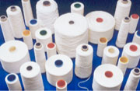

According to their website: ”Artofil is a true niche specialist, supplying high performance yarn for specific applications, designed especially for and in close cooperation with our clients. Our clients are active world-wide in very diverse market segments with as a common characteristic the fact that they all require yarn with special features”.

Artofil supplies to the following sectors:

* Cable sector: Swellable yarn to water block power, data and telecom cables;
* Aerospace: Dimensionally stable (warp and weft) yarn (with a very low shrinkage allowance) for airplane carpets;
* Automotive: Stabilising ("Tabby") yarn for the production of tire cord fabric;
* Interior textiles: Flame retardant and environmentally friendly yarn for window blinds;
* Other industries: Heat resistant and dimensionally stable yarn for technical textiles for a variety of industrial applications including conveyor belts in ovens.

Five people are involved in R&D and especially product development, but also in testing of new products and in adjusting machines. There are people who communicate with clients, listen and react to their needs. On the website examples are mentioned of questions of clients. Extensive experimentation and product development is necessary in the technical application of yarns before usable products can be supplied to the processing industry. As a business partner Artofil supports and enables its clients to be innovative and create competitive advantage in their own markets.

The possibilities for developing yarns for clients with specifically required features or combinations of features are almost limitless. The most common ones are mentioned below but the yarns usually have a combination of two or more features: flame retardant, heat resistant & cooling, high strength, super absorbent, swellable&water blocking, moisture transport, dimensionally stable / low shrinkage, smooth, can be cut without ravelling, conductive, anti-corrosion, voluminous, elastic.

They cooperate in innovation with clients and suppliers, and also with research institutes, e.g in Germany. The patents they have are not applied for, because of reputation or strategic reasons but defensive: to prevent competitors from using it. The patents they have are about the way to produce the yarn.

**B.2. Innovation Support Measures**

Several national innovation support instruments are used by Artofil, including Vouchers, IPC ‘innovation performance contract’, and WBSO (the R&D tax-deduction measure). No EU subsidies have been used.

Vouchers, (the national innovation vouchers provided by Agency NL) is the innovation support instrument that Artofil has used to get advice from a German research institute. Since a few years, Dutch vouchers can also be used for knowledge from institutes abroad, in the EU. The firm still cooperates with this institute. Main impacts are: new partnerships, improved design competencies. The project would have taken place also without the voucher, but later and in steps.

The main objective of the **Innovation Vouchers** scheme in the Netherlands is to enable small and medium-sized companies (SMEs) to buy knowledge/advice from knowledge institutes with innovation vouchers and thus to stimulate interaction and exchange between the knowledge suppliers and SMEs. With an innovation voucher SMEs can buy knowledge from (semi-)public knowledge institutes, from large companies with R&D expenditures that exceed 60 million euro per annum, and from foreign public knowledge institutes within the EU. The knowledge supplier can hand in the voucher with AgencyNL and receive payment. In 2009 two types of vouchers were available: small and large vouchers, 3500 of each type. Small vouchers are worth 2500 euro each and can be used by SMEs to buy knowledge from knowledge institutes. It stimulates SMEs to make the first step towards knowledge institutes. Large vouchers are worth 7500 euro. For these vouchers a mandatory own contribution exists of minimally one-third of the total project costs. The government contributes a maximum of 5000 euro. Entrepreneurs can get a large voucher once a year (in addition to a small voucher). Large vouchers can be used for more complicated questions. Large vouchers can be bundled by entrepreneurs for collective questions. The 2009 budget was 26 million euro. In addition there is also a regional scheme with Innovation Vouchers, which is co-funded by EU Structural Funds.

**IPC ‘innovation performance contract’** is a measure provided by Agency NL. IPC aims at facilitating cooperation and transfer of knowledge within a group of 15 to 35 national and foreign SMEs that share some connection with each other in terms of supply chain, region, sector or They are assisted by a project co-ordinator (typically a SME association), to jointly implement a long-term innovation plan including collective projects. They determine which area they want to research. 20% of the subsidy must be spent on common projects. Risk is shared at 50% for the (collective) SMEs and 50% for the government. Minimum project size €30,000. Maximum grant €30,000.

IPC is a policy instrument specifically designed to stimulate innovation in SMEs. The coordinator can be an SME or an association of SMEs such as Syntens. Beneficial features: Very flexible and expedite administrative procedures; ‘lose scheme’ of running the approved projects. Reduction of obliged administrative costs; Research is demand-driven; SMEs collaborate together and are responsible for defining and steering the collective research to meet their own demands; SME is in charge of the subsidy.

For **WBSO**, the tax-deduction measure, one now can apply twice a year. You have to define in advance the research target and activities, so you have to make it not too specific, not too narrow. What has been the impact? “It helps, it stimulates, lowers the threshold”. The measures are used for very different activities: Vouchers help to establish external knowledge relations, external capacity for innovation; while WBSO is good for internal capacity building.

IPC is about long term collaboration with others, but it is not only subsidizing collaborative research, but also individual projects and also external costs are allowed, e.g. to have a machine adjusted to specifications required. Due to the longer term nature of the work, it takes time and effort, while it still is not certain that it will proof to be successful. The subsidy makes it easier to take the risk of failure. Within IPC it is possible to work with foreign partners, but Artofil worked with Dutch partners. There are many projects concerning sustainability and the partners have learned a lot from each other.

What they want in a support measure is: accessibility; simplicity; not too complex; being able to get the money fast; not to wait too long. Artofil makes use of a consultancy office that gives advice about subsidies.

Most R&D and the received support are focused on techniques to produce new yarns. Product and process innovations are for Artifil very closely linked to each other.

The company has a broad interpretation of the innovation concept, which also includes marketing and organisation.

Simple application procedures are the most important aspect in deciding to apply for support.

**C. Recommendations & Conclusions**

This case study shows that companies that still exist in the traditional industries in the Netherlands must be innovative, otherwise they would not exist today. Specialisation in specific niches with high value added and innovative demanding clients make it possible to compete with low cost production elsewhere and with large bulk producing companies. National tools are for appropriate for firms that already have an innovation track-record, and have experience in doing R&D and in applying for support. The additionality of the support seems to reduce after having used several support instruments.

The main recommendation is to keep it simple.

**D. Information Sources**

* + - The company website [www.artofil.com](http://www.artofil.com);
    - Interview 24 August 2011;
    - Reply to GPrix survey questionnaire.

### Cedeko Raamdekoraties BV

**A. Introduction**

This company is in the textiles sector, but manufacturing is not the main activity. Most of the activities are providing services. Especially since a few years they have taken over/ merged with wholesale firms. The firm sells and makes blinds on client specifications. Time and distance, but also the specificity of the Dutch market also made that the company could compete with lower cost solutions (only 1 % export to some clients across the border). Innovation is not that important for the firm itself, because for a large part they buy in innovative products developed by others.

**B. Analysis of Experiences with the Innovation Support Measure**

**B.1. Company Background**

Cedeko, located in Eindhoven is active in the textile sector. Turnover is 3,300,000 euro which is slightly higher than 5 years ago. The total number of employees is 12, which is less than 5 years ago (21 employees).

Thirty years ago the first company was started, with one product and during the years more product-groups have been included. It started with sales of window-decoration textile, especially roller blinds and other vertical blinds, such as plissé shades. In the beginning others were asked to adjust the blinds to customer demands, basically adjusting the blinds to the specific measurements of the windows. Later they started to do these adjustments themselves and this client-specific adjustment and assembly is still the only manufacturing activity of the company. The number of employees is now 18. There is hardly any export. First of all because time and distance plays an important role in serving the end-users because the German and Belgium markets have different characteristics, e.g. in Germany they often have tilt windows which tilt to the inside, which makes the relevant window decoration possibilities different. They also serve Belgium clients in neighbouring regions and the German market only for a part of the current product range. E.g. in Germany shutters are a fast growing market.

Starting the production or actually the custom specific assembly was made possible thanks to a very large client who had paid 15.000 Euro in advance. This was used to start a production unit in Nuenen in the late 1980s. After the acquisition of the wholesale trade company both were jointly moved to the new site in Eindhoven in 2002.

Cedeko selects their products from the catalogues of manufacturers, so they do not generate or produce new products themselves, but new products have been introduced and also changes in the products which they assemble have taken place.

Digitalisation has started but still most decorators fax Cedeco what they need. The products are assembled and either the decorators pick them up or Cedeko delivers. Since they acquired the wholesale company they also sell a large range of supplies regarding interior decoration on site to the decorators who visit them.

ICT could become more important, but for instance they have no plans for selling through the web, because people still want to see and feel the products.

Another way to innovate is by buying new machinery, e.g. they have now a new cutting table which actually melts the cutting edges so the fabric wouldn’t rafle.

Part of the products are assembled in Czech republic. In 2 days the goods arrive.

But time is essential, it is an important value added, compared to cheaper solution e.g. in the large stores.

Shutters are a rather new product, which is becoming increasingly popular. They are manufactured in china, under Korean management. The delivery takes 6 weeks and are shipped by container.

Ten years ago in 2001 a wholesale company was acquired. It focused on project-decoration for business clients, which included carpets. This acquisition had synergy effects because of economies of scope since clients could be served with a broader product portfolio. New products have been contributing to the development of turnover, and made it possible to survive in this time of crisis, e.g. with tilt windows and shutters.

**B.2. Innovation Support Measure**

The support from Syntens in Eindhoven involved an advice on marketing and organisational innovation. The main impacts from the services of Syntens was the impact on the innovation strategy, but also the external relations and marketing capabilities. It also had an impact on access to new markets and internationalisation.

|  |  |
| --- | --- |
| Improved business or innovation strategy (e.g. an improved business model) | Important |
| Improved marketing competences | Important |
| Access to markets | Important |
| Internationalisation of activities | Important |
| Faster ‘completion’ of innovation project (than would have been the case without the support) | Important |

Simple, and short application is extremely important when considering an application. The support should also fit the SME’s needs, which is not always the case.

**C. Recommendations & Conclusions**

This case study shows that R&D subsidies are not relevant to all firms and that advice and business services provided by regional intermediate organisations like Syntens can contribute to increased innovativeness regarding marketing and organisational innovations. Since many SMEs in traditional sectors in a high-labour cost country like the Netherlands, combines several activities (services, manufacturing and wholesale) this case also shows that because of the blurred boundaries of (traditionally defined) sectors and branches it has become less relevant to have sector specific innovation policy instruments.

**D. Information Sources**

* + - The company website [www.cedeko.nl](http://www.cedeko.nl);
    - Interview September 2011;
    - Response to survey questionnaire.

### Van Haandel

**A. Introduction**

The Mechanical/metallurgy sector in North Brabant was a small sector around 1900 with about 5 percent of total employment, but this increased over the years to almost 10% of manufacturing employment in the early 1990’s and almost 13 percent in 2005. In absolute terms the number of jobs started to decrease after 1990. The concentration and cluster-type development for this sector was less evident that in Leather and Textiles. One of the reasons why this sector did not suffer from similar decreasing trends was the larger degree of diversification of products. Recent growth in employment is partly due to growth of companies that supply to large international automotive (E.g. DAF) and machinery and tool industries, for instance ASML (a manufacturer of machinery for chip-production).



**B. Analysis of Experiences with the Innovation Support Measure**

**B.1. Company Background**

This firm produces metal products. The founder started with machinery. They used to build Liquid gas installations and wholesale. In 1989 the building became too small. The entrepreneur also started to develop and produce parts for engines for racing cars and carts. The owner and founder comes from an entrepreneurial family. He now has several small firms, which originate from different activities. Production (11FTE) is in one legal entity and the other with 4 FTE is the development (50%) and sales (50%) organisation.

Till 2008 they never got a subsidy. It started with a bank-loan. In 2009 the idea was to hire somebody with a high level of knowledge, to bring the development a step higher. This was done via the OP-Zuid measure: innovation officer. The firm also makes use of the WBSO tax measure for R&D. The entrepreneur is positive about the WBSO, but negative about the OP-Zuid measure that involved a lot of bureaucracy and in the end, very late, they got less than originally agreed, while all the costs were made and there were results.

**B.2. Innovation Support Measure**

The Innovation Officer scheme (NL) is a regional instrument within the OP-South programme of the EU Structural Funds. It aims at filling knowledge gaps in SMEs, particularly in the area of innovation, and at launching of innovation processes. Subsidy to lower the costs of hiring a high educated Innovation Officer for one year. It provides a learningexperience, and awareness raising experience for the SME and often the Innovation Officer is offered a job after the project.

The firm is positive about the WBSO, the national tax measure for R&D, but rather negative about the EU co-funded project of the ERDF Structural Fund Operational Programme for the South of the Netherlands. The concept is fine, and the Innovation Officer they selected was very good, and also the project was successful, but ‘getting the money’ was a very difficult and even partly unsuccessful process, since afterwards, only half of the subsidy-amount was granted. The entrepreneur thinks that because it is co-funded by the European Commission the Dutch managing agency is afraid that they will be accused of making failures with the regulations. If the owner would have known in advance about all the problems with getting the subsidy, he would not have applied.

The application procedure was heavy, a three man delegation came to discuss and inquire. The project involved hiring an ‘Innovation Officer’ that would work on R&D projects, especially the project on the parts of the engines. They have developed a whole new method to produce the metal part, with a specially acquired and adapted tool to treat the metal. A lot of time was spend on long lists of detailed descriptions. In the end, later than planned the firm was allowed only half the agreed subsidy. The people from the agency had told him that they were afraid for EU regulations and control, they did not want to take any risks, but according to the SME, wrong decisions were made because of this.

Besides the positive experience with WBSO regarding the application he is also more positive about the way they control you. Take for instance these testing of the parts in all kinds of metal, I keep the ones I have tested, and add a note with dates and results and I don’t have to spend hours on writing long detailed descriptions, they can see for themselves that the part have been made and tested and documented, but in my own efficient way. They would also except if I make pictures, which can also be an efficient way to proof what has been done. Trust has to be build and it is good that they control and do inspections but he does not want to be treated as almost a criminal.

The impact of WBSO is that in difficult times we can keep on working on the R&D projects. They have an external adviser that applies for the WBSO.

After the OP-Zuid experience, with the innovation Officer project, the SME could not afford to hire the person on a full-time basis. But he still works here now and then to help me out. He lives in this village and now has a good job at ASML (the large chip-machinery manufacturer). We are trying to find a new way to produce the engine part, out of solid metal, which has to be done by very sensitive precise tools. Besides this project there are other, less innovative assignments as a metal treating company that remained.

The entrepreneur has once applied for and received a Voucher, but he did not use it, because the introduction visit at the Hogeschool was not successful. He is too small to make such cooperations work. Other refer you to expensive institutes like the Technical University or TNO.

**C. Recommendations & Conclusions**

* + - This case study shows that heavy bureaucratic procedures can frustrate innovative behaviour of small firms. The scheme is ok, but the application procedure, implementation, and especially the ex-post control and payment procedure caused a negative judgement from the entrepreneur. The bureaucracy seems linked to the rules and procedures of the EU Structural Funds and the way the managing agency has applied these regulations.
    - The firm is more positive about the WBSO tax deduction for R&D activities. A voucher was applied for successfully, but after an intake meeting the voucher was not used, because the firm was too small to a relevant partner to the knowledge institute.
    - It is recommended that in the new Operational Programme the managing agency improves its operations: promote easier application procedures which acknowledge that the selection process is not about selecting good proposals and good firms, as if experts of the agency pretend to be ‘investors’ or ‘bankers’ which seek for the highest return on investments. Entrepreneurs expect control, and are willing to show what has been done and how the money was spend. It should be focused on excluding fraud, but too heavy and complex procedures can have a negative impact on the original goal to support the SME.

**D. Information Sources**

* + - Face-to-face interview, September 2011

### Voertuig BV (anonimised)

**A. Introduction**

The automotive sector has never been a major source of employment for the province of North-Brabant as a whole, but after 1960 employment has increased and in 1990 it has grown to a share of 5 percent of total manufacturing employment. Employment was concentrated in the Eindhoven region where it is still an important sector. The sector has also succeeded to get a rather good position on the innovation agenda of regional policy makers.

According to Fier the Dutch automotive industry has grown considerably in recent years and now has over 40,000 jobs. Much of the industry is concentrated in North Brabant, with 8,200 jobs in 2005 according to Eurostat. North Brabant is the seat of international companies (or subsidiaries of these large companies) such as DAF Trucks, VDL Group, Nedschroef, Nedcar, Philips Car Lighting and top research and teaching as the Technical University Eindhoven, TNO Automotive, PDE Automotive and TTAI (TÜV Rheinland TNO Automotive International).



The automotive centre in the Netherlands is the High Tech Automotive Campus (HTACampus) in Helmond. HTACampus brings together automotive companies, research institutions and education. Knowledge sharing and innovation are the goal, and specifically in the areas of automotive technology and clean and sustainable mobility solutions. End of 2009 construction has started building a 6000 m2 Automotive Facilities centre with workshops, laboratories, offices and unique test facilities. The HTACampus therefore has the ability to become an international hotspot for automotive innovation. The map below shows the regional distribution of the automotive industry show, with "many dots close to each other" in the east part of North-Brabant

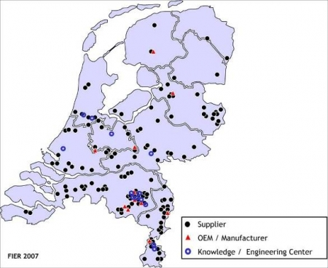

(Source: Automotive Fier, 2007).

**B. Analysis of Experiences with the Innovation Support Measure**

**B.1. Company Background**

This company was established about 30 years ago. It developed and produced a variety of trailers, and as such it is part of the automotive sector. Innovations have always been at the centre of its existence and for several developments in the industry they were among the leading firms in following and developing new trends. E.g. they were among the first use aluminium in order to reduce the weight, and new developments regarding lifting.

In 2003 the SME decided to focus even more on niches markets, and innovation. The core innovation they focussed on after 2003 was the development of a dynamic floor. The firm exports 90% of its products, mainly in Europe. Product innovation has always been important, but after 2003 process innovations became also very important, in order to develop ‘lean manufacturing’ and ‘quick response manufacturing’, they were in 2006 the first in Europe to follow this route. Then the direction was again more on product innovation, in the sense of re-engineering the product and characteristics that could make the production process ever more efficient. Now we study if it can still be made more simple and more weight reduction. They want and must keep their lead over cheaper producers in East Europe for example, this can only be done with a good innovation strategy.

In the past they used TNO, but not anymore because they have become too theoretical and commercial (expensive).

They are still looking for appropriate partners and another current difficulty is to find good technical skilled employees.

**B.2. Innovation Support Measure**

The SME makes use of an ‘expensive’ consultant to give them advice and apply for subsidies. This consultant got hem 2 subsidies: ESF (EU subsidy on social innovation). It went well but at the end only 30% was paid, so they started a legal procedure to get more, they were granted 7% of the original budget. It is really a waste of time if you have to invest so much time and energy to proof that you did right, and have to fight organisations that claim to support you.

The other scheme is IPC. IPC is implemented by AgencyNL and is about long term collaboration with others, but it is not only subsidizing collaborative research, but also individual projects and also external costs are allowed, e.g. to have a machine adjusted to specifications required. According to the respondent the information evening that was organised showed that it was quite complex. You have to do part of the activities together, but other tasks are only for the coordinating firms of the collaborating firms. They had to wait, but the whole budget they suggested was approved, but it was hard work to get it.

With IPC it is allowed to hire, subcontract expertise externally. This is very important for SMEs because they do not always have the acquired expertise in-house. E.g. for some measurements or testing for which specialised equipment and know-how is needed. Most subsidies do not allow for this, but is should be if they want to support us.

Getting the OP-zuid subsidy was very difficult. It was approved and acknowledged, but because the OP-South budget was already spent, it took three years.

**C. Recommendations & Conclusions**

* + - The agencies have to learn to trust and support SMEs, and not mistrust them simply because they are small and because they have a hard time to do all the administrative work. If they want all the paperwork, they should reserve a part of the budget for it.
    - The policy scheme must be easy to understand, it must be simple and understandable.
    - Schemes should have a low entry barrier, and not a high, and selective barrier.
    - It should be allowed for a share of the subsidy to hire external expertise, because SMEs do not have all acquired expertise in-house, or it is too costly and inefficient to build all such expertise in-house.

**D. Information Sources**

* + - Interview, October 2011.

### Metaal Industrie Uden BV

**A. Introduction**

The Mechanical/metallurgy sector in North Brabant was a small sector around 1900 with about 5 percent of total employment, but this increased over the years to almost 10% of manufacturing employment in the early 1990’s and almost 13 percent in 2005. In absolute terms the number of jobs started to decrease after 1990. The concentration and cluster-type development for this sector was less evident that in Leather and Textiles. One of the reasons why this sector did not suffer from similar decreasing trends was the larger degree of diversification of products. Recent growth in employment is partly due to growth of companies that supply to large international automotive (E.g. DAF) and machinery and tool industries, for instance ASML (a manufacturer of machinery for chip-production).

This case study involves a small firm engaged in manufacturing of metal products in North-Brabant. The main problem for this company and the sector as a whole is the competition from firms in countries with lower wages. Many competitors have moved production to Eastern Europe. The company produces metal frames for the furniture industry, the high-end market that is, where new designs, small series, customer preferences, short lyfe-cycles and innovations play an important role.

**B. Analysis of Experiences with the Innovation Support Measure**

**B.1. Company Background**

According to FransScheperof Metaal Industrie Uden BV (MIU): the core issue is "to be consumer oriented, to offer what the market demands". This is different from the way he sometimes sees in other companies or sectors, where they mainly look to save costs, and where the central questions seems to be: how can I produce more cheaply. It is important to know and produce the higher valued products.

Turnover in 2009 was 1000,000 Euro (and 700,000 in 2005). Total number of employees was 10 in 2009. Which is 3 more than in 2005. Most products are sold regional to a number of furniture companies (80% of turnover in the region, 15 % is sold in other European countries). The firm has a very broad conception of innovation, besides product and process innovations, also marketing, organisational innovations and design are very important, but on all possible types of innovation activities MIU has made improvements. In terms of marketing-innovations the firm’s competencies are below average.

Between 10-15% of turnover is spent on innovation. The crisis had only a moderate impact on the company. A few jobs have been created and maintained due to the innovation activities. About 35 % of turnover is from new (since 2005) or strongly improved products, this very high rate is due to the very short life-cycle in the furniture industry for which the firm is producing the metal frames. The series are small, but unique.

Everything they do at Metal IndustrieUdenBV is innovative, else the company could not exist, but the need for innovation lies mainly in that customer focus and responsiveness to customer needs. Design is particularly important. "At one time, customers want the black chair legs and the next moment they want metallic chair legs. You should simply have to listen, go along and respond to such needs. 'design' is essential and that is even becoming more important.

After experience working at a company in Uden that produces beds, he started his own company in 1992 because he saw that the company would come in trouble. He started as a welding company and four years later the company moved to its current location in the industrial terrain in Uden. They make metal frames for furniture, and sometimes other small structures.

Several customers, furniture manufacturers left to Poland and Romania, and they also asked "why don’t you come along?"

But it is indeed possible to produce in the Netherlands, even though the labour costs are higher. A major customer is in Oss, a customer-oriented manufacturer who keeps only 1 day supply in stock, because demand changes fast. This customer only wants to work with Dutch suppliers. Distance for them and for Metal Industry Uden, certainly is still important.

We deliver also in Romania and Poland. The truck that just left goes to Romania, but it's not a great future for us, however, Poland is, it is still a lot closer, but Romania is really just too far. Germany and the Netherlands is the largest end-market for us.

We can deliver within four weeks, a frame like this and 50 frames like that. If you wish to get things from China it takes a few months, you can hardly manage and steer such deliveries. And if anything goes wrong with our delivery or our products, I'm within half an hour in Oss to discuss and fix things, and you can offer more service to customers.

MIU’s strength is in rapid design and in keeping abreast of the technological possibilities. It is also important that you like what you do, that you like what is new, how things work and what the latest developments are. E.g. not everyone reads his professional literature and magazines from beginning to the end. Other ways to keep up technologically include: go to trade-fairs, use interns and test new things. Most innovations at MIU are design-oriented innovations, certain shapes, angles, thickness, material, size, finish, and new combinations, etc. For example, you should test if it is strong enough, or if it can be realized. You could ask TNO to do tests, and MIU used to do that, but TNO has now become so commercial that they actually lost interest in these smaller contracts with SMEs. MIU is now performing the tests themselves and they also do it together with schools on certain projects. For a particular test they now work with a machine that MIU has put together themselves in cooperation with an education institute in the region. For both of them this was a good learning experience.

The recession is well used: in the beginning of the recession two machines to bend tubes were purchased in Italy, because at that time, the Italian supplier had fewer assignments, so the machines were around 70,000 euro’s cheaper than normal.

In the past there were also six-monthly interviews with Syntens, and once they have participated to a workshop, but actually things (markets, companies, technologies) develop so fast nowadays, that organisations like Syntenscan not keep up with the situation in each and every company.

The Chamber of commerce now has a project running to improve the image of the metal sector. They work together with various companies and schools from Uden and Veghel.

It is important to consult with schools and cooperate. Schools can not keep up with developments without cooperating with companies. E.g. at training institutions they are behind in the developments regarding 3-D designing. The software package which MIU is using is not taught in the schools.

BOL and BBL are two types of education in the area. He works mainly with BBL where the main training takes place on the job, outside school. And they less often work with people that followed BOL where they attend school full time. The schools themselves can not tell the difference in level. The two forms are growing towards each other and the distinction is disappearing. It basically shows that schools struggle to keep track of developments and that students learn more in companies than they learn at school.

As Mr.Schepers has said: "everything we do is innovation’. We can conclude that all this innovation is all about design, design, and again: design. Not only regarding the nature and speed of product innovations, but also concerning technological process innovations. It also leads to a need for new skills of workers and also has organizational implications, and finally design is even important in improving the marketing. With a new software application, they can now digitally visualize a drawing in such a way that it resembles a picture of a real prototype. That sells a lot easier than showing the old drawings. E.g. in the case of the drawing of a distribution trolley they have designed for the largest supermarket chain in the Netherlands.

**B.2. Innovation Support Measure**

The firm has made use of the national WBSO tax deduction measure. Applying for WBSO is done through an agency that is specialised in advice about grants. “Next week there will be a control visit about the past WBSO administration, the last one was five years ago. You must be careful that you do not waste too much time in writing and justification. You should be able to submit time registration of employees, which is not a problem, but they want us to write more on paper of what we actually did and what the results are. This type of reporting is quite demanding for most of us. Moreover, you can only use WBSO for longer, larger projects, half years or so. We do about one request for WBSO per year. But that does not mean that all our research and development activities are suitable for WBSO because you cannot apply for small projects, or use it for a single product, or small research or development assignments. You cannot write a project proposal for each and every R&D activity”.

In Euro’s the ‘money received’ from the WBSO tax measure amounts to 10.000. Without this, the innovation activities would have been continued anyhow, but at a slower speed.

For large companies this might be different, because of the scale advantage. They have large projects, which probably also allows them to include hours spend on related ‘small things’.

For example, during the interview Mr.Schepers was asked by a client about the possibility to place wheels under a specific chair frame. It should be figured out whether this is possible, because the legs of the concerning chair are actually too small for the regular wheels. Perhaps his expert supplier of wheels might have a solution, but at least they would have to test if the solution is good or if it calls for more adjustments. This type of R&D activity does not fall under an R&D project for which you can use WBSO, it has to be solved today or tomorrow.

Table Importance of the impact from the concerning measure

|  |  |
| --- | --- |
| Improved internal organisation  Improved business or innovation strategy (e.g. an improved business model) | Important  Some importance |
| New quality certifications (ISO) | Important |
| New safety or environmental certifications | Some importance |
| Improved research competences | Some importance |
| Improved marketing competences | Some importance |
| **Improved design competences** | **Very important** |
| **Improved level of skills of personnel** | **Very important** |
| Formation of new partnerships and networks | Important |
| Improved R&D linkages with universities and research institutes | Some importance |
| Improved R&D linkages with other business organisations | Some importance |
| Improved commercial linkages with other organisations | Some importance |
| Enhanced reputation and image | Some importance |
| Facilitated participation in other R&D or innovation programs | Important |
| Increased turnover | Important |
| Increased profitability | Important |
| **Enhanced productivity** | **Very important** |
| Access to markets | Important |
| Internationalisation of activities | Important |
| **Faster ‘completion’ of innovation project (than would have been the case without the support)** | **Very important** |

**C. Recommendations & Conclusions**

This case study shows that the WBSO tax deduction is a good scheme to promote innovation, also for SMEs in traditional sectors. The rules are however favouring large R&D projects which last about half a year. For this case study company this means that by far not all R&D falls under this scheme.

Simple reporting is extremely important in persuading SME’s to apply for support measures. Also other administrative burden has to be kept minimal, otherwise the measure will fail to support SMEs.

**D. Information Sources**

* + - Interview with FransSchepers, August 19, 2011;
    - Response to the GPrix survey 2010.

### Van den Berkmortel Fijnmetaal BV

**A. Introduction**

The Mechanical/metallurgy sector in North Brabant was a small sector around 1900 with about 5 percent of total employment, but this increased over the years to almost 10% of manufacturing employment in the early 1990’s and almost 13 percent in 2005. In absolute terms the number of jobs started to decrease after 1990. The concentration and cluster-type development for this sector was less evident that in Leather and Textiles. One of the reasons why this sector did not suffer from similar decreasing trends was the larger degree of diversification of products. Recent growth in employment is partly due to growth of companies that supply to large international automotive (E.g. DAF) and machinery and tool industries, for instance ASML (a manufacturer of machinery for chip-production).

**B. Analysis of Experiences with the Innovation Support Measure**

**B.1. Company Background**

This firm produces metal products, for which the owner developed a robot to produce at nights fully automated series of metal products.

Turnover in 2009 was 1,100,000 Euro (800,000 in 2005). There are 6 employees, which was 3 in 2005. Half of the sales is destined to clients in the region, 15% is for export to other European countries.

Van den Berkmortel has developed a robot that can be positioned next to the existing machine. Others have put robots in front of the machine, but the new approach makes it much easier to change from one product to the other, to adjust the machine. Which for instance fraises blocs of aluminium into parts for airplane engines, fully automated, from a digital drawing. We use the robot after working hours, because during the day we do the small series for which you need to operate the machines by hand.

The entrepreneur, founder, started 17 years ago. He worked at Ter Strake, a well known company in machine building and metalworking. He won a prise at the company and he asked if he could get an old machine as prise. After work he started with assignments for farmers in the neighbourhood, and later he quit his job and started full time with his own company.

**B.2. Innovation Support Measure**

The owner and founder of Van den BerkmortelFijnmetaalstarts the interview by saying: “About innovation subsidies I could write a book”. Every region and firm in Europe receives innovation support and many can not show results. We really used it well and did something with it, but did not get paid yet. Van den Berkmortel used the OP-Zuid scheme to develop a robot. It started almost 3 years ago. The project was very successful. One robot is in use by Van den Berkmortel and two others have been sold. All three perform very well, but the company has still not received the subsidy. The long delay in reimbursing the money is not only a major disappointment for the entrepreneur, but also a barrier and delay to further growth, because he can not (pre-finance) invest in building new robots.

An organisation PKM of the branch organisation for the metal industry has served to apply for subsidies. The application for OP-zuid was successful and the used it to develop the robot. It was successful, but after 2-3 years everything stood still because the subsidy was never paid, while the costs for all the consultants doing the paperwork was already paid. After they have filled in all the required accounting and reporting, they called and simply said this is wrong everything has to be reported digital, the next day they came with new different requirements. Many people have spend a lot of time (paid by the SME) to address the issue. They will receive less than originally agreed, but that even has not arrived.

The firm has also used WBSO, this works better, although it was not easy in terms of administrative requirements.

|  |  |
| --- | --- |
| **Improved internal organisation**  **Improved business or innovation strategy (e.g. an improved business model)** | **Very important**  **Extremely important** |
| New quality certifications (ISO) | Not important |
| New safety or environmental certifications | Not important |
| Improved research competences | Not important |
| Improved marketing competences | Important |
| Improved design competences | Important |
| Improved level of skills of personnel | Some importance |
| **Formation of new partnerships and networks** | **Very important** |
| Improved R&D linkages with universities and research institutes | Not important |
| Improved R&D linkages with other business organisations | Important |
| Improved commercial linkages with other organisations | Important |
| Enhanced reputation and image | Some importance |
| Facilitated participation in other R&D or innovation programs | Not important |
| **Increased turnover** | **Extremely important** |
| **Increased profitability** | **Extremely important** |
| **Enhanced productivity** | **Extremely important** |
| **Access to markets** | **Extremely important** |
| Internationalisation of activities | Not important |
| Faster ‘completion’ of innovation project (than would have been the case without the support) | Important |

**C. Recommendations & Conclusions**

The attitude and approach of the agencies is not good. The bureaucracy has to be reduced and they should be reliable support partners.

The agencies have to be aware of the problems they cause by delays, unclear reporting requirements, etc. Especially for small firms all of this has a major impact on the developments.

**D. Information Sources**

* + - Face to face Interview with owner, director in August, 2011;
    - Response to the GPrix survey 2010.

### Prins Autogassystemen BV

**A. Introduction**

The automotive sector has never been a major source of employment for the province of North-Brabant as a whole, but after 1960 employment has increased and in 1990 it has grown to a share of 5 percent of total manufacturing employment. Employment was concentrated in the Eindhoven region where it is still an important sector. The sector has also succeeded to get a rather good position on the innovation agenda of regional policy makers.

According to Fier the Dutch automotive industry has grown considerably in recent years and now has over 40,000 jobs. Much of the industry is concentrated in North Brabant, with 8,200 jobs in 2005 according to Eurostat. North Brabant is the seat of international companies (or subsidiaries of these large companies) such as DAF Trucks, VDL Group, Nedschroef, Nedcar, Philips Car Lighting and top research and teaching as the Technical University Eindhoven, TNO Automotive, PDE Automotive and TTAI (TÜV Rheinland TNO Automotive International).

PrinsAutogassystemen BV is producing alternative fuel systems since 1986 for the automobile industry.

**B. Analysis of Experiences with the Innovation Support Measure**

**B.1. Company Background**

Gas has been the main driving force for the past 25 years for Prins. In 1986 PrinsAutogassystemen started out as a supplier of autogas systems, but it has developed into a very innovative developer of alternative fuel systems. Prins’ mission statement and ultimate long-term goal is to develop a system returning near zero emissions for internal combustion engines.

PrinsAutogassytemen BV, a partner of SHV Gas, has been a world leader in the development of alternative fuel systems for more than 20 years. It has acquired a good reputation for providing its OEM, Country Importers and after market customers with cost-effective and innovative fuel solutions for a wide range of engine types.

After the start in 1986 growth has been modest. New systems were produced: from LPG, to natural gas and mixed systems. In 1999 the company was taken over by a UK family firm. In 2000 Bart van Aerle started as a student with a traineeship at Prins. He was interested to develop a new system for sequential injection. Bart van Aerle together with John King developed this new system. Bart van Aerle is now CEO. The development of that system changed a lot for the company, besides the technological and commercial success of the VSI systems, it implied a shift from a company ‘dragging behind’ towards company leading in innovation. Prins had changed its course: no longer following the trends, but concentrating on being a leading company in new developments and innovations.

In 2007 the UK owners stepped out and NPM a venture capital, investment company stepped in, and now owns a majority of the equity shares. This also was the start of a close cooperation with SHV Gas, who has full ownership of NMP. A minority of the ownership is in the hands of member of the management team. SHV Gas is the world largest distributor of LPG, working with them is important for instance regarding the promotion and expansion of filling-stations in the concerning countries. For instance in Turkey, China, India and Thailand Prins and SHV are working together in this respect. For the development of the market, government subsidies are very important, as well as the price for oil. Italy was for instance an important ‘gas’ country but they have stopped with subsidies and then the market decreases. This also happened in Australia.

Turnover was at its peak 3 years ago in 2008, but it shifted to 17 million because of the crisis. In 2006 there were 15 employees, in 2011 there are 50 full time employees. In addition 40-60 people do the assembly and a bit production in a social welfare construction where jobs for people with less abilities or with handicaps are subsidized by the government.

In co-operation with Keihin Corporation of Japan, one of the world’s most important manufacturers of OE fuel systems, Prins has developed the high-tech sequential gaseous injection system (VSI system), which is suitable for both Liquid Petroleum Gas (LPG) and Compressed Natural Gas (CNG) applications.

Prins is working closely with its global customer base to ensure its systems and components work seamlessly with the latest automotive technology providing best in class solutions for mono-,bi- and dual fuel applications. Collaboration with OEMs or preparations for collaboration have already been established in Sweden, Germany, Malaysia, Japan and Iran.

PrinsAutogassystemen B.V. is NEN-EN-ISO-9001:2008 certified. All components are in-house tested and comply with EU-R67-01/R110/R115, CSA and EPA regulations. Prins C.O.P. for crucial components is based on 100% testing prior to delivery.

Prins is a global supplier of systems and components for automotive, bus, HDV, industrial and marine applications and has established distribution channels in over 52 countries.

What Prins delivers to clients are the two main components: the vaporizers/injectors, the control/distribution and a computer.

Besides the VSI system and components, other products are (see also: <http://www.prinsautogas.com>):Dieselblend system; Direct Liqui Max system; Mixer system; ValveCare.

VSI2 is the next step. This project was also subsidized and also has generated patents. The major innovation was the step from the ‘mix’ systems to the VSI system, but there are new developments all the time.

R&D at Prins has been increasing and by now over half of the Prins staff works in R&D. A logical development, since knowledge and innovation have become the core assets of Prins.

About 5 people are engaged in generic R&D, this platform consists of an expert for software, one for electronics, 2 engineers and a manager. They develop the new technologies and basic systems.

Others then are engaged in applying and adapting the technology to different groups of cars, where to put the parts, where and how to connect it to the different types of engines. Then each application is tested and improved.

Besides application engineers, there are also sales-engineers who manage for instance relations with certain OEMs. This integration of Prins into the design process of OEMs is increasing. But Prins also works with import organizations in various countries.

The crisis has been used to invest in new developments. Very important for this has been the support of NPM and SHV. They have put trust in the future of Prins and their technologies and supported the plan to invest more in innovation, than the reduced cashflow would allow. They invested in VSI2, the direct injection system and the diesel blend system. Now they clearly are ahead of most competitors.

**B.2. Innovation Support Measures**

De support from OP-Zuid (which is EU, EFRO funded Operational Programme for the south of the Netherlands, managed by Stimulus) was about a cooperation with a large supplier of electronics in the region for a project on direct injection. OP-Zuid has heavy and very strict administrative procedures and they take more time than for most other support measures. For example, the progress report of 2010 is still not approved. But the size of the subsidy was larger than normal, since it involved a maximum of about a million euro. So it makes sense to be strict and ask for a lot of proof in administrative terms, but more in general for applications for innovation support projects it is time consuming to make in advance a guess of the exact activities and planning of the research, because it always changes in practice and then you have to make changes and ask for approvals, which then takes a lot of reporting time.

Prins have made use of several support measures. Other measures are WBSO and InternationaalInnoveren (from the national agency: Agentschap NL/ former SenterNovem). For each project they decide if it is best to apply for an ‘environmental/alternative energy’ support measure or innovation support measure. Or actually the ask advice on such issues from an external consultancy bureau specialized in subsidies. Applying for WBSO is not that difficult, the last application concerned a tax-return for 12.000 hours of R&D.

Another policy support measure is provided by the national tax-office, also known as ‘innovation box’. Companies which receive WBSO can apply for this. It implies a reduction on profit-tax rate from 25 to 5 % on the profit related to innovation. The tax office has declared Prins to be a very innovative company, because it has one of the highest shares (40%) of the result before tax that can be labeled as purely generated by innovation (new products developed in the last 5 years).

Prins has also makes use of the national Dutch measure SBIR (Small Business Innovation Research), and in particular the one called: “SBIR the car of the future’. This is a measure to involve SMEs in innovative public procurement where the policymakers in advance describe the technological needs and then the firms can send proposals to Agentschap NL. According to Prins the administrative procedures are ‘licht’ because the people from or hired by Agentschap NL know the sector and from half a page of technical reporting they are able to decide the share they can reimburse. SBIR involves 3 phases: a feasibility study, development phase and a market introduction phase.

There are also schemes to promote internationalization. Prins has taken part in the Agentschap NL programme: ‘InternationaalInnoveren’ and used it to set up a Joint venture in China. Another project involves a Joint Venture in India. It serves to do part of production locally, in collaboration with a local supplier. When there are large clients for products that include gastanks, Prins works together with local suppliers because of the volume of these products. With joint ventures with such suppliers they are able to better fine-tune the production and logistics in the concerning country. For China they for instance had a large Taxi company that asked Prins to adapt 5.000 taxies and transform them to gas fuelled taxies.

In 43 countries Prins cooperates with importers to provide technical support. For instance for the universal systems provided by Prins the parameters of the cars in which they will be applied still has to be entered. This is why Prins is involved in training importers to set these parameters of such universal systems.

The main partners in innovation for Prins are SHV (for everything concerning gas) and the Japanese company Keihin, one of the world’s largest producers of injectors and fuel systems. Two Japanese engineers where even permanently stationed at Prins in Eindhoven for some time. One of them has become a general manager and the cooperation in innovation is still very good.

Concerning the sheltered workshop (‘socialewerkplaats’), there is a recent political discussion in the Netherlands on how to continue and finance this national system. It involves a cost subsidized establishment where work is offered to persons who, due to a combination of severity of disability and/or labour market conditions, cannot secure competitive employment. It will become different if this system of sheltered workshops will disappear but it is not expected. It has become hardly impossible in the Netherlands to engage in industrial manufacturing, so without the system things would change and the assembly would possible be outsourced to others outside the region and outside the Netherlands.

|  |  |
| --- | --- |
| Improved internal organisation  Improved business or innovation strategy (e.g. an improved business model) | Not important  Not important |
| New quality certifications (ISO) | Not important |
| New safety or environmental certifications | Not important |
| Improved research competences | Not important |
| Improved marketing competences | Not important |
| **Improved design competences** | **Very important** |
| Improved level of skills of personnel | Not important |
| Formation of new partnerships and networks | Not important |
| **Improved R&D linkages with universities and research institutes** | **Very important** |
| **Improved R&D linkages with other business organisations** | **Very important** |
| Improved commercial linkages with other organisations | Not important |
| **Enhanced reputation and image** | **Very important** |
| Facilitated participation in other R&D or innovation programs | Important |
| **Increased turnover** | **Extremely important** |
| **Increased profitability** | **Very important** |
| Enhanced productivity | Some importance |
| **Access to markets** | **Very important** |
| Internationalisation of activities | Some importance |
| **Faster ‘completion’ of innovation project (than would have been the case without the support)** | **Very important** |

**C. Recommendations & Conclusions**

This casestudy shows how a rather traditional SME manufacturer of parts and components in the automotive industry in the Netherlands has transformed into a highly innovative company. This transformation was internally motivated (and a traineeship from the Technical University has played an important role) and it was possible because shareholders could be persuaded to invest in product development. Schemes such as the WBSO tax incentive scheme has helped and had a positive impact on for instance turnover. Several other measures which have helped in speeding up the innovation activities include the national measures: ‘InternationaalInnoveren’ and ‘SBIR de auto van de toekomst’ from Agentschap NL, the national tax-measure ‘innovation-box’, and the EU funded regional programme ‘OP-Zuid’ managed by Stimulus. For ‘OP-Zuid’ the subsidy was quite large, but the administrative requirements are very strict and demanding, and after one year the progress report for 2010 was still not approved.

**D. Information Sources**

* + - The company website: http://www.prinsautogas.com
    - Interview met ArieBogers, augustus 2011;
    - Response to survey 2010.

### Food NL (anonimised)

**A. Introduction**

Since 1920 the food sector has decreased in terms of its share in total manufacturing employment in North Brabant from 23 % in 1920 to 12 % in 1990. Data from Eurostat for the years after 1990 point to a slightly higher recent share of 17% in 1995 and 15 % for 2005.

One of the historical clusters in food manufacturing in North Brabant is the sugarproducts industry in West (North-)Brabant which is based on the production of beet sugar. In 1919 some 30 small beet sugar factories established the CSM (CentraleSuikerMaatschappij) which in 2007 has been taken over by the Suikerunie. The existence of beetsugar production has played a major role in the industrialisation of the cities of Breda and Roosendaal, where before 1900 many sugarproduct manufacturers started production. In 1858 the first mechanical production of peppermint in the Netherlands took place in Breda. One of the well known companies was ‘Kwatta’ which stopped production in 1970. Current sugar products manufacturers are for instance: Lonka, Leaf, Hooijmeyer, Venco and Penotti in Roosendael and Perfetti Van Melle in Breda.

Nowadays, Southeast Netherlands (which also includes the province of Limburg) is the third exporting regions of the Netherlands in food production and processing. The current added value of the food sector lies in the fact that it overlaps with technology areas such as high-tech systems and Lifetec. In addition to large manufacturers such as Campina, Bavaria, and Nutreco, there are hundreds of SMEs established in food business. They produce foods ranging from sweets, meat, dairy, beer and fruit to ingredients and "powders" for the food industry.

Although food can be labelled as a traditional industry, it is one of the priority sectors of the national innovation strategy under the heading of ‘food and flowers’. Also regional policy makers are still convinced of the dynamic importance of this sector for the future of the economy of North Brabant.

**B. Analysis of Experiences with the Innovation Support Measure**

**B.1. Company Background**

The food producing SME has 55 employees and a turnover of 5,000,000 Euro in 2009 (in 2005 this was higher: 6,000,000). In 2009 it had 85 FTE (which was 95 in 2005). 95 percent of sales has a destination in the region. The company has a broad perception concerning the concept of innovation, also including design, marketing, new markets and organisational innovation. Expenditure on innovation equals some 6-10% of total turnover. The impact of the crisis is felt badly. The innovation activities have however maintained some 10-20 jobs, jobs that would have been lost if the company had not innovated. Organisational innovation is most important, product and process innovations are very important and also marketing is important. In 2005 the firm was behind the average competitors concerning innovation, but in 2009 is performed above average in their line of business.

**B.2. Innovation Support Measure**

This case study firm has used 4 national innovation support measures, (although in the survey they had reported to have received support from 2 measures) which addressed internal innovation projects. They have never participated in a regional or European project. The impact of the national support instruments has been reported positive, but the additionality is limited in the sense that without the measure the firm would have pursued the innovation project anyhow, but more slowly.

The first mentioned support instrument involved tactually several types of support from Syntens, the regional unit of the national innovation agency network. They had received advice on innovation and the annual visits by consultants of Syntens served as a sounding board for the entrepreneur. The main impact from this advice was the improved internal organization. The innovation project was completed faster than would have been the case without the advice. It was estimated that over the years the support was equal to about 15.000 Euro. The support was mainly used for product innovation.

The second measure was the WBSO tax deduction for R&D. The total for about five years was equal to about 75,000 Euro. The main impact from this support was the increase in turnover, profitability, productivity and access to new markets. Fast and simple administrative procedures are most important characteristics to have SMEs participate in support schemes.

**C. Recommendations & Conclusions**

It is very important to stimulate SMEs to innovate because standing still means getting behind.

Measures should have fast and simple administrative procedures, because otherwise they are not helping SMEs to benefit from innovation activities.

**D. Information Sources**

* + - The company website;
    - Telephone interview august 2011;
    - Response from the GPrix survey.

### Metal NL (anonimised)

**A. Introduction**

The Mechanical/metallurgy sector in North Brabant was a small sector around 1900 with about 5 percent of total employment, but this increased over the years to almost 10% of manufacturing employment in the early 1990’s and almost 13 percent in 2005. In absolute terms the number of jobs started to decrease after 1990. The concentration and cluster-type development for this sector was less evident that in Leather and Textiles. One of the reasons why this sector did not suffer from similar decreasing trends was the larger degree of diversification of products. Recent growth in employment is partly due to growth of companies that supply to large international automotive (E.g. DAF) and machinery and tool industries, for instance ASML (a manufacturer of machinery for chip-production).

**B. Analysis of Experiences with the Innovation Support Measure**

**B.1. Company Background**

This metal products manufacturer did not use any innovation support. It has 40 employees and a turnover of 7,200,000 Euro, which was much higher in 2005 with 14,000,000. The main goals for innovation are to develop new metal products and use new production technologies. Its concept of innovation is limited to product and process innovation. Ten percent of the products were sold in the region, and another 10 % in the rest of the country. 70% is exported to European countries, and 10% outside Europe. The firm was effected severely by the crisis. The innovation activities are limited to new products, but no new jobs have been created. Especially process innovation is important for the performance of the company. The competencies are behind the average innovation competencies in their line of business. Only a few percent of sales concerns new or strongly improved products.

**B.2. Describe “No Measure”;**

No measure has been used, because the information about the possible support measures is very poor and some instruments are too difficult to apply for. The guidance and accessibility of the agencies and their support measures is limited. Other companies hire expensive consultants to find subsidies, but we can not afford this. The crisis makes it too difficult and risky to invest more in innovation activities, but also difficult to find the time to get informed and understand the possibilities to apply for measures. The support measures are rather given to firms that do not really need it. We need it, but it is too difficult for us to get it.

**C. Recommendations & Conclusions**

* + - Measures and agencies should be more accessible.
    - Agencies should support during the applications, and they should be less selective.
    - Application procedures are very heavy and aimed at firms that are already innovative. They are not designed to support firms like us. The concept of measures is also very complex sometimes.

**D. Information Sources**

* + - The company website;
    - The telephone interview of august 2011;
    - The response to the GPrix survey, 2010.

## Case studies PT – Northern / Central Portugal

### PT-TX1 – Textile SME No MEASURE (anonimised)

**A. Introduction**

Textile is one of most well-know Portuguese sectors in external markets due to the exporting character of the industry. In part this the result of an early internationalization process that started in 1960 with the adhesion to EFTA (European Free Trade Association) as a founder member together with Austria, Denmark, Norway, Sweden, Switzerland and the UK. In the sixties the development continued to expand mainly based on the competitive price and flexibility of production. EFTA was a valuable experience for its members and in particular for Portugal that had an urgent need to increase exports. The know-how created in aspects like business relationship, design collaboration and manufacturing processes would later become crucial in the process of integration in the European Union.

Since then, the industry has evolved from the classical low-cost manufacturing industry to a complete cluster covering from design, brand management, marketing to innovative new products such as technical textiles, a direct outcome of an intense collaboration with R&D centres and universities, in particular with the University of Braga which is now a textile knowledge centre recognized internationally.

Nowadays, the textile industry is still one of the most important sectors of the Portuguese economy. It represents around 11% of total exports, 22% of the turnover of the manufacturing industry and 7% of production, involving 7,000 companies from which almost 96% are SMEs. Despite this figures, in the last decade, 20% of orders were diverted to an expanding market: Asia, clearly shows the sector must undertake serious changes to become competitive.

In recent years, the development of the SMEs of the sector was characterized by a paradigm shift, moving from exploiting a competitive advantage based in low production costs, with an economic model characterized by extensive production, reduced number of customers and large series of standardized products to another model characterized by intensive, value-added small series and a variety of clients, as a way to escape the current dynamic of change.

This case study analyzes a textile SME with no measure used.

**B. Analysis of Experiences with the Innovation Support Measure**

**B.1. Company Background**

PT-TX1 is a textile SME operating in the clothing industry with its facilities located in the Central Region of Portugal. The company has around 230 people working in a 6000 SQM facilities and a turnover in 2010 around 5 million Euros. The company is specializing in high quality woman wear and exports 85% of the turnover to over 20 countries with main markets in Brazil, Denmark, Finland, France, Italy, Norway, Spain, Sweden, UK and the USA.

Established in 1979, this family-run company initiated its activity focused on fashion and development of collections for international brands. The company has two production chains, one producing blazers, jackets and dresses and another producing trousers, skirts and shorts, each one delivering around 400 garments per day. Flexibility is a key word here and both chains can easily change style and items to adapt to the clients demand while keeping a high level of productivity.

With a team of pattern designers and fabric specialists, the company is capable of creating new fabric and new designs based in a simple drawing or a photograph supplied by the client. The all process from idea to product is managed by the company, enabling the production of new fabrics with a personalized or even exclusive design.

This only possible with is the strong partnership with some of the most well known Portuguese weavers, usually close by, giving an important competitive advantage over other manufactures as the whole process is controlled by the company from top to bottom.

To adapt to different requirements of clients, the company provides three different solutions:

• Full Price/ Vertical Service: Includes every material and fabrics used.

• C.M.T.: “Cutting, Manufacturing and Trimmings” all supplied by the company while the client provides the fabric.

• C.M.: “Cutting and Manufacturing” done inside while every other component, trimming, accessory and fabric is supplied by the client.

Main competitors are located in Asian countries; with lower costs, these manufacturers can cope yet with the quality, flexibility and range of services provided by the company and after the financial turmoil in 2009, the company is making a steady recovered and business prospects are promising.

**B.2 Describe “No Measure”;**

These SMEs find it difficult to apply to a strictly R&D-oriented programme. The company has a clear innovation policy but it doesn’t “fit” well in the existent programmes.

At the time of the GPrix survey, the company was initiating a new project using the “SI Qualificação PME” programme. The project has an illegible investment of 229,148 with an incentive of 114,574 Euros.This programme supports projects that increase the skills of the SME in addressing needs such as internal staff capacity to internationalization projects. The broad scope of the measure is sometimes limitative to the SME since it has to breakdown their innovation plan in order to fit it in the specific objectives of the measure. A single application to several types of innovation activities would facilitate the access of these medium-size traditional industries to the support measures.

The project is aligned with the strategy for collective efficiency (“Estratégia de Eficicência Colectiva) materialized with creation of the Competitiveness and Technology Poles (PCT), namely the fashion pole (PCT Moda). This knowledge network involving the textile, shoe and jewellery industries under a common ground is facilitating the access of SMEs to these measures, providing the knowledge and experience of the other members of the network creating to build successful applications. In fact, the project was recognized by PCT Moda as a “Complementary project”, i.e., a project that contributes to the shared strategy of the pole for the sector, by this way receiving a higher priority in the assessment of their application and additionally get a 5% increase in incentive.

The synergies and complementarities created inside the network will certainly help to maximize the use of the support measures and pave the way for a more active participation in the upcoming European framework programme.

**C. Recommendations & Conclusions**

Textiles and in particular cloth manufacturing has been one of the top exporting industries of the country. The industry is experiencing a fierceful competition from Asian countries, creating a lot of damage in the industry as the enterprises are closed, destroying a lot of jobs and putting a lot of social pressure in the local economies, especially because these companies are often located around an informal textile cluster geographically concentrated in a specific region. This the case of the region where this company is located in which in a decade 50 companies disappear representing almost 5000 jobs lost. Unfortunately this sometimes unfair selection process is not only based on the intrinsic competitiveness of each company but also resulting from the negative effects of the economic recession (being the access to credit the main constraint) that is hampering economical viable companies from doing the investments they need to respond the orders they have in hands from clients.

However, there are some positive signs in this radical transformation of the Portuguese textile industry, even with the high social cost. The dynamic innovation effort observed in industry in general and in this company in particular, shows a strong commitment to quality, design, flexibility and the creation of innovative services to their clients. The recent recover in the demand with a noticeable increase of orders can be a turning point for the clothing industry from a decaying industry to an attractive and competitive business capable of creating qualified jobs.

Innovation support measures have been targeting mostly to promote R&D in the enterprises and clearly this has produced a significant change in the textile industry with noticeable technology advances (for instance, Portugal is now a world leader in technical textiles) but traditional sectors have other needs and a special attention must be given innovation in services, design and marketing, as these are two major axes on the innovation policy of the these SMEs. The knowledge network created under the fashion competitiveness pole (“PCT Moda”) could play an important role here, either defining common strategies either enhancing the technological cooperation.

**D. Information Sources**

* + - The company website;
    - Phone interview in October 2011

### PT-ME1 - 3DTECH Lda.

**A. Introduction**

Portugal is among the world's leading manufacturers of moulds, particularly in the area of injection moulds for plastics, exporting more than 90% of total production. The analysis of the evolution of the trade balance over the past two decades shows a steady growth in terms of exports.

The Portuguese Moulds Industry has been growing and consolidating its reputation in the international market, driven either by external demand, either by a competitive approach to quality, price and delivery time. Currently, the Portuguese Moulds Industry has about 532 companies, mostly SMEs, engaged in the design, development and manufacture of moulds and special tools, and employs about 8250 workers, with a geographic distribution bipolar, namely in the Central Region and in particular around the cities of Marinha Grande/Leiria and Oliveira de Azeméis.

In 2010, exports reached a value of about 318 million and that the total value of production was around 350 million Euros, representing the fact that Portugal, over the years, has demonstrated a high degree of adaptability to the needs of its customers and the trends or markets or technologies. Major markets are Germany, Spain, France, the Czech Republic, Mexico and the USA.

This sub-sector of the metalworking industry shares a lot of the characteristic of other traditional sectors but shows also important differences, making it a special case in Portuguese economy. First of all, it is a research intensive industry where new technologies play a key role on the competitiveness of the sector. Secondly, most of the clients are international players (such as car manufactures) turning this industry one of the most active exporting industries in the country with more than 90 % of the production to the external markets.

The industry has two important sectoral organisations playing an important role in the development of this cluster of Central Region:

* CEFAMOL - National Association of Casting Industry : [www.cefamol.pt](http://www.cefamol.pt)
* CENTIMFE - Technological Centre for the Moulds, Special Tooling and Plastics : [www.centimfe.pt](http://www.centimfe.pt)

In particular, the latter is leading the recently establish “Competitiveness and Technology Pole for Engineering & Tooling” which is promoting a Regional RTD Network involving the companies operating in this sub-sector. The main goal is build a common strategy and to establish the necessary critical mass required to promote the competitiveness of this highly exporting sector.

The statistical information concerning the major industries served by moulds sector shows that the automotive industry has been consolidating its growth and importance in the development of the sector, having evolved from a relative weight of only 14% in 1991 to 72% in 2010. However, the sector is also serving other industrial sectors of great importance and new products and technologies are being developed to cover the demand of these new niche clients.

This case study analyses the application of two innovation support measures in a manufacturer of aluminium moulds.

**B. Analysis of Experiences with the Innovation Support Measure**

**B.1. Company Background**

3DTECH Lda., was established in March of 1999 and since then is exclusively dedicated to the manufacture of moulds in aluminium alloys. With a turnover of 2.1 million Euros and a team of over 20 technicians, the company integrates advance manufacturing together with a highly innovative policy to keep its competitiveness in this highly specialized industry.

The company has unique skills in the segment of Product Engineering, Rapid Prototyping and Tooling & Production Tools. The evolution of the company strategically, commercially and technologically provides a strong position in the market either in the production of Tools Series, in the development of integrated engineering projects as well as in the production of components.

The greatly reduced manufacturing lead times, the new environment of small / medium series product and real simulation of the main variables of the conceptual mould are the main factors associated with its high value added.

As strategic priority, the company seeks for constant technological research and consequently has a long track record of participation in national and international R&D projects resulting in the development of several technological partnerships to create value and business differentiation. Not surprisingly, currently the company invests more than 12% of the turnover in innovation activities.

Between 2004 and 2008, the company participated in the European project “EURO TOOLING 21” under the FP7-NMP programme. The main objective of the project was to raise the competitiveness of the European tooling industry by increasing toolmakers' share in the total added value of the extended supply chain of final products, measurable in added value per employee per hour, aiming at preparing the European tooling industry for the 21st century ([http://www.eurotooling21.com](http://www.eurotooling21.com/)). In this project 3DTECH analyzed the manufacturing technology to produce large moulds based on non-conventional resins, multi-materials moulds and metallic jets. The project enabled 3DTECH the embodiment of a new industrial sector, which has been translated into effective capacity of manufacturing tools to produce units with a substantially lower price and lead time.

**B.2. Innovation Support Measures**

First Measure

The innovation support measure used by the company was the “SI Qualificação PME/Vale Inovação” which the programme that implements the innovation voucher scheme in the country. The Innovation Voucher Programme provides funding to consultancy services research centres and universities. These research organisations must be prior qualified to do so and in turn SMEs can decide which of these organisations are better prepared to respond to the SME needs. The applicant must be an SME according to the EU definition.

With this measure, the company could implement new technologies to increase the rate of machinability, real gains in the durability of the Aluminium Mould and practical development of the concept of Hybrid Moulds.

The company found the measure very effective and its straightforward application procedures makes it the ideal tool to face very concrete R&D problems with the help of the scientific community. The support received was around 70.000 Euros and the results obtained had a direct impact in the company performance with a noticeable raise in turnover and staff.

Second Measure

The second measure used by the company was under the “I&DT Empresas” (R&D Enterprises). The aim of this programme is to intensify the regional efforts in RTD, create new knowledge in order to increase the competitiveness of enterprises, to promote integration of firms in international networks of knowledge and encourage the demonstration, technological experimentation, dissemination and technology transfer to industry.

The programme is divided in several measures and from these the company chose a measure designated by Co-Promotion Projects. These are carried out through partnerships between companies and research centres which, due to the complementarily of skills or interests common use of results of R&D, combine to enhance synergies and share risks and costs. This is in fact one of the most popular measures among SMEs of the traditional sectors with more than 130 projects approved in 2010 in the sectors covered by the Gprix study alone.

Besides 3DTECH, the consortium included a research centre in Polymer and a big industry of cork products. The main goal was the endogeneisation of competencies and skills on the Design and Manufacture of components and systems for the Automotive Industry in thermoplastic engineering + a plastic carrier gasket in rubber cork, including Carter Seals, Gaskets Transmission Seals and Valve covers. The support received was around 70.000 Euros.

The experience with the measure was again very positive with a significant impact in the innovation capacity of the company, leading to the creation of new products with better characteristics in terms of weight reduction and reduced NVH (Noise, Vibration and Hardness) as well increased productivity through the optimization of the component assembly (reducing handling) specially targeting the automotive industry. In this highly competitive industry, the capacity of suppliers to provide new innovative high-tech solutions is essential to keep up with the pace of evolution of their products. Also very important for the company was the development of partnerships with the big industry and research centres, something that the company could not implement without the support of this measure.

In fact, Portugal is the one of biggest producers of cork in the world and the fine characteristics of this natural material makes it a promising solution for the automotive industry but also, and maybe more important to the aeronautic and aerospace industries where weight and resistance are crucial.

**C. Recommendations & Conclusions**

In conclusion, this SME is far away from the typical company of the so called traditional industries. With a strong and consistent innovation policy, the company makes good use of public support to stay on the technology edge of the mould industry, open new markets with innovative solutions with a high degree of transferability to other industries operating in the mould cluster of the Central region. Despite the economic recession, the company is keeping a steady growth in part resulting from the internal impact of the support measures (around 10%).

This type of partnerships big industry-SME-research centre is crucial for the SMEs of the traditional sectors has it promotes more R&D intensity inside the company but also because it creates a set of developments that have strong innovative nature, exploring the potential of the country own resources in high added-value products helping to the repositioning of traditional sector of the country.

**D. Information Sources**

* + - The company website: [http://www.3dtech.pt](http://www.3dtech.pt/)
    - Programme’s website: [http://www.incentivos.qren.pt](http://www.incentivos.qren.pt/innerpage.aspx?idCat=17&idMasterCat=10&idLang=1)
    - Face to face interview November 2011
    - Response to the GPrix survey (ID 481).

### PT-ME2 – Meireles S.A.

**A. Introduction**

In macroeconomic terms, the Metallurgical/Mechanical sector holds a very important position in national economy being responsible for 5% of Turnover and 6% of Gross Value Added (GVA) and jobs created in the country. Most of the companies in the sector are located in the Central and Northern regions covered by the Gprix study.

The metallurgical and metalworking sector is dominated by SMEs with approximately 72% of businesses having fewer than 10 employees and 95% of the companies having fewer than 50 employees. The industry is concentrated mainly in industrialized areas along the coastal areas (66% of the total number of companies, 72% of all jobs and 59% of the industry turnover).

Trade relations are mainly within the European Community, notably with Spain, Germany, France, Italy, UK and Belgium. Angola is one of the most promising markets in the near future with a steady average growth of approximately 5% in the last 5 years. Other emerging markets such as Brazil and the Middle East have also promising prospects for the sector. The total exports in 2010 raised to and encouraging figure of 10.000 million of Euros, showing a consistent growth when compared with the preceding year. More important, this figure represents almost a third of the national total.

This case study analyses the application of two innovation support measures in a manufacturer of household appliances.

**B. Analysis of Experiences with the Innovation Support Measure**

**B.1. Company Background**

Meireles S.A. is an industrial company establish in 1931 specialized in the production of cookers, ovens and exhaust systems for home and professional applications. As the main Portuguese producer of household appliances, the company was for many years focused in the internal market and only start to export its products in the 80’s. In a first phase the company started to expand their business to Spain and later to other European markets. This export strategy was rewarding and in 2010 the company became the leader of cookers’ sales in Spain. With a turnover of over 19 million Euros, currently the company produces more than 80.000 cookers per year, the main segment of its line of products in a 14.000 sqm industrial plant with about 200 employees and exports to more than 40 countries around the world.

In 1996, the company has signed a cooperation agreement with Nardi, an Italian manufacturer of household appliances that allow the company to extend their range of products to other type of home appliances such as washing machines, vitro-ceramic hobs and refrigerators. The agreement includes exchange of technical know-how and a common commercial strategy by implementing a cooperative approach in external markets.

Mains competition comes from Turkish and Chinese manufacturers, the first ones are presenting similar products n terms of quality and performance although not so developed in terms of design and functionalities while Chinese manufacturers despite the ‘traditional’ poor quality of its products will surely be one of future tough competitors as the industry there is catching up in terms of quality and performance.

Despite the recent economic turmoil that is severely hampering growth in traditional sectors, the company was able to stabilized its sales by compensating the losses in the internal market through a steady growth in the external markets and in particular in new emerging markets in Africa, Australia and the Middle East.

The company is following also an expansion strategy to Eastern European countries, namely in Poland and in Russia; with a good value for money, Meireles products are competitive in these markets and prospects look good for the next years.

The success in these markets is in part resulting from and active policy of continuous innovation with a strong focus in improving quality, design and usability of its products.

**B.2. Innovation Support Measures**

First Measure

The innovation support measure used by the company was the “SI Inovação – Sistema de Incentivos à Inovação” or Incentive System to Innovation in English. The measure supports investment projects of productive innovation promoted by companies, individually or in cooperation. The aim is to promote innovation in the business, through the production of new goods, services and processes that support their i) progression in the value chain; ii) improve the targeting of companies to international markets and iii) encourage entrepreneurship qualification and structural investment in new areas with growth potential. The beneficiaries are enterprises including non-SMEs with a strong in the industry.

The company wanted to develop new models and upgrade existent ones with new features thus focusing on new technologies to be integrated in the production process which is right in the scope and objectives of the measure. Consequently, the company didn’t found any difficulty in adapting their project idea to this specific measure with the help of a consultancy company with experience in filling the application for this type of programme (QREN). After approval, the project took a year to be completed and the management was satisfied with the results: two more employees, new markets entry, an increase in turnover and increase its capacity to innovate. The eligible investment was 169,040 Euros with an incentive of 92,972 Euros.

The company would probably go ahead with the project even without the support but they found the structured approach towards the measure help them to move faster. On the other hand, the worst experience with the measure is the difficulty to receive the support. First, there are no advance payments and secondly the process of reporting expenses is excessively complicated taking almost 4 weeks to finalize it. Then, there are also delays in the approval process of the programme managing authority leading to an excessive period of time from the first investment in the project made by the company until the final payment.

The innovation policy of the company fit well in this measure, but this not always the case. In fact, the ultimate goal was not to develop only new products *per si* but to improve the competitiveness of the company in external markets. i.e., the company wanted to use this measure also to create a basis from where they could increase their exports. The problem resides in the lack of proper measures to promote the internationalization of SMEs which is the mail goal of the company. The existent measures are very limited in scope (mostly support the SME participation in international fairs) doesn’t have the necessary broad scope to be effective.

Second measure

The second measure used by the company was SI SME Qualification - Incentive Scheme for the Qualification and Internationalization of SMEs – that supports investment projects promoted by SMEs, individually or collectively within three strategic lines: innovation, modernization and internationalization; The company apply to this measure to support their internationalization process but its effects in the company were limited.

**C. Recommendations & Conclusions**

Many of the existing innovation support measures were designed to increase R&D in companies either by supporting the creation of an internal R&D department either through the promotion of projects in cooperation with universities and research centres. However in this type of company producing mature and highly standardised products (such as cookers and ovens), R&D doesn’t play the same role as for example in the ICT sector where an intensive R&D activity is crucial.

Therefore, these companies tend to focus more in other types of innovation, namely in design and marketing. Today, being competitive in price is not enough to conquer new markets and the consumer buying decision is more biased by the design and quality perception rather than its construction or lifetime.

Consequently, they see design as the main innovation tool to expand the company economically so they want to build capacity in this area. Same as in R&D, an innovation support measure focused in design and marketing could also support the internal capacity, supporting the development of design teams, and the collaboration with external designers.

Another possible line of support would be in the internationalization process by supporting expert advice in those external markets and get support to build partnerships abroad with local agents or with a permanent infra-structure. Future measures could be focused on the internationalization process of SMEs, helping them to succeed in a global market.

**D. Information Sources**

* + - The company website: [www.meireles.pt](http://www.meireles.pt)
    - Programme’s website: [http://www.incentivos.qren.pt](http://www.incentivos.qren.pt/innerpage.aspx?idCat=17&idMasterCat=10&idLang=1)
    - Response to the GPrix survey (ID 503).
    - Face to face interview September 2011

### PT-ME5 – TEGOPI – Indústria Metalomecânica S.A.

**A. Introduction**

In macroeconomic terms, the Metallurgical/Mechanical sector holds a very important position in national economy being responsible for 5% of Turnover and 6% of Gross Value Added (GVA) and jobs created in the country. Most of the companies in the sector are located in the Central and Northern regions covered by the Gprix study.

The metallurgical and metalworking sector is dominated by SMEs with approximately 72% of businesses having fewer than 10 employees and 95% of the companies having fewer than 50 employees. The industry is concentrated mainly in industrialized areas along the coastal areas (66% of the total number of companies, 72% of all jobs and 59% of the industry turnover).

Trade relations are mainly within the European Community, notably with Spain, Germany, France, Italy, UK and Belgium. Angola is one of the most promising markets in the near future with a steady average growth of approximately 5% in the last 5 years. Other emerging markets such as Brazil and the Middle East have also promising prospects for the sector. The total exports in 2010 raised to and encouraging figure of 10.000 million of Euros, showing a consistent growth when compared with the preceding year. More important, this figure represents almost a third of the national total.

This case study analyses the application of two innovation support measures in a manufacturer of heavy metalworking.

**B. Analysis of Experiences with the Innovation Support Measure**

**B.1. Company Background**

TEGOPI is a Portuguese company with over 65 years, specialized in heavy metalworking. The company was established in 1946 as a privately owned society with the designation of "Teixeira Gomes & Pinho, Lda". In the mid-60s, large projects in the fields of petrochemical, cellulose and cement positioned the company in the spectrum of steel works, including design, fabrication and commercialization of travelling, portal and semi-portal cranes, becoming market leader within a few years until the present day.

In 1988, the company becomes a public limited company and changes its designation into "TEGOPI - Indústria Metalomecânica, SA" and two years later part of the capital stock is purchased by two other companies, "Francisco António Fernandes, SA" and "Grupo Quintas & Quintas". In 1993, the latter buys the shares of FAF, becoming main shareholder and one year later Quintas & Quintas Group holds 100% of the capital stock.

From this moment onwards, TEGOPI becomes more and more involved in exports, above all dedicating itself to new ranges of production: welded components, lifting and movement equipments, windmill steel structures and electric equipment modules. The windmill steel structures represent about 70% of our orders portfolio nowadays and they can be seen in countless wind-farms all over the globe.

In the '90s, he invested in the manufacture of wind towers and is now the largest domestic manufacturer of such equipment, exporting 95 percent of its production. With a successful internationalization and expansion, the company elects to quality and innovation as important factors that contribute to this success.

The company has a 107,000 Sqm industrial plant located in Vila Nova de Gaia, a city in the Portugal’s North Region, employs around 300 people and shows good growing indicators with a 32 million Euros turnover in 2010, expected to raise to 39 million in 2010 and 49 million in 2012.

TEGOPI has three business areas: Wind Towers, Lifting & Movement Equipments, and Welded Steel Components. Throughout its history, the company has developed recognized expertise in welding technology that allowed them to gain position in high-demand markets such as renewable energy (wind, water and waves). Its main markets are Germany, France, Portugal and the UK and their largest customers are GE, Nordex, Enercon, and Efacec TEREX.

 The internationalization process of TEGOPI started in 2009, through the establishment of a joint venture in Turkey to produce and commercialize wind towers in the Black Sea region. The unity of Turkey (ALKEG-TEGOPI) began labouring in October 2010. The company's objectives are now to come to South Africa and Brazil as part of its internationalization strategy.

**B.2. Innovation Support Measures**

First Measure

The innovation support measure used by the company was the “SI Inovação – Sistema de Incentivos à Inovação” or Incentive System to Innovation in English. The measure supports investment projects of productive innovation promoted by companies, individually or in cooperation. The aim is to promote innovation in the business, through the production of new goods, services and processes that support their i) progression in the value chain; ii) improve the targeting of companies to international markets and iii) encourage entrepreneurship qualification and structural investment in new areas with growth potential. The beneficiaries are enterprises including non-SMEs with a strong in the industry.

The company wanted to improve the office and production facilities that presented at the time several restrictions and setbacks in daily run capable of compromising its future expansion. The objective was to introduce new manufacturing processes and equipments to cope with the company’s steady in terms of innovation and corporative development.

The main goal is to intensify the internationalization of the company in those parts of the globe where a greater need of equipments and components associated to renewable energy is anticipated. This need of going global was also encouraged by their main customers like GE and Nordex which have already a strong presence in markets like Brazil and the Middle-East but also indirectly in other European countries such as Germany, France or the United Kingdom. By building new facilities and an innovative plant with a proper layout, the company intends to implement a continuous fabrication program and a 25 per cent increase of the present capacity. The eligible investment was 12,407,532 Euros with an incentive of 6,840,962 Euros.

Seconds Measure

The second measure used by the company was the SIFIDE programme. This measure provides tax exemption for R&D activities perform by an enterprise as a way to support their investments in research and development. The measure is straightforward and quite effective in achieving its objectives. The benefit for the company is clear and the experience with the measure is positive. The process of reporting puts some difficulties to the accounting system of the company but after expert consultancy and some adaption becomes another process of the innovation cycle in the company.

**C. Recommendations & Conclusions**

The first measure “SI Inovação” is well designed for this type of companies, clearly moving from a traditional medium-sized enterprise to an international player while trying to stay competitive in a changing market. This type of companies would probably do the same innovation without the measure but with such large figures the support becomes financially attractive. The benefits of the project are clear in terms of growth and job creation but its impact go far more than that with positive effects also in the organization behaviour towards innovation, creating the basis sustainable growth in such difficult markets a renewable energy. The main recommendation would be the simplification of the application procedures and project monitoring while keeping a rigorous control. The same applies to the SIFIDE measure that still requires a significant amount of resources.

**D. Information Sources**

* + - The company website: [http://www.tegopi.pt](http://www.tegopi.pt/)
    - Programme’s website: [http://www.incentivos.qren.pt](http://www.incentivos.qren.pt/innerpage.aspx?idCat=17&idMasterCat=10&idLang=1)
    - Telephone interview November 2011;
    - Response to the GPrix survey (ID 700).

### PT-LR1 – LEATHER SME (anonimised)

**A. Introduction**

The footwear industry has 1350 companies employing around 35 thousand people, representing a net contribution of 1300 M€ to the country’s economy. The weight of exports in the sector turnover is huge with nearly 96% of the production going to international markets. In 2009, the sector was responsible for 1167 M€ of exports, contributing positively to the Portuguese trade balance since imports stayed at only 144 M€.

Most of the companies are located around a small city named S. João da Madeira where shoe production dates from 1458. The proximity of firms facilitates collaboration and soon evolve into a full operational cluster capable of pursuing common strategic objectives.

From the simple production plants of the past subcontracted by major European brands, the footwear industry was capable of moving up on the value chain to produce high-quality, highly fashionable articles, taking advantage of the extensive know-how accumulated throughout the years and a remarkable networking capacity.

The brand “Made ​​in Portugal” on a shoe is now a sign of quality for the customer and while before many of the production was labelled as “Made in Italy” to satisfy the client requirements, today the brand means quality at a fair price something that really reveals a real change in the customer perception towards Portuguese products. Developing high-quality products for niche or luxury markets is a way to differentiate from the extremely low costs of Asian competitors.

This tendency that can be observed in the creation of new brands entirely made in Portugal from design to manufacturing especially targeting the international luxury market (cases as Luis Onofre, Miguel Vieira and Carlos Santos are well known in Europe).

Two major vectors must be detailed. One came from the technological aspects with introduction of new manufacturing techniques that arose from the collaboration with technological centres mostly supported by national innovation programmes. Technologies like CAD, lean manufacturing and remote communications led to an increase of efficiency and efficacy of the industry when reacting to demand, creating a the same time, a whole new business area of solution providers to the footwear industry that use the industry as a testbed for their innovative products.

Another important vector is internationalization. Portuguese brands are also crucial survival factor for the industry by moving its competitive advantage from low production cost to complete fashion campaigns, strengthen the control over the value chain. This successful strategy needs further support to keep growing and further alignment of the footwear industry with the general internationalisation of the Portuguese fashion industry is necessary, including the cooperation with the textile and jewellery industries. This the idea behind the creation in 2008 of the Competitiveness and Technology Pole for Fashion (“PCT Moda”) that is networking major actors in the fashion industry to define a common strategy for the sector with the objective of increasing the added value of its products and promote innovation in business models or technologies.

**B. Analysis of Experiences with the Innovation Support Measure**

**B.1. Company Background**

PT-LR1 is an SME dedicated to the production and marketing of footwear. Established in 2002, the company exports around 90% of its turnover, producing high-quality footwear for international brands located in France, Spain, Germany, England, Denmark and Sweden.

The company, located in the North Region of Portugal, employs around 100 workers, and produces between 1,000 and 1,200 pairs of shoes per day. With a turnover of nearly 4 million Euros the company invests over 10% of its turnover in innovation.

The company perceives innovation as the main tool to stay competitive in the global markets, in particular in process and product innovation. As part of their innovation policy, the company is engaged in using environmentally friendly products in their shoes such as chrome-free leather without nickel, soles and laces made with natural materials and insoles in recyclable materials among others innovations.

In 2007, the company had to change strategy to be more focused on niche markets, developing important innovations in footwear comfort and design, creating a "modern enterprise and capable of responding to the challenges International ". First, the company start an intensive plan of training to its 100 employees in order to adapt to the new reality of the business by improving team work and motivation. Secondly, the company invest in new equipments and software introducing automatic cutting, automatic sewing carriers and 3D systems) to improve the design and the quality of their products.

Despite this moment of crisis in the world economy, the company is optimistic about the future. The prospect sales for 2012 are optimistic and the company is expecting an increase of exports in particularly in new or improve products while existent products. There are also new emerging markets in target resulting from the constant presence of the most innovative companies in the major international fairs (the company is usually presence at two major footwear fairs, the GDS in Dusseldorf, MICAM in Milan and ModaCalzado in Madrid with the support of institutions such as the APICCAPS - the Portuguese Association of Manufacturers of Footwear and Leather and the Vocational Training Centre for the Footwear Industry that promote the presence of the country footwear industry in international fairs).

**B.2. Innovation Support Measures**

The company intended to develop a new concept in orthopaedic footwear, a high value niche market. The project aimed to develop new materials and technologies to improve the comfort and well-being of disabled users by creating a new line of orthopaedic footwear with enhanced properties.

The company used the Innovation Voucher scheme to get expert consultancy from the Centre for Textile Science and Technology, a research unit of the Minho University. By exchanging knowledge the company wants to create new capacities inside the company that could enable them to develop a new line of products with differentiating properties to respond to high-value niche markets as it is health.

The main result was the creation of special membrane much more lightweight than traditional solutions capable of providing more comfort to users and “breathable” sensation that promotes adaption to the room temperature. This project had an illegible investment of 33,000 Euros and receive and incentive of 24,750 Euros.

Despite the small amount (but also minimizing the natural risk of R&D process) the experience of the company with the measure is very positive because allows them to try new ideas, do some R&D and decide which projects should go ahead to a second stage where other support measure are more effective, namely those supporting productive investment.

As result of the line of development initiate by the voucher, the company is trying to create new products based on the knowledge created and is already engaged in two other projects with total investment of around 700,000 Euros funded at 42% by using the “I&DT Empresas” and “SI Qualificação PME” programmes to leverage their innovation effort. The supporting framework is well designed in helping SMEs to develop a project from the idea to market entry although some harmonisation between programmes and simplification of procedures both at the application and reporting times would be derisible to reduce the impact on resources the SME that has to cope with the additional administrative weight resulting from using different measures.

**C. Recommendations & Conclusions**

In this case the voucher was used to acquire R&D services from a research centre and the experience with the measure was positive. The Innovation Voucher scheme is truly demand-led programme and responds to real needs in traditional industries. Currently the measure has a limited impact because of the illegibility criteria but the simplicity of application procedures and easy management makes it a perfect solution to cover the complete innovation cycle from the first idea to market entry if some changes are introduced in the measure such as a broader focus on different types of innovation and more flexibility in the costs illegible and its application.

The footwear sector, despite being considered in the past an declining industry has been successful in using innovation not only to survive but to become one of the strategic industries of the country, namely through its synergies with the all fashion industry and the sector keeps being an important factor for the country economy, in particular with a major contribution to the recovery of the export figures. The relevant changes implemented in the last two decades have changed the industry to a competitive player in the global markets but better cooperation among actors is needed to extend the support programmes to other forms of innovations.

**D. Information Sources**

* + - The company website;
    - Phone interview in October 2011

## Case studies UK – West Midlands

This section presents an overview of 10 case studies of SMEs in the West Midlands. The main findings and overall themes that have arisen are summarised in this section. The case studies are then shown in full in Sections 1.1 to 1.10. The SMEs, measures received, and an indication of each company’s innovation model are shown in Table 1. Of the 10 SMEs studied, four received measures during the 2005-2009 period being investigated by GPrix. Three of these received two measures each. A fifth SME has received a range of support measures, with innovation support being pursued since before 2005. Table 2 shows the different types of product, process, marketing and organisational innovations that have been used by each SME during the 2005-2009 period.

Innovation models used by SMEs

Product and process innovation forms a major part of the innovation model for nine of the 10 SMEs. These types of innovation are seen as particularly important for survival in a competitive market. Those companies at the forefront of innovation have a strong record in new product development and the implementation of new processes. Despite this, the introduction of new or significantly improved product and process innovations does not seem to have been particularly prevalent amongst the SMEs in the 2005-2009 period, with two companies (Leather SME #1 and Metallurgy SME #2) having undertaken none of this kind of innovation (see Table 2), and five others only having introduced one type of product/process innovation out of the five given in the table.

Marketing innovation is also seen as important and seems to be, for some companies at least, integral to product development. Marketing innovation seems to have been implemented more widely than product or process innovation during 2005-2009, with seven of the 10 companies introducing new marketing practices – significant changes to the design or packaging of a good or service are shown as being the most widely introduced. Three companies, however, did not introduce any new marketing innovations at all. However, whereas many companies seem to be listing “enter new markets” as among their main goals, few companies record “marketing” among their main *understanding* of innovation. This seems to be consistent, with companies reporting deficiencies and unmet needs in marketing support. Organisational innovation was also quite prevalent with seven of the 10 companies innovating in at least one of the areas given, two of these (Textiles SME #1 and Automotive SME #1), using three types of innovation. Three companies chose to not innovate on an organisational level at all.

Overall, during the 2005-2009 period, one company (Leather SME #1) introduced no innovation activities at all and two others (Metallurgy SME #1 and Automotive SME #2) only introduced one type of innovation, out of the 12 listed. Textiles SME #3 (Party Shop Supplies Ltd.) seems to have been the most innovative of the 10 SMEs, having introduced 10 new or significantly improved types of innovations during the period being investigated.

Innovation is often viewed as an incremental process – applying new ideas to existing products and processes. This type of innovation has explicitly been referred to by some SMEs (i.e., Metallurgy SMEs #1 and #2), but seems less explicit in the discussions of others (e.g., Textiles SME #1, Ceramics SME #1, Automotive SME #2, and the two leather SMEs). That is, many of these companies see innovation as a part of the natural day-to-day operation of the company and that would assume building on existing ways of working. Whilst the innovation in some companies is in response to customer requests, in other companies (the two leather SMEs, for example) it seems to be more a response to market requirements and a need to cut costs in order to remain competitive.

Impact on SMEs as a result of innovation activities

Table 3 summarises the resources devoted to innovation by the ten case study SMEs over the 2005-2009 period of investigation, and shows some impacts as a result of innovation activities. The total amount of expenditure on innovation activities as a share of turnover in 2009 varied from 0% to the 11-15% bracket. Only two companies reported being in this higher bracket, however (these were both textiles companies); six SMEs reported spending 6% or less of their turnover on innovation activities. None of the SMEs had devoted more resources to innovation in 2009 than they had in 2005, and four had devoted fewer resources.

Two companies reported that they had lost job positions as a result of introducing new or substantially improved products or processes since 2005 (Leather SME #1 and Ceramics SME #1). However, six of the ten SMEs declined to answer this question. The majority of companies had at least sustained job positions, with one (Metallurgy SME #1) reporting this to be greater than 50. This SME also reported creating more than 50 positions. For other companies, the creation of new job positions was less and ranged from 1 to 20 across the various SMEs.

The types of measures received and why successful/unsuccessful

*Successful measures*

Of the 10 SMEs, four (Leather SME #2, Textiles SMEs #1 and #3, and Metallurgy SME #2) received support for overseas marketing innovation. These measures typically provide general and specific market information and identify trade partners of relevance. They are not sector-specific but can be used across all sectors. The indication is that they are extremely effective and the majority of SMEs that have used them have subsequently expanded into overseas markets. The exception was Textiles SME #1, who chose not to expand into the US market identified by Passport to Export, but this was because of tough terms of trade required by the proposed partners, not because of the measure, which was judged by them as providing outstanding value for money and contributing very worthwhile learning. Marketing innovation support is judged as being a very cost-effective and targeted method of marketing to overseas partners; because it provides SMEs with a targeted list of potential partners it thus limits the time and costs associated with SMEs searching for partners themselves.

Use of product and process public support measures was limited with these only being used by two companies. Metallurgy SME #2 (CMT Engineering) reported that KTP support, the EU financed internship, and MAS-WM (Manufacturing Advisory Service – West Midlands) were useful for providing competitive advantage, leading to productivity and quality improvement, and helping to increase process efficiency. They criticise the first two of these for not supporting marketing projects, however, and despite the company having had some support for marketing, they still have unmet support needs in this area. Automotive SME #1 (Wild Springs and Wireforms Ltd.) received some support for process innovation – a Capital Funding allowance towards the purchasing of machinery. This bought forward both product and process innovations and resulted in the company taking the lead in new innovation, developing new commissions, and engaging new employees over the 2005-2009 period. Such support measures therefore offer the opportunity for product innovation, and for product and possibly market diversification.

*Unsuccessful measures*

Two measures were viewed as unsuccessful. One was the MAS-WM Strategic Change Project, which was received by Textiles SME #1 (Kiniki). This resulted in an immediate drop in sales as a result of recommendations made by a consultantin experienced in the specific type of marketing the company required. The findings of this company were in direct contrast to those of CMT Engineering who were positive about this support measure. Also viewed negatively was Business Link, also used by CMT Engineering. Whilst it is unclear what effect this support measure had on the company, it was criticised for being staffed by people “who had lost jobs in other firms”. Taken together, this indicates the importance to a support measure of having experienced and successful advisors on the team.

How a measure and its advisors are perceived is also important. In relation to MAS-WM, because this measure is Government sponsored, Kiniki had the perception that it would work, and that they were safe investing their money. However, an inexperienced representative resulted in the support measure having unintended negative effects. Furthermore, whilst advisors that have lost jobs in other firms may not necessary be bad advisors, SMEs are likely to view this to be the case and this might influence their involvement with a measure. This happened with Leather SME #2, who refused an offer of free business advice from the Black Country Chamber of Commerce because the consultant had previously failed in their own business.

Why SMEs have not had a measure and the barriers to applying

There are a number of reasons why SMEs have not had a measure. This may be because there are specific barriers to them applying or it may be due to other reasons:

* There are no measures applicable or SMEs are not well-informed about the available measures. This is particularly relevant for the leather sector, which reports that there are no leather-specific innovation programmes and that funding for new technology, which is a major aspect of innovation in this sector, is not available. Easy access to information about process innovations or programmes that would help them to innovate is limited, however, with trade associations having been disbanded and all the trade shows taking place overseas. This is further compounded by the fact that machinery manufacturers are all situated overseas and their agents are unwilling to travel into the UK. Metallurgy SME #1 also reports not being well-informed about public support.
* A number of SMEs indicate that the time and effort it takes to access a measure is prohibitive. Leather SME #2 report that by the time it takes to fill in relevant forms the money is no longer available, whilst Textiles SME #2 has eschewed innovation measures because of the lengthy timescale between application and funding. Metallurgy SME #1 also report conflicting timescales as being the main obstacle to cooperating with Higher Education Institutions who are more focused on big long-term projects, rather than the quicker solutions needed by SMEs. Ceramics SME #1 suggests that they might be more likely to apply for an innovation support measure if they become more widespread and co-ordinated, and the norm rather than the exception. This would suggest that SMEs are sceptical about the available measures and see them as not worth the time and effort that it takes to apply.
* Most schemes preclude support if R&D has already started, which limits their accessibility.
* SMEs lack the skills required to pursue and complete funding applications. This suggests a need for training by funding bodies.
* The company philosophy. For example, if a company innovates on an incremental basis and sees innovation as part of normal working practice, it might feel that it does not need any further leverage in terms of innovation. There might also be an underlying ethos of self-reliance.
* Many public support initiatives are not open to SMEs that belong to a group of companies under a single ownership, and where the total number of employees within that group is over what is legally defined as an SME. This is the case even for those companies within the group that run on a semi-autonomous structure. Some of the automotive and metallurgy SMEs studied here fall into this classification and are therefore not eligible for many types of Government support.
* Funding access might be too restricted to specific sectors and this precludes getting support where it is needed.

Conclusions

The importance of innovating in order to survive in a competitive market has been stressed by all of the companies examined. However, in some, innovation activities have been limited during the 2005-2009 period of the GPrix investigation. The reasoning behind this is not always clear and may to some extent be a consequence of companies having not had access to innovation support, for whatever reason. Whilst, in the main, the public support measures used by SMEs reported here have been successful, their use is not commonplace and the reasons why SMEs have not been involved in a measure are many. Some businesses seem to be well versed in knowledge of support measures but are still not choosing to engage with them, or are unable to engage with them. This does not reflect well on the provision of innovation support measures in the UK.

SMEs have a number of needs which would encourage them to participate in innovation support programmes:

* Programmes need to have simple application procedures with short application-to-funding periods, simple reporting requirements and transparent proposal evaluation procedures, with adequate external assistance/guidance being provided throughout the project and afterwards.
* SMEs need easy access to information about the available programmes and also about other innovation requirements – new machinery that comes onto the market, where the trade shows are, what manufacturers are showing there, etc. Advice about the available European grants would also be welcome.
* SMEs want well-trained, well-informed and experienced consultants and those that have been successful in business, not those that have failed.
* Combining different types of innovation in the same package might be more effective. For example, product and marketing innovation are seen to go hand-in-hand for some SMEs. This suggests that a combined product/marketing innovation might be more beneficial than one which offers only one of these.
* Allow public support to be applied for retrospectively or at least in parallel with research and development activities.
* Allow funding applications in one industry for inventions from another.
* A company operating as a separate entity, even if it is owned by a larger group, should be allowed the same level public innovation support as that offered to an independent SME.
* Innovation support must be “quick” in order to keep up with competitors.
* Innovation support must be affordable.

It is also important to note that SMEs themselves need to acknowledge their need for an innovation programme in order to provide full commitment to the programme and increase the likelihood that it will succeed.

**Table 1 Summary of case studies in the West Midlands, giving the name of the measure if applicable, whether or not the measure was successful, and the company innovation model**

|  |  |  |  |  |  |  |
| --- | --- | --- | --- | --- | --- | --- |
| **Company** | | **Sector** | **Received measure?** | **Name of measure and type of innovation used for (2005-2009)** | **Was measure successful?** | **Innovation model of company** |
| 1.1 | Leather SME #1 | Leather | No | N/A | N/A | No innovation activities from 2005-2009 but looking towards bringing in new product and process innovations. Typically have always been at the forefront of innovation. Innovation tends to be in response to the innovation of competitors and a need to cut costs in order to remain competitive. |
| 1.2 | Leather SME #2 | Leather | Yes – same measure received on two occasions | OMIS: Overseas Market Introduction Service (overseas marketing) | Yes – both successful – have now expanded into markets in Korea and Dubai. | Product, process, marketing, organisational innovations introduced 2005-2009. Product and marketing innovations are seen as being the most important for survival. Products are typically developed as a response to market requirements and a need to cut costs to remain competitive. |
| 1.3 | Textiles SME #1 – Kiniki | Textiles | Yes – two different measures received | 1. MAS-WM Strategic Change Project (marketing innovation – sales promotion)  2. Passport to Export (overseas marketing ) | 1. No – consultant was inexperienced and gave advice that resulted in loss of sales.  2. Overseas market not pursued but measure was considered to provide good contribution to learning. | Product, marketing, organisational innovations introduced 2005-2009. Regards product innovation especially as essential, and is consistently innovative. |
| 1.4 | Textiles SME #2 – Selectus  (company now gone into administration) | Textiles | No | N/A | N/A | Marketing, organisational innovations introduced 2005-2009. Sees product innovation as essential and had a strong record in new product development. Most manufacturing had been moved to China at time of administration. |
| 1.5 | Textiles SME #3 – Party Shop Supplies Ltd. | Textiles | Yes – two different measures received | 1. Passport to Export (overseas marketing)  2. ERDF Funded Internationalisation Scheme (overseas marketing) | 1. Yes – led to using OMIS and expansion into Sweden.  2. Yes – led to new markets in Finland, Switzerland and Germany. | Product, processes, marketing, organisational innovation from 2005-2009. Sees innovation as essential for survival, especially marketing innovation and embraces innovation and support measures. |
| 1.6 | Ceramics SME #1 | Ceramics | No | N/A | N/A | Product, processes, marketing, organisational innovations from 2005-2009. Company sees all types of innovation as a natural part of its day-to-day operation, and necessary for long-term prosperity not as an optional extra for short-term survival. |
| 1.7 | Auto SME #1 – Wild Springs and Wireforms Ltd. | Automotive | Yes | Capital Funding (support for process innovation - monetary support towards purchase of a new machine) | Yes – helped in subsequent product and process innovation | Process and organisational innovations from 2005-2009. See product and process innovation as particularly important and part of business vision is to innovative. In pursuit of innovation the company collaborates with clients and suppliers. |
| 1.8 | Metallurgy SME #1 | Metallurgy | No | N/A | N/A | Product, marketing, organisational innovations from 2005-2009. Undertakes continuous product innovation for global markets – this is incremental rather than radical resulting in an evolution of existing products rather than brand new ones. Innovations tend to be customer-led. |
| 1.9 | Metallurgy SME #2 | Metallurgy | Range of measures received | Range of public support received from before 2005:  Product and process:  KTP; EU financed internship; MAS-WM; Business Link  Overseas marketing:  DTI; Defence Export Service; UKTI | All except Business Link were seen as providing important and useful support and up-to-date knowledge.  Business Link was criticised for being staffed by people “who had lost jobs in other firms”, | Marketing innovations from 2005-2009. Undertakes continuous product innovation in product niches. Innovation model is incremental not radical – applies new ideas to new and improved products. Have a Design and Development Manager. Marketing is seen as particularly important, and integral to product development, but they have unmet support needs in this area. |
| 1.10 | Automotive SME #2. | Automotive (supply chain) | No | N/A | N/A | Process innovations from 2005-2009. Innovation model is strong in process and organisational innovation; less strong in marketing innovation. Innovation is seen as related to normal business activity and is customer-led – demands for new approaches to manufacturing require major process innovation. |

**Table 2 Summary of the types of innovation introduced from 2005 to 2009**

|  |  |  |  |  |  |  |  |
| --- | --- | --- | --- | --- | --- | --- | --- |
| **Company** | | **TYPE OF INNOVATION** | | | | | |
| **Q7. Product innovation**  **New or significantly improved…?** | | **Q10. Marketing innovation**  **Introduction of…?** | | | |
| **Goods** | **Services** | **Significant changes to the aesthetic design or packaging of a good or service** | **New media or techniques for product promotion** | **New methods for sales channels** | **New methods of pricing goods or services** |
| 1.1 | Leather SME #1 | No | No | No | No | No | No |
| 1.2 | *Leather SME #2 | Yes | No | Yes | No | No | Yes |
| 1.3 | *Textiles SME #1 – Kiniki | Yes | – | Yes | Yes | Yes | No |
| 1.4 | Textiles SME #2 – Selectus | No | No | Yes | No | No | No |
| 1.5 | *Textiles SME #3 – Party Shop Supplies Ltd. | No | Yes | Yes | Yes | Yes | Yes |
| 1.6 | Ceramics SME #1 | No | Yes | Yes | Yes | No | No |
| 1.7 | *Auto SME #1 – Wild Springs and Wireforms Ltd. | No | No | No | No | No | No |
| 1.8 | Metallurgy SME #1. | No | Yes | Yes | No | No | No |
| 1.9 | *Metallurgy SME #2 | No | – | No | Yes | No | No |
| 1.10 | Automotive SME #2 | No | No | No | No | No | No |
|  | | **Q8. Process innovation**  **New or significantly improved…?** | | | **Q9. Organisational innovation**  **Introduction of…?** | | |
| **Processes for manufacturing goods or providing services** | **Logistics, delivery or distribution processes** | **Support processes** | **new business practices for organising procedures** | **New methods of organising work responsibilities** | **New methods of organising external relations with other firms or public institutions** |
| 1.1 | Leather SME #1 | No | No | No | No | No | No |
| 1.2 | *Leather SME #2 | Yes | No | No | No | Yes | No |
| 1.3 | *Textiles SME #1 – Kiniki | No | No | No | Yes | Yes | Yes |
| 1.4 | Textiles SME #2 – Selectus | No | No | Yes | Yes | Yes | No |
| 1.5 | *Textiles SME #3 – Party Shop Supplies Ltd. | Yes | Yes | Yes | Yes | Yes | No |
| 1.6 | Ceramics SME #1 | Yes | Yes | Yes | Yes | No | No |
| 1.7 | *Auto SME #1 – Wild Springs and Wireforms Ltd. | No | No | Yes | Yes | Yes | Yes |
| 1.8 | Metallurgy SME #1 | No | No | No | Yes | Yes | No |
| 1.9 | *Metallurgy SME #2 | No | No | No | No | No | No |
| 1.10 | Automotive SME #2 | No | No | Yes | Yes | Yes | No |

* Indicates that the SME has had a public support measure. “–” indicates a non-response.

**Table 3 Summary of resources devoted to innovation and impacts on SMEs as a result of innovation activities**

|  |  |  |  |  |  |  |  |
| --- | --- | --- | --- | --- | --- | --- | --- |
| **Company** | | **IMPACT** | | | | | |
| **Q11.**  **Total amount of expenditure on all innovation activities as a share of turnover in 2009** | **Q12.**  **Level of resources devoted to innovation in 2009 compared to 2005** | **Q14.**  **Number of job positions created, sustained or lost as a result of introducing new or substantially improved products/processes since 2005** | | | **Q17.**  **Proportion of current sales by value from new or substantially improved products/processes introduced since 2005** |
| **Created** | **Sustained** | **Lost** |
| 1.1 | Leather SME #1 | 0% | Same | 6-10 | – | 11-20 | 16-25% |
| 1.2 | *Leather SME #2 | 1-5% | Fewer | 6-10 | 41-50 | 0 | 16-25% |
| 1.3 | *Textiles SME #1 – Kiniki | 11-15% | Fewer | – | 6-10 | – | 16-25% |
| 1.4 | Textiles SME #2 – Selectus | 1-5% | Same | 6-10 | 6-10 | – | 16-25% |
| 1.5 | *Textiles SME #3 – Party Shop Supplies Ltd. | 11-15% | Same | – | 6-10 | – | 26-50% |
| 1.6 | Ceramics SME #1 | 6-10% | Same | 1-5 | 31-40 | 1-5 | 1-5% |
| 1.7 | *Auto SME #1 – Wild Springs and Wireforms Ltd. | 1-5% | Fewer | 11-20 | 11-20 | 0 | > 50% |
| 1.8 | Metallurgy SME #1. | 1-5% | – | – | – | – | – |
| 1.9 | *Metallurgy SME #2 | 1-5% | Same | > 50 | > 50 | – | 16-25% |
| 1.10 | Automotive SME #2 | 6-10% | Fewer | 11-20 | 11-20 | – | 26-50% |

* Indicates that the SME has had a public support measure. “–” indicates a non-response.

### Leather SME #1 – No Measure Received

1. **Introduction**

This case study provides information about Leather SME #1 which is a saddle manufacturer based in the leather sector. Saddle manufacture falls under SIC 1512 “Manufacture of luggage, handbags and the like, saddlery and harness” in the SIC 2007 industry classification.

The saddle manufacturing industry in highly concentrated in Walsall in the West Midlands, UK. Once one of the main sources of employment in this area, the saddle-making industry declined in the early part of the 20th Century and by the mid-1950s only a dozen or so makers remained. The increasing popularity of riding from the 1960s on has led to an increased demand for saddles, however, and the saddle industry in Walsall still makes a major contribution to the local identity. Saddlery, as well as other types of leather manufacturing, is heavily reliant on hand-produced and bespoke manufacture and there has traditionally been limited innovation in the industry. The need to make use of new technologies if leather sector industries are to remain competitive has been emphasised (EMCC, 2004).

This case study provides the company background, describes the company’s main competitors in the saddle industry, and outlines the company perception of innovation. It goes on to discuss the company’s business vision and intended innovation plans for the future and finally presents some recommendations and conclusions. To date, Leather SME #1 have not received any public support programme for innovation activities. Despite this, they have always tended to be at the forefront of innovation in the saddle making industry.

**B. Analysis of Experiences with the Innovation Support Measure**

**B.1. Company Background**

History, turnover and main products

Leather SME #1 has been a market leader in the manufacture of high quality saddles for more than 30 years. They are based in the heart of Walsall in the West Midlands, UK and are a member of the Society of Master Saddlers. The current owners bought the company in 1986 when the previous owners retired. In 2005, they acquired another company when their owners retired. This new company added a new aspect of manufacturing to the company – the production of saddle-trees (the solid framework of the saddle which is typically made of birchwood laminate). They currently have two factories.

In 2009 the company had 50 employees compared to 60 in 2005. The reduction in employees over this time was partly a consequence of the merger with the new company (when the original management team who were members of the family left), and partly a consequence of natural retirement of employees. It was not necessary to take on new employees to replace the retirees.

Leather SME #1 produces an extensive range of saddles with standard width fittings. They also offer a special “design to order” bespoke service which forms the bulk of their business. The finest materials are used, from handmade saddle-trees, to the highest quality leathers. The styles offered range from general purpose saddles to dressage, jump, show, wide fitting, and speciality saddles.

Leather SME #1 has a world-wide market. They export to around 30 countries including New Zealand, Iceland, Australia, South Africa and Japan. They have always made solid good quality saddles in the middle market. In recent years they started making higher quality saddles because the industry demanded it. Turnover has increased from £2 million in 2005 to £3 million in 2009. In 2009 the total share of sales to Europe was 25%, compared to 40% to the rest of the World, and 35% to the rest of the UK (none of their sales were to the West Midlands).

The company’s saddles are stocked in upwards of 60 stockists across the UK. The traditional way of selling is that an agent/fitter will go out to a customer with 20-30 saddles from different manufacturers and the customer will make their choice taking the recommendations of the fitter on board. Because the experience of the saddle fitter is important for knowing what is right for a particular horse, customers will normally go to a master saddler. The fitter will record the necessary style and fit adjustments and send them through to the relevant manufacturer.

Main competitors and innovation perception

Leather SME #1 is strong in the saddle industry, being one of the top four. Their order book has fluctuated in recent years, with advance orders ranging from six months to only two weeks (optimal is six weeks for logistic control and meeting customers’ expectations) but they have always had work. Over recent weeks orders have stabilised at around five to six weeks of advance orders. The competition is strong. This is because there are about 20 other manufacturers in the UK, many of which make bespoke saddles. Some of the smaller manufacturers are more flexible so Leather SME #1 is competing against flexibility. In addition, lots of companies will work in a less bespoke manner, for example, only manufacturing a small number of saddles (maybe 10) and will just work to style (making adjustments only for size). There is also some threat of mass produced saddles being imported from China but this is currently not an issue. However, Leather SME #1 report that they get their bespoke section right more often than they get it wrong, and so customers are confident in their product/service. Their turnover has increased despite them not spending money on advertising.

Leather SME #1 see innovation as being about the process of production rather than in terms of materials or product design; it is about producing the same sort of quality by changing the process and deskilling the process. For them, speeding up the process is the only way that manufacture can move forward. Because they offer the bespoke aspect they have remained busy when other businesses have failed but they now need to deskill some of the processes, which is a risk in itself but it means they can become more competitive in the market place.

Traditionally, the saddle business is all craft skills; everything is made by hand. Leather SME #1 has always been at the forefront of innovation in the saddle trade, especially in relation to modernising production. Traditionally, the numbers of saddles made in a week by hand craft processes have been six. By modernising production processes, Leather SME #1 have been able to increase this to 12 per week. This has put them at the forefront of the saddle industry and stood them in very good stead in the 1980s, 1990s and the beginning of 2000s. However, they have not put any money into research and development over recent years (at least since 2005), having been satisfied with the product they have been producing and what the market has been asking for. Their focus during this time has been on producing new models of saddles.

Consequently, they are now lagging behind in terms of innovation. From 2005 to 2009 they did not introduce any new or significantly improved product, process, organisational or marketing innovations but report that 16-25% of current sales are from previously introduced improvements in products or processes. During this time they have slipped behind in relation to one competitor that has introduced the use of synthetic materials for saddle production, now uses better quality synthetics, and has since gone on to produce leather saddles using the same mass production techniques which are achieving higher production. The quality is not as good as bespoke saddles but they hit a niche in the market. Leather SME #1 feel that product, process and organisational innovation capabilities are highly important for their firm’s survival and performance and are now taking steps to modernise and upgrade.

Business vision and scope

Leather SME #1 is looking to innovate in a number of areas related to production processes and new products:

*Automated cutting*

In Leather SME #1’s view, the saddlery industry has changed from a craft operation to a factory business and it needs to be able to increase the automated processes. However, every saddle is finished and designed for one horse and because of this bespoke factor it is very hard to automate production and make everything the same.

One area of possible innovation is to automate cutting and Leather SME #1 is seriously investigating this because they need to increase production. They also find that hand cutters are very difficult to come by because of the skill factor. There are a number of issues with automated cutting, however: (1) this deskills the operation already in place and once these skills are lost they are not easy to be able to get back; (2) automated cutting tends to automatically nest the patterns in a way that maximises cutting (i.e. leather is cut in any direction without taking account of the way the leather is sitting); this does not matter in many industries but in saddle manufacture it reduces quality (hand cutting makes it possible to get the best quality cuts); and (3) the biggest problem is the time marking flaws in the leather; you have to consider that you cannot cut into those parts of the leather.

The types of machines the company are looking at are the kind that would be used in the aircraft seat industry. These machines are very expensive; an automated machine costs around £100,000 but is likely to speed up production to 200 cut saddles per week as opposed to 36 cut by a hand cutter. Leather SME #1 feels that in order to be competitive, they might need to invest in this type of innovation, except for the very top end saddles. The extra cutting capacity allowed by automated machinery might allow them to cut saddles for other saddlery manufacturers, however, in order to recoup some of their outlay.

*Automated production of saddlery straps*

Hand finishing of saddlery straps is typical of the industry but is tedious and time-consuming. Leather SME #1 have now reached a size where automotive strap finishing is appropriate and will release time; if they are to increase saddle production they need to increase strap production and are therefore looking to innovate in this area. Saddlery straps need to be made in leather because they need the variable breaking strain in an accident scenario. Straps cannot be made in nylon or biothane (synthetic) replacements because these are slippery and will not give, so the only option to increase production is to automate. There is a strap finishing machine available in Italy which the Managing Director expects to be looking at within the next few months. Their skilled workers will be using these machines and as one is about to retire there will be no laying-off of labour.

*Plastic saddle-tree production*

The saddle-tree is the basic framework of the saddle which is traditionally made out of Finnish birchwood which has to be grown at a certain height for the industry otherwise it delaminates and falls apart. Leather SME #1 lag behind in the innovation side of the saddle-tree trade because there is a competitor in Walsall that is making synthetic saddle-trees; these are plastic saddle-trees with different shaped head plates which can be adjusted (in contrast to traditional wooden saddle-trees). They have colour-coded head plates of different sizes which can be exchanged, thereby allowing the size and fit of the saddle to be adjusted. Because of this, Leather SME #1 have been losing out on their mid-market range and have plans to produce a plastic saddle-tree with a similar system of colour coding. Leather SME #1 have previously not put research and development into this area because there has always been prejudice against plastic saddle-trees. However, they are putting additional innovation into the plastic saddle-tree; they are producing in plastic what would normally be produced in wood, and are strapping it down with metal in the same way that a wooden saddle-tree would be strapped (contrary to the cheaper plastic saddle-tree market). Their aim is to produce the same ride that would be given with a bespoke saddle and they are looking for it to have the same strength as a wooden tree.

The cost of producing a plastic saddle-tree is about 37% less than producing a wooden one. The new system will allow for the production of three different saddles on one saddle-tree, each made in three different sizes and two colours (black and brown). There will be no other adjustments. It will be made down to a price. The same quality and materials will be used but cutting will be maximised using automated cutting. Some of the bespoke nature will be lost, but there will be the facility of a fit change to the saddle using different size head plates. Traditionally, saddle panels are stitched together. In the new saddle, panels will be attached together by velcro which will mean it is possible to get inside it to change the head plate and therefore the fit. It is a simple adjustment that can be done by the person buying the saddle. Thus, there is a lot of functionality compared to a traditional saddle. Leather SME #1 will keep their original saddle lines and operate these new saddles as an additional and separate line.

*Issues in process innovation*

Much of the leather production process is about the quality of the product. In the past, Leather SME #1 has bought machines to do the finishing but they result in a lower quality product than does the hand-finishing. Machines have even in some cases been slower. There are machines that are close in producing high-end quality but the UK has always been behind on leather production equipment; they do not manufacture it. The Italians have good leather-working machines, which they demand in their factories because of their emphasis on high-end goods and handbags, but they do not have any agents in this country. This is also the case with the raw leather product and automated cutting machines. Leather SME #1 spend £1-2 million per year on leather but still do not get agents coming to them; they have to go out and source leather themselves. In relation to automated cutting machines, information on these is difficult to source and there appears to be only one UK manufacturer (most are in China).

The lack of agents and manufacturers in the UK is a barrier to innovation. To source machinery, Leather SME #1 will need to invest time and money visiting machine manufacturers in Italy. There is also a problem in relation to the cost of the machinery: they only do one job. Therefore, the cost of machinery in relation to what it can produce is problematic.

**B.2. Innovation Support Measure – No Measure Received**

Leather SME #1 has not participated in an innovation support measure in the period 2005-2009. They have not applied for any innovation measures because they feel that there are none that are applicable to them. They have looked for leather-specific innovation programmes and have ascertained that there are none available for the UK saddlery industry. Neither do they have any knowledge of aid anywhere in the field for funding new technology, which is a major aspect of innovation in this field. In the 30 years that the Managing Director has been in the industry he has not seen any innovative grant aid which would assist the UK saddlery industry. There are initiatives for selling which have been put forward by the UK Board of Trade but there have not been any initiatives for assisting production, or management of production, in this field. Even advice aimed specifically at leather companies is limited.

The Managing Director suggests that one of the main problems with applying for innovation measures and grant aid is that they “usually have to jump through so many hoops that it is counterproductive”. The follow-up to any initiative might also be problematic. A number of years ago they were advised and supported by Business Link to invest in a software programme for production management (this operates the order processing system – job sheets, etc.) for which they received some grant aid. The system works well but changing the software incurs charges which seem disproportionate to the changes made. Accordingly, they operate without these changes; for example, working with out-of-date cut-off dates following closure of the factory during holidays.

Leather SME #1 suggests that what they really need is a “production controller” or “strategy engineer”. This would be someone who has a range of IT skills and can operate these types of software programmes; someone who can look at production control, who can take the order, translate that onto the order computer, and then process that through onto the job sheet with all the differences and difficulties that there are. This person will also have to go abroad, go to exhibitions, and work flexible hours. However, these types of people are not typical in the industry because of the broad spectrum of roles, and because many people already in the industry are older, the IT awareness is not there. Typically, therefore, this is a job undertaken by the “boss” because he is in charge of the business; but Leather SME #1 needs someone dedicated to this role who can work with the software systems. If the company were going to participate in an innovation programme they would be looking for some kind of programme that would help to introduce this type of person to the industry. For Leather SME #1, finding the right person to fill this role is the hardest thing. They are now looking to train someone up themselves. This person will need outside training which they would also look to participate in an innovation support measure for, if an appropriate measure was available.

1. **Recommendations & Conclusions**

SME needs

In order for Leather SME #1 to participate in an innovation support measure it is of very high importance that such programmes have simple application procedures and can provide adequate in-house knowledge on project management, which links to the requirement for a production controller or systems engineer which has been discussed earlier. It is also highly important that such programmes have short time-to-contact periods, simple reporting requirements, and provide adequate assistance/guidance during the project by the programme officer. Leather SME #1 also suggests that SMEs involved in innovation programmes must strongly acknowledgement the need for such a programme. This is in order to provide full commitment to participation in the programme and increase the likelihood that it will succeed.

One of their specific needs is that they have easy access to information about available programmes which would help them to innovate – currently they have not found any that are suitable. Of some importance is that programmes ask for transparent proposal evaluation procedures, have limited requirements to get loans, provide bank guarantees, etc., and provide additional financing opportunities. It is also important that such programmes are aimed towards their interests, provide adequate guidance both during and after the programme, and advise on appropriate general economic conditions. It is of little importance that such measures have short application-to-funding periods, or provide networks of potential partners, or marketing information.

What is clear is that Leather SME #1 is thinking about their operation for the future. They know that they are lagging behind in innovation in the industry; they know that they are not up to speed on innovative ideas; and they know they are behind on manpower in certain areas. For them, it is a question of relative cost over ability; they need to be in full production to be able to afford to employ the people that they would like to have. They need to be producing over 100 saddles per week and they are hovering around the high 90s at the moment. They are behind where they would like to be but they have got more work coming in and will probably be able to increase production. Their theory is that they will then be able to train someone for the new production controller/systems engineer position.

Concept of innovation

In Leather SME #1’s view there is little that can be innovative as far as design and materials is concerned. Leather is the traditional material and is the material of requirement because of its safety and feel. Synthetics are now being used and might be classed as being innovative but in reality they are creating another (reduced) price band. But leather affords a greater profit margin and shops are demanding this more expensive product. Therefore, the company do not want to decrease the price by totally deskilling saddle making.

For Leather SME #1, therefore, innovation is really about changing production processes and introducing new products, such as the plastic saddle-trees. They also suggest that there could be innovation in the order process whereby orders could be automated using PIN numbers rather than by phone, email, fax, etc. This would mean less confusion in the order process because the customer is in control of what goes in. There is no system like this at the moment. However, introduction of such as system would mean more software costs.

Impact of the financial crisis 2008-2010

Leather SME #1 did not experience any reduction in orders for new or established products as a result of the financial crisis. They feel that high quality of their range is responsible for this. Their failure to innovate in production processes in recent years has not appeared, therefore, to negatively impact on their orders during this time. The financial crisis did, however, affect some of their customers and their ability to pay.

The biggest problem that Leather SME #1, and everyone else in the leather industry experienced, was the foot and mouth crisis which occurred all over Europe before the recession. Animals could not be moved and saddle fitters were not permitted into restricted areas,so the demand for saddles was reduced. Leather SME #1 had no orders at all for two months and existed on pre-orders and orders from Australia (although Australia insisted on every saddle going into the country being irradiated to check there was no disease in the leather). It is clear that innovation or involvement in innovation support programmes during this period would not have surmounted the problems experienced as a result of foot and mouth.

**D. Information Sources**

* Primary research: Interview with the Managing Director of Leather SME #1and observation of the *in-situ* factory.
* EMCC (2004). Textiles and leather in Europe: The end of an era or a new beginning. Report for the European Monitoring Centre on Change (EMCC).

Available at http://www.eurofound.europa.eu/emcc/publications/2004/sf_lt_1.pdf

* Skillfast-UK (July, 2007). *A Sector Skills Agreement Action Plan for footwear and leather.* Report from the Sector Skills Council for Fashion and Textiles.
* Cox, H. &Frenz, M. (2002). Innovation and performance in British-based manufacturing industries: A policy analysis. *The Business Economist, 33*(2), 24-33.

### Case Study: Leather SME #2 – Measure Received – OMIS

(Overseas Market Introduction Service)

1. **Introduction**

This case study provides information about Leather SME #2 which is a leading manufacturer of high quality handmade light leather goods based in Walsall in the West Midlands, UK. Leather goods manufacture falls under SIC 1512 “Manufacture of luggage, handbags and the like, saddlery and harness” in the SIC 2007 industry classification.

The light leather goods trade was once one of the dominant industries in Walsall. However, this industry has seen severe contraction since the 1970s, although the number of manufacturers has recently stabilised. Today there are only around ten manufacturers in Walsall. Walsall manufacturers have experienced difficulties competing with the low labour costs of many overseas manufacturers (from Argentina, China and India, for example). The remaining manufacturers in this industry are mostly producing for the luxury accessories market.Light leather goods manufacture, as well as other types of leather manufacturing, is heavily reliant on hand-produced and bespoke manufacture and there has traditionally been limited innovation in the industry. The need to make use of new technologies if leather sector industries are to remain competitive has been emphasised (EMCC, 2004).

This case study provides the company background, describes the company’s main competitors in the light leather goods industry, and outlines the company perception of innovation. It goes on to discuss the company’s business vision and intended innovation plans for the future, discusses the innovation support measure the company have been involved with, and finally presents some recommendations and conclusions. Participation in innovation support measures seems to be very limited across the leather sector. Leather SME #2 is the only company out of the returns that has reported participating in an innovation support measure.

**B. Analysis of Experiences with the Innovation Support Measure**

**B.1. Company Background**

History, turnover and main products

Leather SME #2 was founded in the later 1800s. At this time they made saddles, bridles and lorinery (saddler’s ironmongery/hardwear). This mode of products continued up until the end of the 1st World War, during which time the company made saddles, bridles and hardwear for the Ministry of Defence. Following the 1st World War, the Ministry of Defence no longer needed their extensive stocks of saddles and related products and sold these off to the general public. This negatively impacted on the sales of Leather SME #2 and they changed to making dog collars and leads, and small leather goods. This continued until the 1980s when they began to make belts. The company still make belts today. However, because of competition from abroad, they have concentrated on expanding the small leather goods side of their range and have also moved into making luggage.

The company do not typically make handbags. This is because handbags are a fashion-orientated business and the company would need to develop four or five new ranges each year and spend a lot of money on their promotion. This is a resource that they do not have and given that they are very busy that there is no reason to diversify into this area. They sometimes make special orders, however.

Leather SME #2 increased their employee base by seven in the five years from 2005 to 2009. They still need more staff, however. They could have significantly increased their sales in 2010 if they had had more staff. During this time they had to turn business down and their staff were working overtime, but this has declining benefits as employees need to be at home. The bulk of their total sales is exported to outside of Europe with only 2% going to the UK (none to the West midlands), and only 3% to the rest of Europe. The company increased their turnover by around £0.4 million in the years between 2005 and 2009.

Main competitors and innovation perception

Since the 1980s the belt business has declined, largely because of pressure from the Far East. As belt-making is fairly low-skilled it is easy for companies to set up this type of manufacture, and furthermore, the Far East can buy their leather cheaper from the same tanneries in Italy because they are given import subsidies by the Chinese Government. This means that ultimately belts can be bought cheaper from the Far East than they can from the UK.

From 2005 to 2009, Leather SME #2 introduced new product innovations (services), processes innovations (manufacturing), organisational innovations (new methods of organisation), and marketing innovations (changes to design and packaging, and new methods of pricing goods/services). They estimate that the total amount of expenditure on all activities as a share of turnover in 2009 is between 1% and 5%. They now devote fewer resources to innovation than they did five years ago. They suggest that product and marketing innovations are highly important for survival and performance in the industry, with process and organisational innovations being only slightly less so. They judge their firms innovation capabilities to be above average (2005 and 2009) compared to their competitors and suggest that 16-25% of their current sales come from new or substantially improved products or processes introduced since 2005.

On the innovation side, 20 years previously the company took a conscious decision to concentrate on traditional, English products, on the basis that “there is a big world outside of the UK”. In the UK, the market tends to polarise on two sides – the top end and the cheaper end. There is very little middle market at all. The company sits in the middle range market and as a result they do very little business in the UK. Furthermore, there is limited demand for their wallets and purses in the UK as they are not marketed under a brand name. The company export most of their produce, with one of their main markets being Japan, where they are one of the top importers of middle range wallets and purses. The company give a lifetime guarantee to products in Japan, where their products are branded under the company name. They are happy to provide this guarantee because it dramatically increases the trust in the brand and increases business (returns are very limited in relation to sales). In relation to salary, the Japanese spend a lot on wallets and are keen to make sure they last, and customers often prefer for a product to be repaired instead of a new one. The company are trying now to expand their brand-named goods to Italy, Korea, Dubai, and Hawaii.

Leather SME #2 sees innovation as being important even for a traditional company. The Managing Director suggests that the UK leather sector in general needs to find ways of driving the costs down. They suggest that there is a credibility gap between goods made in the UK, and those made in Hong Kong, China, etc. with those made in the UK being more likely to command a premium because there is value in the “Made in England” label. However, this premium is limited and the narrower the gap between the UK and other countries, the easier it is for them as a company to do business. It is vitally important for them, therefore, that they look at ways of deskilling and lowering costs. The aim is to keep the hand skills to where they are noticed on the product, or where it is necessary to have them, and use machinery elsewhere.

Business vision and scope

Leather SME #2 would like to grow the business under their own brand name rather than making for other brands. They feel that this would give them more security and more control in their product, and see expanding their own brand and marketing more overseas as the best way of guaranteeing the company’s growth. Working for other companies put constraints on them because they have to get raw materials from specific countries, etc. and this makes a lot of work and costs money. There are no current plans to expand in the UK. They hope to expand overseas which then might encourage high-end stores such as Harvey Nicholls and Selfridges in London to buy their products. Current UK high-end stores do not recognise their brand and it has been unproductive for the Managing Director to so far try to sell the brand to them. They are only a small company with limited resources and so place those resources and energies where they get the best return (with countries overseas such as Japan). This does, however, add extra costs to developing the business. The company will be participating in the Top Draw fashion exhibition in London in September 2011. This is attended by overseas distributors as well as London store buyers. The company’s own brand had been growing year on year and given that Japanese customers love the products they thought there would be other countries that appreciate them – South Korea, Taiwan, possibly China (although China looks very much to the high end of the market and are only just starting to consider middle market leather products).

Leather SME #2 also has some products made in China under a diffusion brand name. This is around 30% cheaper than their company named brand and sells to lower range outlets. Leather SME #2 approves the leather, and the product comes back in to the Walsall building for inspection and is inspected to same quality control standards, but is cheaper. The range is selling well due to the company brand name endorsement. The company are therefore looking to expand this area as it is an easy type of business to manage and brings in useful revenue.

The company have previously tried to innovate by expanding into the area of leather finishing. This was because they were experiencing problems getting hold of leather of good quality and consistency. Because of these frustrations they set up a leather finishing unit in Rugeley, UK. However, after two years they closed it down because of the costs and management time and decided to concentrate on the manufacture of leather goods. They now have their leather finished by another company.

Leather SME #2 is looking to innovate in areas relating to production processes; they are looking at machinery that can deskill the process, or in areas where there is no great skill they are looking to see if the process can be replaced by machine. For example, edge creasing can be done by hand but an edge creasing machine significantly increases the speed of the process. They have also looked at machinery and products that improve the quality and finish of the leather (for example, edge stains which can be applied by machine instead of by hand and are more likely to be colourfast). There are, however, a number of issues in process innovation in the light leather goods industry.

*Issues in process innovation*

The light leather goods sector in the UK is on the decline (in Walsall there has been a reduction from 60 companies in its heyday to three). The whole infrastructure of the leather service and supply side of the industry in the UK has also faded away so there are additional costs associated with going overseas for machinery (to Italy or the Far East, for example). There is no trade association in the UK to support the leather manufacturing industry or advise them what is going on (about machines, etc), and no Government policy to guide the sector. The Managing Director of Leather SME #2 suggests that this is because the Government does not see the future of Britain in traditional manufacturing but in high skilled science technologies, computers, etc. There used to be the British Leatherwear Manufacturers Association but because there are hardly any British manufacturers left, it got combined with the British Jewellery and Giftware Federation. There is a British Leather Federation but these provide support for the leather production and finishing sector. The sector is now reliant on individual companies to try and find out what is going on within the industry. This is problematic as companies need to know what is happening in terms of new machinery, and deskilling and improving the consistency of the operation. Distrust of competitors is another difficulty in the leather trade and manufacturers are reluctant to share how it is best to get the best information.

Much of process innovation and production of new machinery typically takes place in the Far East and Italy: there is a big growth in low labour costs out in the Far East, and Italy has good leather-working machines because of their emphasis on high-end goods. These countries have trade shows but it is getting to see them. For example, getting to the Leather Trade Show in Hong Kong (which takes place twice a year) from the UK costs around £5,000 and this creates a barrier to finding out about current developments in the industry. Manufacturers will not come to England. There are also costs associated with importing machinery into the UK and often manufacturers might not want to deal with a small company (for example, many will not supply only one machine). Leather SME #2 would like to explore more process innovation but the lack of availability in this country limits their ability to do so.

*Other issues in the sector*

Leather SME #2 has been experiencing more and more difficulty getting skilled workers. The Walsall College used to do a leather goods training course but with the decline of the industry this came to an end because of lack of interest. The company train workers in-house, but find that young trainees are not prepared to stick to the six-month training course (the company have now cut this down to three months in an effort to keep trainees). Older employees (30+) or trainees who have family working in the factory tend to be more likely to stay with the company. Transfer of workers across different companies tends to be limited in the industry, especially if someone has worked with one company all their life. If that company goes out of business, workers do not want to move to another company, which effectively takes the skills out of the workforce. The company has even tried paying “golden hello’s” to new employees to encourage them to stay but this upset staff that had been with the company for years. Both getting skilled staff and training new staff is difficult, therefore it is very difficult to increase production.

**B.2. Innovation Support Measure – Measure Received**

Innovation support measures received during 2005 to 2009

Leather SME #2 received an OMIS (Overseas Market Introduction Service) innovation support measure, which was managed by the Black Country Chamber of Commerce, on two occasions during the 2005 to 2009 period. On each occasion they paid for £1,500 worth of support, the source of which was UK Central Government (the Department of Trade and Industry). On both occasions, support was provided for marketing innovation. The company reports that this support measure was effective on both occasions and that whilst they would have taken the same or similar steps without this support, they would have done so more slowly and less effectively. The measure was particularly effective for helping the company to improve marketing competencies, form new partnerships and networks, enhance their reputation and image, aid their access to markets, internalise activities, and ultimately to increase turnover.

Paying for support from OMIS means that a company gets support from OMIS trade teams located in British embassies, high commissions and consulates across the World, in order to benefit their business. There are a number of services that OMIS offer: finding contacts, financial support (a grant for foreign visits), and trade missions (OMIS will organise the trade stands for a company, publicise the trade show, contact people they think might be interested in the product and normally hold a cocktail party at the country’s Embassy to try and promote the fact there is a British Trade Mission showing). Black Country Chamber of Commerce is the key organiser of OMIS. Leather SME#2 contacted them via recommendation of a contact of the Co-Director of their company who has worked out in the Middle East.

Leather SME #2 chose to pay for support that effects introductions in order to help them expand into overseas markets. They paid their £1,500 towards a market visit which included a set of introductions to the market of choice and a grant of £400 towards flights. The £1,500 is paid to the Department of Trade and Industry who, via the Black Country Chamber of Commerce, will contact OMIS trade teams at the British Embassy of the relevant market, who will look for relevant contacts. They will send these back to the Chamber of Commerce who will pass them on to the company. It is up to the company to follow this up themselves with the OMIS team, although the Chamber of Commerce will give them clarification of aspects if able. OMIS will then arrange appointments, which they will also attend and/or act as translator if requested to do so. Before looking for contacts the OMIS team require a brief about the company (who they are, what they do, level and type of market, whether they sell direct to retailers, etc). They will then provide the company will the details and responses to enquiry of up to eight contacts. The basis behind these introductions is that overseas distributors are more likely to be receptiveto introductions, and “far more likely to get doors opened”, by someone from the British Embassy, than they would if a company had contacted them directly.

On both occasions, Leather SME #2 found the OMIS support measure effective. They used it to effect introductions in Korea and Dubai and are now in business in both of these countries. They are now looking at investing in another OMIS support measure for introductions to South America. They report that for a small company it is a very cost effective way of finding people – it is a targeted rather than a “shot-gun” approach. For the time being it is the best way forward for them. Overseas marketing would not have been so much of a priority for them if they had not paid someone to do it. OMIS has been a good start for them because in countries like Dubai (where there are potentially 200 distributors) it would be almost impossible and extremely costly to find partners without it, even if you were to visit the country. The initiative was aimed at making them more innovative in terms of marketing and has helped to speed up the process of marketing overseas. As production has increased so has turnover and this is party related to OMIS.

Why received no other innovation support measures

Leather SME #2 has not been involved in any support measures other than OMIS on a formalised basis. Part of the problem is that there are no leather specific support programmes and they have not come across any product/process innovations that would help the company to innovate. However, they are a very lean company, with low overheads, and organisationally, they keep on top of new processes and products that would help them to become more effective.

The company were initially cynical about paying for OMIS support as they have had problems in the past with the Black Country Chamber of Commerce – they reported that by the time they had filled in the required forms the money tended to no longer be available, or had all been used by the consultants. So the money never gets from Europe to the “sharp end”. Furthermore, Black Country Chamber of Commerce offered to send the company a free business consultant to advise them on how they could improve their business, but when they asked for this person’s background, they found that the consultant was from a business that had failed. The company are always happy to accept advice but feel that it should come from a source that has been successful in business.

**C. Recommendations & Conclusions**

SME needs

In order for Leather SME #2 to participate in an innovation support measure it is of very high importance that such programmes have short time-to-contract periods, short application-to-funding periods, and that adequate external assistance/guidance is provided during the project. It is of high importance that this type of assistance continues after the project. It is also of high importance that such a measure addresses a number of *administrative needs* (simple application procedures and reporting requirements, transparent proposal evaluation procedures, adequate assistance/guidance during project by programme officer), *internal needs of the SME* (adequate in-house knowledge on project management, adequate networks of potential partners, compliance of programme aims to SMEs interests, easy access to information about available programmes), and *external needs* (adequate marketing of information about the programme, appropriate general economic conditions). Also of importance are a number of financial needs – high funding rates, limited requirements to get loans, provide bank guarantees, etc., and availability of additional financing opportunities.

The company would be looking more for a source of information than for other aspects of innovation – they require someone telling them where the innovation is and what it is, i.e., sources of good quality information, finding out about trade shows, what manufacturers are showing there, etc. Information on available grants coming out of Europe would also be useful. Currently, much of their time is spent finding information; it is a question of the company looking outside the UK to see what it going on and they do not have the time for this. The company, like other businesses in this sector, is run by an owner manager who does all the buying and selling, but does not have time to travel to overseas trade shows.

In relation to improving innovation support measures, the Managing Director of the company suggests that clear information and support by well trained, well informed, successful consultants is very important. They suggest that too often consultants are business people who have owned their own business and failed, and as a last resort have gone into consultancy to take them up to retirement. The Managing Director wants to be guided by successful people who do consultancy work out of commitment and interest, and because they want to pass on their skills and knowledge to others.

Concept of innovation

Leather SME #2 suggest that there is not much home grown innovation for the leather industry in the UK because the best type of innovation arises when a number of large companies are all innovating to compete with their competitors (the car industry, for example, that can afford to have a dedicated innovation department). The leather industry is not big enough to have that kind of structure, and therefore does not lend itself to innovation. The light leather goods sector can have new designs, colours, etc. but the Managing Director does not see this as innovation. He suggests that competitive innovation is going on in the shoe trade but only in Northampton (the traditional place for making shoes). It does not extend to other aspects of the leather sector.

Impact of the financial crisis 2008-2010

The financial crisis of 2008-2010 meant that Leather SME #2 “had to work harder to stand still”. They dealt with this by introducing new products. The possible range of new products is by necessity limited, however; they are generally a wallet and purse manufacturer and there are only so many configurations of these that can be made. The company has tried to expand into handbags but this has been difficult (especially in Japan) as they are not known for handbags and it has been difficult to get distributors to trial them. There were some initial worries that business in Japan might be affected by the earthquake and tsunami of 2011 but business there is even stronger than before. The Japanese economy is booming as Japanese people do not tend to travel during times of uncertainty.

**D. Information Sources**

* Primary research: Interview with the Managing Director of Leather SME #2 and observation of the *in-situ* factory.
* OMIS website, UK Trade and Investment: http://www.ukti.gov.uk/export/howwehelp/ overseasmarketintroductionservices.html
* EMCC (2004). Textiles and leather in Europe: The end of an era or a new beginning. Report for the European Monitoring Centre on Change (EMCC).

Available at http://www.eurofound.europa.eu/emcc/publications/2004/sf_lt_1.pdf

* Skillfast-UK (July, 2007). *A Sector Skills Agreement Action Plan for footwear and leather.* Report from The Sector Skills Council for Fashion and Textiles.
* Cox, H. &Frenz, M. (2002). Innovation and performance in British-based manufacturing industries: A policy analysis. *The Business Economist, 33*(2), 24-33.

### Textiles SME #1 – Kiniki – Two Measures Received – MAS-WM Strategic Change Project and Passport to Export

1. **Introduction**

Kiniki has been selected as an example of a firm which has received two innovation measures: one which turned out to be counter-productive, as well as another which proved successful, although not necessarily in financial terms. It is also a business which plateaued for some years before recent successful product and marketing innovations have restored growth and increasing employment.

Kiniki is perhaps unusual in that it was founded on the basis of exploiting the then innovative business model of direct marketing, rather than stemming from a product or service concept.

**B. Analysis of Experiences with the Innovation Support Measure**

**B.1. Company Background**

Kiniki was founded in 1992 by John Walker, a test driver for a tyre manufacturer, who was looking for an opportunity to make money. On a flight from the US back to the UK he read a book on how to make money from mail order (or cataloguing, as it was referred to in the US). He identified men’s underwear as having the key ingredients for a successful business: mass market, large mark-up, repeat sales, and easy to post. Using family skills in dressmaking, black nylon briefs were sold via an advert in the classified sales publication Exchange & Mart. It was not long before Kiniki was turning over £250,000 p.a. and employing 14 home workers in addition to family members.

In return for a promise to create jobs, the local authority provided John with a factory facility which allowed the introduction of computer aided manufacturing processes and more complex styles. Spending on advertising increased and the customer database reached the half million mark. Some 10,000 colour brochures were being sent out weekly to existing clients. Initially, the arrival of internet technologies was helpful to Kiniki which had developed a head start in online sales with the relatively early adoption of a transactional website. Turnover increased to £1,000,000 p.a. However, from this point in the mid 2000’s sales and profits stagnated and the number of regular clients fell dramatically. A fundamental reason was the spread of broadband which encouraged a massive increase in online competition as the trend to online selling grew and buying from a wide variety of suppliers became faster and easier. Another contributory factor was that the relatively small market for raunchy men’s underwear had reached saturation.

Over the period 2005-2009, Kiniki introduced new product innovations (goods), organisational innovations (new business practices for organising procedures, New methods of organising work responsibilities and decision making, New methods of organising external relations with other firms or public institutions), and marketing innovations (significant changes to the design or packaging of a good or service, new media or techniques for product promotion, new methods for sales channels, new method of pricing goods or services). The total amount of expenditure on innovation activities as a share of turnover in 2009 was 11-15% and the proportion of current sales that comes from new or substantially improved products or processes introduced since 2005 is 16-25%.

**B.2. Innovation Support Measure – Two Measures Received**

MAS-WM Strategic Change Project

With stagnant sales and profits Kiniki embarked on an MAS-WM (Manufacturing Advisory Service – West Midlands) Strategic Change Project. The project, costing £32,000, of which Kiniki contributed half, was intended to develop “a clear road map to consolidate the company’s current business, and give it a clear road map to grow the business”. The 44 days of consultancy allegedly devoted to the project resulted in only one specific recommendation, which was to discontinue the traditional practice of regular discounting and replace it with “bogoff” promotions. In addition to the software costs of implementing this, the new strategy turned out to be disastrous with weekly sales falling immediately by two thirds. The policy was quickly reversed and the normal sales level was restored. Kiniki had believed that the MAS project would be beneficial as it was Government sponsored. However, the consultant appointed had only had retail shop experience and had no understanding of direct marketing, let alone internet marketing.

Passport to Export

A much better experience was provided by Kiniki’s participation in the Passport to Export scheme. Kiniki already had some individual customers in the US and believed that the development of trade partnerships would allow it to expand in this huge market. For a refundable “entry fee” of £1,500 it was provided with a wealth of general and specific market information and prospective trade partners were identified and prioritised. In the event, it was decided not to pursue the US market because of the tough terms of trade required by the proposed partners (e.g., sale or return, 60-90 days credit, an advertising budget), and because of the design and garment size changes seemingly required by American customers. Despite this, Kiniki regarded Passport to Export as providing outstanding value for money and contributing very worthwhile learning.

Involvement with non-publicly funded innovation

Throughout the period2005-2009, Kiniki was also engaging in non-publicly funded innovation. It has always regarded product innovation as essential and initially saw this in terms of more and more styles and colours of men’s underwear. It regards marketing and organisational innovation as “highly important”. In 2005, Kiniki rated itself as above average in marketing innovation and average elsewhere. At time of interview, the company saw itself as above average in product and marketing innovation.

Kiniki now sees innovation as looking for something new to beat competition, whether this is marketing, product or organisational change. The extent of this change varies greatly from, for example, a new approach to merely describing its product, to a fundamental shift in its target market and logistics business models. In both these respects, Kiniki has a strong competitor focus as well as a strong customer orientation.

Kiniki has, in the past, experimented with widening its product range to appeal to broader market segments and reducing costs and increasing volumes by importing a range of more standard briefs from China. Unfortunately the 40,000 pairs ordered turned out to be inferior to the samples provided and most were scrapped so as not to lose Kiniki’s reputation for high quality products. An additional concern was that Kiniki would risk its reputation for all its products being made in the UK –almost a unique selling point in today’s textile market.

Following a different direction for new product and market development, Kiniki came to realise that the women’s market offered better volume and price opportunities, in particular, swimwear. Simultaneously, John Walker enjoyed an extended Eureka moment, whereby a chance observation of light passing through a particular fabric resulted in the development of a product which allowed the wearer to get a sun tan through a bathing costume – the “Tan-Through” product. The combination of material construction and complex print designs took eight years from initial idea to the granting of worldwide patents. The company now has four patents, each costing £3,000 per patent, per country, per year to maintain. The success of this particular product innovation is such that it has increased total sales and employment, and now accounts for 80% of summer season and 20% of winter season sales.

Kiniki is now embarking on even broader new product developments. For example, while new designs have generally emerged in-house based on a combination of imagination and customer feedback, the firm is beginning to work with London-based freelance designers (who typically source from Turkish and other low cost locations where they know the supplying factories). In another example, Kiniki is investigating the possibilities of selling lounge-wear to existing customers.

This shift in Kiniki’s focus has led to changes in its online visual imagery and customer buying experience, for which it has engaged outside consultants. Learning from the earlier bad experience, Kiniki identified a suitable consultant through its Advertising Agency. Despite paying the full cost of this exercise, Kiniki has been pleased with the results. From Kiniki’s current perspective, the most useful innovation support for them would be help in identifying the best suppliers of marketing innovation. This would enable the firm to move more quickly towards its objective of “fast fashion”.

Kiniki has generally been at the forefront of internet technology and this was demonstrated when it won first prize in the ECMOD (European Catalogue & Mail-Order Days) award for the best transactional website. Once again, Kiniki is deepening its relationships with external website builders and social media marketing experts to maintain this lead. It is increasingly using analytical software packages to make better use of the enormous amount of data it receives from customer order behaviour and prospect responses to online competitions and special offers.

Kiniki’s website now has a downloadable trade pack for prospective partners outside of the UK. Trade partners qualify through a minimum purchase value which gives them access to discounted prices, 100% stockholding by Kiniki, and drop shipment directly to final customers if required. Trade partners may be retail shops only, internet retailers only, or businesses which offer on and offline sales.

The combination of the Tan-Through product with effective exploitation of the public relations opportunities it provides has led to the appointment of trade partners in several South American countries, including, for example, distribution in 120 Mexican department stores. As with the designers above and the launch of Tan-Through, Kiniki is beginning to source its ideas and operational activities from a wider range of external suppliers.

When thinking about internal factors contributing to innovation success, John Walker highlighted the importance of being able to see clearly “in the mind’ eye” the ideal end result and being willing to commit 100% effort until completion, despite a large number of expected setbacks en route. Finally, whilst Kiniki is not pressing for more innovation support, it does believe that a major injection of capital would “enable it to fly”. It has considered selling equity, but believes the time is not yet right since the business would be under-valued compared to its underlying strength and potential.

**C. Recommendations & Conclusions**

SME needs

In terms of the necessary specific needs from publicly supported innovation programmes, Kiniki sees some specific needs as being of high importance: *administrative needs* (simple application procedures, adequate assistance/guidance during the project by the programme officer), *financial needs* (high funding rates, limited requirements to get loans/provide bank guarantees, etc., availability of additional financial opportunities), *SME internal needs* (adequate in-house knowledge on project management), and *external needs* (adequate external assistance/guidance during the project).

Still of importance are a number of *administrative needs* (short time-to-contract and application-to-funding periods, simple reporting requirements, transparent proposal evaluation procedures), *SME internal needs* (adequate network of potential partners, compliance of programme aims to SME interests, strong acknowledgement of need to participate in innovation programmes, easy access to information about available programmes), and *external needs* (adequate marketing of/information about programmes, adequate external assistance/guidance after project, appropriate general economic conditions).

This case highlights a number of lessons:

1. The importance of ensuring that external business consultants are selected on the basis of having relevant up-to-date specific experience. It is a common perspective that the objectivity of an outsider with knowledge of generic business analysis and planning skills is useful per se. While this can be true, a lack of expertise in a specific business model can result at best, in a huge time commitment for the firm in bringing the outsider up to speed, or at worst, in highly damaging recommendations.
2. Stimuli to innovation and improved business processes can come from the increased use of external partnerships with suppliers of specific expertise. This approach requires a culture conducive to openness and co-operation plus the time and resources to build external relationships.
3. The importance of “new blood” to innovation. The emphasis now given to online marketing techniques has largely been prompted by John Walker’s son, James, who has recently joined the family business.
4. The role of lateral thinking in creating imaginative solutions to customer needs by combining ideas from different sources has been pivotal in giving Kiniki a new lease of life.
5. A willingness to commit resources over a lengthy time period has been fundamental to bringing innovation to market.
6. A more structured and regular approach to innovation might have produced better returns for Kiniki over a shorter timescale.

1. **Information Sources**
   * Primary research: Interview with the Managing Director of Kiniki, John Walker.
   * [www.Kiniki.com](http://www.Kiniki.com)

### Textiles SME #2 – Selectus – No Measure Received

1. **Introduction**

Selectus has been chosen as an example of a highly innovative firm which has eschewed publicly supported innovation measures, largely because of the excessively lengthy time scale between application and funding. It is also interesting because it is an example of yet another West Midlands textile firm which has gone into administration though, paradoxically, not because of a lack of innovation, but, to some extent, because of innovation.

As at the time of administration, Selectus had two main areas of focus. Firstly, it produced a range of decorative narrow fabrics and ribbons sold into a variety of industries including the world’s leading fashion brands and the packaging industry. Secondly, it applied the latest technological developments in narrow fabrics to solving a range of industrial issues and, in this context, was very much part of the movement towards technical textiles as advocated by a number of Government and industry bodies.

Selectus describes product innovation as essential, and marketing and process innovation as important. In both 2005 and 2009 it rated its product and process innovation as above average, and marketing and organisational innovation as lagging in 2005 and average by 2009.

Finally, Selectus provides a fascinating case of organisational innovation through its attempt to shift manufacturing from the West Midlands to China.

1. **Analysis of Experiences with the Innovation Support Measure**

**B.1. Company Background**

Selectus was founded in Switzerland in 1725. The person from the company who consented to be interviewed for this case study is a sixth generation member of the family and was Technical Director at Selectus until the firm went into administration in August 2010. Selectus purchased the Biddulph site in North Staffordshire in the West Midlands, in 1936, which, in its heyday, employed 400 people. Sales in 2009 were around £500,000, of which 50% were exported.

Selectus has a strong record in new product development. It was, for example, one of the developers of Velcro, with rights to manufacture for the UK and some European and Commonwealth countries. It owned the UK trade mark for Velcro until 1999.

Among more recent product developments at Selectus were the Brand Protection System, PaniQmode and Hang*IT*. The Selectus Brand Protection System incorporates a variety of overt features and additional layers of forensic and verification technology to ensure a product’s authenticity can be accurately confirmed. Such technology is vital in Global Brand owners’ battles with counterfeiters and parallel importers. PaniQmode is an interactive textile pad which allows wearers to control such electronic items as iPods from within a garment.

In the mid-2000’s, Selectus made the decision to shift manufacturing to China over a period of time. The logic behind this organisational and process innovation was to try to compete with Chinese manufacturers who had taken market share from Selectus, and to follow the increasing number of UK customers who were moving their own manufacturing to China. Selectus established wholly-owned holding and trading companies in Hong Kong: the former for ease of administration such as dividend payment, and the latter for the efficient processing of goods and services between the UK and China. A wholly-owned manufacturing operation was also established in Guandong province.

This approach to structuring, with three elements spread across mainland China and Hong Kong, was innovative, as was the choice of a wholly-owned enterprise in China compared to the ‘conventional’ joint-venture arrangement. It is a testament to Selectus that they overcame the complexities of Chinese regulations and business practices. Nevertheless, even the control provided by the presence of a wholly-owned manufacturing presence did not eliminate the problem of counterfeiting and the world famous Rigilene polyester boning product (used, for example, in corsets) continued to be copied by Chinese manufacturers.

At the time of closure of Selectus, most manufacturing had been transferred to China and the factory employed 100 persons. Establishment time was longer than anticipated and costs were higher, resulting in a cash flow crisis which, coupled with a downturn in business in the recession, saw a profitable company being put into administration.

**B.2. Innovation Support Measure – No Measure Received**

Selectus had not participated in an innovation support measure during the period 2005-2009. Whilst Selectus had not themselves applied for support, they had received a share of EU funding owing to their indirect participation in the ‘Electroband’ project. This was a project to improve the treatment of chronic leg ulcers through a new type of bandage which incorporated electrodes to stimulate the calf muscle. The project was initiated by a consortium of existing medical industry suppliers and firms wanting to extend their expertise into the medical industry. In the UK, this included Ladkin Hosiery who invited Selectus to be involved because of their weaving expertise. Other members of the partnership included Ormiston Wire and Fibre Extrusion Technology in the UK, and firms from Denmark, Sweden and the Czech Republic. Pera Innovation (UK) co-ordinated the project. A patent has been applied for but at time of interview there is no funding in place for clinical trials.

Selectus had considered applying for a number of support measures, and had even considered moving their R&D facility to another part of Biddulph to provide eligibility in one situation. However, in a fast moving market, R&D people at Selectus chose to move ahead with potential innovations as quickly as possible and to fund them from existing resources.

In SMEs like Selectus, product innovations tend to emerge from a variety of informal processes. For example, talking to salespeople, talking to people in other industries, and brainstorming.

1. **Recommendations & Conclusions**

Selectus suggested that the most useful improvement to public sector innovation funding would be allowing R&D to start in parallel with the funding application, whereas most schemes precluded support if the development had already started.

A second comment was that R&D people are not necessarily skilled in pursuing funding applications and this suggests the need for training by the appropriate funding bodies.

On a broader front, the case illustrates the riskiness of major innovations. While Selectus was accustomed to the fact that new products may or may not be successful, the move into China was more of an unknown risk. Selectus chose a strategy which appeared to offer more control and therefore less dissemination risk, and less risk of manufacturing and marketing failure. On the other hand, the strategy put more assets at risk. While the timing of the recession was unfortunate, the company may not have factored sufficient business risks into its investment payback calculations. The recommendation is therefore is to allow for these more explicitly, at the same time recognising the risks of not undertaking the innovation.

A further suggestion, from the author of this case study, is that there should be some sort of methodical approach to seeking applications in other industries for the inventions from this industry. As with most industries, product and process innovations in one industry can find applications in other, often faster growing industries. The problem lies in identifying which industries are the most likely candidates to provide opportunities.

1. **Information Sources**

* Primary research: Interview with the former Technical Director of Selectus.
* [www.selectus.co.uk/](http://www.selectus.co.uk/)

### Textiles SME #3 – Party Shop Supplies (brand name: Charlie Crow) – Two Measures Received – Passport to Export and ERDF Internationalisation Scheme

1. **Introduction**

Party Shop Supplies has been selected as an example of a family firm which aims to double current sales, mainly through entering new geographical markets. In pursuit of this, it has embarked on two public supported innovation measures, which have, so far, led to benefits ahead of expectations. Growth and optimism is unusual in what has been a continually declining clothing sector. The firm is also of interest in that it is one of three firms in Stoke-on-Trent, West Midlands, which serves the niche market of fancy dress costumes, and in which it has developed a sub-niche with its focus on the educational benefits for children.

Party Shop Supplies sees innovation as essential for survival and benchmarks itself as having above average innovation capabilities. Evidence for this can be seen in its adoption of internet technologies in support of its multiple marketing channel strategies, its new product development and its entry into new international markets.

1. **Analysis of Experiences with the Innovation Support Measure**

**B.1. Company Background**

Charlie Crow is the registered brand name for Party Shop Supplies which began business in 1985 as a partnership between husband and wife Bernard and Sue Crowder. In 1995 it became a Limited company. By 2005 their sons, Charles and Peter, had joined the company and intend to continue growing the family business.

The company designs and manufactures, using batch production methods, children’s costumes and accessories. Owing to increased demand and limited production capacity in its factory in Stoke-on-Trent, since 2005 50% of production has been made in the UK and 50% outsourced to manufacturers in China. Charlie Crow is planning to reduce this percentage in the future in response to environmental and supplier-inflationary issues, as it looks to enhance its already fast response and control over quality, and develop its skills in production. It has recruited two additional machinists and is currently looking for a source of grants to invest in new equipment.

Charlie Crow’s products have two different aspects to them. Firstly, they may be worn purely for fun in fancy dress party situations or for celebrations such as Christmas, Easter and Halloween. Secondly, they can play an important part in children’s education. This may occur, for example, in historical role play or by encouraging children to express themselves through role play and to stimulate creativity.

Charlie Crow prides itself on its attractive and innovative designs but, unlike its competitors, it does not offer licensed character costumes (such as the Elvis Presley costumes for adults marketed by Smiffys Partyshop: a rival manufacturer). This denies some opportunities but it eliminates the risks of loss of licences and changes in fashion. Charlie Crow sees another competitive advantage in its strengths in understanding and responding to a continual barrage of legislative change, mainly associated with product safety.

During the period 2005-2009, Charlie Crow introduced new products, new manufacturing processes, logistics and support processes. The firm also introduced new business practices and new methods of organising work but did not develop new methods of organising external relationships excepting for developments in dealing with marketing channels as noted below. In addition to new methods for sales channels, Charlie Crow made significant changes to product design, packaging, pricing and promotion. Expenditure on innovation in 2009 was estimated at between 11 and 15% of turnover.

Charlie Crow uses a variety of marketing channels in the UK:

* Directly to the public in the UK and rest of the world via e-commerce websites, for example, [www.charliecrow.com](http://www.charliecrow.com)[www.party-shop.co.uk](http://www.party-shop.co.uk)[www.costumes4kids.co.uk](http://www.costumes4kids.co.uk)[www.costumesforkids.co.uk](http://www.costumesforkids.co.uk)
* Through distributors of school products.
* Directly to schools and nurseries through direct mailing.
* Business-to-business to party retailers and retailers via the trade websites [www.charliecrowtrade.com](http://www.charliecrowtrade.com)[www.charliecrowtrade.co.uk](http://www.charliecrowtrade.co.uk)
* Through wholesalers of party products.
* Mail order retailers (mainly toy catalogues).
* Through dance school suppliers.
* Direct to dance schools.

There are a number of advantages to this multi-channel strategy, for example:

* Charlie Crow sells at a range of prices allowing a good spread of manufacture, distributor and retailer profit margins.
* Customer base is wide and diverse which spreads risks of market downturn in specific sectors.
* Charlie Crow can efficiently service both small and volume customers.

Of particular benefit to trade customers is Charlie Crow’s “drop shipment” service which means web based costume resellers do not have to carry stock themselves but have access to the entire range of Charlie Crow all of which is stocked in Stoke-on-Trent.

**B.2. Innovation Support Measure – Two Measures Received**

Charlie Crow has received two support measures which are seen by the company as jointly enabling a structured and coherent growth in international markets within the context of a number of associated developments.

Initially Charlie Crow made costumes for adults but later became the only UK company to meet the 1990 toy standards for children and this encouraged them to focus on costumes for children, and, in particular, within educational markets. At this time, most sales ended up in the Danish market after UK retailer Toys R Us entered a franchise agreement with Top Toy in Denmark who sold under their own brand. However, by 1999, Charlie Crow discontinued this business following demands for ever lower prices. During this time Charlie Crow was gaining the confidence to build its own brand – “Charlie Crow” – and this coincided with the advent of internet technology permitting direct sales to the public. Interestingly, and perhaps paradoxically, the web presence also stimulated sales to wholesalers and retailers.

This latter development stimulated the need for better packaging and the realisation that this would also allow Charlie Crow to return to European markets. At the suggestion of an International trade Advisor at the North Staffordshire Chamber of Commerce. Charlie Crow joined the UK DTI Passport to Export scheme and later the ERDF funded Internationalisation scheme. Charlie Crow would have undertaken these types of activities without funding support, but more slowly and less effectively.

Passport to Export

Passport to Export was crucial in helping Charlie Crow to achieve the confidence that export was right for the firm, and in helping them to enable a self imposed programme with objectives to open up on a new market within 12 months and to achieve a professional presence at the Nuremberg Toy Fair in February 2011. Charlie Crow feels that you get out of Passport to Export what you put in. It led to using the companion OMIS (Overseas Market Introduction Service) to investigate the Swedish market. When some 20 contacts were obtained, a 4 day visit was made and orders were received immediately from wholesalers, retailers and schools and new business from Norway followed.

ERDF Funded Internationalisation Scheme

Unlike Passport to Export, which is a national programme with a menu of optional fixed elements, a bespoke bid was assembled to seek ERDF (European Regional Development Fund) funding to help in the internationalisation process. A grant of £2,500 was matched by Charlie Crow and used to re-design and translate packaging and attend workshops run by the body for helping the company with achieving knowledge of European standards. This helped open new markets in Finland, Switzerland and Germany.

Concept of innovation

Although rating product, process, marketing and organisational innovation as essential, marketing innovation was seen to be the most important area for future innovation. This was seen in terms of new products, new markets and new methods. New markets related to new geographical markets, the latest to be explored being the USA, and to new market segments, the latest being investigated being the museum sector. New methods particularly relate to improvements in internet marketing.

Barriers to innovation were stated to revolve around cost and market conditions but it was also apparent that the pressures of everyday business life were making the opportunity to plan innovation difficult. This is particularly true when trade exhibitions are impending.

SME needs

In relation to participating in publicly supported innovation programmes, Charlie Crow regards all aspects of support as of very high importance: i.e. *administrative needs* (simple application procedures, short time-to-contract and application-to-funding periods, simple reporting requirements, transparent proposal evaluation procedures, and adequate assistance/guidance during the project);*financial needs* (high funding rates, limited requirements to get loans/provide bank guarantees, availability of additional financial opportunities);*internal SME needs* (adequate in-house knowledge on project management, adequate network of potential partners, compliance of programme aims to SME interests, strong acknowledgement of need to participate in innovation programmes, and easy access to information about available programmes); and *external needs* (adequate marketing of/information about programmes, adequate external assistance/guidance during and after project, and appropriate general economic conditions).

1. **Recommendations & Conclusions**

The company embraces innovation and is therefore open to innovation support measures. Although much of the marketing strategy and techniques innovation was generated without support, the support provided was effective in implementing international marketing and was believed to represent good value for money.

In the one case, success appeared to be dependent on the willingness of Charlie Crow to exploit a relatively standard package of support and, in the other, to help develop a highly customised support package. In both cases, the establishment of specific objectives seemed important to achieving successful outcomes.

Along with other SMEs which have clear competitive advantages, it seems that internet and international marketing present the biggest opportunities for growth and that innovation measures should particularly focus on these.

1. **Information Sources**
   * + Primary research: Interviews with Company Directors.
     + The company websites (noted above).

### Ceramics SME #1 – No Measure Received

1. **Introduction**

The UK ceramics industry is currently experiencing rapid change and there are many challenges for firms in terms of innovation. On the demand-side, there are pressures on ceramics companies, such as the design of products and response times, as well as price. On the supply-side, there are pressures on ceramics companies, such as the competition from overseas and the issues of outsourcing and cost reduction. In essence, many of these issues have caused some UK ceramics companies to make redundancies, close factory sites and in some cases cease production altogether. However, it is just too simplistic to claim the UK ceramics industry is facing a general problem of over-capacity. This is because certain areas of the industry are competitive and profitable, with good design and effective marketing strategies. In other words, the relative decline of UK ceramics companies is not universal or common across the different market segments. There are various experiences of success as well as failure across the numerous sectors, but in all aspects innovation remains an important feature. For example, in terms of product innovation, Endeka Ceramics have developed a technology to reduce kiln-firing temperatures with a range of energy efficient glazes and clay; and in terms of marketing innovation, Duson become one of the first companies in the industry to offer a custom design service from decoration to shape of the ceramic body.

The company in this case study is a manufacturing supplier of clays, glazes, kilns, machinery and materials used in ceramics production such as brushes and moulds. The firm is an SME, operating in a traditional sector playing a key role in the supply chain and often acting as a vital link between material producers (e.g., clay) and final stage manufacturers (e.g., potters). The company also has a long-standing heritage in the industry and has a highly respected position in the business community for sound knowledge and problem-solving skills. The company has been chosen for a case study because it is located in the centre of the ceramics industrial district of North Staffordshire and the Managing Director of the company is very knowledgeable about the industry as a whole and even offers a seminar programme for clients on technical issues in the ceramics industry (e.g., kiln-craft). The company faces moderate competition and has established a good reputation for supplying informal advice to SME manufacturers and micro-firms known as studio potters (Jackson and Tomlinson, 2009).

Ceramics SME #1 is a dynamic and independent company that has diversified across many areas of the supply chain including manufacturing various equipment and tools, products and materials, as well as technical services and even educational seminars. Whilst the company has not received any innovation support, this is not because it is insulate or myopic in its business context. Indeed, the opposite is true; the company is creative and enterprising and consequently views innovation as a natural part of its day-to-day operation that is a necessity for long-term prosperity, rather than an optional extra for short-term survival in a crisis or economic downturn.

1. **Analysis of Experiences with the Innovation Support Measure**

**B.1. Company Background**

History, turnover and main products

Ceramics SME #1 was originally founded in 1932 and employs 45 people on two separate sites. The number of employees at the Stoke-on-Trent site has increased from 30 to 32 between 2005 and 2009. This modest increase in employment (when the industry overall is in decline) is indicative of the dynamic nature of the firm as it has sought new markets particularly in the area of studio potters. The group currently comprises the holding company and three subsidiaries covering ceramic clay and coal, kilns, and wholesale distribution. There have been other ceramics companies that have merged into the group over recent years including other kiln manufacturers and technical ceramic product manufacturers. The two sites cover the main areas of business. Namely, clay mining and clay processing on one site; and material processing, glaze manufacturing, warehousing and technical sales on the other site. In terms of clay and clay-related products, the company manufactures most of the bodies, grogs, glazes and slips that are sold in the company showroom, often from unique clays obtained from local South Staffordshire clay mines. The kilns are also manufactured to order covering a wide variety of high quality electric and gas fired kilns for ceramics and other heat treatment processes. Finally, the company is one of the largest hobby-ceramics suppliers in the UK supplying a vast range of brush-on glazes, stains, colours, plaster moulds and bisque ware. Overall, this has resulted in an annual turnover of £1.5 million in 2009 which is a slight increase from £1.2 million in 2005. The destination of company sales is exclusively in the UK with approximately 50% in the West Midlands and the remaining 50% in the rest of UK. The company has no plans to start exporting in the foreseeable future, which may be a potential area of growth that could be supported by an innovation support measure, particularly in marketing.

Business vision and scope

The business vision of the company is clear and has been developed over 80 years of trading through some of the most troubled episodes in the history of ceramics in North Staffordshire. Since 1932, the company has been a leading supplier of clay from a unique source of clay mines in South Staffordshire. Over the past forty years the company has diversified into the manufacture of other ceramics-related specialist products (e.g., grogs, glazes and kilns) and technical services (e.g., education and distribution) based at a site in North Staffordshire. The company is an amalgam of manufacturing capability, service provision and distribution hub. The company approach has allowed it to survive the relative decline in the ceramics industry as a whole through a mix of product and service diversification, as well as identifying the increasing number of studio potters for whom bespoke, small-scale batches and occasional technical support services are vital in their survival.

Concept of innovation

The perception of innovation underpins the entire company ethos. Firstly, the company does not view innovation as an episodic event, but rather as an integral part of the whole operation of the company. As a result, the company is constantly trying to improve, develop and refine products and services through close working relationships with its customers and its own suppliers. Secondly, the company largely sees innovation as customer-led and not supplier-induced. This philosophy has had a profound effect on the structure and conduct of the company. In respect to structure it means the company does not employ dedicated R&D personnel; rather there is a collective responsibility to seek innovative opportunities as and when they arise; and in respect to conduct, it means the company reacts to customer needs rather than being proactive in developing innovations in search of a problem. In other words, the problem occurs before the solution and not vice-versa.

Over the period 2005-2009, the company introduced new product innovations (goods and services), process innovations (processes for manufacturing goods or providing services, logistics, delivery or distribution processes, and support processes), organisational innovations (new business practices for organising procedures), and marketing innovations (significant changes to the design or packaging of a good or service, new media or techniques for product promotion). The total amount of expenditure on innovation activities as a share of turnover in 2009 was 6-10% and the proportion of current sales that comes from new or substantially improved products or processes introduced since 2005 is 1-5%. They now devote about the same resources to innovation as they did in 2005. They do, however, report product and organisational innovation as being of no importance, and process and marketing innovation as only slightly important, to the company’s survival and performance. For all four types of innovation, they regard their innovation capabilities within the industry as about average.

The company has been involved in product innovation such as the introduction of bespoke products following customer feedback; and process innovation such as the introduction of an improved website especially developed for micro-firms. They have also cooperated on innovations activities with other enterprises/institutions. Furthermore, the company remains committed to innovation as an on-going part of core business activity.

**B.2. Innovation Support Measure – No Measure Received**

Ceramics SME #1 has not received any funded innovation support measure in the previous five year period. This is because it has not applied for any (as opposed to being refused). It is difficult to ascertain whether the decision not to apply for any innovation support measure is because none were considered suitable, or whether it was because there were barriers to applying (i.e., time and effort). The company philosophy may be evident as well; that is, the company innovates constantly on an incremental often case-by-case basis and therefore does not need any further leverage in terms of support for innovation.

There are possibly three broad circumstances when the company would have applied for an innovation support measure. Firstly, if and when a customer and/or supplier presents a problem and/or set of issues that would warrant a joint bid in order to secure the correct level of funding or related technical assistance. Secondly, if and when the company has a much larger innovation idea that cannot be funded and/or supported by plough-back profit and the incremental approach, respectively. Thirdly, if and when the innovation support measures become more widespread and co-ordinated such that it is the norm rather than the exception. Ceramics SME #1 is an independently-minded company that is both simultaneously cautious and certain of its own ability to deal with any change in a positive way.

Notwithstanding, there is every possibility that the decision not to apply for or seek-out any innovation support measures has had an opportunity cost. The company highlighted one example where the development of a new application of its existing kiln technology with a non-ceramics client did not come to fruition after several months of applied research. This incident cost the company time and a relatively small investment of money, but was nevertheless the sort of activity where an innovation support measure could have made all the difference. In the end, it was the client who withdrew from the project, but Ceramics SME #1 could have continued with the innovation activity had they had innovation support and tried subsequently to sell the newly acquired know-how to other non-ceramics clients. As a result of the new application not coming to fruition, the company is wary and overly-cautious about engaging in such partnerships in the future but is always keen to establish where co-financing for innovation can be secured thereby reducing risk to the company.

1. **Recommendations & Conclusions**

SME needs

Ceramics SME #1 is precisely the sort of company that should apply for innovation support measures. It is a small-sized firm, it is already innovative, it is stable with a long-term history and a very detailed knowledge of its customers’ needs; hence a support measure would be likely to add value to a diversified and creative company, particularly in the area of marketing, if used to develop export-led growth. This is how the company added value to domestic sales when they introduced an on-line shop to cater for studio-potters located outside the area of Stoke-on-Trent. In addition, it is worth noting that the company does not seek grants for the sake of it; so it is more than likely that an innovation support measure used in this type of company would have a positive and long-lasting influence.

The reasons why this company has not applied for any innovation support measure in the previous five years was investigated in the structured interview. The company is very well-placed and sufficiently well-versed in business acumen to be fully aware of any available measures. It is possible to conclude that Ceramics SME #1 does not see any innovation support measure as relevant, or simply not worth the time and effort. Either way this does not reflect well on the provision of innovation measures in the UK. Furthermore, the company management team is aware of various innovation support measures offered by the Ceramics Industry Forum in particular, and by more general organisations such as Business Link, but none have been relevant or appropriate in recent years.

The actual process of innovation at the company tends to be customer-led. As a result, the company co-operates with clients on a case-by-case basis and would not necessarily benefit from generic innovation support measures. However, the company would appreciate more information on the sources of innovation support. Preferably this would be on a regular basis, so that longer term plans can be formulated regarding what innovation support measures to apply for going forward. In addition, advice on how to co-finance innovation projects would be useful as the company is often reacting to customer-based problems on the demand-side, where there is no apparent or readily available source of finance. An ideal solution would be some form of match-funding with an external agency and the company along with the customer. For instance, the firm would possibly benefit from closer collaboration with local universities and /or research agencies in terms of technical problem-solving, but it has decided against this in favour of working directly and exclusively with clients, many of which are micro-firms.

Finally, in terms of specific needs for participating in an innovation support measure, the company regards as important or highly important certain aspects of *administration support* (simple application procedures, short time-to-contract and application-to-funding periods, simple reporting requirements, transparent proposal evaluation procedures, adequate guidance during the project), *financial support* (high funding rates, limited requirements to get loans/provide bank guarantees, etc., availability of additional financial opportunities), and *external support* (adequate marketing of/information about programmes, adequate external assistance/guidance during and after project, appropriate economic conditions). Of low importance is *internal support* (adequate in-house knowledge on project management and networks of potential partners, compliance of programme aims to SME interests, strong acknowledgement of need to participate in innovation programmes, easy access to information about available programmes).

Impact of the financial crisis 2008-2010

The impact of the 2008-2010 financial crises on Ceramics SME #1has been difficult to assess. Whilst many firms in the sector has made redundancies and/or ceased treading altogether, the company has benefitted from supplying to a wide cross section of the industry including studio potters (e.g., one-person firms that produce small-batches) and educational establishments (e.g., schools as part of initiatives to use kilns in the art departments). It is possible to state that the diversified product and service portfolio of the company allied to a flexible and innovative approach has helped to the company be resilient through the crisis, although the company must also consider ways and means to export going forward.

1. **Information Sources**

* Primary research: Interview with the Managing Director of Ceramics SME #1.
* Jackson, I. and P. R. Tomlinson, (2009). “The role of the co-operation in a creative industry: the case of UK studio pottery.” International Review of Applied Economics, Vol 23(6), pp. 691-708.

### Automotive SME #1 – Wild Springs & Wireforms Ltd. – Measure Received – Capital Funding

1. **Introduction**

This case study provides information on Wild Springs &Wireforms Ltd., which is a Tier1 component supplier and Original Equipment Manufacturer (OEM) established within the automotive parts supply sector. Automotive parts supply manufacture falls under SIC 2932 “Manufacture of other parts and accessories for motor vehicles” in the SIC 2007 industry classification.

The UK Automotive Sector is a large complex sector with still much of its history retaining examples of a traditional industry. It is located across much of the region, but mainly in the central belt of the West Midlands. A significant proportion of the regional automotive industry is located around the regional capital of Birmingham. The West Midlands is the main location for the UK automotive industry, and accounts for just under 30% of total UK car production. There are many successful West Midlands vehicle manufacturers producing premium, commercial and niche vehicles for the world market. The region has suffered from divestment and closure of volume vehicle manufacturers, but the supply chain to global volume manufacturers has remained. In addition to the vehicle manufacturers the region has many of the most significant Tier 1 global component suppliers. The supply chain to the major manufacturers within the area and to worldwide customers that are based within the region is considerable. The number of 1st and 2nd tier suppliers situated within the West Midlands and registered with auto-industry databases is conservatively around 300 firms. This high number of regional automotive companies does mean that nearly all major emerging technologies are being researched and developed in the West Midlands.

It is envisaged that there will be a continual although slowing reduction in employment levels for the foreseeable future. On average the UK is suffering a 5% decline in automotive jobs year on year. Gross value added (GVA) will be increased by the application of technology into existing and emerging markets. Whilst vehicle manufacturers and Tier 1 companies have declared a desire to procure locally (often a normal strategy for companies), dependent on whether the supply chain can rise to the challenge. Regularly stated, is the supply chain needs to improve in all aspects including design, development and research, and in the skills needed to exploit opportunities. Pricing premiums are continually being challenged and eroded with increasing emphasis on reduced cost, zero defects and on time delivery. In the long term the supply chain from being Original Equipment Manufacturers (OEM) to the lowest tier must develop and supply new and innovative products that can fulfil both customer and increasingly stringent legislative demands.

Manufacturing competitiveness and technological innovation throughout the whole industry is dependent on growing the quality of people and skills, with companies needing to capitalise on new technologies, in order to allow development of products, and opportunities for business growth, or just the maintenance of market share. Thus a continued requirement is a high level of strategic management skills and a relevant base level of workforce skill. Graduate retention is an issue and appears crucial in maintaining innovation. Productivity and the value added may be on the increase but still lag behind those of the German and Japanese industries. In addition, business still finds it extremely difficult to recruit a suitable workforce with relevant skills (general, graduate and beyond) and believe a poor image and recent divestments are compounding these difficulties.

This case study provides the company background, describes the company’s activities, some competitor insight within the automotive industry, and outlines the company’s notions of innovation. It goes on to discuss the company’s business vision and intended innovation plans for the future and finally presents some recommendations and conclusions. To date, Automotive SME #1 has received only one identified public support programme for innovation activities. Despite this modest support the company would be observed as tending to be at the forefront of innovation in the automotive supply sector of the automotive industry.

**B. Analysis of Experiences with the Innovation Support Measure**

**B.1. Company Background**

History, turnover and main products

Wild Springs &Wireforms Ltd. is a medium sized company that has its history established originally as a family owned business and then was purchased by a major European wide automotive supply manufacturer. In 2004, the parent company had decided that several of its sites were no longer strategic to their business direction and these sites were placed up for sale, one of these was the present Wild Springs and Wireforms Ltd. site.

In 2003, Allan Cooke, who had previously held managing director roles within large automotive supply companies, purchased Wild Manufacturing Group in Birmingham; then in 2004 he purchased Wild Springs and Wireforms Ltd.

These two plants were subsequently situated within the Birmingham geographical belt: Wild Springs &Wireforms Ltd. in Redditch, with the other plant close to Birmingham City centre (this second asset subsequently moved to newer premises a few years later, but not far from its original site).

A further third acquisition was added to the group in 2006 with the purchase of an established industrial firm in Hungary. This firm was adapted to produce products within the group’s automotive supply specialism.

Then in 2009 Wild Group took the opportunity of expanding its business further by buying two additional facilities, one in Aszar Hungary and the other in Cannock UK, both of these facilities were previously owned by a large American company.

The Cannock facility was consolidated to within the Birmingham facility and the smaller of the two Hungarian sites was consolidated into the larger facility in Aszar Hungary.

All three plants, whilst now associated under a single ownership (Wild Group) and benefitting from some central services (a human resources function, for example), act as semi-autonomous companies and make managerial decisions accordingly.

Wild Springs &Wireforms Ltd. has seen its employee numbers increase from 75 in 2005 to its current total of 115 employees, and has a present turnover of around €8.5 Million, of a group turnover of approximately €50 Million and 600 employees within the group.

The group produces a wide range of automotive industry related engineered parts under SIC 2932 “Manufacture of other parts and accessories for motor vehicles” (SIC 2007). They can be categorised as precision and deep-drawn components, closures, and technical stampings. Wild Springs &Wireforms Ltd. produces products within the remit of wire-forms and springs. These *inter alia* include metal structures for front and rear automotive seating, trim components for upholstery, centre arm rest components, and springs of many designs and uses to the automotive sector.

Some of the case company’s customers include vehicle manufacturers such as: Audi, BMW, Fiat, Ford, GM, Honda, Isuzu, Jaguar, Land-Rover, Nissan, Skoda, Seat and VW. It also has amongst its customers, first-tier suppliers to the industry such as: Autoliv, BorgWarner Turbo Systems, Anixter, Dana, Delphi, Fehrer, Honeywell, Johnson Controls, Keiper, Lear, Perkins, Proseat, Trelleborg, TRW, T-Tech and Visteon.

Main competitors and innovation perception

Wild Springs & Wireforms Ltd. on the face of it, is positioned within a very competitive industry with the number of 1st and 2nd tier suppliers situated within the West Midlands estimated to be around 300 of some 1500 UK firms within the SIC sub-category (2932 “Manufacture of other parts and accessories for motor vehicles”) (Annual Business Monitor, 2010). However, the specialism of Wild Springs & Wireforms Ltd. (see previous section) constitutes only some of the many products categorised under SIC 2932[14]. The company does have a small number of similar manufacturer competitors within the same geographical region of the West Midlands and further afield in the UK. The company also, of course, experiences competition from worldwide similar product manufacturers. Recent experience does however suggest that Wild Springs & Wireforms Ltd. does strongly compete with, inter alia, Chinese and more recently Indian Sub-Continent manufacturers, both on cost and quality specifications. Current experience has shown that the company’s lean manufacturing system facilitates the making of certain products cheaper to sell than Chinese rival companies, particularly when shipping costs are factored in to Far East product orders. Further experience has shown that Wild Springs &Wireforms Ltd. design and offers high specification tolerances of its products that beat Indian Sub-Continent rival companies whom possibly lack company infrastructure to meet automotive sector customers’ needs and regulatory high-specification requirements (for example, ISO TS 16949 Automotive).

The company perceives innovation across a number of dimensions. From the questionnaire response the company did introduce new or significantly improved goods between 2005 and 2009. Process innovation for good or services and support were introduced, as was new business practices, new methods of organisation and external relations. No new marketing innovation was introduced in the timeframe studied. The company collaborates both with its clients and suppliers in its pursuit of innovation. Product and process innovation remain important for this manufacturing company and within these two criteria the company perceives itself to be above average within its industry, and believes that over 50% of current sales are associated to the introduction of product and process innovations since 2005.

In addition to questionnaire responses conveying positive support for product and process innovation within the company over the period, interview and observation data qualitatively enriches this conveyed perception. As previously noted, strongly competing with both home and foreign companies have led to increased orders and significant turnover. Case study interview with the General Manager, Mr. Howard Nuttall, and observation of the *in-situ* plant identified lean and flexible production approaches that whilst having reduced the number of shop floor workers tending any particular machine, in actuality the company has substantially increased its employee number. This has been due to investment in innovative production methods and high-value multi-tasking plant. Therefore, whilst employee numbers has increased, investment in plant has increased disproportionately. This combination of quick response rates to customer needs, both in “walking through” design issues literally on the shop floor when necessary and CAD approaches when also or alternatively determined, flexible-multitasking machines and a skilled competitively remunerated workforce, is perceived as a combination that is capable of competing in a global market.

Business vision and scope

Wild Springs &Wireforms Ltd. has over the period of the study engaged in the development of a robust business model that has, *inter alia*, sustained it through a period of recession. When many of its local competitors were periodically shutting down production and closing for business due to down turn in orders, Wild Springs &Wireforms continued to have their front office open for business and continued to interface with existing and potentially new customers. The latter frequently being customers from recession hit rival firms.

Wild Springs &Wireforms strategy of staying open, even if having to reduce production at times, has developed the company’s strength and purpose. It sent a message to customers of its ability to manage under difficult times and an impression of being a stable company with which to cooperate. The scope and vision for Wild Springs &Wireforms has been to be innovative and push the product boundaries and increase the product range whilst establishing the company as one of high quality specialisation. The company has invested intensively in capital expenditure, with machines that bend, bang and weld wire and metal stampings to high precision levels. Its vision is the continued growth of its product range and diversification within the automotive sector, along with the full utilisation of its capital capacity by working closely with its customers in design and innovation.

**B.2. Innovation Support Measure – Measure Received**

Wild Springs &Wireforms Ltd. has participated in an innovation support measure in the period 2005-2009. However, Mr. Nuttall did point out that whilst the company does run on a semi-autonomous structure, it is part of a small group of three businesses. This trio constitutes a group of companies under a single ownership which makes a firm size over the legal definition of being recognised as medium-sized (˂250 employees). Therefore, whilst Wild Springs &Wireforms employs 115 people at its plant, it is part of a 600 employee group which consequently precludes it from many government support initiatives (more often for SMEs).

At about the middle of the survey period (2007) the company applied for and received a capital funding allowance of €40,000 towards the purchase of a wire configuring machine with a total purchase price of €120,000. The purchase of the new machine brought forward new innovations in both product and processes (seat trim wire machine) that were envisaged within the company plan to be realised possibly in four years time. This allowance gave opportunity to be a lead company in the new innovation. The company with its high capital intensive processes engages in judgments and decisions under conditions of risk. It continues to put itself at the leading edge in innovative production techniques and processes that require high capital investments that seeks returns over several years.

Machinery costing anything from €100,000 to more than €300,000 dominates the factory floor. Therefore support measures such as that received, offer the opportunity to diversify both in products and possibly markets and be innovative in production processes. The company under the leadership of its General Manager, Howard Nuttall, has to finely balance the plant’s capacity, by not over utilising some machines and allowing other capital intensive plant to be under-utilised. The support measure received assisted in the subsequent development of new commissions for the company and did contribute to the engaging of new employees over the period (see earlier data on employment figures).

Responses to the questionnaire as to the level of impact from participating in the measure, the following were deemed as being of high importance: “Improved R&D linkages with other businesses; Enhanced reputation and Image; Increased Turnover and Profitability; Enhanced Productivity; and Access to Markets”.

However, as earlier noted, due to the legal ownership and size of the business, Wild Springs &Wireforms Ltd. has not been able to apply for nor receive business support measures that it would like to. On the one hand being a semi-autonomous SME with a €8.5 Million turnover and 115 employees, but on the other hand being part of a group ownership that finds itself at the smaller end of being a large company by definition with a €50 Million and 600 employees, the company finds itself ineligible for most support measures.

1. **Recommendations & Conclusions**

SME needs

The General Manager, Mr. Nuttall, indicated within the questionnaire that administrative needs, financial needs and SME internal needs were all “important” or of “high importance” to small and medium-sized enterprises. Only when responding to external needs did he indicate that “adequate marketing of/information about programme(s)” and “adequate external assistance/guidance during projects” were deemed of being low importance. However, “adequate external assistance/guidance after projects (exploitation)” and “appropriate general economic conditions” was seen as being “important” and of “high importance” respectively, for SMEs.

Wild Springs &Wireforms Ltd. aspires to innovate and expand its workforce with technical and supervisory training, improve on its graduate recruitment and retention, and of course continuously improve on its products, production processes and service to customers. It is apparent from this case that support measures need to be targeted at innovative business such as companies like Wild Springs &Wireforms Ltd. to assist them in their growth trajectories. The inhibiting nature of the SME definition may need to be addressed to support potential high growth SME-group type structures.

Concept of innovation

The concept of innovation for Wild Springs &Wireforms Ltd. is to be found across multidimensional and often interrelated aspects of the firm. The company consider innovation as inherent in its dealings with its customers and the markets within which it operates. Keeping the “customer happy” is all important to the company and Mr. Nuttall, the General Manager. Seeking ways to innovate its products for its customers is often sought by Wild Springs &Wireforms Ltd. and whilst this is not always preferred by some of its automotive manufacturing clients, as they have fixed design requirements, other manufacturers cooperate and permit suggested design and innovation recommendations by Wild Springs &Wireforms Ltd. This approach can lead to ‘win-win’ outcomes. For example, the redesign by Wild Springs &Wireforms of a client’s car upholstery metal framework resulted in reduced steel and welding, uses under-capacity of some plant, transports more economically (“not transporting fresh air” due to the original structure) and therefore becomes cheaper for both client and Wild Springs &Wireforms. For the company it believes that it is more innovation and design led rather than R&D led. For example, car seats retain much of the original ergonomic shapes over time therefore innovation and design play important change factors in such established products.

Design and innovation appear to be often inherently linked at this case company. As stated, when opportunity arises that allows the company to recommend design modification; innovation opportunity arises not just in the product, but also in the production flow configuration, the shop floor operatives and designers and the materials used. Design and the innovation that ensues do often start from shop floor suggestions. This can result in not only a product that is innovated from its original design, but innovation is found in the various facets of the production process that produces the innovated product. Innovation therefore for Wild Springs &Wireforms Ltd. does not only cover product and process, but includes market and organisational innovation.

Impact of the financial crisis 2008-2010

Wild Springs &Wireforms Ltd. weathered the recession better than many of its rivals, both home and abroad. It retained its customer-base even though orders did drop. Its volumes have fully recovered to-date. The company did make some redundancies and through its works council agreed pay freezes and three day working weeks. As earlier highlighted, its “front office” remained open for business, with its interface with existing and any new customers always available. Having heavily invested in capital, the company offered competitive products that were produced faster than many of its rivals and to a high quality specification. Whilst the plant was the ownership of the company, the tools used on much of the machinery are often owned by the automotive client. During a recession, some rival 1st Tier supplier firms ceased production and consequently the automotive manufacturer clients withdrew their tools. Wild Springs &Wireforms Ltd. continued production, retained their client’s tools, and thus retained their reputation and retained good relationships with their clients whilst operating in a challenging time.

**D. Information Sources**

* Primary research: Case study interview with the General Manager, Mr. Howard Nuttall, and observation of the *in-situ* plant.
* Annual Business Monitor, Office of National Statistics, 2010.
* Standard Industrial Classification, 2007.
* <http://www.wild.uk.com>
* <http://www.wildautomotive.com/plants/redditch>

## Introduction to Case Studies 4.8.8 to 4.8.10: SMEs in groups

In the course of our research for the GPrix project, we found that many manufacturing SMEs are part of business groups, accounting for a little over 20% of the responses to the GPrix questionnaire in both the total sample and in the West Midlands sub-sample. In this document, we report case studies on three such firms located in the West Midlands:

1. Metallurgy SME #1;
2. Metallurgy SME #2; and
3. Automotive SME #2.

These three companies belong to a business group which is referred to here as *Engineering Group A*. This is not a complete listing of firms within Engineering Group A. This report will refer to other firms within the group without undertaking complete case studies. The three firms listed above are enterprises within Engineering Group A which, in turn, is part of a larger plc (this will be referred to here as PLC-A).[15] However, these firms are diverse with respect to their main activities, innovation models and participation in support programmes. Accordingly, each yields different insights: Metallurgy SME #2 includes four operating firms displaying a range of innovative activities with respect to products, processes, markets and associated services; Metallurgy SME #1 gives an example of a long-established enterprise in a traditional sector that has invested and innovated in a related range of niche products and services; and Automotive SME #2 gives insight into a specialist producer of high value added products and services supplied to demanding and high-growth markets.

PLC-A is a UK-based multi-national group, which originated in the 1960s with a loan of less than £10,000 and first year sales of less than £20,000. PLC-A now manufactures on 70 sites in the UK and elsewhere (notably in India) with its main interests in the design, manufacture and marketing of steel, automotive and niche engineering products. In 2007 PLC-A recorded turnover of around €1 billion, subsequently declining by 40% during the recession but then recovering steeply with forecast revenue for 2011 of “about €1.3 billion”.

Engineering Group A is based in the West Midlands, mainly in the Black Country sub-region. This PLC-A Division was formed from small and medium companies as well as from niche manufacturing assets acquired from larger companies (often divested as no longer having “strategic fit”). Engineering Group A continues to identify appropriate acquisitions in niche manufacturing.

The relationship between the group and its component enterprises is essentially two-fold, combining strict financial controls with operational autonomy. On the one hand, the group is financially integrated, dedicated to reducing overhead and minimising production costs. To this end, the group HQ is focussed on financial reporting, employing mainly accountants, who receive daily reports and 16-week cash forecasts from group enterprises and a limited number of other specialists (e.g., to deal with health and safety and environmental regulations, group energy policy and so forth). Conversely, the HQ maintains no personnel function, which is devolved to enterprise-level line managers using services purchased from the Engineering Employers’ Federation (e.g., for writing staff handbooks). On the other hand, each enterprise has operational autonomy: for the enterprise Managing Directors, it is “operationally like running your own business”. One indicator of the degree of operating autonomy is in procurement; while managers of PLC-A firms are expected to regard other PLC-A firms as their “first choice” they nonetheless “don’t have to” purchase from other PLC-A firms. The aims of this relationship are likewise two-fold.

1. To be a “tightly run ... low-cost producer” (“looking at every single cost ... the whole time”).
2. By operating autonomously, enterprises are enabled to be “highly service oriented, seeking close partnerships with their customers”; and to be “proactive, flexible and innovative”; and to “develop continuously their products”.

This group structure has a number of advantages compared to alternative large firm strategies in traditional sectors elsewhere within the West Midlands.

1. Integrating firms within a group, yet “without losing the focus of individual companies”, contrasts strongly with the agglomeration strategy of reducing once independent firms to “sub-divisions within a conglomerate”, which may lead to loss of unique products, distinctive expertise and market presence. Informed commentators on the recent history of the ceramics industry, for example, have identified such corporate homogenisation of SMEs in the ceramic sector as a major contributory reason for the eventual failure of Doulton and Wedgwood, the two main ceramics firms that emerged from the merger and takeover boom of the 1960s as the dominant firms in that industry until their respective bankruptcies in the mid-late 2000s.
2. The operational autonomy of Engineering Group A enterprises is complemented by cross-fertilisation and “adoption of best practice”. This is facilitated by a member of the Board of Directors of PLC-A, who is the Link Director responsible for – and thus with a coordinating role across –Engineering Group A. This linking role works both internally and externally:
   1. Internal coordination includes the “passing on of best practice”; and
   2. External links make available a wider range of ideas and opportunities than are typically received by SME owners and managers (for example, introducing a LEAD project to Metallurgy SME #1; see Case Study 1.8, below).
3. Group structure enables efficiencies in resource use. For example:
   1. Central purchasing of energy and services reduces costs; and
   2. Resources can be shared to ensure efficient capacity utilisation. In the case of Metallurgy SME #2, four different enterprises are able to minimise costs by sharing the same factory complex and by shifting labour according to fluctuations in demand; likewise, Automotive SME #2 and another Engineering Group A firm occupy the same site in the West Midlands and, although distinctly different companies, both manufacture tubular components and exploit synergies.
4. Employee transfer is facilitated by staff training – for example, at this firm Engineering Group A firm and Automotive SME #2– to exploit synergies between the two parallel businesses. In turn, employee transfer also “disseminates knowledge” and thus the spread of best practice between firms within the group.
5. Firms taken over by Engineering Group A have typically had some common features: enterprises bought from larger firms with which there was no longer a strategic fit typically suffered from lack of investment and strategic direction; while independent SMEs – as so often in the West Midlands – were typically characterised by weak management, an inability to invest and, in some cases, succession problems. Conversely, the group structure and approach of Engineering Group A brings to its acquisitions management expertise, continuity, and, while continuously focussed on cash flow, greater ability and preparedness to take risks and to support at least some strategic investment informed by a long-term perspective.[16]

In sum, the salient features of the group structure of Engineering Group A seems to correspond well with the characteristics suggested by the research literature as most consistent with a value-creating outcome of company acquisition (Archbold, 2000, pp.66-68):[17] in particular, the firms within Engineering Group A are strongly related in terms of their productive activities, which favours operational and financial synergies as well as enhanced managerial efficiency and corresponding ability to generate superior return.

In a legal sense, enterprises with groups such as Engineering Group A are not SMEs. Yet, in an economic sense they act and function similarly to independent SMEs. While group enterprises face much the same problems as independent SMEs, belonging to a group can solve some of the endemic problems facing SMEs that are often the focus of public policy interventions. In particular, while operating autonomously, group support and relationships may overcome managerial weaknesses, including lack of capacity to absorb knowledge from outside of the enterprise. For example, among the knowledge transfer benefits may be a shared (group) emphasis on moving towards higher value added activities, particularly manufacturing related services such as product testing. In addition, in comparison with independent SMEs, enterprises within groups may be even more flexible with respect to deployment of plant and labour.

If group membership enhances capacity to share and absorb knowledge, then the effect of public support for one firm within a group may be multiplied by effects on other group members. This suggests that support programmes for firms within groups may have greater “scalability” than for independent SMEs. If so, then this scalability or multiplier effect suggests a value for money argument for expanding the eligibility criteria for SME support programmes to firms operating within groups.

In spite of these group advantages, the firms within Engineering Group A tend to be focussed on “cash and survival”. Although these businesses “do generate cash”, “margins are low and volatile” and do not support sufficient long-term investment. Lack of investment in plant and equipment is a “major problem”. Many of the group enterprises exploit existing plant dating from the 1960s and even the 1950s but do not generate sufficient margin to justify replacement. Conversely, production in Poland, where it is “like 40 years ago here”, and in India, combine recent acquisitions “with UK knowledge” to yield higher returns consistent with new investment. In addition, lack of investment applies also to people at all levels, with both a “lack of apprentices” and relatively few graduates in management, with many older colleagues having been trained in large firms that are no longer active in the industry (e.g., IMI).

Given these advantages and problems, what then is the case for public support?

There is evidence that not only independent SMEs but also enterprise groups are affected by market failure with respect to finance. Even in circumstances of strong, post-recession recovery of order books and revenue, Engineering Group A reports that there are “still credit problems”; indeed, that they are “more credit constrained than previously”, even after a relationship with their bank going back 20 years or more. This takes a number of forms, each of which is a source of competitive disadvantage for UK manufacturing firms.

1. As is well known, banks are repairing their balance sheets by reducing their assets (i.e., their stock of loans), which has reduced the availability of credit both for working capital and for long-term investment finance. In turn, credit constraint has adverse effects in both the short run and in the long run.
   1. In the short run, restricted finance for working capital dictate lower stock levels which, in turn, makes short delivery times harder to meet.
   2. In the long run, restricted finance exerts both direct and indirect adverse effects on investment:
      1. the direct effect is limited availability and/or high cost of investment finance; and
      2. the indirect effect is that restricted credit in the short run means that firms have to use retained earnings to ensure adequate working capital rather than to fund investment.
2. Credit insurance for future receipts from customers is both more expensive and, in some cases, impossible to obtain. Consequently, compared to complete coverage before the financial crisis, as much as 25-30% of credit to customers is uncovered, leaving Engineering Group A to “take the hit”. Firms are reluctant to put credit limits on customers’ accounts, because overseas competitors are often in a position to offer longer credit periods.

The consequence is that for SMEs in traditional manufacturing industry the financial system is failing with respect to its core functions of bridging lags between payments and receipts, allocating capital for investment, and of managing risk. Moreover, similar problems exist in energy markets: electricity supplies can be secured only with huge deposits and then for only one month in advance.

Although by the end of 2010 the credit situation was “now easing”, later evidence suggests a continuing problem, especially in relation to long-term investment finance. Both lack of bank credit and radical uncertainties in the business environment, especially in relation to raw materials and energy prices, work to preclude such investment. Respondents from both Engineering Group A and from another group of similar firms in the metal engineering sector explained that even in a period of recovering and even healthy cash flow, firms are reluctant to commit retained earnings to long-term investment, because the priority has to be to protect working capital (e.g., to be able to cope with sudden and large rises in the price of steel or of energy; with currency fluctuations; with a major customer default; and so forth). Indeed, certainty with respect to being able to cover working capital requirements has become an even greater priority as banks have become more aggressive in response to even short-run difficulties (whereas previously arrangements concerning overdrafts were quite loose, now cheques will be bounced). Because bank credit is severely rationed, if available at all for SMEs (whether SMEs or part of a group), for firms in traditional manufacturing industry a threat to working capital is more than ever a “threat to the viability of the company”. Consequently, firms “can’t use retained earnings to fund investment”.

Against this background of severe credit rationing and corresponding constraints on investment, the experience of Engineering Group A is that public sector support – grants – for investment in plant and equipment was more readily available in the 1990s than in the 2000s under Advantage West Midlands (AWM; the Regional Development Association, abolished in 2011). In part, this was because firms within Engineering Group A, as members of a group, were not eligible for equipment and training grants limited to SMEs. Moreover, the AWM policy of focussing support on clusters did not help metal manufacturing, for which there was no dedicated cluster group.

**Support proposals**

Against this background, a number of public policy interventions and reforms are widely supported within the community of manufacturing employers.

1. The setting up of an Industrial Development Bank with majority of manufacturers on its board to ensure regular credit flow to businesses.
2. The help available to SMEs should be made on the basis of a company as an entity; in other words, a company owned by a larger group but operating as a separate entity should be entitled to the same help as an independent SME.
3. There should be a tax distinction between financial services businesses and industrial companies. The rationale is that manufacturing cashflow requires large outlays over long periods.
4. R&D tax credits should be revised to encourage investment in practical production processes; in particular technical design, which is related to R&D but more characteristic of the innovation of model in traditional manufacturing industries.
5. Special capital allowances and lower tax thresholds should be used to encourage SMEs.

**Information Sources**

* Chief executive of the Engineering Group A Division and Board member of PLC-A, interviewed on December 10th 2010.
* Archbold, S. (2000). A Re-examination of Management Motives in Related and Unrelated Acquisitions, *Economic Issues*: Special Issue on Economics and Business Strategy, 5(3) (December) 63-86.

### Metallurgy SME #1[18] – No Measure Received

1. **Introduction**

Analysis of the region and the sector has been presented in Deliverable 1.2 – *SWOT analysis and SME profiling of targeted regions*.

Metallurgy SME #1 is one of the world’s leading producers of specialist steel strip with a wide range of cutting applications. The firm was created by PLC-A in 2004 from three related acquisitions, but draws on 150 years of experience to undertake continuous product development for a small range of niche but global markets. It exports to demanding markets in the developed world, notably the US and Germany, and has had particular success in developing exports to China. The main current obstacle to innovation, investment and growth is lack of finance for capital investment: on the one hand, bank finance has not been available since the global financial crisis; while, on the other, public policy is not sympathetic to firms that are part of groups, even when they operate as separate entities.

Metallurgy SME #1 is a successful manufacturing firm with much the same features as the widely admired German “Mittelstand” companies. It is important as a case study, because constraints on its growth are among those that

1. are commonly reported by manufacturing SMEs, and
2. could be eased by public policy.

This case study suggests that to benefit from public support programmes requires firms themselves to be more aware of what is on offer; more fundamentally, however, institutional stability, simplification and reform of support programmes are necessary to better serve the needs of such firms.

**B. Analysis of Experiences with the Innovation Support Measure**

**B.1. Company Background**

Sector of main activity: Mechanical/Metallurgy

Main activity: Manufacturing

|  |  |  |  |  |  |  |  |  |
| --- | --- | --- | --- | --- | --- | --- | --- | --- |
| **Turnover: £ million** | | **Number of employees** | | **Strength of competition** | **Destination of Sales:  % of total \*** | | | |
| **2005** | **2009** | **2005** | **2009** |  | **WM** | **UK** | **Europe** | **World** |
| £31m | £21.6m | 335 | 196 | Very strong | 0.0% | 15% | 35% | 50% |

* WM = West Midlands; UK = elsewhere in the UK; Europe = other European countries; World = rest of the world.

Source: GPrix Survey database.

Metallurgy SME #1 has a history of more than 150 years and has become one of the world’s leading producers of specialist steel strip with a wide range of cutting applications (mainly metal and wood but also meat, fish, frozen food, cloth and other materials). Its particular competence is to develop cutting tools for industrial customers to use in their own machines. In doing so, it adds value to a commodity product, steel strip, by passing it on to customers in forms that are ready to use with little further processing. The firm is:

* + Capital intensive, and has benefitted from major investment in process technology under Engineering Group A,
  + Export oriented (with sales and support organisations to sell onto the US and German markets, although currently its biggest single market is China), and
  + Undertakes continuous product innovation, particularly of its bi-metal products developed to combine small quantities of exotic materials in the cutting edge (the “teeth”) with larger quantities of tough but more familiar backing material (the “back”).

A substantial part of turnover (around 10%) is still derived from a now out-of-date metal cutting bandsaw technology. While new entrants to metal manufacturing have skipped this technology, notably in China, there are still many firms with machines that require this product. Ironically, because there is now only one major competitor left in this market (a German firm) the margin is high and is likely to remain so for some years to come. Management recognise that this market will eventually dwindle, so the main emphasis is on quality and developing innovative products with high service content.

Metallurgy SME #1 is aware of and responds strategically to its competitors and potential competitors. Two examples illustrate:

1. When an EU competitor and supplier decided to sell its assets, Metallurgy SME #1 purchased these assets for two reasons:
   1. to prevent them from being purchased by a non-EU company and so forestall the creation of a potentially low-wage competitor; and
   2. to extend its own operations in the bi-metal market.
2. Metallurgy SME #1 has taken advantage of the displacement of tool production to China to export specialist steel strip for saw blades to China. However, the senior management are aware that their present market position in China, although currently secured by lack of local capability to match the quality of the steel, may be “time limited”; eventually, their current position may be challenged as Chinese producers develop capability to produce similar niche, high-value products.

Product innovation is currently incremental rather than radical, resulting in the steady evolution of existing products rather than brand new ones. In turn, this requires process innovation, such as the introduction of laser welding in the manufacture of bi-metal strip. The knowledge that Metallurgy SME #1 applies is largely “tacit knowledge”: respondents make the interesting point that had their technologies been patented in the past then, given their 150-year history, they surely “would have lost it!” This suggests substantial differences in the appropriate methods of protecting intellectual property in new-technology and traditional manufacturing sectors. The particular expertise of Metallurgy SME #1 is in “doing things to steel to give it useful properties” and in “knowing how to make materials work together”. In turn, “capability to confront technical challenges” comes from “proprietary chemistries” and accumulated “metallurgical expertise” as well as from the current activities of a small, in-house development team.

Metallurgy SME #1 has no separate research and development function, although it does maintain in-house capacity for product development. Typically, “innovation is driven by customer firms”, whereby “the customer comes to us” seeking help to turn an idea “into a viable manufacturing process”. In such cases, Metallurgy SME #1 develops a product for use in the customer’s manufacturing process: current examples include a project to reduce the quantity of diamond grit used on cutting surfaces; and the application of proprietary knowledge to enhancing the performance of specialist blades supplied to a major manufacturer of machines for the food processing industry. The fundamentals of this innovation process are “established reputation” and “relationships”, so that “customers come to Metallurgy SME #1 with propositions” typically involving the “refinement and evolution” of products.

Process innovation can be dictated by product innovation. For example, major investments include: laser welding technology; and new furnace installations in order to move into stainless steel products, which while not new to the market were new to the firm. Moreover, although much of the capital stock is dated – as witnessed by the 1969 vintage of the rolling mill, a “mainstay of the business” – the control systems are up-to date. For example, continuous radiation measurement of the thickness of strip enables computer control of the machine to ensure acceptable uniformity; when it was installed, the control system was measurement by micrometer and manual adjustment. Process innovation of this type enables increase in both physical productivity and quality.

**B.2. Innovation Support Measure: No measure received**

Metallurgy SME #1 have not used support from either Business Link or the Manufacturing Advisory Service, although they were admittedly not well informed about their offer. By the time of writing (September 2011) Business Link has been effectively abolished and the response of Metallurgy SME #1, together with similar responses from other manufacturing SMEs, establishes that relationships had yet to be formed with many firms. In contrast, Metallurgy SME #1 have undertaken a LEAD project to provide staff training in normal working hours leading to NVQ qualifications related to lean manufacturing. These experiences highlight two issues.

1. The institutional instability characteristic of business support in the UK means that investment in such a relationship might well have been wasted. In turn, this has a discouraging effect on SME engagement with publicly funded business support more generally.
2. Consistent with other evidence suggesting reluctance by SME management to engage with the shifting world of business support, the LEAD project was initiated by the PLC-A Link Director responsible for Engineering Group A, with the Metallurgy SME #1 management acknowledging that they “would not have found it for themselves”.

Conversely, Metallurgy SME #1 were aware of UK Trade and Industry (UKTI). While they have not yet used UKTI support, tending “to rely on our own network”, they do anticipate the possibility of turning to UKTI for support to enter emerging markets in which, as yet, they have no experience. Metallurgy SME #1 have “no recent experience of contact with universities” but are currently “looking at the possibility of cooperating with Sheffield University” to complement in-house expertise. In addition, the firm is cooperating with an engineering academic who acts a “conduit to assistance” from universities. However, the main obstacle to cooperating with Higher Education Institutions (HEIs) is conflicting timescales: while firms “typically want a solution in days through access to the right equipment”, universities are typically focussed on big projects stretching over years. In the future, two types of assistance from HEIs might be useful.

1. A particular type of research-related support needed by Metallurgy SME #1 is access to testing equipment and software (e.g., simulation programmes).
2. Knowledge Transfer Programmes (KTPs) were seen as potentially useful, although concerns were expressed about the “difficulty to get a programme that lasts that length of time”. Accordingly, the so-called “Mini-KTP” might be more appropriate, although these were not known to Metallurgy SME #1 at the time of the interview.

The view of the senior management of Metallurgy SME #1 is that their main need from public policy is “support for strategically important capital projects”. They see this as essential “to preserve strategically important capacity”, by which is meant “product that travels ... a global product with sufficient margin to trade in Germany, the US, Japan and China”. Support for capital investment would be particularly valuable given the current situation in which lack of “sensible funding for capital projects” is “a major restriction”, with parts of their product range now “at capacity”. Accordingly, support for capital investment would be the best type of “help for investment, innovation and growth”.

The “fundamental issue is finance”. In the past, loans were more available and at lower cost. An additional problem is that restrictive covenants with their current (UK) bank are an obstacle to different sources of finance. Whereas, in the past, the bank had supported expansion, now the opposite is the case: now, the bank “prefers debt reduction to capital expansion”. Moreover, the bank shows little interest in “long-term commitment to the firm’s viability”, instead revaluing the firm’s assets at “distress sale prices” (which reduces the firm’s ability to collateralise loans and so increases the cost of finance even should it be available). In turn, this is adversely “affecting the capital investment programme” to the extent of being the “worst in 40 years’ experience”.

What Metallurgy SME #1 need from the public sector is help “to remove obstacles to capital investment”. With respect to the availability of public support programmes, Metallurgy SME #1 respondent identified “one big message”; namely, although responsible for their own viability, as an enterprise within a group the firm is barred from participating in programmes dedicated to SME support.

**C. Recommendations & Conclusions**

Respondents at Metallurgy SME #1 acknowledged that with respect to innovation support programmes, they were “not tuned in to what is available to us”. The evidence suggests that the company is not exceptional on the “demand side”. A corollary is that on the “supply side” of business support, institutional stability is essential if relationships are to be built with SME owners and managers. Otherwise, many of the intended beneficiaries will simply remain unaware of potential sources of help; or, even if aware, reluctant to use them.

Timeliness is crucial in business support. Business support programmes “can take too long” to meet business needs.

Severely restricted loan finance is affecting business decisions with respect to investment, innovation and growth, especially in capital intensive firms like Metallurgy SME #1. The corollary of this market failure is a potentially enhanced role for public sector support.

The problems faced by Metallurgy SME #1 and many similar such manufacturing firms are consistent with the “Support proposals”, above. For example, the Link Director for Engineering Group A was fully aware of R&D tax credits, although Metallurgy SME #1 managers were not. While it may be moot point as to whether Metallurgy SME #1 and many similar firms conduct research, there is ample evidence of cutting edge product development. Simplification and reform of R&D tax credits would boost innovation in a broad range of traditional manufacturing industry.

**D. Information Sources**

* + - The GPrix survey database.
    - Company managers – including the Managing Director of Metallurgy SME #1–interviewed on 18th April2011.
    - The company website.
    - Websites dedicated to the specific measure being analysed here.
    - See: Deliverable. 1.5 - *7 regional reports with an analysis of regional R&D&I policies in the target 7 regions*.

### Metallurgy SME #2[19] – Range of Measures Received

1. **Introduction**

Analysis of the region and the sector have been presented in Deliverable 1.2 – *SWOT analysis and SME profiling of targeted regions*.

Metallurgy SME #2 was established in 1986 and comprises four operating companies that each produces niche products for domestic and overseas markets. Each of these four companies engages in continuous product innovation. Such innovation is incremental rather than radical, producing new products with the “same function” but at lower cost and with higher quality.

While Metallurgy SME #2 has received a range of public support for product and process innovation, they have particular but unmet needs for support in marketing; “the bringing to market issue”, which is seen as integral to product innovation.

1. **Analysis of Experiences with the Innovation Support Measure**

**B.1. Company Background**

Sector of main activity: Mechanical/Metallurgy

Main activity: Manufacturing

|  |  |  |  |  |  |  |  |  |
| --- | --- | --- | --- | --- | --- | --- | --- | --- |
| **Turnover: £ million** | | **Number of employees** | | **Strength of competition** | **Destination of Sales:  % of total \*** | | | |
| **2005** | **2009** | **2005** | **2009** |  | **WM** | **UK** | **Europe** | **World** |
| £8.8m | £7.9m | 101 | 105 | Moderate | 5% | 70% | 10% | 15% |

* WM = West Midlands; UK = elsewhere in the UK; Europe = other European countries; World = rest of the world.

Source: GPrix Survey database.

Metallurgy SME #2 was established in 1986 and is one of the companies within Engineering Group A Ltd., which is one of the group companies owned by PLC-A. Metallurgy SME #2 comprises four operating companies of divisions that occupy a single site in the West Midlands:

1. Division 1, producing steel pipe fittings for gas, steam and water applications;
2. Division 2, producing anti-vibration, noise and shock mounts for use in military, industrial and commercial applications;
3. Division 3, producing insulation components and materials for heat and electrical applications;
4. Division 4, producing specialised thermoplastic clamps for the finishing industry.

Metallurgy SME #2 companies are now the only UK supplier of some or all of their products (the “last one standing”!): for example, G-clamps in the case of Division 4; and the anti-shock devices produced by Division 2 (the only UK competitor was bought by PLC-A). Such examples are common and may serve to highlight the slender base on which rests continuing UK presence in many areas of manufacturing. As a corollary, such examples also highlight the importance of company groups in UK manufacturing: in several cases, the firms taken over by PLC-A were either not viable as independent SMEs or/and the owner wanted to retire and had no successor. In such cases, the alternatives were not continued independent existence or group membership but, rather, failure or exit on the one hand or group membership on the other. In these circumstances, Group membership not only provides solutions to lack of capability and scale but also to the succession problem.

Metallurgy SME #2 companies were badly affected by the recession but experienced rapid recovery in orders as customers began to restock. The depreciation of sterling has been a “major help” in winning new orders, including from Scandinavia and Germany. However, management are “worried by public sector cuts”, in part because of the dependence of Division 2 on military orders.

Each of these divisions produces niche products for domestic and overseas markets. Each in its own way demonstrates that traditional manufacturing activities now include continuous innovation in particular product niches. In the case of the Metallurgy SME #2 companies, this is first and foremost the application of new ideas to new and improved products. Division 3, for example, once worked mainly with asbestos but large investment in production facilities enables work with a range of materials designed for extreme conditions (e.g., for induction and arc furnaces).

Innovation also enables and takes place through diversification. For example, Division 4 began as an injection moulding company but was able to survive only by diversification: specifically, by building on its expertise in designing and using plastics, especially in high-temperature conditions, to establish itself as a supplier of specialist clamps designed to withstand the extremely hostile environments encountered in the metal finishing industry. A recent innovation for the same industry is a type of float to provide an insulating layer to reduce heat loss in anodising baths.

Division 2 is the most profitable of Metallurgy SME #2’s niche producers, producing a range of anti-shock devices, around 90% of which are for military applications. It undertakes continuous product innovation, for example by improving materials so that they can operate within a wider temperature range without losing their damping qualities.

Typically in the Metallurgy SME #2 companies, innovation arises “from asking customers what they want”, from anticipating some customer need or from being aware of market developments so as to be able to identify a “gap to exploit”. This is very different from the situation at Metallurgy SME #1, who typically are approached by customers (see the previous case study). In the main, although there are some exceptions, Metallurgy SME #2’s customers “don’t come to us; we go to customers”. For example, Division 1 was able to use its proprietary technology for joining tubes, in order to manufacture half tubes that reduced customers’ transport costs after the London ban on large lorries was introduced. A second example is the introduction of victaulic grooving for pipe joining, which came “from talking to customers”.

The Metallurgy SME #2 companies do not undertake research leading to “revolutionary new products”. Yet they do undertake continuous product development. To this end, Metallurgy SME #2 has a Design and Development manager, who trained in product design and who works across the divisions to facilitate product and process improvements. At the time of interviewing, a current project was the redesign of a plastic product to make it easier to handle. Another recent example was a machine designed in-house for a particular kind of metal bending. Overall, innovation at Metallurgy SME #2 was characterised as “80% product and 20% process (e.g., new machines)”. Managers at Metallurgy SME #2 pointed out that few companies of their size have a Design and Development Manager (or equivalent) and that such a “high cost overhead” would not be supportable in any of the operating companies individually. In addition, Metallurgy SME #2 engages externally to develop or acquire new products. Examples include the following:

1. Collaboration with a local university, in particular by the use of equipment which is otherwise “hardly used”. For example, Division 4 has benefitted from help with complex plastic moulding and for advice on “who to talk to”.
2. In the case of Division 2, another route to product innovation has arisen from cooperation with the Ministry of Defence (MoD): PLC-A won by auction the right to be sole producer of a product designed by the MoD.

Increasingly, good margins are obtained not from manufacturing as such but from applying manufacturing expertise and know-how to related services. Indeed, even quality is not the key to competitive advantage, for “quality is now taken for granted”. Instead, margin is “all about service”. Accordingly, Division 1 do not just manufacture products. In addition, they have developed logistics expertise in holding a wide range of strategic stock, “just in case”, and delivery expertise so they can supply both domestic and overseas customers “just in time”: the service provided by Division 1 relieves customers of the need to hold their own stocks to offset unpredictable demand fluctuations (in effect, Division 1 “holds their stocks”). Likewise, Division 2 do not just manufacture vibration and shock mountings but provide technical expertise, including proprietary software, to provide design assistance and advice on mounting arrangements. Design assistance enables customers to avoid the situation where they discover too late that equipment cannot adequately cope with the vibration levels experienced under actual operating conditions, in which case the choices are either to redesign equipment, incurring additional cost and delay, or to accept compromised performance.

**B.2. Innovation Support Measure – Range of Measures Received**

Metallurgy SME #2 has received a range of public support for product and process innovation. However, this firm has particular but unmet needs for support in marketing, which is seen as integral to product innovation.

At Metallurgy SME #2, marketing is of particular importance in the innovation process. Innovation “all revolves around being close to the market” and “diversifying into new markets”. In particular, marketing support has been particularly important in developing export markets. On average, the Metallurgy SME #1 companies export 25% of their output. Often, exported products have first been developed for the domestic market.

From before the 2005-09 period being investigated by GPrix, Division 2 has pursued a long-term strategy of developing sales in the US, and in European and Far Eastern markets, and in the past has received important help from the Department of Trade and Industry (DTI), now the department for Business, Innovation and Skills (BIS), to attend trade exhibitions, attend meetings on technical aspects of anti-shock mounts and to secure overseas partners. Also mentioned as providing important support was the Defence Export Service Organisation (DESO) based in the Ministry of Defence. Interestingly, the Defence Export Service was thought by PLC-A managers to have been “disbanded for political reasons”. The background to this is that DESO seems to have been very effective in promoting defence exports. This aroused opposition to DESO from human rights groups, which in 2007 persuaded the then government to close DESO. Yet the then Government, presumably concerned about the economic consequences of “ethical” foreign policy (author’s interpretation), from April 2008 transferred DESO to UK Trade and investment, renaming it in the process the UKTI Defence and Security Group.[20] The reason for detailed comment on DESO is that here we have further evidence of the confusion created among firms by continuous institutional instability in UK business support, and even by name changes.[21] Institutional instability, including unnecessary changes in organisation and programme names, disrupt the long-term creation of relationships and spread of knowledge and so diminish the effectiveness of business support.

Metallurgy SME #2 has been active in China for more than 10 years and PLC-A maintains its own office in China to facilitate contacts for both sales and purchases. Division 1 also has a joint venture with a French competitor in tube fitting to produce a product not made by either firm. However, in spite of Metallurgy SME #2’s own capabilities in exporting and other internationalisation strategies, UKTI help has proved “definitely useful”, particularly “if going into a new country”. For example, UKTI helped to export a new handbrake design to Italian and German firms by identifying suitable agents and partners and setting up meetings. Division 2, in particular, found that UKTI was bringing “great benefits” and had made a “big difference” in exporting to the US. In addition, Metallurgy SME #2 has used support from a local university for desktop/web research into overseas companies that use their range of products (for example, metal finishing firms in the Middle East with a potential demand for the products of Division 4).

Division 1 have had experience with a Knowledge Transfer Partnership (KTP) aimed at developing a push fit tube fitting to substitute for screw fittings. This would be a source of competitive advantage for customers, who would save on tube installation costs by being better able to move to unskilled methods for joining tube (an emerging trend over the recent past). Metallurgy SME #2 managers were positive about KTPs; in particular, the KTP Associate is seen as a valuable additional “resource”, bringing to the firm “up-to-date knowledge”. Unfortunately, the Associate did not complete the project, leaving to take up an offer from the US. Managers were impressed by the quality of the Associate, who was chosen from 57 applicants (it was also noted that these were “mainly overseas” – the question was raised as to why there is so little interest from home students). The downsides of KTPs were that the procedure is “unbelievably bureaucratic” (“slow and poor” and “too bureaucratic” were among other comments) and that it is “hard to get a good associate”.

Lack of timeliness from the perspective of firms’ needs was also a reservation expressed with respect to Metallurgy SME #2’s experience of KTPs; namely, from initial discussion to appointment of an Associate in 2010 took between nine months and one year. “Bureaucracy” and inability to appoint a replacement when the Associate left before completion of the project were the major drawbacks with KTP.

While the national owner of KTP, the Technology Strategy Board, puts the main emphasis on engineering related R&D and only reluctantly supports marketing projects, Metallurgy SME #2’s main need for KTPs and similar programmes is in “marketing” to realise the potential of new product development: for “getting to market is by far the hardest bit”. In contrast to the assumptions of programme providers, the “hardest bit” is not “design or manufacturing but selling”. Indeed, the company see as one of their strengths the ability “to come up with new ideas”. Yet, in their experience, it was “mistaken” to make a product “without market research”. Hence, in the integrated process of “market research” (“finding what customers want”) and “product development”, there is a particular need for marketing support. As in other interviews, we find evidence of inconsistencies between supply-led provision, as opposed to demand-led needs.

A similar experience was with an EU financed internship programme for undergraduates. Although these were free to the company, Metallurgy SME #2 was unable to get either engineering or marketing expertise, which was what was needed.

Only one other public source of business support was mentioned favourably: the Manufacturing Advisory Service (MAS). For example, MAS had provided subsidised advice from an expert on ergonomics who had advised on the setting of a manufacturing cell, “getting the tools in the right place”, which had led to both productivity and quality improvement. Another example was subsidised on-site training in lean manufacturing methods, including provision of an “excellent” “Lean Tool Box” handbook that had helped to make “processes more efficient”. Conversely, Business Link was dismissed as “hopeless”, being seen as staffed by people who had “lost jobs in other firms”.

In addition, private sources of value included:

1. The Engineering Employers’ Federation (EEF), which facilitates networking as well as providing a range of support on, for example, personnel and health and safety issues;
2. Various trade associations, which broker connections as well as providing access to facilities and technical advice; and
3. The Chamber of Commerce provides help with the paperwork required for exporting.

Metallurgy SME #2 reported two problems in obtaining R&D tax credits:

1. “Only research” is eligible; “product development” of the kind routinely undertaken at Metallurgy SME #2 is “probably not”.
2. There is a huge problem of “recording”. The “complication of keeping records” and associated bureaucratic costs were perceived as too great in relation to the potential benefit.

However, it was acknowledged that other firms in the Engineering Employers’ Federation “like” R&D tax credits and that the possibility of claiming would be kept under review. In any event, claims “would come at it from the need to do R&D”; policy would not be “driven by tax breaks”.

Again, the complaint was raised that PLC-A firms, because not SMEs in a legal sense, are “excluded” from the support systems for SMEs, “even though we can use support well”. In addition, it was felt that funding access was too restricted to specific sectors. Hence, although Metallurgy SME #2 had been able to access some support targeted at the automotive sector, such restrictions tended to preclude support “when it was needed”.

1. **Recommendations & Conclusions**

For Metallurgy SME #2, the integrated process of product development and getting the product to market could be “done more quickly with support”. Support priorities are “finance and marketing”. We have commented on financing issues in relation to Metallurgy SME #1 (for example, in the relation to credit insurance issues reported by the managers of Metallurgy SME #1). In relation to Metallurgy SME #2, we note in addition the need for marketing support (the “bringing to market issue”), in particular in relation to exporting.

We conclude with some typical views on obstacles to SME collaboration with universities. Partly in relation to their own experience and partly in relation to general attitudes among SMEs in traditional manufacturing industry, Metallurgy SME #2 managers suggested that SME owners and managers typically are “inhibited in their contact with universities”, even though universities have invested in useful knowledge and equipment not otherwise accessible to SMEs. An example was given of a recent “Innovation Summit” in the region, at which universities were well represented but which was attended by “few SMEs”. It was felt that SMEs “need more experience of working with universities” in order to “build confidence”. The suggestion was made that universities engage in active outreach work, making contact with local SMEs and offering relevant support. Interestingly, at least one recent sub-regional initiative that has come to the attention of the GPrix team is a pilot scheme funded by a local authority that in essence is consistent with this proposal; [22] it is a form of voucher scheme, offering SMEs around £5,000 of customised advice and support. It is demand-led, in that the activities to be supported are not prescribed by the programme but by the firm. If successful, the pilot will inform a bid for ERDF funds to enable large-scale implementation. However, while the principle is consistent with the PLC-A proposals, the targeting by this programme only of SMEs with a high-growth strategy will exclude most established SMEs in traditional manufacturing (significantly, SMEs with a near-term high-growth strategy are proving far from easy to locate and enrol in the programme).

While there was a positive attitude towards working with universities, two reservations were expressed with respect to timeliness and cost.

1. Universities are “not quick”! Yet “any innovation must be quick to keep up with the market”. From the perspective of universities, it is difficult for academics to be responsive to commercial timelines when, typically, their primary responsibilities are for teaching, research, research supervision and academic management.
2. University advice is expensive; in particular, their overhead rates are “ludicrous”.

On both counts, comparison between the direct relationships between firms and HEIs that UK business support agencies try to broker and dedicated intermediary institutions in other countries, such as Germany’s Fraunhofer institutes, could be instructive.

1. **Information Sources**

* The GPrix Survey database.
* Company managers - including the Managing Director of Metallurgy SME #2–interviewed on April 18th 2011.
* The company website.
* Websites dedicated to the specific measure being analysed here.
* For further detail on DESO, see the UKTI website and its links: <http://www.ukti.gov.uk/defencesecurity.html>.
* The “Let’s Do High Growth” (LDHG) project:  
  <http://www.bicbsg.info/financial-assistance-1-118.html>
* Otherwise, see: Deliverable. 1.5 –*7 regional reports with an analysis of regional R&D&I policies in the target 7 regions*.

### Automotive SME #2 – No Measure Received

1. **Introduction**

Analysis of the region and the sector have been presented in Deliverable 1.2 –*SWOT analysis and SME profiling of targeted regions*.

Automotive SME #2 is part of the PLC-A group and is a manufacturer of specialist tube assemblies made in “exotic” materials for mainly automotive, aerospace, scientific, medical and military markets. The company’s particular expertise is in applying “advanced craft skills” and process know-how to manufacture products designed by customers. Accordingly, their innovation model is particularly strong in process and organisation.

Automotive SME #2 are less strong in marketing, although their strategy is to diversify away from over-dependence on major customers and into new sectors. The company engages with support programmes provided by major customers and trade associations but not with publicly-supported programmes. Reasons for this include: scepticism; lack of time; inadequate communication; exclusion of firms belonging to groups; and an ethos of self-reliance. Yet support needs were identified: with respect to collaboration with university partners; and, in particular, with respect to the need to enhance capability in marketing.

**B. Analysis of Experiences with the Innovation Support Measure**

**B.1. Company Background**

Sector of main activity: Other (aerospace)

Main activity: Manufacturing

|  |  |  |  |  |  |  |  |  |
| --- | --- | --- | --- | --- | --- | --- | --- | --- |
| **Turnover: £ million** | | **Number of employees** | | **Strength of competition** | **Destination of Sales:  % of total \*** | | | |
| **2005** | **2009** | **2005** | **2009** |  | **WM** | **UK** | **Europe** | **World** |
| £1.5m | £4.5m | 18 | 32 | Strong | 0% | 80% | 10% | 10% |

* WM = West Midlands; UK = elsewhere in the UK; Europe = other European countries; World = rest of the world.

Source: GPrix Survey database.

Automotive SME #2 has been in the business of forming tube for over 100 years. Like many long-established manufacturing firms, the company have been through a long process of diversification, once broadening but eventually coming to focus on particular niches. Automotive SME #2 is now a specialist manufacturer of precision manipulated and coiled ridged tube assemblies supplying the automotive (including motorsport), aerospace, scientific, medical and military markets.

Automotive SME #2 is located on the same factory site as another company within Engineering Group A. There is some interchange of personnel between the two businesses but Automotive SME #2 employees have higher skill levels. Correspondingly, Automotive SME #2 specialises in high value added tubing products in “exotic” materials such as titanium produced in small batches for a range of specialist applications, including scientific and military.

Whereas this Engineering Group A company is very clearly a manufacturing environment, with cellular production of steel tubing (for example, for the auto industry), Automotive SME #2 activities are characterised as solving problems of engineering development by the application of advanced craft skills. There is no standard product range; indeed, no two component designs are the same. Typically, Automotive SME #2 produces a high variety of products at low volumes, which tends to a craft perspective. The Automotive SME #2 approach to customers is “bring us your problems and we will sort them out”.

Automotive SME #2 does “not decide to make a new product and then try to sell it”. Moreover, they generally do not design products themselves. Rather, customers bring designs to the company, requiring their know how to manufacture the products. However, Automotive SME #2 does get involved in the design to suggest modifications to ease manufacturing and reduce costs. Accordingly, their innovation model is “not product innovation but process innovation”. The company is “always looking for ways to improve quality and/or lower cost” (for example, by robot welding).

As we have found elsewhere in researching innovation among SMEs in traditional manufacturing industry, the Automotive SME #2 concept of innovation is not separate from their normal business activity (for example, continuous efforts to drive down failure rates):

Any change – for the better – is innovation ...

Almost by definition, innovation is incremental rather than radical:

... more about evolution than a fundamental step change ... improving in all sorts of ways all the time ... if you didn’t you would go out of business.

This does not mean that process innovation at Automotive SME #2 resolves entirely into continuous improvement. Many customer specifications demand new approaches to manufacturing that require both major process innovation (e.g., to cope with a new material) and/or organisational innovation (e.g., to optimise the supply chain). However, such process innovation is a “jump” with respect to deployment of existing technology rather than the development of new technologies: for example, to supply a major customer in science research, Automotive SME #2 constructed clean room facilities housing the most technologically advanced laser welding and ultra high vacuum leak testing equipment. Moreover, major process innovation typically requires organisational innovation: Automotive SME #2 have the engineering and project management skills to ensure that this type of very specialised project can be brought to a successful outcome. A particular example of organisational innovation is the development of systems for “traceability”, which is particularly important in aerospace.

Part of the Automotive SME #2 strategy involves diversification. In part, this is to ensure that the company does not become too dependent on particular customers. To this end, the strategy is two-fold: not to be more than 25% dependent on any one customer; and, in order not to be too dependent on any one sector, to diversify into other sectors such as oil and gas, wind turbines and commercial marine.

Finally, there is a third firm that shares the site of these two companies. This third firm brought together the testing facilities of other companies in Engineering Group A and merged them with a newly acquired testing firm. This firm specialises in a variety of non-destructive testing procedures for large components (e.g., aluminium crank cases for lorry producers), employing for example an operative trained in radiography. This reflects a strategy of diversification from traditional manufacturing expertise into manufacturing-related services.

**B.2. Innovation Support Measure – No Measure Received**

Automotive SME #2 have not engaged significantly with public-sector support programmes. However, this does not imply reluctance to engage with external support at all. The firm does make use of programmes from major customers and from trade associations. Currently, they are undertaking the Advancing UK AeroSpace, Defence & Security Industries (ADS) 21st Century Supply Chains (SC21) programme. ADS is the trade organisation for the UK Aerospace, Defence, Security and Space industries.SC21 is “a change programme designed to accelerate the competitiveness of the aerospace and defence industry by raising the performance of its supply chains”.[23] The aim of SC21 is supply chain improvement, which “is critical to the continued competitiveness of the UK aerospace and defence industry”. Innovation is at the heart of SC21; according to the programme website:

Delivering innovation: we will build on success to enable our industry to be a leader in the development of competitive value chains. We will pursue the most competitive solutions for our customers, by accessing innovation and specialist expertise. We will encourage innovation and investment of all types throughout the supply chain, achieved through providing a more trusting and open environment.

In contrast to engagement with SC21, there are several related reasons why Automotive SME #2 has not made use of publicly available innovation support programmes.

1. **Scepticism. Experience with the “Lift Off” programme, which was inaugurated and financed for the aerospace cluster in the region by Advantage West Midlands (the Regional development Association, abolished in 2011) left** Automotive SME #2 managers sceptical of the value of such programmes and, in particular, of the quality of the consultants engaged on the programme.[24] In contrast to SC21, run by the trade association, they “could not see much improvement”. The “Lift Off” programme was inaugurated in 2002, which indicates the long persistence of reputational effects on SME engagement in support programmes.
2. **Lack of time**. Automotive SME #2 managers are “all busy people”. The scepticism noted above does not incline them to prioritise finding out about support programmes, so they were “not aware” of what support was on offer.
3. **Communication.** The view was expressed that support programmes are “not advertised clearly”. This is consistent with our findings concerning the effects on SME owners and managers of a multiplicity of programmes combined with continuous change of names, programmes and delivery organisations.
4. **Group companies are** excluded from SME support programmes. This is a recurring theme of these case studies.
5. **Self-reliance.** In addition to these reasons, there is another that is often met in the SME community; namely, a corollary of an ethos of self-reliance can be a certain reluctance to seek support from external bodies, particularly when these are not directly industry related. Automotive SME #2 managers spoke about engaging in programmes initiated by customers and trade associations, notably SC21; otherwise, the approach is to “get on with it and do our own thing”.

In principle, benefits of working with universities were acknowledged: in particular, access to “expertise”; and “bringing a theoretical perspective to bear on an area of practical concern”. For example: specific training in the design of experiments was very useful; and “Sandwich placements” were regarded very favourably (“some of these ... brilliant”). In addition, the Engineering Group A Link Director stressed the importance of university or academic input when a problem was “outside the range of tacit knowledge” and, hence, not amenable to a practitioner “trial and error” approach. In addition, universities provide “independent expertise”, which provides greater security against loss of intellectual property; in contrast, for example, suppliers “have a vested interest ... will pass expertise on whatever the agreement”. However, in spite of these positive perceptions with respect to collaboration with universities, two strong reservations were expressed:

1. Firstly, the familiar “problem of time scales”; and,
2. Secondly, the barrier of “cultural differences” – the feeling that universities were not “down to earth” or “practical”.

Of course, these reservations are related. From the perspective of Automotive SME #2 managers, “time is at a premium” and activities have to be “very focussed”. What is wanted is that universities should “talk to us at a level we can appreciate and understand”, “respond in time” and “take decisions and get on with it”.

In the context of its industry, Automotive SME #2 regards itself as “leading” with respect to process innovation and “above average” in relation to organisational innovation. However, its self-assessment with respect to marketing innovation is that it is “average” (from the GPrix questionnaire survey). Accordingly, “marketing support would be welcome”. For Automotive SME #2“finding the market” is the “hardest bit”. However, marketing expertise is “a high cost overhead”, for managers “time is at a premium” and there are “few if any specialist marketing people in the group”. What is needed is a marketing specialist to identify market opportunities and to make links: to “see if there is a place for us in the market” and to “help to get into it”. The Engineering Group A Link Director saw a role for UKTI assistance but also, in particular, “a KTP in marketing would be useful”. A KTP Associate in marketing would be a particularly valuable resource for enabling Automotive SME #2’s diversification strategy (see the previous section).

**C. Recommendations & Conclusions**

This case study yields some insights into why SMEs may be reluctant to engage with publicly-supported programmes. Reasons include:

1. Scepticism, which points to the importance of building reputation and trust over term – hence, to the need for institutional stability in support programmes and their provision;
2. Lack of time, so that busy managers need good reasons to invest time and energy in scoping potential support programmes – hence, again suggesting the need for institutional stability;
3. Inadequate communication – here, again, institutional stability would help;
4. Exclusion of firms belonging to groups; and
5. A possibly exaggerated ethos of self-reliance.

Nonetheless, support needs were identified: with respect to collaboration with university partners; and, in particular, with respect to the need to enhance capability in marketing. For universities to be effective partners, they need to learn to act in a timely manner and to be more sensitive – including culturally – to SME needs.

**D. Information Sources**

* The GPrix Survey database.
* Company managers –including the Managing Director of Automotive SME #2–interviewed on 19th April 2011.
* The company website.
* Websites dedicated to the specific measure being analysed here.
* On SC21, see: <http://www.adsgroup.org.uk/pages/91430300.asp>
* The (now defunct) Lift-Off programme: <http://www.advantagewm.co.uk/news-media-events/news/2006/01/liftoff-for-west-midlands-aerospace-suppliers.aspx>

## Sources

(ZEW 2011a) Zentrum für Europäische Wirtschaftsforschung (ZEW) (ed.): Innovationsverhalten

der deutschen Wirtschaft. Indikatorenbericht zurInnovationserhebung 2010. Mannheim, January 2011, ftp://ftp.zew.de/pub/zew-docs/mip/10/mip_2010.pdf

(ZEW 2011b) Zentrum für Europäische Wirtschaftsforschung (ZEW) (ed.): Innovationsverhalten derUnternehmen in Deutschland 2009. Aktuelle Entwicklungen - Bundesländerunterschiede - internationaler Vergleich, February 2011, http://www.e-fi.de/fileadmin/Studien/StuDIS_2011/StuDIS_7_2011_01.pdf

(Gallup 2007) The Gallup Organization (ed.): Innobarometer2007. Flash EB Series #215. http://www.proinno-europe.eu/page/admin/uploaded_documents/Fl215_Analytical_Report_2007.pdf

(OECD) Organisation for Economic Co-operation and Development (ed.): The measurement of scientific and technological activities. Proposed guidelines for collecting and interpreting technological innovation data. Oslo manual. http://www.oecd.org/dataoecd/35/61/2367580.pdf

1. Traditional sectors in the GPrix context are: food, textile, leather and ceramic producing industries, metallurgy/mechanical engineering and automotive suppliers.
2. MV = missing values
3. In Germany the overall innovation intensity (innovation spending as share of turnover) was 2.74 per cent in 2009 (see ZEW 2011a, p. 6).
4. Research intensive industries had an innovation intensity of 8.4 per cent in 2009 (see ZEW 2011a, p. 6). For Definition of research intensive industries see ZEW 2011a, p. 2.
5. See ZEW 2011a, p. 9.
6. See ibid.
7. See ibid.
8. See: ZEW 2011b, p. 77.
9. See ZEW 2011b, p. 77 (except GPrix column).
10. The target group includes companies employing 20 or more persons, operating in the EU27 Member States, in Switzerland and Norway. The targeted number of main interviews was the same (200) in each country surveyed.Gallup interviewed 5,238 enterprises from 15 to 23 October 2007, using fixed-line telephone methodology. Eligible respondents were top company managers responsible for strategic decision-making, including general managers, owners and financial managers.
11. See OECD.
12. See [Community Innovation Survey EUROSTAT on-line database](http://epp.eurostat.ec.europa.eu/portal/page/portal/science_technology_innovation/data/database)
13. =Bund-Länder-Gemeinschaftsaufgabe„Verbesserung der regionalen Wirtschaftsstruktur“ (GRW)
14. Products categorised under SIC 2932 – Airbags (safety) for motor vehicles mfr , Anti-roll bar (motor vehicle) mfr , Arm rest (motor vehicle) mfr, Auto spare parts mfr, Axle mfr (motor vehicle), Belt mfr car safety, Brake and parts (not brake linings) (motor vehicle) mfr, Cam shaft (motor vehicle engine) mfr, Cap mfr for petrol oil or radiator (motor vehicle), Car mfr body parts, Car mfr components, Carburettor mfr and parts (motor vehicle), Catalysers mfr, Clutch mfr and parts (motor vehicle), Coach mfr chassis and parts, Coupling for articulated motor vehicle mfr, Crank shaft mfr (motor vehicle engine), Cylinder mfr insert (motor vehicle), Differential unit (motor vehicle) mfr, Disc mfr brakes, Door mfr (motor vehicle), Drive shaft (motor vehicle) mfr, Engine mfr block finished (motor vehicle), Engine mfr components including bearings (motor vehicle), Exhauster mfr, Exhaust pipes mfr, Exhaust system and component (motor vehicle) mfr, Fuel mfr tank (motor vehicle), Gear box mfr manual or automatic (motor vehicle), Half shaft mfr, Independent suspension unit mfr, KD sets for car and commercial vehicle, Mfr engine cleaning waste dealing in components incl. bearings (motor vehicle), Motor vehicles and their engines parts and accessories for mfr, Motor mfr vehicle seat, Parts mfr of motor vehicle (not electric), Piston mfr (motor vehicle), Piston ring mfr (motor vehicle), Propeller mfr shaft (motor vehicle), Radiator mfr (motor vehicle), Radiator mfr grill, Registration plate (motor vehicle) mfr, Road wheels mfr, Running gear (motor vehicle) mfr, Safety mfr belt car, Seat mfr motor vehicle, Shock absorber (motor vehicle) mfr, Silencer (motor vehicle) mfr, Spring mfr suspension (motor vehicle), Steering boxes mfr, Steering columns mfr, Steering mfr equipment components (motor vehicle), Suspension shock absorbers mfr, Suspension spring (motor vehicle) mfr, Tipping gear (complete and parts not hydraulic) (motor vehicle) mfr, Track rod (motor vehicle) mfr, Universal joint (motor vehicle) mfr, Valve mfr engine (motor vehicle), Wheel mfr and hub (motor vehicle), Window mfr winding gear not electric (motor vehicle), Bumpers for motor vehicles mfr, Cylinder mfr liner (motor vehicle), Heater (motor vehicle) mfr, Panel mfr for motor vehicle bodywork (fibreglass metal), Steering wheels mfr, Windscreen mfr wiper (non electric).
15. Quotations in this section, unless otherwise attributed, are from the Chief executive of Engineering Group A and Board member of PLC-A, interviewed on10thDecember 2010.
16. The latter may be particularly associated with family-owned firms less subject to the short-term pressures of the stock market (i.e., the threat of takeover should “shareholder value” not be continuously demonstrated to the satisfaction of financial institutions).
17. Archbold, S (2000). A Re-examination of Management Motives in Related and Unrelated Acquisitions, *Economic Issues*: Special Issue on Economics and Business Strategy, 5(3) (December) 63-86.
18. Quotations are from interviews with senior managers at Metallurgy SME #1, unless otherwise attributed.
19. Quotations are from interviews with senior managers at Metallurgy SME #2, unless otherwise attributed.
20. For further detail on DESO, see the UKTI website and its links: <http://www.ukti.gov.uk/defencesecurity.html>. The *Wikipedia* entry is also informative about the history and effectiveness of DESO: <http://en.wikipedia.org/wiki/Defence_Export_Services_Organisation>
21. Even the name change from DTI to BIS was not direct; there was a now mercifully forgotten intermediate rebranding!
22. The “Let’s Do High Growth” (LDHG) project, supported by Stoke-on-Trent City Council, Keele University, Keele Science Park and Staffordshire University.

    <http://www.bicbsg.info/financial-assistance-1-118.html>
23. For further details on SC21, see: <http://www.adsgroup.org.uk/pages/91430300.asp>
24. The (now defunct) Lift-Off programme was intended to deliver supply chain improvement programmes enabling companies to improve performance. For details on this programme, see: <http://www.advantagewm.co.uk/news-media-events/news/2006/01/liftoff-for-west-midlands-aerospace-suppliers.aspx>